ELECTRIC SHOCK PREVENTION FOR HUMAN
CHAPTER1
INTRODUCTION
A device providing for discharging static electricity between a person and an grounded object to prevent un pleasant static shock to the person includes an insulated housing supporting a first contact arranged for manual engagement, a second contact for contacting the grounded object and a conductor of high resistance there between for allowing transmission of current at a rate which is sufficiently low to avoid shock. An electric shock preventer provides electrical shock protection for human, which consist of shock sensing element and transceiver module.
A current sensing circuit includes a power transistor, a sensing transistor configured to copy a current flowing through the power transistor at a predetermined ratio, a current sensing resistor configured to detect a voltage from the current copied by the sensing transistor, an input resistor configured to convert an input voltage to a current, a cross self biasing cascade block configured to adjust currents at both ends of the input resistor, and a common gate transistor and a reference resistor configured to convert a current output of the input resistor to a final sense voltage. The RF Transceiver uses RF modules for high speed data transmission in the digital-RF architecture work at speeds up to 433MHZ.

1.1CAUSE OF ELECTRICAL SHOCK:
It is a sudden agitation of the nervous system of body due to the passage of electric current. When electric current pass through the body, causes a sudden jerk and paralyses the nerve centers, stops breathing and upsets normal heart functions.Its effects are sudden and extremely painful. Victim may become unconscious and even die.
1.2ELECTRICAL ACCIDENTS ARE GROUPED INTO TWO
CATEGORIES:
- Accidents that happened due to unsafe conditions
- Accidents that happened due to unsafe acts
- Every activity has certain inherent potential accidents.
- Unless the care is taken the accidents are bound happen

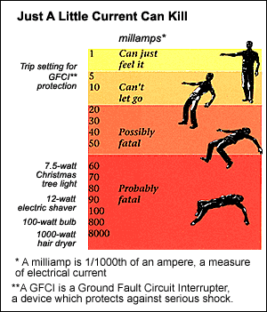
Figure 1.1 little current can kill

CHAPTER 3
EXISTING SYSTEM
In the existing system to prevent shock we have mainly used the non-conductor of electricity such as wood, plastics, rubber gloves, rubber slippers to avoid electric shock.Since it is not a proper or completed solution. The workers or people who were working in EB line or factory where having problems. So we go for our proposed system.Wear safety glasses with side shield or goggles to avoid eye injury and face protection. Wear clothing that is neither flopping nor to tight. Loose clothing will catch on corner and rough surface.
CHAPTER 4
PROPOSED SYSTEM
The objective of this project is to describe methods of detection of unsafe electrical conditions with respect to the grounding of electrically operated mining equipment. it also includes a discussion of prototype instruments which effectively monitor the condition of the grounding safety devices currently in use on mining equipment and warn of dangerous conditions as soon as they appear.
4.1 FIELD OF INVENTION:
This invention relates generally to electrically powered systems of the kind which may present various hazardous electrical shock risk conditions when operating in their intended environment. The invention relates more particularly to an electric shock prevention method and system when any one or more of its associated electrical shock risk conditions exist.
4.1.1 FEATURES OF ESP:
- Adjustable Sensitivity.
- Tripping Time Less Than 30 Milli Seconds.
- The ESP will automatically cuts off power supply thus preventing electrical
- Available in single phase & three phase with 10 mA to 300 mA sensitivity.

4.1.2 APPLICATION:
Protect Your Family & Industry against Shock, Electrocution; Protect Your Family & Industry against Shock, Electrocution, Electrical Fires, and Overload & Short Circuits. It deals In Every Electrical Installation Including,
- Domestic & Industrial
- Hospitals
- Machine Tools
- Air conditioners & Deep Freezers
- Computer & Electronic Power Supplies

4.1.3 HARDWARE REQUIREMENTS:
- PIC16F874A/877A
- Potential sensor
- Encoder
- Zigbee TX & RX
- Decoder
- Pic micro controller
- Transformer-3 arms
- Relay
- 5v-power supply
- Opto coupler
- Lamp load
4.1.4 SOFTWARE REQUIREMENTS:
- Embedded Ckeil
.
5.2 ZIGBEEARCHITECTURE:
• ThephysicalandMAClayerstakefulladvantageofthephysicalradiospecified byIEEE802.15.4.The802.15.4specificationdescribesapeer-to-peerradio usingDirectSequenceSpreadSpectrum.Thespecificationalsocallsoutthe datarates,channelization,andmodulationtechniquestobeemployed.
• TheZigBeeAlliancespecifiesthelogicalnetwork,security,andapplication software,whichareimplementedinafirmwarestack.It istheZigBee networking stackthatcreatesthemeshnetworkingcapability.Eachmicrocontroller/RFchip combinationrequiresitsownZigBeestackduetothedifferencesinmicro- controllersandRFchips.Typically,theZigBeestackisincludedwitheitherthe microcontrollerorRFchip.Thestackmaybelongtothechipvendor,beprovided bythechipvendorfromathirdpartysource,orbeprovidedbyathirdparty source foraspecificmicrocontroller/RFchipcombination.

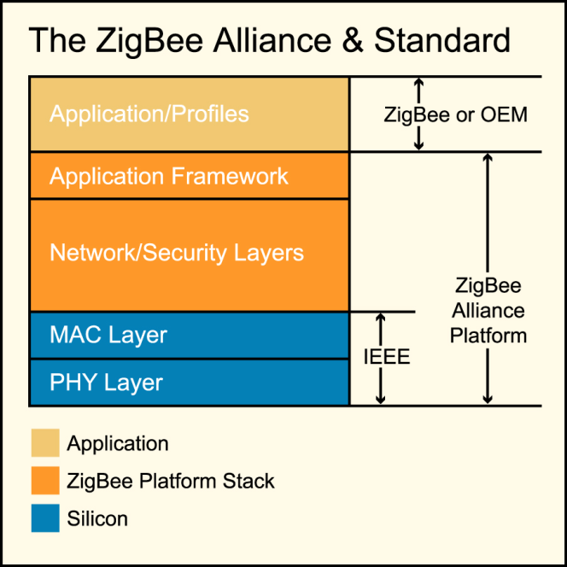
Figure5.2 Zgbeearchitecture
AwordabouttheZigBeeAlliance:Thefollowingdiscussionincludesoptionsthatrequire accesstointellectualpropertyavailableonlytomembersof theZigBeeAlliance.There are threetypesofmembership;allcompaniesthatplantoreleaseproductsincorporating ZigBeetechnologymustbecomeatleastadoptingmembers,anentry-levelmembership thatprovidessuchbenefitsasaccesstospecificationsanddeveloperconferences/ workshops.
5.2.1 ZIGBEEIMPLEMENTATION:HARDWARE ANDFIRMWARE CONSIDERATIONS:
IninvestigatingZigBeedevelopmentresources,you’llwanttovisittheZigBeeAllianceatwww.zigbee.org.MembersoftheZigBeeAllianceofferZigBee-compliantplatforms,in eitherthechipsetsthemselvesordesign-inmodulesdevelopedonthem.Therearethree basicoptionsforZigBeehardwareimplementation:
• Chipsetreferencedesigns
ZigBeechipmakersofferreferencedesignswhich,toberelevantforasmany differentapplicationsaspossible,areverybroad.Usingareferencedesignmay meangivinguprealestateandincurringcostforcapabilitiesyoudon’tneed,but you’llavoidthetimeandexpenseofacustomdesign.
• Chipsetcustomdesigns
Youcansavespaceandrecurringproductexpensebybuildingacustomdesign aroundachipset.Besuretoworkwithachipsetyouknowwell;asallcurrent setsconsistofanRFchippairedwithamicrochip,you’llneedbothRFanddigital designengineeringcapability.
• Design-inmodules
ThereareanumberofOEMmodulemanufacturers,includingCirronet,whose productsincorporateZigBee-compliantchipsets.Withanymodulesolution,the RFworkisalreadycomplete,oftenwithoptimizationforparticulartypesof applications,andtypicallyincludingFCCandETSIcertificationasamodule.You mayor maynotfindamodulethatsupportsyourapplicationintheoptimum manner,butif youdo,you’llgettomarketveryquicklyandgreatlyreduce developmentcosts.Becausemodulemanufacturersaggregatedemandfroma numberofcustomers,theyoftenwillbebuildingmodulesinsuchlargequantities thatthepriceofamodulemayevenbelessthanthecostofachipsetsolution.
5.2.2 ZIGBEEIMPLEMENTATION:PROFILECONSIDERATIONS:
Thechipsetandthestackareincompletewithoutaprofile,whichdefinesthemodule application.Asmentionedpreviously,therearepublicprofilesandprivateprofiles.For publicprofiles,ZigBeeLogoCertificationisavailable;privateprofilesarenotintendedto interoperateandthereforecannotbecertified.
At thispoint,thesimplefactisthatthereisonlyoneZigBeepublicprofile,andthat’sfor lighting.IfyouaredevelopingaZigBeesolutionforanyothertypeofapplication,and can’twaitforthedevelopmentofanappropriatepublicprofile,you’llneedtogowithone oftheprivateprofilesthathavebeendeveloped,ordevelopyourown.
Somechipmakershavecreatedprivateprofilesthatareintegratedintotheirstacks, typicallygeneral-purposeserialUARTs.Modulemanufacturersaremorelikelytooffer application-specificprivateprofiles,andmayoffersomethingsuitabletoyourneeds.

Implementingprofiles,eitherpublicorprivate,isnosmallundertaking.Inadditiontothe needtolicensedevelopmenttoolsfromthestackprovidersandattendingatraining class,bepreparedtospendafairamountoftimestudyingthevariousfirmware componentsthatconstitutetheZigBeestack.Alsomakesurethatyourfirmware engineersarefamiliarwiththemicrocontrollerusedintheplatform.Whilenoneofthese itemsisinsurmountable,theydoaddtodevelopmentcostsandtimetomarket.
If youdecidetouseathird-partyZigBeemodule,youcanstilldevelopyourownprofile. Mostmodulemanufacturerscanprovidethehardwareabstractionlibraries,which reducestheeffort.Somemodulemanufacturersofferservicestocreateacustomprofile fortheircustomers.Whilethisisnotafreeservice,it cansimplifythedevelopmenteffort andshortentimetomarket.
5.2.3 ZIGBEEIMPLEMENTATION:CERTIFICATIONANDTESTING:
Onceyouhaveengineeredyourproductwiththenecessaryhardware,firmware,and profile,it’snowtimetostarttesting.FirstthereistheFCCandETSItests.Thenthere aretheZigBeetests,butbeforeyoucanrunthesetests,youmustjointheZigbee Alliance.ByjoiningtheZigBeeAllianceyougainaccesstotheIP embodiedinthe Zigbeetechnology.WithoutjoiningtheAlliance,yourlegalabilitytousetheZigBee technologycanbecalledintoquestion.
AnyZigBeeproductyoumarketmustfirstpassoneoftwotestinglevels,eitherZigBee FriendlyorZigBeeLogoCertified.Eachrequires thatZigBeeCompliantPlatformtestingbesuccessfullycompletedfirst.
ZigBeeCompliantPlatform(ZCP)testingmaybe completedbyachipsetmanufacturer or amodulemanufacturerandpassedthroughtotheircustomers.Thistestingis concernedprimarilywithcompliancetestingatthestackprofile(differentfromthe applicationprofiles).AslongastheZigBeeimplementationusesthestackprofileused for theZCPtesting,it doesnotneedtoberepeated.If,however,adifferentstackprofile isneededforyourdeviceandthatstackprofilewasnottestedbythechipsetormodule manufacturer,youwillneedtorepeattheZCPtests.
ZigBeeFriendlytestingassuresthatproductswithprivateprofileswon’tcauseproblems forothernearbyZigBeenetworks.Ifachipsetormodulemanufacturerhaspassed ZigBeeFriendlytesting,aproductincorporatingitsdevicedoesnotneedtoberetested aslongastheprofileusedinthetestingisusedunchanged.If anychangesaremadeto theprofile,theproductwiththemodifiedprofilemustbesubmittedforZigBeeFriendly testing.Moduleconfigurationsettingsarenotconsideredchangestotheprofile.

CHAPTER 6
RESULT AND DISCUSSION
- In this project electric shock is avoided by using zigbee to prevent the . life of human beings.
- If the voltage is below 12v it should not sensed by the electric potential Sensor.
- If the voltage is above 12v entire unit will be off.

 | Mill ampere | Effect
SAFE | Less than 1 | No sensation,not felt.
SAFE | 1 to 8 | Shock sensation; not painful; can let go at will
UNSAFE | 8 to 15 | Painful shock; can let go at will.
UNSAFE | 15 to 20 | Painful shock; loss of adjacent muscle control; can not let go.
UNSAFE | 20 to 50 | Painful, severe muscular contractions; difﬁculty breathing.
UNSAFE | 50 to 100 | Possible ventricular ﬁ brillation.
UNSAFE | 100 to 200 | Certain ventricular ﬁ brillation.
UNSAFE | More than 2000 | Severe burns; severe muscular con- tractions; chest muscles clamp heart .

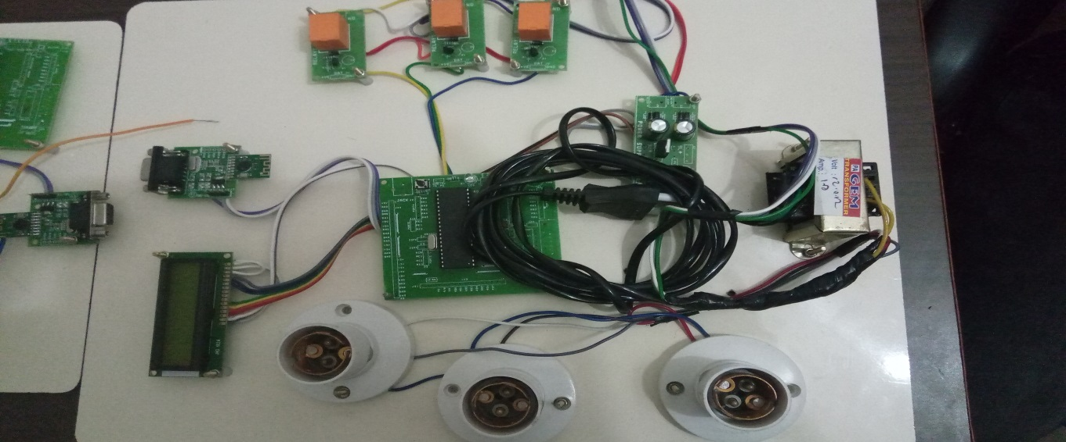

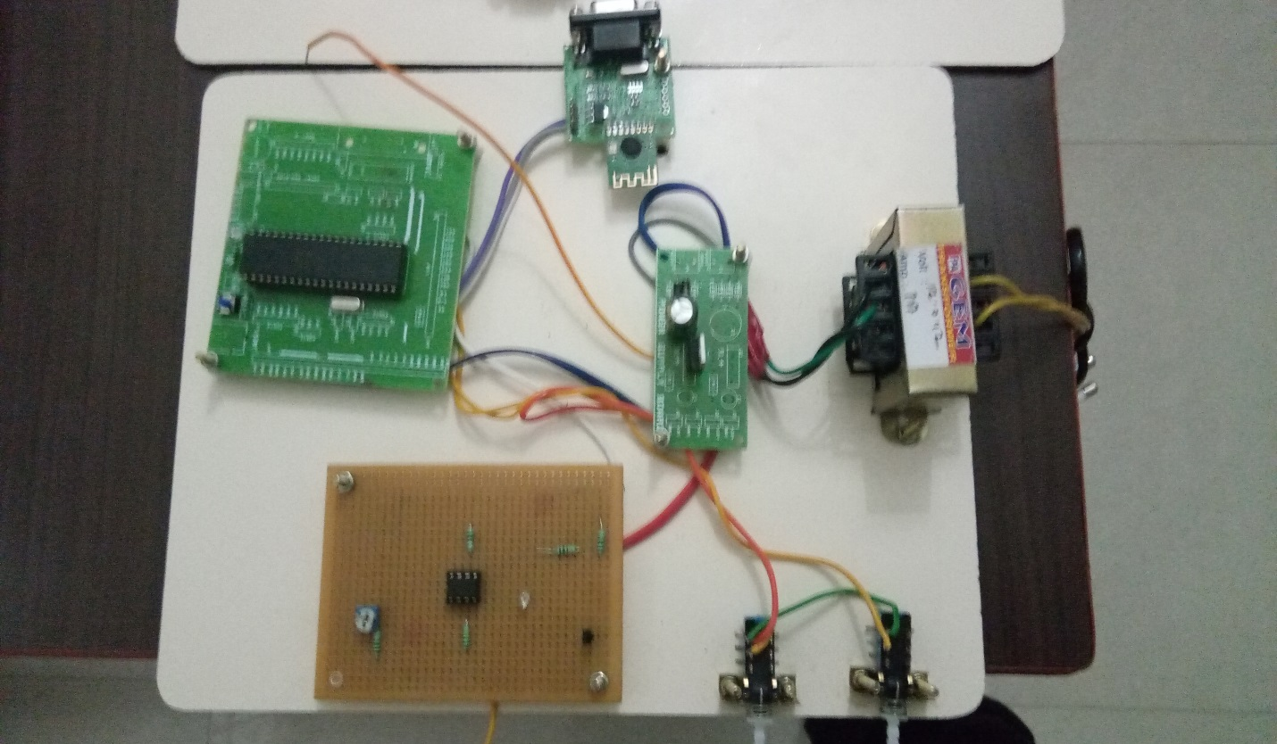
Figure6:shock prevented results
EXPERIMENTAL RESULT:
Logic | Lamp
If >12v | Off
If<12v | On
Manually switch | On and off

CHAPTER 7
CONCLUSION
The effect of electric shock depends on a variety of factors ,including the strength of the current,the area of the body through which current passes ,and whether the person is grounded or insulated from the ground.Death caused by an electric shock is referred to as electrocution.to avoid injury by an electric shock,the embedded based shock preventer is used where it controls the total power unit of a factory or department which prevents human life from electric shock.
In future it can be implemented in such a way that instead of shutting down the entire unit, finding proper way to reduce improper power supply.

REFERENCES
- K. Ji, X. Rui, L. Li, A. Leblond, and G. McClure, “A novel ice-shedding model for overhead power line conductors with the consideration of adhesive/cohesive forces,” Comput, Struct, vol. 157, pp. 153-164, 2015.
- G. McClure, K. Ji, and X. Rui, “An Integrated Ice-Shedding Model of Electric Transmission Lines with Consideration of Ice Adhesive/Cohesive Failure,” Proc. 9th Int. Conf. on Structural Dynamics, pp. 3731-3736, June30-July 02, 2014.
- X. Meng, L. Hou, L. Wang et al., “Oscillation of conductors following ice-shedding on UHV transmission lines,” Mech. Syst. Signal Pr., vol. 30, pp. 393-406, 2012.
- H. Landis Floyd II, PE, CSP, CMRP, Fellow IEEE(2014)”Leading Edge Developments in Advanced Safety Management and Applications to Electrical Safety” No.19.
- Floyd, A.H.L. and Floyd, H.L(2013),”Cultural Drift and the Occlusion of Electrical Safety, IEEE IAS Electrical Safety Workshop,Dallas, TX.
- F. Mirshafiei, G. McClure, and M. Farzaneh, “Modelling the Dynamic Response of Iced Transmission Lines Subjected to Cable Rupture and Ice Shedding,” IEEE Trans. Power Del, vol. 28, no. 2, pp. 948-54, 2013.
- F. Yang, J. Yang, Z. Zhang et al., “Analysis on the dynamic responses of a prototype line from iced broken conductors,” Eng. Fail. Anal., vol. 39, no. 0, pp. 108-123, 2014.
- L. B. Gordon and L. Cartelli,(2009), “A complete electrical hazard classification system and its application,” in Proc. IEEE IAS Electrical Safety Workshop, St. Louis, MO, Feb. 2–6,2009, pp. 62–74.
- CawleyJ.C., Brenner, B.C.(2009),”Analyzing on the Job Electrical Injuries, a Survey of Selected U.S. OcupationalElectrical Injuries”IEEE Industry Applications, Magazine,May/June 2013.

