Design of Horn Feed for Parabolic Reflector Antenna
CHAPTER
PROPOSED SYSTEM
The proposed system involves multi mode horn feed design for parabolic reflector in order to reduce the cross polarization in the resonating frequency of 2.79 GHz in the Ansoft HFSS tool.
SOFTWARE REQUIREMENT
The software used for simulation of parabolic reflector using horn feed antenna is HFSS. HFSS known as High Frequency Software Simulator is a commercial finite element method solver for Electro Magnetic structures from Ansoft. ANSOFT HFSS is the industry leading 3D Electro Magnetic (EM) simulation tool for high frequency and high speed electronic components. Electro Magnetic simulation is a valuable tool in antenna design and platform integration providing the designer the ability to virtually design and evaluate what if scenarios as well as verify the final manufactured design. With multiple simulation technologies and powerful automated adaptive mesh refinement providing gold standard accuracy, HFSS can help antenna designers who are constantly challenged with implementing designs across more and more frequency bands inside a smaller and smaller footprint.
HFSS provides automatic, accurate, and efficient solutions to overcome these challenges, making it the ultimate tool of choice for antenna simulation. Basic performance characterization such as return loss, input impedance, gain, directivity and a variety of polarization characteristics can be analyzed in HFSS. Key post-processing features such as the ability to overlay the 3D far-field pattern on the antenna geometry can provide the designer invaluable insight and direct correlation between the antenna and the resulting radiation pattern. HFSS also offers electric and magnetic field visualization both in the near-field and far-field providing design understanding that is not easily available through measurement.
Procedure to simulate
- Open and make new project
- Draw objects
- Assign material property
- Define boundary conditions
- Solve
- Display result
DESIGN STEPS INVOLVED IN PROPOSED SYSTEM
Mathematical Model
The numerical modeling of reflector antennas is a necessary stage of their design. Due to numerical modeling dimensions of all antenna elements are defined. The more factors are accounted during antenna numerical modeling the more accurately the antenna elements dimensions is defined.
Mathematical model of reflector antenna in radiation and receiving modes
The single-reflector is analyzed in this work. The single-reflector antenna within coordinate system X, Y, Z and its geometric dimensions are shown in figure 5.1. Antenna element dimensions and markings are the following: F_{h} – phased center of feed horn; F –parabolic focus; D_{p} – parabolic diameter; D_{g} – hyperboloid diameter; F_{P} – parabolic focus distance; F_{g1} – far focus hyperboloid distance; F_{g2} – near focus of hyperboloid distance; 2_{θM max} 2Θ₀– parabolic aperture angle; M – point on parabolic surface; R_{M}, θ_{M}, φ_{M} R_{M}, θ_{M}, φ_{M} – spherical coordinates of M point with respect to parabolic focus F.
Single-reflector antenna in radiation mode
Pyramidal horn is used as feed-horn. The feed horn is executed by rectangular waveguide figure 5.2.The horn dimensions A_{h}, B_{h} are aperture dimensions, R_{h} is horn depth. The case when polarization plane of feed horn coincides with YZ plane is considered. The dimension of waveguide cross section satisfies a uniqueness condition of wave TE10: a< λ <2a, where λ– wavelength.
The complex amplitude of field in a rectangular waveguide at horn input:
Where a- is the dimension of the wide wall of rectangular waveguide.
is the characteristic impedance of the waveguide.
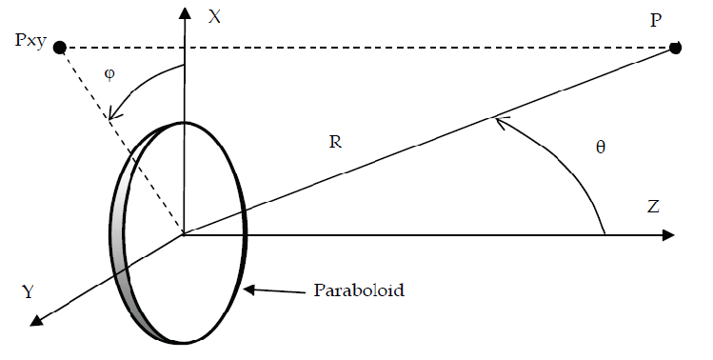
Fig. 5.1 Antenna and point P in space
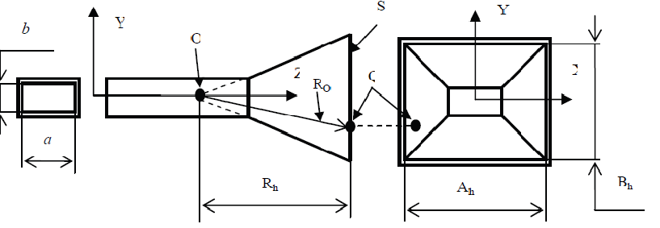
Fig. 5.2 Rectangular waveguide and horn feed
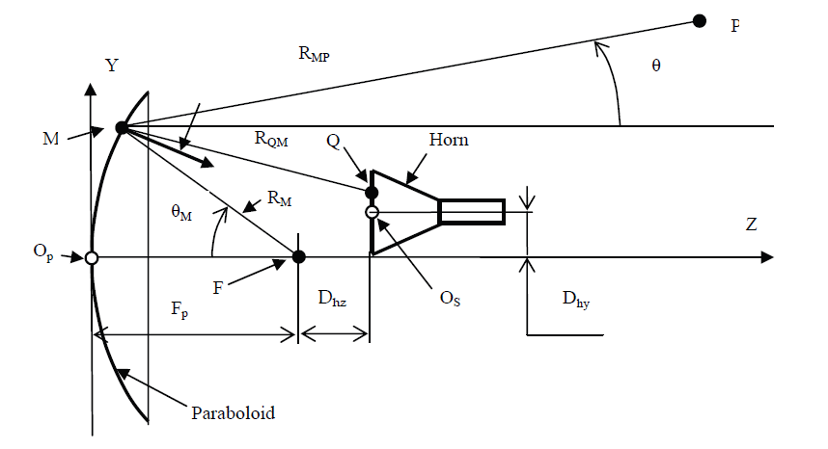
Fig. 5.3 Single reflector with feed horn
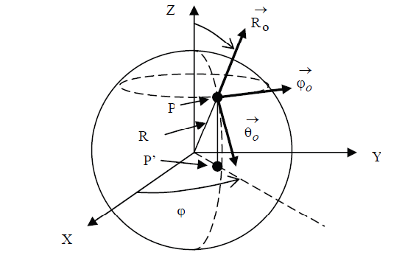
Fig. 5.4 Spherical coordinate system
The expression for RQM results from figure 5.3 by means of rectangular coordinates of the point Q and M in X, Y, Z coordinate system.

The antenna directivity diagrams F_{θ}(θ,ϕ), F_{ϕ}(θ,ϕ) and antenna gain G are calculated based on E_{θ} и E_{ϕ} components.
A single-reflector antenna in receiving mode
A reflector antenna can receive a spherical wave from any points of far, intermediate and near field zones space. Let a spherical wave source be located in the point P shown in figure 5.4. The amplitude of the wave electric field of is equal E_{i}. It is necessary to calculate power P_{i} entering the waveguide. The algorithm of power P_{i} calculation includes the following:

The vector of surface current on Paraboloid surface is calculated based on the Spherical wave magnetic field$H_{I}$ and the wave propagation direction. The remaining will be same as the radiation model of reflector antenna.
Mathematical model of horn feed
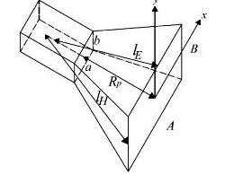
Fig. 5.5 Horn feed
Mathematical model for pramidal horn
$A$=0.45λ$√G$
$$B=\frac{1}{4λ}{Gλ^{2}}/{0.514}$$
$$R_{1}=\frac{A^{2}}{3λ}$$
$$R_{2}=\frac{B^{2}}{2λ}$$
$$R_{E}=R_{2}(1-\frac{a}{A})$$
$$R_{H}=R_{1}(1-\frac{b}{B} )$$
Horn feed design procedure
Initially create a horn feed antenna. The steps involved in creating horn feed is,
- Start the software. Double click the HFSS 13.0 icon
- In the file list, click Save As. Type the project name in the box and click ok
- Insert HFSS design
- Setup the project preferences
Setting the project preferences
- Set unites to inches. 3D Modeler<Units select cm and click ok
- Set Solution type. HFSS<Solution type, check driven model and click ok
Designing the base of the horn
The base of the horn has a uniform rectangular cross section, the width is 0.4 cm, the length is 0.9 cm, and the height is 0.315 cm To draw the base, create a 3D rectangular box.
Click the box icon or go to Draw<Box. Enter the fallowing values -1.15, -0.395, and 0 for x, y, z, respectively and 2.286, 1.016, 0.5 for dx, dy, and dz, respectively. The drawing is with respect to the origin (0, 0, 0).Type Base in the name field. Material assigned is vaccum and choose color and transparency at user preference. Click ok.
Followed by this draw base of the horn using the following instructions in order to excite the horn antenna.
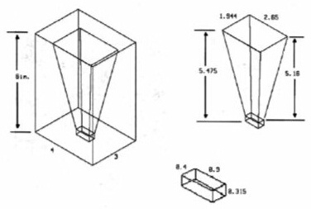
Fig. 5.6 Dimensions of horn antenna
Designing the base 2D rectangle
To create the funnel or tapering of the horn antenna, draw and connect two rectangles, and then connect them to create the 3D funnel. Place the first rectangle on the top of the 3D antenna base. Draw<rectangle. Now move the cursor to one corner of the top of the antenna base, and click on it, then move the cursor to the opposite corner of the top of the antenna base and click again. The rectangle window is open. Type funnel base. Assign material to be vaccum. Choose color and Transparency of your preference. Click ok. Note that the dimensions of the rectangle should match those of the top of the antenna base and the r_{e}, r_{h} should be equal for the horn to be a pyramidal horn antenna.
Designing the horn aperture
Next, draw the 2D rectangle that represents the top of the funnel, or the aperture of the horn. Click Rectangle icon or Draw<Rectangle. Type the fallowing values: -4.15, 2.795, 10.05 for x, y, z, respectively. Type horn top in the name field. Assign material to be vaccum. Choose the color and Transparency at user preference. Click ok.
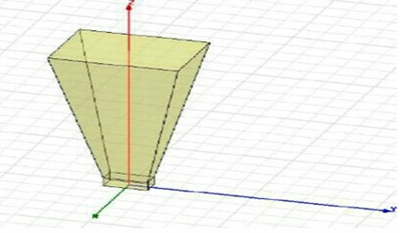
Fig. 5.7 Horn antenna
Connecting 2D objects to create the funnel
Now connect the 2D objects that make up the base and the top of the funnel to create the 3D, funnel-shaped object. Choose the horn top and funnel base from the Model tree by holding down the ctrl key. Go to 3D Modeler<surface<connect. Name it funnel.
Uniting the horn base with funnel
Although it is not strictly necessary, unite the two 3D objects-the horn base and the funnel, to create one 3D horn antenna structure. This makes the problem simpler by keeping the number of objects to a minimum. Choose base and funnel from the list of 3D objects. Then 3D Modeler<Boolean<unite. Then click ok.
Designing the 3D air box around the horn antenna
To simulate the horn antenna, enclose the horn with bounded box of air. Click Box icon or Draw<Box. Type in the fallowing values: -1.5, -2, 0, for x, y, z, respectively and 3, 4, and 6 for dx, dy, and dz, respectively. Type Air box in the name field, vaccum is the assigned material and choose color and transparency at user preference. Click ok.
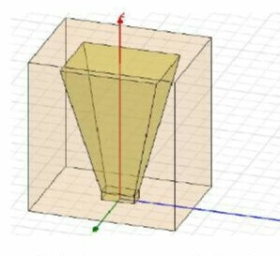
Fig. 5.8 Horn antenna with air box
Assigning boundaries and excitations
Choose the surfaces of the horn and assign Perfect E. All faces of the horn should be chosen except the top and the bottom. Then the Boundaries right click Assign<Perfect E and name it perfect E_horn_sides. Assign radiation boundary to the air box. Choose the faces of the air box and boundaries right click Assign<Radiation. Name it rad air. Assign Excitation to the bottom face of the horn. Excitations<wave ports. Name it as Wave port.
ADVANTAGES AND DISADVANTAGES
Advantages
- Parabolic reflector antennas are able to provide very high levels of gain
- The larger the 'dish' in terms of wavelengths, higher the gain
- The parabolic reflector or dish antenna is able to provide high levels of directivity due to gain
Disadvantages
- Cost: The antenna needs to be manufactured with care. A paraboloid is needed to reflect the radio signals which must be made carefully. A feed system is also required. This can add cost to the system

- Size: This antenna is not as small as some types of antenna, although used for satellite television reception are quite compact.
APPLICATIONS
- Direct broadcast television: Direct broadcast or satellite television has become a major form of distribution for television material. The wide and controllable coverage areas combined with the much larger bandwidths for more channels mean that satellite television is very attractive. However as signal levels are low, directive antennas must be used to provide sufficient gain while being able to receive signals from only one satellite in the visible sky. The parabolic reflector antenna is able to meet these requirements and has the added advantage that it would not be as long as a Yagi or equivalent gain and directivity.
- Microwave links: Terrestrial microwave links are used for many applications. Often they are used for terrestrial telecommunications infrastructure links. One of the major areas where they are used these days is to provide the backhaul for mobile phone / cellular backhaul.
- Satellite communications: Many satellite uplinks or those for communication satellites require a high level of gain to ensure the optimum signal conditions d close angular proximity. Again the ideal antenna for most applications is the parabolic reflector antenna.
- Radio astronomy: Radio astronomy is an area where very high levels of gain and directivity are required. Accordingly the parabolic reflector antenna is an ideal choice.

