Design Of Closed Control Loop For Boiler Air Flow System using Embedded system

CHAPTER-I

1.1 INTRODUCTION
Present industry is increasingly shifting towards automation. Two principle components of today’s industrial automations are programmable controllers and robots. In this frame work, it is required to optimize the boiler efficiency which in turn helps to generate maximum amount of power in an optimized environment
This project work proposes a prototype of closed loop air damper control method used where the oxygen supply can be controlled with the help of actuator, microcontroller through simulation.
The main function of the boiler is to generate steam at desire pressure and desired steam generation rate in boiler system; fan is the major role for outside power supplies like coal, air, Oxygen to the furnace.
Types of Fan in Boiler operation:
- Primary air (PA) fan
- Induced draft (ID)fan
- Forced draft (FD) fan
1.2 Primary Air (PA) fan:
- This fan is automatic control in boiler operation
- It supplies mixed coal along with air through mills to furnace
  - Induced Draft (ID) fan:
- It also automatic control, it helps to exit unwanted smoke to chimney tower
1.4 Forced Draft (FD) fan:
It is controlled manually in the existing boiler system.
- It provides oxygen to the closed vessel of furnace through vane/damper arrangement.
- It’s not easy to control the flow of oxygen in forced draft fan, because it depends upon the nature of coal.
- It requires more man power, less effective, less dynamic.

HARDWARE SPECIFICATION

4.1 LCD DISPLAY
Liquid crystal displays (LCDs) have materials which combine the properties of both liquids and crystals. Rather than having a melting point, they have a temperature range within which the molecules are almost as mobile as they would be in a liquid, but are grouped together in an ordered form similar to a crystal.
An LCD consists of two glass panels, with the liquid crystal material sand witched in between them. The inner surface of the glass plates are coated with transparent electrodes.
The LCD’s are lightweight with only a few millimeters thickness. Since the LCD’s consume less power, they are compatible with low power electronic circuits, and can be powered for long durations. The LCD’s don’t generate light and so light is needed to read the display. By using backlighting, reading is possible in the dark. The LCD’s have long life and a wide operating temperature range. Changing the display size or the layout size is relatively simple which makes the LCD’s more customer friendly. The LCDs used exclusively in watches, calculators and measuring instruments are the simple seven-segment displays, having a limited amount of numeric data. The recent advances in technology have resulted in better legibility, more information displaying capability and a wider temperature range. These have resulted in the LCDs being extensively used in telecommunications and entertainment electronics. The LCDs have even started replacing the cathode ray tubes (CRTs) used for the display of text and graphics, and also in small TV applications
.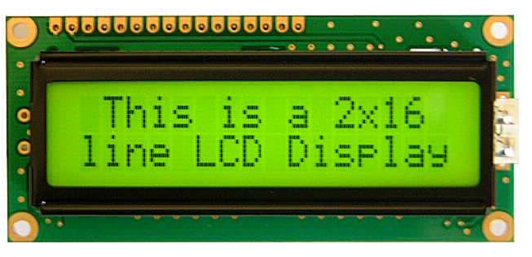
FIGURE: 4.1 LCD DISPLAY
4.2 POWER SUPPLY:
The ac voltage, typically 220Vrms, is connected to a transformer, which steps that ac voltage down to the level of the desired dc output. A diode rectifier then provides a full-wave rectified voltage that is initially filtered by a simple capacitor filter to produce a dc voltage. This resulting dc voltage usually has some ripple or ac voltage variation.
A regulator circuit removes the ripples and also remains the same dc value even if the input dc voltage varies, or the load connected to the output dc voltage changes. This voltage regulation is usually obtained using one of the popular voltage regulator IC units.

LOAD

IC REGULATOR
FILTER
RECTIFIER
TRANSFORMER

FIGURE: 4.2 Power supply
4.3 OXYGEN SENSOR
An oxygen sensor (or lambda sensor) is an electronic device that measures the proportion of oxygen (O2) in the gas or liquid being analyzed.
It was developed by Robert Bosch GmbH during the late 1960s under the supervision of Dr. Günter Bauman. The original sensing element is made with a thimble-shaped zirconia ceramic coated on both the exhaust and reference sides with a thin layer of platinum and comes in both heated and unheated forms. The planar-style sensor entered the market in 1990, and significantly reduced the mass of the ceramic sensing element as well as incorporating the heater within the ceramic structure. This resulted in a sensor that started sooner and responded faster.
The most common application is to measure the exhaust gas concentration of oxygen for internal combustion engines in automobiles and other vehicles in order to calculate and, if required, dynamically adjust the air fuel ratio so that catalytic converters can work optimally, and also determine whether a catalytic converter is performing properly or not. Divers also use a similar device to measure the partial pressure of oxygen in their breathing gas.
Scientists use oxygen sensors to measure respiration or production of oxygen and use a different approach. Oxygen sensors are used in oxygen analyzers which find a lot of use in medical applications such as anesthesia monitors, respirators and oxygen concentrators.
Oxygen sensors are also used in hypoxic air fire prevention systems to monitor continuously the oxygen concentration inside the protected volumes.
4.4 amplifier:
An electronic amplifier is a device for increasing the power of a signal. It does this by taking energy from a power supply and controlling the output to match the input signal shape but with a larger amplitude. In this sense, an amplifier may be considered as modulating the output of the power supply.
4.5 FLOW SENSOR:
A flow sensor is a device for sensing the rate of fluid flow. Typically a flow sensor is the sensing element used in a flow meter, or flow logger, to record the flow of fluids. As is true for all sensors, absolute accuracy of a measurement requires functionality for calibration.
There are various kinds of flow sensors and flow meters, including some that have a vane that is pushed by the fluid, and can drive a rotary potentiometer, or similar device.
Other flow sensors are based on sensors which measure the transfer of heat caused by the moving medium. This principle is common for micro sensors to measure flow.
Flow meters are related to devices called velocity meters that measure velocity of fluids flowing through them. Laser-based interferometer is often used for air flow measurement, but for liquids, it is often easier to measure the flow.

4.6 DRIVER CIRCUIT
A transistor is a semi conductor device used to amplify and switch electronic signals. It is made of a solid piece of semiconductor material, with at least three terminals for connection to an external circuit. Today, some transistors are packaged individually, but many more are found embedded in integrated circuits.

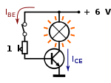

FIGURE: 4.3 Transistor as a switch
4.7 RELAY:
A relay is an electrically operated switch. Current flowing through the coil of the relay creates a magnetic field which attracts a lever and changes the switch contacts. The coil current can be on or off so relays have two switch positions and they are double throw (changeover) switches. Relays allow one circuit to switch a second circuit which can be completely separate from the first. For example a low voltage battery circuit can use a relay to switch a 230V AC mains circuit. There is no electrical connection inside the relay between the two circuits; the link is magnetic and mechanical.
The coil of a relay passes a relatively large current, typically 30mA for a 12V relay, but it can be as much as 100mA for relays designed to operate from lower voltages. Most ICs (chips) cannot provide this current and a transistor is usually used to amplify the small IC current to the larger value required for the relay coil. The maximum output current for the popular 555 timer IC is 200mA so these devices can supply relay coils directly without amplification.
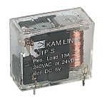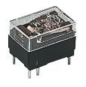
FIGURE: 4.4 RELAY
Relays are usually SPDT or DPDT but they can have many more sets of switch contacts, for example relays with 4 sets of changeover contacts are readily available. Most relays are designed for PCB mounting but you can solder wires directly to the pins providing you take care to avoid melting the plastic case of the relay. The animated picture shows a working relay with its coil and switch contacts. You can see a lever on the left being attracted by magnetism when the coil is switched on. This lever moves the switch contacts. There is one set of contacts (SPDT) in the foreground and another behind them, making the relay DP
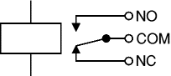
FIGURE: 4.5 RELAY OPERATION
The relay's switch connections are usually labeled COM, NC and NO:
- COM = Common, always connect to this, it is the moving part of the switch.
- NC = Normally Closed, COM is connected to this when the relay coil is off.
- NO = Normally Open, COM is connected to this when the relay coil is on.

CHAPTER 5
SOFTWARE TOOLS
5.1 INTRODUCTION
MPLAB IDE is an integrated development environment that provides development engineers with the flexibility to develop and debug firmware for various Microchip devices
MPLAB IDE is a Windows-based Integrated Development Environment for the Microchip Technology Incorporated PIC microcontroller (MCU) and PIC digital signal controller (DSC) families. In the MPLAB IDE, you can:
- Create source code using the built-in editor.
- Assemble, compile and link source code using various language tools. An assembler, linker and librarian come with MPLAB IDE. C compilers are available from Microchip and other third party vendors.
- Debug the executable logic by watching program flow with a simulator, such as MPLAB SIM, or in real time with an emulator, such as MPLAB ICE. Third party emulators that work with MPLAB IDE are also available.
- Make timing measurements.
- View variables in Watch windows.
- Program firmware into devices with programmers such as PICSTART Plus or PRO MATE II.
- Find quick answers to questions from the MPLAB IDE on-line Help.
5.2 MPLAB SIMULATOR
MPLAB SIM is a discrete-event simulator for the PIC microcontroller (MCU) families. It is integrated into MPLAB IDE integrated development environment. The MPLAB SIM debugging tool is designed to model operation of Microchip Technology's PIC microcontrollers to assist users in debugging software for these devices

IC PROG
The PRO MATE II is a Microchip microcontroller device programmer. Through interchangeable programming socket modules, PRO MATE II enables you quickly and easily program the entire line of Microchip PIC microcontroller devices and many of the Microchip memory parts.
PRO MATE II may be used with MPLAB IDE running under supported Windows OS's (see Read me for PRO MATE II.txt for support list), with the command-line controller PROCMD or as a stand-alone programmer
5.3 COMPILER-HIGH TECH C
A program written in the high level language called C; which will be converted into PIC micro MCU machine code by a compiler. Machine code is suitable for use by a PIC micro MCU or Microchip development system product like MPLAB IDE.
5.4 PIC START PLUS PROGRAMMER:
The PIC start plus development system from microchip technology provides the product development engineer with a highly flexible low cost microcontroller design tool set for all microchip PIC micro devices. The PIC start plus development system includes PIC start plus development programmer and MPLAB IDE.
The PIC start plus programmer gives the product developer ability to program user software in to any of the supported microcontrollers. The PIC start plus software running under MPLAB provides for full interactive control over the programmer.

5.5 SOURCE CODE:
#include<pic.h>
#include"pic_lcd8.h"
#include"pic_adc.h"
#define set RB0
//#define mov RB1
#define inc RB1
#define dec RB2
#define ent RB3
#define R RB4
#define R1 RB6
#define R2 RB5
void keypad ();
void check();
unsigned char i,ct,aa,ct1,add,a=0;
//R=1;
void main()
{R=1;
TRISA=0xff;
TRISB=0x0E;
TRISC=0x00;
TRISD=0x00;
// ADCON1=0x00;
R=1;aa=0;
Lcd8_Init();
Lcd8_Display(0x80,"-THERMAL POWER-",15);
Lcd8_Display (0xc0,"------PLANT-----", 16);
Delay (65000);Delay(65000);Lcd8_Display(0xc8,"Real:",5);

Lcd8_Display(0x94,"Coal:",5);R=1;R1=R2=1;
Lcd8_Command(0x01);
while(1)
{ //R=1;TRISC=0x00;
Lcd8_Display(0xc8,"Real:",5);
Lcd8_Display(0x94,"Coal:",5);
ct=Adc8_Cha(0);
Lcd8_Decimal3(0xcD,ct);
ct1=Adc8_Cha(1);
Lcd8_Decimal3(0x99,ct1);
//add=ct+ct1;
// Lcd8_Decimal3c(0x85,add);
if(!set)keypad();
//if(!inc)R=0;
//else R=1;
if(aa)check();
}
}
void keypad()
{
//Lcd8_Command(0x01);
Lcd8_Display(0xc8,"Real:",5);
Lcd8_Display(0xC0,"Set:",5);
while(ent)
{
if(!inc)i++;
else if(!dec)i--;
Lcd8_Decimal3(0xC4,i);Delay(8000);aa=1;
}
}

void check()
{
ct=Adc8_Cha(0);
if(ct==i){R=1;R2=0;Lcd8_Display(0x80,"-----NORMAL-----",16);}

//if(ct<i) {R=1;R1=1;Lcd8_Display(0x80,"------OFF------",16);}
if(ct<i && a==0) {R=0;R2=0;Lcd8_Display(0x80,"--LOW AIR FLOW--",16);Delay(65000);Delay(65000);R=1;a=1;}
if(ct>i && a==1) {R=0;R2=0;Lcd8_Display(0x80,"--HIGH AIR FLOW-",16);Delay(65000);Delay(65000);R=1;a=0;}

if(ct1<50 ) {R1=0;Lcd8_Display(0x9D,"COAL LVL LW",11);}
if(ct1>50 ) {R1=1;Lcd8_Display(0x9D,"COAL LVL HI",11);}
//Lcd8_Decimal3(0xcd,ct);
}

5.6 SIMULATION LAYOUT:

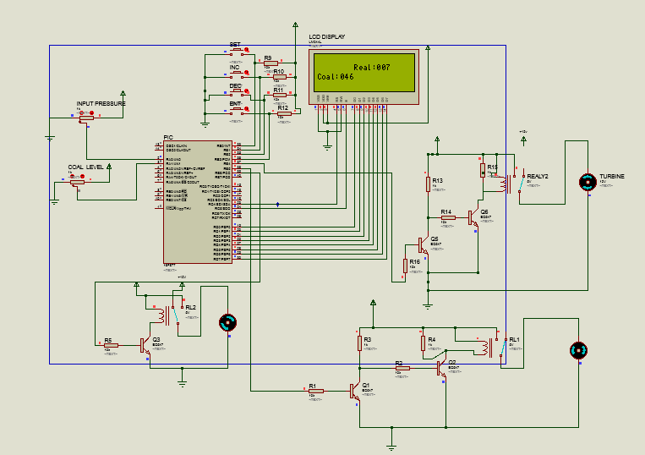

HARDWARE SNAPSHOT

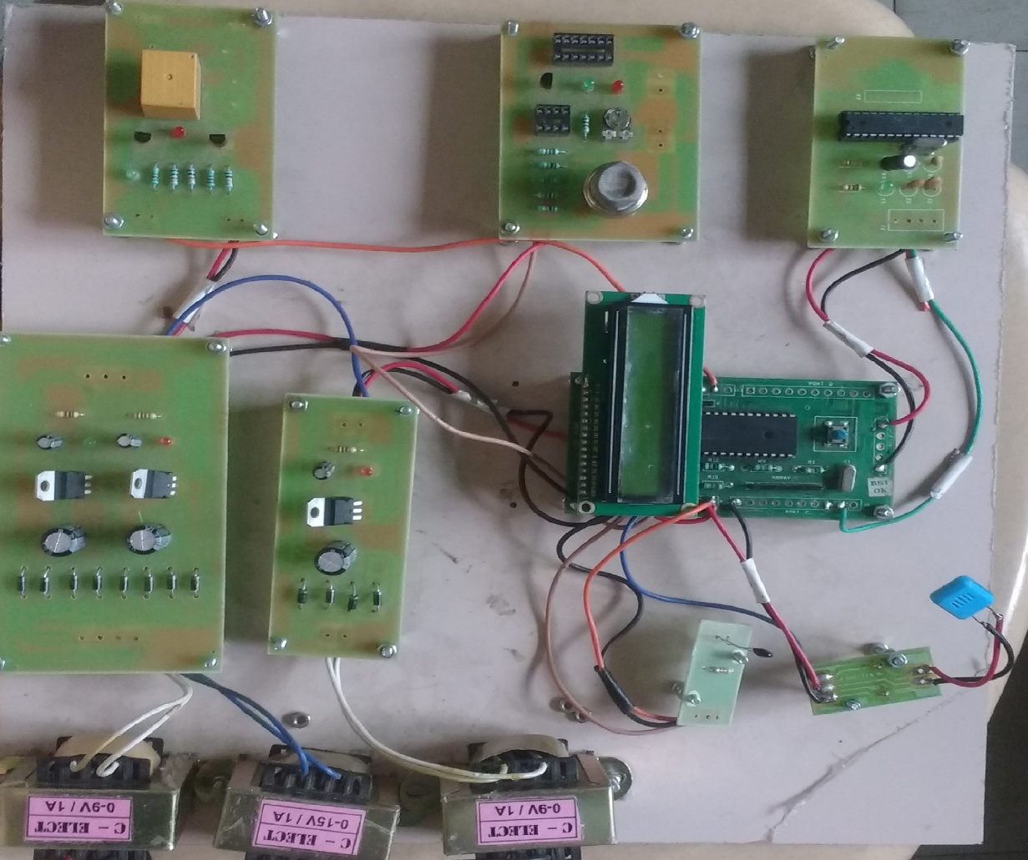

CHAPTER 6
CONCLUSION AND REFERENCE

6.1 CONCLUSION:
Boiler or steam generator is an integral part of most of the core industries like power plant, Steel plant etc. as machines are always susceptible to damages, any problem related to boiler will hampers the total process of production or service in an industry.
We are highly honored to be part of the project which deals with immediate steps to repair, renovate and re-establishment of small industrial package boilers. From the project we have learned basic ideas about stream generator, its working processes, and requirement in industries, individual parts and their functions and the means to improve the efficiency of the boiler while maintaining the environmental laws and pollution act.
The project has immensely helped as to use our theoretical knowledge and skills in practical field while dismantling the boiler parts and analysis for any defects and needful works for their repair.
Overall it has been a great learning experience and gains a lot of experience and gain a lot of experience which we can utilize in practical field in future.

6.2 FUTURE SCOPE:
Future emission scenarios for the period upto 2020-2021 are generated based on the estimates o2 and air flow combination in boiler system from thermal power plant have increased from 323474.858Gg for the percentage of boiler load, nitrogen content in the coal, and rate of gas cooling it makes a large power production for the environment.

6.3 reference
- R.Hari Krishnan, V.Ramprasath-“Controlling power plant boiler and draft fan using lab view IEEE boiler fan simulation circuits”, vol. 27, no. 9 pp.476-487, Sep 2011.

- Rhys Thompson, Dane Wong-IEEE, “Boiler induced draft fan optimization” page no-16-22, published in the year of 2011.

- Juio, Maria p.caton “Controlling power plant boiler &draft fan” in 2014.

- Goyal, IEEE state journal “Design of boiler fan and its operation under control system” IEEE state journal published in the year of 2009.

- Mcgraw hill “Heating boiler operator’s manual maintanance operation and repair” published in the year of 2014

- C.S.Wallace,”Operation of boiler fan controlling for the power plant” page no, 560-568, published in the year of 2014.

- http://www.atmel.com/

- http://www.microchip.com/

- http://www.ieeeexplore.org

- http://www.ctv.es/pckits/home.html

- http://www.aimglobal.org/

