DESIGN AND IMPLEMENTATION OF ATM THEFT MONITORING SECURITY SYSTEM

CHAPTER 1
INTRODUCTION
1.1 METHODOLOGY
In today’s technically advanced world, autonomous systems are gaining rapid popularity. As the social computerization and automation has been increased and the ATM and credit card has been installed and spread out to simplify the activity for financial activity, the banking activity has been simplified, however the crime related with financial organization has been increased in proportion to the ratio of spread out of automation and devices So by using the GSM technology, Vibrations sensor, MEMS module, DC Motor, external ATM machine can be predicted. In this project GSM is used to give signal for corresponding bank and police station. Here DC Motor is used to close the door of the ATM and stepper motor is used to open the solenoid valve for emit gas(chloroform) and bring the theft to unconscious stage. Vibration sensor buffers a piezoelectric transducer. If the assembly is supported by its mounting points and left to vibrate “in free space” the device will behave as a form of vibration sensor. The sensing element should not be treated as a flexible switch, and is not intended to be bent. Sensor Value 500 roughly corresponds to 0g acceleration. Acceleration will deflect the sensing element up or down, causing Sensor Value to swing either way.
1.2 OBJECTIVE OF THE PROPOSED SYSTEM
The proposed project includes system structure, hardware circuits and software program for GSM based automatic theft monitoring system. In this project,mems sensor and vibration sensor is used. The goal of this system is to develop smart security purpose and this system is reduces therobbery in atm.

2.2 PROBLEM IDENTIFICATION IN EXISTING SYSTEM
Presently the ATM machines have only one security system. It only provides security to the entrance door itself, by placing ATM card detectors near the door this technology exists in Few ATM centers only. By using the existed technology ATM machines are not safe in order to provide proper security for money. So it is proposed a new technology which can overcome this problem.
CHAPTER 3
PROPOSED SYSTEM
3.1 WORKING PRINCIPLE:
This project proposed a new technology which can overcome the existing problem. It provides security for the ATM machine itself. Then the attacker try to damage the ATM machine vibration detection sensors and mems detector gets activated. A message is passed to the nearby police stations and bank manager with the help of GSM. When attacker try to break the glass door the solenoid value is activate and its leak the chloroform.

CHAPTER 4
SYSTEM SPECIFICATION
4.1 HARDWARE SPECIFICATION
- PIC MICROCONTROLLER-16F877A
- LCD DISPLAY
- VIBRATION SENSOR
- MEMS MODULE
- SOLENOID VALVE
- GSM MODEM
- RELAY
- DC MOTOR
- REGULATED POWER SUPPLY
4.1.1 EMBEDDED SYSTEM
As the name signifies, an embedded system is embedded or builds into something else. Embedded systems encompass a variety of hardware and software components, which perform specific functions in host system, for example satellites, washing machine, handheldtelephones and automobiles but as technology advance to connect devices to the internet and to each other, the potential of embedded technology has increased. Home appliances, mobile phones, cars, avionics etc.., are all using embedded technology. Embedded systems have become increasing digital with a non-digital peripheral and therefore both Hardware and software coding signs are relevant. Most embedded control product must special requirement, cost effectiveness, low power, small-footprint and a high level of system integration. Typically, most embedded control systems are control system.

4.1.2 Microcontroller (PIC 16F877A)
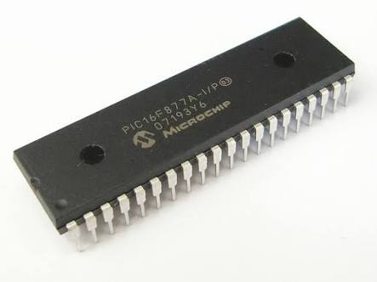
Fig.4.1 PIC16F877A Visual diagram
Microcontroller PIC16F877A is one of the PIC Micro Family microcontroller which is popular at this moment, start from beginner until all professionals. Because it is very easyusing PIC16F877A and use FLASH memory technology so that can be write-erase until thousand times. The superiority this RISC Microcontroller compared to with other microcontroller 8-bit especially at a speed of and his code compression. PIC16F877A have 40 pin by 33 path of I/O. PIC16F877A perfectly fits many uses, from automotive industries and controlling home appliances to industrial instruments, remote sensors, electrical door locks and safety devices. It is also ideal for smart cards as well as for battery supplied devices because of its low consumption. EEPROM memory makes it easier to apply microcontrollers to devices where permanent storage of various parameters is needed (codes for transmitters, motor speed, receiver frequencies, etc.). Low cost, low consumption, easy handling and flexibility make PIC16F877A applicable even in areas where microcontrollers had not previously been considered (example: timer functions, interface replacement in larger systems, coprocessor applications, etc.). In System Programmability of this chip (along with using only two pins in data transfer) makes possible the flexibility of a product, after assembling and testing have been completed. This capability can be used to create assembly-line production, to store calibration data available only after final testing, or it can be used to improve programs on finished products.

4.1.3 PIC Microcontroller Features:
A PIC microcontroller is an amazingly powerful fully featured processor with internal RAM, EEROM FLASH memory and peripherals. One of the smallest ones occupies the space of a 555 timer but has a 10bit ADC, 1k of memory, 2 timers; high current I/O ports a comparator
High-Performance RISC CPU
- Lead-free; Ro HS-compliant
- Operating speed: 20 MHz, 200 ns instruction cycle
- Operating voltage: 4.0-5.5V
- Industrial temperature range (-40° to +85°C)
- 15 Interrupt Sources
- 35 single-word instructions
- All single-cycle instructions except for program branches (two-cycle)

Special Microcontroller Features
- Flash Memory: 14.3 Kbytes (8192 words)
- Data SRAM: 368 bytes
- Data EEPROM: 256 bytes
- Self-reprogrammable under software control
- In-Circuit Serial Programming via two pins (5V)
- Watchdog Timer with on-chip RC oscillator
- Programmable code protection
- Power-saving Sleep mode
- Selectable oscillator options
- In-Circuit Debug via two pins

Peripheral Features
- 33 I/O pins; 5 I/O ports
- Timer0: 8-bit timer/counter with 8-bit prescaler
- Timer1: 16-bit timer/counter with prescaler
  - Can be incremented during Sleep via external crystal/clock
- Timer2: 8-bit timer/counter with 8-bit period register, prescaler and postscaler
- Two Capture, Compare, PWM modules
  - 16-bit Capture input; max resolution 12.5 ns
  - 16-bit Compare; max resolution 200 ns
- Synchronous Serial Port with two modes:
  - SPI Master
  - I2C Master and Slave
- USART/SCI with 9-bit address detection
- Parallel Slave Port (PSP)
  - 8 bits wide with external RD, WR and CS controls
- Brown-out detection circuitry for Brown-Out Reset

Analog Features
- 10-bit, 8-channel A/D Converter

4.1.4 Input and Output Ports:
General purpose I/O pins can be considered the simplest of peripherals. They allow the PIC microcontroller to monitor and control other devices. To add flexibility and functionality to a device, some pins are multiplexed with an alternate functions.Some pins for these I/O ports are multiplexed with an alternate function for the peripheral features on the device. In general, when a peripheral is enabled, that pin may not be used as a general purpose I/O pin. Additional information on I/O ports may be found in the PICmicro™ Mid-Range.

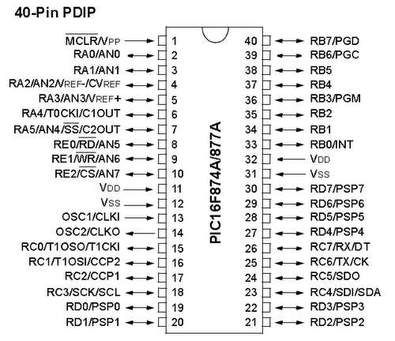
Fig 4.1 PIC 16F874A pin diagram

PORTA and the TRISA Register
PORTA is a 6-bit wide, bidirectional port. The corresponding data direction register is TRISA. Setting a TRISA bit (= 1) will make the corresponding PORTA pin an input (i.e., put the corresponding output driver in a High-Impedance mode). Clearing a TRISA bit (= 0) will make the corresponding PORTA pin an output (i.e., put the contents of the output latch on the selectedpin). Reading the PORTA register reads the status of the pins, whereas writing to it will write to the port latch. All write operations are read-modify-write operations. Therefore, a write to a port implies that the port pins are read; the value is modified and then written to the port data latch. Pin RA4 is multiplexed with the Timer0 module clock input to become the RA4/T0CKI pin. The RA4/T0CKI pin is a Schmitt Trigger input and an open-drain output. All other PORTA pins have TTL input levels and full CMOS output drivers. Other PORTA pins are multiplexed with analog inputs and the analog VREF input for both the A/D converters and the comparators. The operation of each pin is selected by clearing/setting the appropriate control bits in the ADCON1 and/or CMCON registers.
Table 4.1 Port A Pin Detail
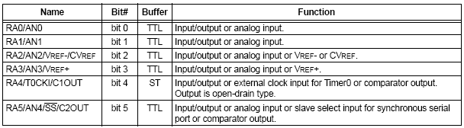

PORTB and the TRISB Register
PORTB is an 8-bit wide, bidirectional port. The corresponding data direction register is TRISB. Setting a TRISB bit (= 1) will make the corresponding PORTB pin an input (i.e., put the corresponding output driver in a High-Impedance mode). Clearing a TRISB bit (= 0) will make the corresponding PORTB pin an output.
Three pins of PORTB are multiplexed with the In-Circuit Debugger and Low-Voltage Programming function: RB3/PGM, RB6/PGC and RB7/PGD. Each of the PORTB pinshas a weak internal pull-up. A single control bit can turn on all the pull-ups. This is performed by clearing bit RBPU (OPTION_REG<7>). The weak pull-up is automatically turned off when the port pin is configured as an output. The pull-ups are disabled on a Power-on Reset
Table 4.2 Port B Pin Detail
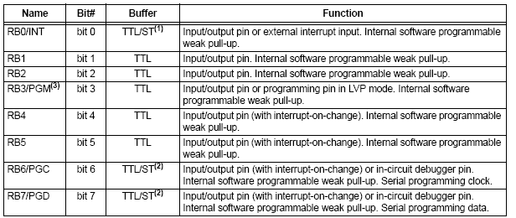
PORTC and the TRISC Register
PORT C is an 8-bit wide, bidirectional port. The corresponding data direction register is TRISC. Setting a TRISC bit (= 1) will make the corresponding PORTC pin an input (i.e., put the corresponding output driver in a High-Impedance mode). Clearing a TRISC bit (= 0) will make the corresponding PORTC pin an output (i.e., put the contents of the output latch on the selected pin). PORTC is multiplexed with several peripheral functions. PORTC pins have Schmitt Trigger input buffers. When the I2C module is enabled, the PORTC<4:3> pins can be configured with normal I2C levels, or with SM Bus levels, by using the CKE bit (SSPSTAT<6>). When enabling peripheral functions, care should be taken in defining TRIS bits for each PORTC pin.Since the TRIS bit override is in effect while the peripheral is enabled, read-modify write instructions.
Table 4.3 Port C Pin Details
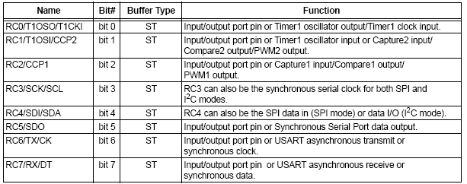
PORT-D PIN DETAILS
PORTD is an 8-bit port with Schmitt Trigger input buffers. Each pin is individually configurable as an input or output. PORTD can be configured as an 8-bit wide microprocessor port (Parallel Slave Port) by setting control bit, PSPMODE (TRISE<4>). In this mode, the input buffers are TTL.
Table 4.4 Port D Pin Detail
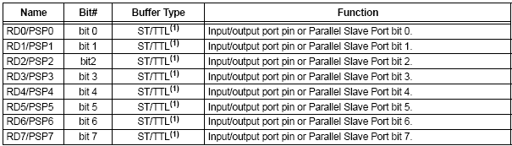

CHAPTER 5

IMPLEMENTATION AND TESTING

5.1 EXPLANATION

PIC microcontroller is interfaced with vibration sensor, mems sensor, GSM, LCD, and DC motor. First initialize GSM and wait until it obtains the network. Accelerometer [ADXL335] The displacement of the machine measured by the 3 axis accelerometer. Finally there is also a chance that he can try and lift the whole of the ATM machine. Hence once the predefined threshold level is crossed the microcontroller is trigger indicating the ATM machine is being tried to shift out of its place. • If either of the above three things were to happen there is a trigger to the controller, the door of the ATM is automatically shut down. The chloroform gas is released into the chamber, It is reported that exposure to chloroform at 920-1 100 ppm for 2-3 min resulted in dizziness .Hence meanwhile the PPM level of the gas is continuously measured and monitored. When this level reaches the peak level beyond which it could be lethal to the person inside, the valve is closed. The next step, the siren goes on, alerting the public. An SMS is sent to the concerned persons using the GSM module connected to the microcontroller. The SMS could be sent to police, bank manager and the security guard. We could keep displaying the PPM level and status of the emergency level.
• Now there is need of the bank manager or the police to come and open the door and apprehend the thief. Once the code is accepted, the door is ready to be opened. But before that there will be gas in the chamber, this can cause effects to the outsider, so there is as exhaust fan setup at the top of the ATM chamber, this is turned on. Once the PPM level comes down below certain acceptable level the door opens. Then the alarm is disabled and the board is reset again.
5.2 SNAPSHOT OF PROJECT
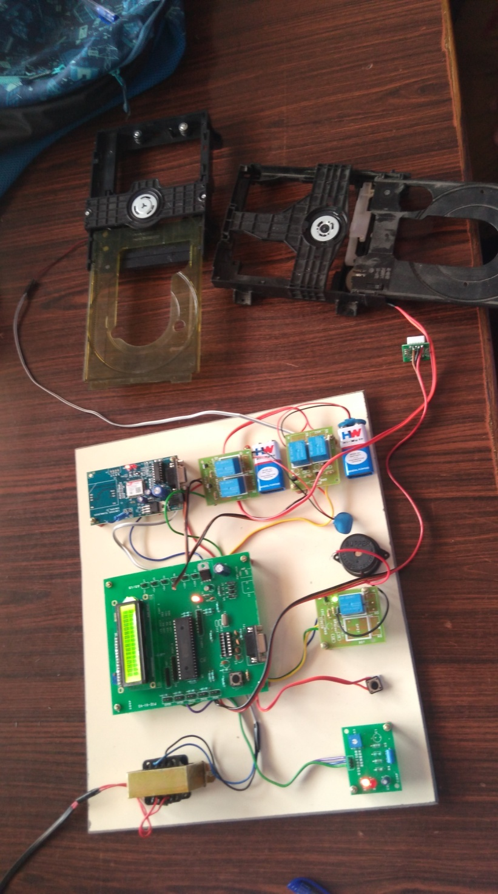

CHAPTER 6

CONCLUSION
As we all know, these days most of the ATM has been attacked by the robberies. Also gradual increases the theft of ATM after the year by year. This paper demonstrates how an automation of “ATM THEFT” prevention from robbery (or) thief can be implemented using GSM Technology, vibrating sensor, dc motor, stepper motor, LED display, buzzer with ATM Machines center. By implementing this project we can catch thief and Robbery in ATM itself and also we can save our precious time.

REFERENCE
- Sivakumar T, GajjalaAskok, K. SaiVenuprathap, “Design and Implementation of Security Based ATM theft Monitoring system”, Volume 3, Issue 1 (August 2013) PP: 01-07.
- M.R.Dineshkumar,M.S.Geethanjali,R.Karthika,M.Nagaraj,N.Vijayanandam(2013),“Protected Cash Withdrawal in ATM Using Mobile Phone”,International Journal Of Engineering And Computer Science, Vol.2, pp.1346-1350.
- M.Ajaykumar, N.BharathKumar(2013)“Anti-Theft ATM Machine Using Vibration Detection Sensor”, International Journal of Advanced Researchin Computer Science and Software Engineering, vol.3, pp.416-418.
- S.T.Bhosale, Dr.B.S.Sawant(2012) “Security in E-Banking via Card Less Biometric ATMs”, International Journal of Advanced Technology &Engineering Research, Vol.2, pp.9-12.
- Navneet Sharma, Vijay Singh Rathore(2012)“Role of Biometric Technology over Advanced Security and Protection in Auto Teller MachineTransaction”, International Journal of Engineering and Advanced Technology, Vol.1,pp.249-251.
- HridyaVenugopal, Hema.U, Kalaiselvi.S, Mahalakshmi.M(2012)“Enhanced voice recognition to reduce fraudulence in ATM machine”, InternationalJournal of Computer Network and Security,vol.4,pp.52-56.
- A.D.Luca, M.Langerich and H.Hussma(2010)“towards understanding ATMsecurity: a field real world ATM use”, in proceedings of the sixsymposium on usable privacy and security: Redmond, Washington, pp. 1-10.
- Aggarwal, C. C., Wolf, J. L., and Yu, P. S.(2009) “Caching on the World Wide Web”, IEEE Transactions on Knowledge and Data Engineering,Vol.11, pp.94-107.
- Kumar, K.Shailaja, G.Shailaja, A.Kavitha, A.Saxena.(2006)“mutual authentication and agreement for GSM”, international conference mobilebusiness (icmb’06), pp. 25-26.
- Zaslavskv.V and Strizhak.A.(2006) “credit card fraud detection using self-organizing maps”, information and security, pp. 48-63.
- Z.Li, Q.Sun, Y. Lian and D.Giusto.(2005)“association based graphical password desire resistant to shoulder surfing attack”, international conferenceon multimedia a expo, china, pp. 245-248.

