AUTOMATIC BUS SEATS COUNT AND RF TRACKING USING IOT

CHAPTER 1
INTRODUCTION
1.1 OBJECTIVE
As cities continue to grow in size and population, new challenges arise for the design of urban mobility infrastructures. While public bus transport systems have the capacity to absorb large masses of urban travelers, their public image often suffers from a negative perception. First, from a passenger’s point of view, bus networks in dense urban areas are often considered as complex and difficult to navigate. Second, in contrast to private modes of transport, travelling on buses offers only a low level of comfort and convenience. Third, bus journeys lack a sense of personal control and ownership that is valued by car users. To overcome these inherent weaknesses of the physical bus transport system, researchers increasingly turn their attention to digital technologies in order to improve the perceived quality of bus transport. To fill this gap, the Internet-of-Things (IoT) provides great opportunities to improve existing public transport system by embedding smart technology into real world transport usage contexts.

1.2 EXISTING SYSTEM
In Existing Method, we show how this paradigm can be applied to the public transport domain and present the Bus Navigator; UBN provides Difference novel information services for bus users.
Micro navigation GPS based Bus Tracking and Monitoring based Crowd-aware route recommendation Public Passengers Display Android Phone, This Method Crowd-aware route recommendation collects and predicts crowd levels on bus journeys to suggest better and less crowded routes to bus riders.
Passengers along a bus journey by recognizing boarded bus vehicles and tracking the passenger’s journey progress GPS value Sent GSM Modem view Android Mobile.

CHAPTER 2
SYSTEM ANALYSIS

2.1 PROPOSED SYSTEM
The main use of this project is to display and announce the stopping in the buses. The project has several RF Transmitter sections which could be used for provide the information to bus. During the time of running if the bus crossed across there in the relevant receiver section, the particular transmitter section indicates the relevant message to driver through RF wireless communication. From this we can display the relevant stopping.

2.2 PROPOSED DIAGRAM
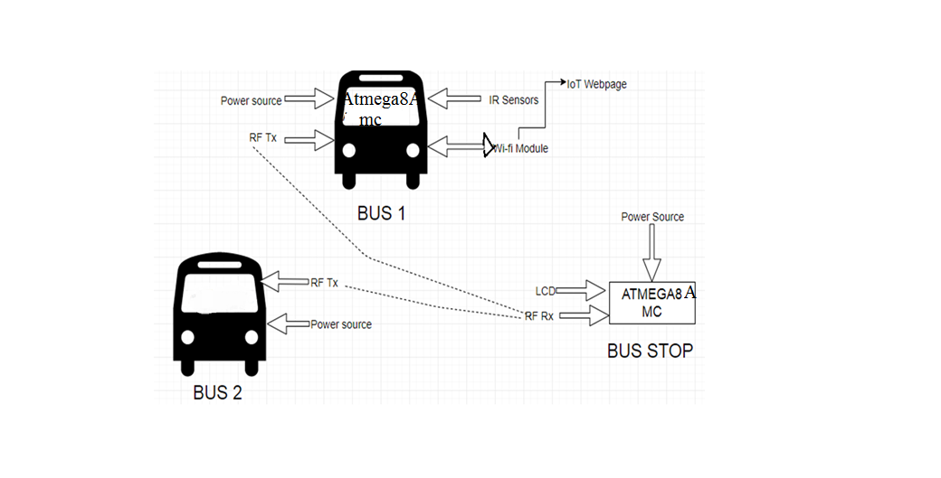

Fig 2.1 Proposed Diagram

CHAPTER 4
SOFTWARE DESCRIPITION
4.1 SOFTWARE
- Platform - AVR STUDIO
- In System Programmer - ProgISP 172
- Compiler – Win AVR
- Embedded C language
4.2 EMBEDDED C LANGUAGE
Embedded C is a set of language extensions for the C programming language by the C Standards Committee to address commonality issues that exist between C extensions for different embedded systems. Historically, embedded C programming requires nonstandard extensions to the C language in order to support exotic features such as fixed-point arithmetic, multiple distinct memory banks, and basic I/O operations.
In 2008, the C Standards Committee extended the C language to address these issues by providing a common standard for all implementations to adhere to. It includes a number of features not available in normal C, such as, fixed-point arithmetic, named address spaces, and basic I/O hardware addressing.
Embedded C uses most of the syntax and semantics of standard C, e.g., main() function, variable definition, data type declaration, conditional statements (if, switch case), loops (while, for), functions, arrays and strings, structures and union, bit operations, macros, etc.
Advantages of Embedded c
- Possesses of cross development in nature
- Dependent on hardware architecture(microcontroller or other devices)
- Used to limited resource like RAM,ROM and I\O peripherals on embedded controller

CHAPTER 5
CONCLUSION & RESULTS
5.1 RESULTS
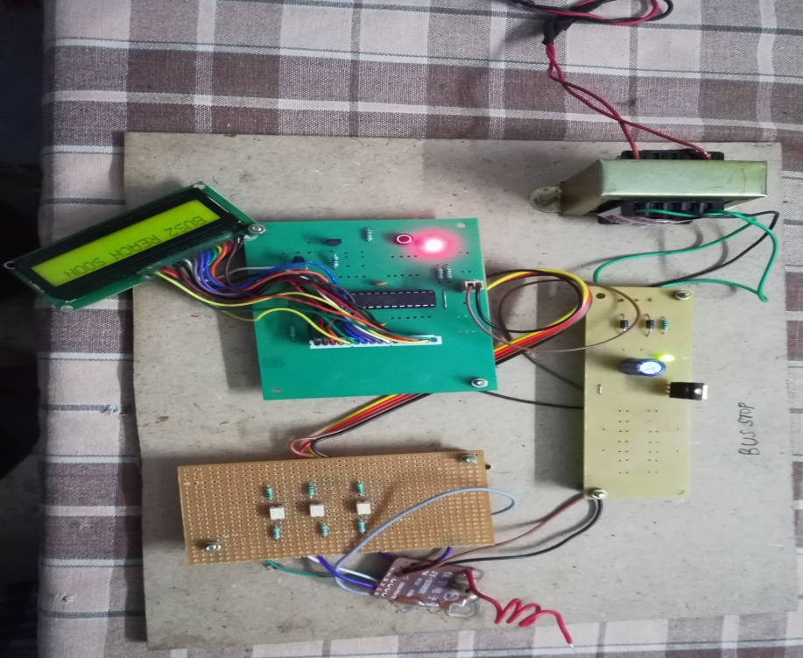
Fig 5.1 Diagram of RF Tracking System
RF Transceiver is used to tracking the bus to enter to the certain system and displayed using LCD display.

\
5.2 CONCLUSION
The progress in science & technology is a non-stop process. New things and new technology are being invented. As the technology grows day by day, we can imagine about the future in which thing we may occupy every place.
The proposed system based on Atmel microcontroller is found to be more compact, user friendly and less complex, which can readily be used in order to perform. Though it is designed keeping in mind about the need for industry, it can extended for other purposes such as commercial & research applications. Due to the probability of high technology (Atmega8A microcontroller) used this “AUTOMATIC BUS SEATS COUNT AND RF TRACKING USING IoT” is fully software controlled with less hardware circuit. The feature makes this system is the base for future systems.
The principle of the development of science is that “nothing is impossible”. So we shall look forward to a bright & sophisticated world.

5.3 FUTURE ENHANCEMENTS
In future, everywhere the smart mobile facility is available, so anyone can easily to check the bus seats availability and checks the status of bus using RF wireless communication.

ANNEXURE - I
CODING
#include <ESP8266WiFi.h>
#include <WiFiClient.h>
#define ssid "bus Wifi" // WiFi SSID
#define password "project123" // WiFi password
#define LEDPIN 5 // Led
String t = "NULL";
String t1 = "NULL";
String t2 = "NULL";
String t3 = "NULL";
String h = "NULL";
String etatLed = "";
#define button1 16 // Led
String g = "NULL";
intf,e,d;
String etatLed1="";
ESP8266WebServer server ( 80 );
String getPage()
{
page += "<ul><li>SALEM TO OMALUR(NOS): ";
page += t1;
page += "</li></ul>";
page += "<ul><li>SALEM TO METTUR(NOS): ";
page += t2;
page += "</li></ul>";
page += "<ul><li>SALEM TO MECHERI(NOS): ";
page += t3;
page += "</li></ul>";
// page += "<h3>GPIO</h3>";
// page += "<form action='/' method='POST'>";
// page += "<ul><li> ";
// page += etatLed;
// page += "";
// page += "<INPUT type='radio' name='LED' value='1'>lane1";
// page += "<INPUT type='radio' name='LED' value='0'>lane2</li></ul><br></br>";
// page += "<ul><li> ";
// page += etatLed1;
// page += "";
// page += "<INPUT type='radio' name='LED1' value='1'>lane3";
// page += "<INPUT type='radio' name='LED1' value='0'>lane4</li></ul>";
page += "</body></html>";
page += "</body></html>";
return page;
}
Void handle Root(){
if ( server.hasArg("LED")|| server.hasArg("LED1")) {
handleSubmit();
} else {
server.send( 200, "text/html", getPage() );
}
}
Void handle Submit() {
// Actualise le GPIO / Update GPIO
String LEDValue,LEDValue1;
LEDValue = server.arg("LED");
LEDValue1 = server.arg("LED1");
//Serial.println("Set GPIO ");
Serial.print(LEDValue);
if ( LEDValue == "0" ) {
Serial.println ("B");
etatLed = "LANE2 BOOKED";
server.send( 200, "text/html", getPage() );
} else if ( LEDValue == "1" ) {
Serial.println ("A");
etatLed = "LANE1 BOOKED";
server.send( 200, "text/html", getPage() );
}
if ( LEDValue1 == "1" ) {
Serial.println ("C");
etatLed1 = "LANE3 BOOKED";
server.send( 200, "text/html", getPage() );
} else if ( LEDValue1 == "0" ){
Serial.println ("D");
etatLed1 = "LANE4 BOOKED";
server.send( 200, "text/html", getPage() );
}
}
void setup() {
Serial.begin( 9600 );
server.begin();
Serial.println( "HTTP server started" );
pinMode(LEDPIN, OUTPUT);
pinMode(button1, INPUT_PULLUP);
delay(2000);
}
void loop() {
// while (!Serial.available()) { }
p = char(Serial.read());
delay(2000);
if(p=='f')
{
f++;
t1=f;
}
else if(p=='g')
{
e++;
t2=e;
}
else if(p=='h')
{
d++;
t3=d;
}
else if(p=='k')
{
t="SEATNO:L1 L2 L3 L4 ";
}
else if(p=='l')
{
t="SEATNO:L2 L3 L4 ";
}
else if(p=='m')
{
t="SEATNO:L1 L3 L4 ";
}
else if(p=='n')
{
t="SEATNO:L1 L2 L4 ";
}
else if(p=='o')
{
t="SEATNO:L1 L2 L3 ";
}
else if(p=='p')
{
t="SEATNO:L1 ";
}
else if(p=='q')
{
t="SEATNO:L2 ";
}
else if(p=='r')
{
t="SEATNO:L3 ";
}
else if(p=='s')
{
t="SEATNO:L4 ";
}
else if(p=='t')
{
t="SEATNO:L2 L4 ";
}
else if(p=='u')
{
t="SEATNO:L1 L2 ";
}
else if(p=='v')
{
t="SEATNO:L1 L3 ";
}
else if(p=='w')
{
t="SEATNO:L2 L4 ";
}

else if(p=='x')
{
t="SEATNO:L2 L3 ";
}
else if(p=='y')
{
t="SEATNO:L4 L3 ";
}
else if(p=='z')
{
t="SEATNO:NO FREE ";
}
server.handleClient();
delay(1000); }

referenceS
- S. Shah and B. Singh, “RFID Based School Bus Tracking and Security System,” pp. 1481–1485, 2016.
- A. F. Abidin and M. Kolberg, “Towards Improved Vehicle Arrival Time Prediction in Public Transportation: Integrating SUMO and Kalman Filter Models,” Proc. - UKSim-AMSS 17th Int. Conf.Comput. Model. Simulation, UKSim 2015, pp. 147–152, 2016.
- T.Bojan, U. Kumar, and V.Bojan, “Designing vehicle tracking system - An open source approach,” 2014 IEEE Int. Conf. Veh.Electron. Safety, ICVES 2014, pp. 135–140, 2015.
- T.Bojan, U. Kumar, and V.Bojan, “Designing vehicle tracking system - An open source approach,” 2014 IEEE Int. Conf. Veh.Electron. Safety, ICVES 2014, pp. 135–140, 2015.
- S. Lee, G. Tewolde, and J. Kwon, “Design and implementation of vehicle tracking system using GPS/GSM/GPRS technology and smart phone application,” 2014 IEEE World Forum Internet Things, pp. 353–358, 2014.
- J. Zambada, R. Quintero, R.Isijara, R.Galeana, and L. Santillan, “An IoT based scholar bus monitoring system,” 2015 IEEE 1st Int. Smart Cities Conf. ISC2 2015, 2015.

