AUTOMATED TEST SOFTWARE (ATS) ON CLOUD
CHAPTER 1

TEST PROCESS

1.1 INTRODUCTION
Software testing is an integral part of software development process. Software testing is analyzing a system or a component by providing defined inputs and comparing them with the desired outputs to check the discrepancies between the desired and actual outputs and correct them. Basically software testing can be divided into two categories.

- Manual testing
- Automated software testing

Manual software testing is as the name suggests done manually that is it requires human input, analysis and evaluation. Automated software testing is the automated version of manual software testing.
Software testing has evolved since 1970’s as an integral part of software development process. The reason being the ability check the errors and faults present in the software so that they are corrected .Testing is done in many phases depending upon the requirements of the software being developed. Testing can be both manual and automated depending on what suits the requirements. Testing is a planned process with care taken especially on what test has to be done when will be discussing automated software testing in detail in paper.

CHAPTER 2

AUTOMATED AND MANUAL TESTING

2.1 AUTOMATED SOFTWARE TESTING
Using automated software testing helps in avoiding the error humans make. The error may occur due when humans get tired of doing the process repeatedly. Automated testing programs will not do the same they will not miss a test by mistake. The automated test program will also provide a means of storing the results of the tests accurately. The results can be automatically fed into a database and can be used to provide useful statistics on how the software development process is progressing.

2.1.1 TEST AUTOMATION PROCESS CYCLE
Finalization of test automation
Selection of tool and customization
Development and testing scripts
Testing using automated scripts

CHAPTER 3

APPLICATION PLATFORM

3.1 OVERVIEW OF APPLICATION PLATFORM
Software application development began with desktop applications, which could be used on standalone machines only. However, with the advent of internet and online commerce, web application development gained importance. Word processors and media players can be considered to be typical desktop applications, while an online shopping cart on an ecommerce website can be considered as a web application.
By definition, a desktop application means any software that can be installed on a single computer (laptop or a desktop) and used to perform specific tasks.
Some desktop applications can also be used by multiple users in a networked environment. Web application development, however, soon started replacing desktop applications for reasons of portability and better functions from usability point of view. Web application development is usually made on client-server architecture and use a web-browser as the client interface.

3.2 STANDALONE APPLICATION
A standalone or thick client refers to an application running on a desktop environment such as windows or Mac platforms. When the Graphical User Interface (GUI) was developed by Apple in the 1980s, it made it possible to do things in an easier way on a desktop computer. The users could now perform 95% of their work without having to remember cryptic commands.
The thick client architecture, where the code runs on the client as well as the processing of data, was once the norm. With the spreading of internet the thin client model became more popular. The thin client also became more popular because the standalone applications grew more complex and depended on third party controls.

3.2.1 STANDALONE BI APPLICATION
A standalone or thick BI application uses the client/server model. The client works as a standalone computer and works with the obtained result sets of data.
A thick client system contains the client with the application and a database. The client obtains the data from the database and can then work with it locally. The client calculates and forms the data and sends it back to the database. Because the data is manipulated locally the traffic over the network is reduced. The model is illustrated in
Client Database
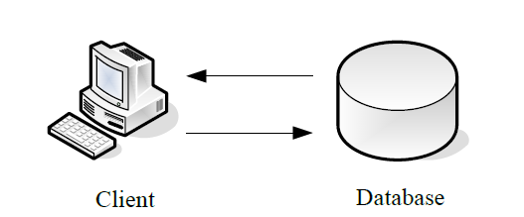
Fig. 3.1 Thick Client Models

1. The user logs into the application on the client.
2. The user executes a request. The application submits the SQL statement to the database.
3. The database receives the user request and passes it to the RDBMS.
4. The RDBMS analyses the SQL statement and performs the task.

3.3 WEB BASED APPLICATION

The World Wide Web came to life in the early 1990s when CERN laboratory in Switzerland needed to distribute documents and graphics via the Internet.
To run resources in the form of executable programs the CGI (Common Gateway Interface) was invented. The CGI allowed a web browser to execute resources on a web server. This took web sites to another level, what we could call web applications and made it possible to use far more logic than HTML could accomplish. The developers were able to accomplish standard data processing functionality such as database access and they could distribute it across the world.
As the World Wide Web grew users became more comfortable with using various applications on the web. The users did not have to run different programs for each function that they wanted to perform.

3.3.1 WEB BASED BI APPLICATION
If you choose to implement your BI application on the web, it also uses the client/server model. But in this case the server does the computation and then presents the data to the client. The server must be more robust and have more computational power than in the case of a standalone application. The client on the other hand does not have to be as robust as the client in a thick client solution.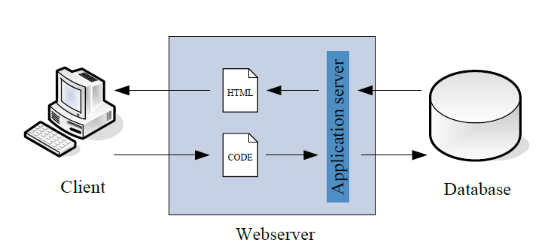
Fig. 3.2 Web Based Bi Application

There are more steps in this model than in the previous to get the data. To get the data to the client, these steps are performed:
1. The user logs onto the system and starts a web browser.
2. The user navigates to a BI web site.
3. The application server submits the SQL statement to the database.

3.3.2 IMPLEMENTATION
To compare a web based and a standalone application according to size and the time it took to implement we will study code from the two different implementations and compare the amount of time it took to implement them. We will look at a number of classes the two solutions and compare these to each other according to size.

CHAPTER 4

CLOUD COMPUTING

4.1 CLOUD COMPUTING
A Definition for cloud computing can be given as an emerging computer paradigm
Where data and services reside in massive scalable data centers in the cloud and can be accessed from any connected devices over the internet.
Cloud computing is a way of providing various services on virtual machines allocated on top of a large physical machine pool which resides in the cloud. Cloud Computing comes into focus only when we think about what it has always wanted -away to increase capacity or add different capabilities to the current setting on the fly without investing in new infrastructure, training new personnel or licensing new software. On the fly and without investing or training become the keywords in the current situation. But cloud computing offers a better solution.

4.2 TYPES OF CLOUD

4.2.1 PRIVATE CLOUD
This type of cloud is maintained within an organization and used solely for their internal purpose. So the utility model is not a big term in this scenario. Many companies are moving towards this setting and experts consider this is the 1st step for an organization to move into cloud. Security, network bandwidth are not critical issues for private cloud.

4.2.2 PUBLIC CLOUD
In this type an organization rents cloud services from cloud provider’s on-demand basis. Services provided to the users using utility computing model.

4.2.3 HYBRID CLOUD
This type of cloud is composed of multiple internal or external clouds. This is the scenario when an organization moves to public cloud computing domain from its internal private cloud.

4.3 CHARACTERISTICS OF CLOUD COMPUTING

4.3.1 SELF HEALING
Any application or any service running in a cloud computing environment has the property of self healing. In case of failure of the application, there is always a hot backup of the application ready to take over without disruption.

4.3.2 LINEARLY SCALABLE
Cloud computing services are linearly scalable. The system is able to break down the workloads into pieces and service it across the infrastructure. An exact idea of linear scalability can be obtained from the fact that if one server is able to process say 1000 transactions per second, then two servers can process 2000 transactions per second.

4.4. ENABLING TECHNOLOGIES

4.4.1 CLOUD COMPUTING APPLICATION ARCHITECTURE

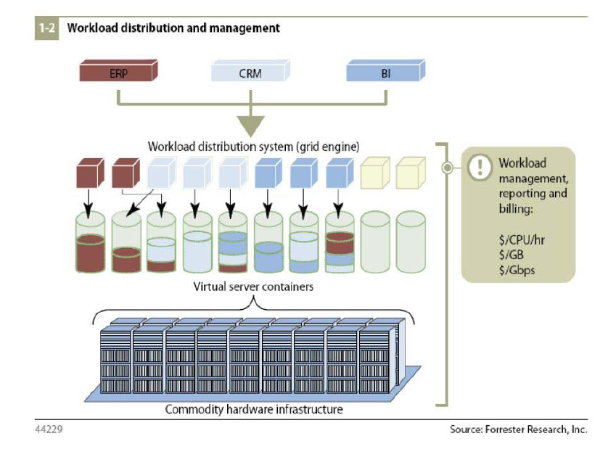
Fig. 4.1 Cloud Computing App Architecture
This Fig. 4.1 gave the basic architecture of a cloud computing application. We know that cloud computing is the shift of computing to a host of hardware infrastructure that is distributed in the cloud. The commodity hardware infrastructure consists of the various low cost data servers that are connected to the system and provide their storage and processing and other computing resources to the application.

4.4.2 SERVER ARCHITECTURE

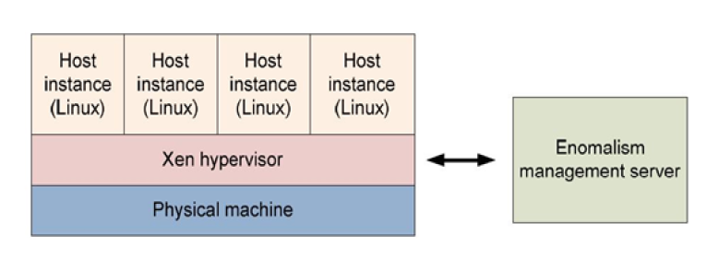

Fig. 4.2 Server Architecture

Cloud computing makes use of a large physical resource pool in the cloud. As said above, cloud computing services and applications make use of virtual server instances built upon this resource pool. There are two applications which help in managing the server instances, the resources and also the management of the resources by these virtual server instances. One of these is the Oxen hypervisor which provides an abstraction layer between the hardware and the virtual OS so that the distribution of the resources and the processing is well managed. Another application Cloud Computing that is widely used is the Anomalism server management system which is used for management of the infrastructure platform.

4.5 CLOUD COMPUTING SERVICES

4.5.1 AMAZON WEB SERVICES

The ‘Amazon Web Services’ is the set of cloud computing services offered by Amazon. It involves four different services. They are Elastic Compute Cloud (EC2), Simple Storage Service (S3), Simple Queue Service (SQS) and Simple Database Service (SDB).

4.5.2 ELASTIC COMPUTE CLOUD (EC2)
Amazon Elastic Compute Cloud (Amazon EC2) is a web service that provides resizable compute capacity in the cloud. It is designed to make web scale computing easier for developers. It provides on-demand processing power.

4.5.3 SIMPLE STORAGE SERVICE (S3)
S3 or Simple Storage Service offers cloud computing storage service. It offers services for storage of data in the cloud. It provides a high-availability large-store database. It provides a simple SQL-like language. It has been designed for interactive online use. S3 is storage for the Internet. It is designed Cloud Computing to make web-scale computing easier for developers. S3 provides a simple web services interface that can be used to store and retrieve any amount of data, at any time, from anywhere on the web. It gives any developer access to the same highly scalable, reliable, fast, inexpensive data storage infrastructure that Amazon uses to run its own global network of web sites.

4.6 ADVANTAGES OF USING CLOUD

4.6.1 CLOUD PROVIDERS' POINT OF VIEW

Most of the data centers today are underutilized. They are mostly 15% utilized. These data centers need spare capacity just to cope with the huge spikes that sometimes get in the server usage. Large companies having those data centers can easily rent those computing power to other organizations and get port out of it and also make the resources needed for running data center (like power) utilized properly.

4.6.2 CLOUD USERS POINT OF VIEW
- Cloud users need not to take care about the hardware and software they use and also they don't have to be worried about maintenance. The users are no longer tied to someone traditional system.
- Virtualization technology gives the illusion to the users that they are having all the resources available.
- Cloud users can use the resources on demand basis and pay as much as they use. So the users can plan well for reducing their usage to minimize their expenditure.

CHAPTER 6

IMPLEMENTATION AND RESULTS

6.1 OVERVIEW:

Fig. 6.1 over view of ATS Software

6.1.1 CLIENT – SERVER COMMUNICATION
The client-server characteristic describes the relationship of cooperating programs in an application. The server component provides a function or service to one or many clients, which initiate requests for such services.
Servers are classified by the services they provide. For example, a web server serves web pages and a file server serves computer files. A shared resource may be any of the server computer's software and electronic components, from programs and data to processors and storage devices. The sharing of resources of a server constitutes a service.

Whether a computer is a client, a server, or both, is determined by the nature of the application that requires the service functions. For example, a single computer can run web server and file server software at the same time to serve different data to clients making different kinds of requests. Client software can also communicate with server software within the same computer. Communication between servers, such as to synchronize data, is sometimes called inter-server or server-to-server communication.

6.2 BLOCK DIAGRAM OF ATS
Login

Dashboard

Report Window
Runner Window
Designer Window
Admin Window

Test Case
Configure Window
Execution
Console window
+
Database

Test Plan

Test Suite

Fig. 6.2 Block Diagram of ATS

CHAPTER 7

CONCLUSION AND FUTURE SCOPES
The development process involved the following programming languages/scripts HTML5, CSS and JAVASCRIPT. The final application developed is hosted in Amazon EC2 cloud servers that run on Linux Operating system.
Instruments/systems like Video Signal Generator, Audio Signal Generator, Video Analyzer, Audio Analyzer and Embedded Application (Device Under Test) were controlled from web applications that runs on a browser and interacts to client machine hardware devices through a client application.
The system is scalable which allows the user to add the required test instruments to test setups and respective test case in the test configurations. The existing system is capable of testing Audio as well as Video signals. Communication bus test and other future interface tests will be added to the test system as and when required.

REFERENCES

[1] F.M. Aymerich, G. Fenu, and S. Surcis. An approach to a cloud computing network. Applications of Digital Information and Web Technologies, 2008. ICADIWT 2008. Pages 113 –118, August 2008.
[2] Craig, Rick D.; Jackie, Stefan P.: Systematic Software Testing Boston: Artech House, 2012. (Artech House Computing Library). - ISBN 1-58053-508-9
[3] D.M. Cohen, S.R. Dalal, M.L. Fredman and G.C. Patten, “The AETG System: An Approach to Testing based on Combinatorial Design”, IEEE Trans. Software Engineering, July 1997, pp. 437-444.
[4] N.B. Ebrahimi, “On the Statistical Analysis of the number of Errors Remaining in a Software Design Document after Inspection”, IEEE Trans. Software Engineering, Aug. 2011, pp. 529-532.
[5] Tom McGibbon, “An Analysis of Two Formal methods VDM and Z, http//www.dacs.dtic.mil, Aug. 13, 1997.
[6] Y.K. Malaiya, N. Li, J. Bieman, R. Karcich and B. Skibbe, “The Relationship between Test Coverage and Reliability”, Proc. Int. Symp. Software Reliability Engineering, Nov. 1994, pp. 1867-195.
[7] J. Rosenberg, “Some Misconceptions about Lines of Code”, Proc. Int. Software Metrics Symp, Nov. 2015, pp. 137-142.
[8] Ritu Dangwal. Public Computing, Computer Literacy and Educational Out- come: Children and Computers in Rural India, pages 59–66. IOS Press, Ams- terdam, The Netherlands, 2005.
[9] Myers, Glenford J.: The Art of Software Testing New York: John Wiley & Sons, 1989. (Business Data Processing). - ISBN 0-471-04328-1
[10] Myers, Glenford J.: The Art of Software Testing New York: John Wiley & Sons, 2009. (Business Data Processing). - ISBN 0-471-04328-1
[11] H. Yin, Z. Lebne-Dengal and Y.K. Malaiya, “Automatic Test Generation using Checkpoint encoding and Antirandom Testing”, Proc. Int. Symp. Software Reliability Engineering, 1999, pp. 84-95.

