ARTIK CLOUD BASED SMART CAR PARKING SYSTEM
CHAPTER 1
INTRODUCTION
IOT technology grows in various fields of smart applications but it is not yet found boundary constraints of this technology. Some smart applications which it has implementing currently such as on smart grids, smart lighting, smart energy, smart city, smart health etc. This is broadly classified into three categories such as sensing, processing and connectivity. Whereas sensing includes sensing the speed of vehicles and humans or any objects (accelerometer), sensing of temperature, pressure etc. And these can be processing by using some processors such as network processor, hybrid processor MCU/MPU etc. And the devices are connected by using some technologies called GPS, Wi-Fi, BT/BTLE, RFID etc.
More than half of the world’s people are living in the cities. So the cities have reached full of its occupancy. As people uses vehicles for transportation so there is large number of vehicles exists for people convenience. Most of the time people spend their precise time on searching parking lots to park their vehicles. Thus congestion occurs in the traffic it leads to a hectic job to find the parking space to park their vehicle. The most traffic occurs only because of vehicle congestion in the urban areas, thus people are wasting time in searching the parking area abnormally to park their vehicles.
The proposed parking system uses Raspberry pi and ArduinoUno (ATMega328p) microcontroller and Ultrasonic sensors are used to fetch data. It is implemented using a web application that is connected to the Samsung ARTIK IoTcloud which uses Raspberry Pi as Web socket to communicate and Raspberry Pi as MQTT Client to perform actions send from the cloud. The system helps user to know the availability of parking spaces on a real time basis and locations of Parking Areas using Google Map API’s.

CHAPTER 2
SYSTEM ANALYSIS
2.1 EXISTING SYSTEM
Work in this field is being preferred by most of the automobile companies like TOYOTA,BMW,BOSCH,ERICSSON using different micro controllers and sensors such as RASPBERRY PI, ARDUINO,INTEL GALILEO controllers uses sensors like IR,ULTRA SONIC,RFID,through Wireless Sensor technologies, GPSand UHF.
Jung-Ho Moon, Tae Kwon Ha(2013) has worked on car parking monitoring system using wireless sensor networks. Ramneet Kaur and Balwinder Singh (2013) described how the design and implementation of car parking system can be done through FPGA. Soh Chun Khang et.al, (2010) presents a parking system in which driver comes to know about the space availability in the parking lot with the help of SMS service. Tsung-hua Hsu, Jing-Fu Liu, Pen-Ning Yu, WangShuan Lee and Jia-Sing Hsu developed an automatic parking system for vehicles with the help of position estimation and tracking algorithms. Mala Aggarwal,SimmiAggarwal, R.S.Uppal(2012) introduced the comparative implementation of automatic car parking system with least distance parking space in wireless sensor networks.
Most of these are research type paperswhich are proposed the architecture but not implemented as working models. Many of the proposed model are failed to implement in providing large scaleparkingsystem

In another study, the authors propose an SPS based on the integration of UHF frequency, RFID and IEEE 802.15.4 Wireless Sensor Network technologies. This system can collect information about the state of occupancy of the car parks, and can direct drivers to the nearest vacant parking spot by using a software application. However, in this work, the authors having no mathematical equations for the system architecture and do not create a large-scale parking system. The results of this paper only implement the proposed architecture; they do not mention the performance of the parking system. In another study, the authors propose an SPS based on the integrationof UHF frequency, RFID and IEEE 802.15.4 Wireless Sensor Network technologies. This system can collect information about the state of occupancy of the car parks, and can direct drivers to the nearest vacant parking spot by using a software application. However, in this work, the authors have no mathematical equations for the system architecture and do not create a large-scale parking system. The results of this paper only implement the proposed architecture; they do not mention the performance of the parking system.
Role of low power consumption sensors and controllers is an important factor while designing a proposed system. Powers supply also an important feature. Most of the existed systems focuses on indoor car parking, in case of street parking systems are failed to give better performance. Clouds and servers have important role in IoT smart car parking, choosing appropriate clouds will improve performance and life of device.
2.2 PROPOSED SYSTEM
The proposed system uses Combination of Raspberry pi and Arduino Uno Microcontroller and 4 HC-SR04 sonars instead of IR and RFID. Sonar is connected on Arduino Uno which is used to check the availability of free parking slots, then sends these data to Raspberry pi by using USB Serial Communication.For this Project, we are focused on one parking station, we can monitor n number of parking stations using ARTIK cloud.

Raspberry pi uses node.js Programming language which helps to get Serial Port data and Forwards to Samsung IoT cloud – ARTIK. Here Raspberry pi act as web socket client and communicate with Artik cloud using Web socket protocol. Cloud analysis data and set actions according to it. Raspberry pi act as MQTT Client and receives messages from Artik cloud.
A Web and is developed to monitor Free parking slots from corresponding parking stations which uses web socket protocol to communicate with Artik cloud and receives the data from it. Google Map is integrated to find out parking stations. Free slot is updated in every 10 seconds.
WEB APP

RASPBERRY PI 3
ARDUINO UNO
BOARD
ATMEGA 328P-PU
ULTRASONIC SENSOR 1
POWER SUPPLY

IOT ARTIK CLOUD

ULTRASONIC SENSOR 3

ULTRASONIC SENSOR 2

Fig 2.1 block diagram of proposed scheme

CHAPTER 5
RASPBERRY PI 3

The Raspberry Pi is a series of small single-board computers developed in the United Kingdom by the Raspberry Pi Foundation to promote the teaching of basic computer science in schools and in developing countries. The original model became far more popular than anticipated, selling outside of its target market for uses such as robotics. Peripherals (including keyboards, mice and cases) are not included with the Raspberry Pi. Some accessories however have been included in several official and unofficial bundles.
IOT CLOUD INTEGRATION
ARTIK Cloud is an open data exchange platform for the Internet of Things, designed to accelerate device interoperability and enable new data insights

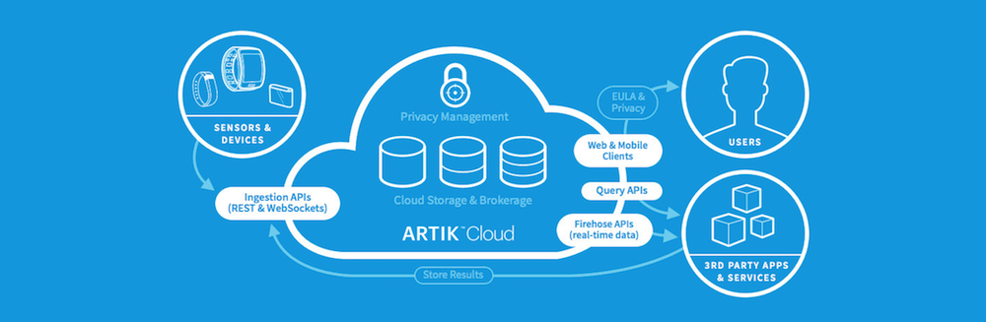
Fig 8.1 Cloud Structure
ARTIK Cloud is device-agnostic and scales to all IoT applications, including smart homes, smart cities, and industrial IoT! Developers can think beyond a single device and focus on making new connections around data. We call this Data Driven Development (D³).
- Clients can access and aggregate historical data from different sources, thus opening a new perspective on big data.
- Clients can use many different protocols to send and receive data, including REST, Web Sockets, MQTT, and COAP.

- ARTIK Cloud is the only service that gives users complete control over their data. By granting access to devices and applications, users promote an ecosystem of services around data.

8.1 BASICS
ARTIK Cloud is designed to be as easy as possible to integrate with existing devices and services. This article presents the basic concepts behind how ARTIK Cloud recognizes users, devices, data and applications.

8.2 AUTHORIZATION
The API's authorization model is based on a very simple set of permissions (READ and WRITE) on users and other entities in the system. These grants user the right to perform activities in ARTIK Cloud via the API calls.
If a user has created her own account, only he/she will have access to his/ her data. If you have admin privileges on the user, you will be able to perform some limited actions on behalf of the user, such as getting the user's profile information and changing the user's application properties.
Future changes to the API might include more fine-grained management of permissions by the user, more permission types and more activity checks.

8.3 MESSAGES
Data is stored in ARTIK Cloud by applications and devices in a message. ARTIK Cloud recognizes two message types; one carries only data, and the other carries Actions for devices.
Each message in ARTIK Cloud is associated with a set of identifying metadata: the device ID, user ID and application ID. To record a message, an application must provide the payload and the device ID. ARTIK Cloud can automatically infer the user ID and application ID from the access token that was generated during authentication. When the message is received, ARTIK Cloud also creates a timestamp.
Applications must specify at least one of these parameters when querying ARTIK Cloud. This means that depending on the scenario, data can be queried per user, per device or per application. Learn about sending and receiving messages via REST and WEBSockets.

8.4 USER ID
A user ID is defined by ARTIK Cloud and assigned on user creation, which is done through ARTIK Cloud Accounts. With a user ID, applications may obtain the user's profile and device list, and may request to create and manage an application profile for that user.
Users can additionally choose to grant an application access to their data. Once an application has been granted access, it may also request data from the user's devices. Users may remove these permissions at any time.

8.5 DEVICE ID AND DEVICE TYPE
Any source of data in ARTIK Cloud is called a device. Devices in ARTIK Cloud can be sensors, appliances, applications, services, etc. Usually one user will own one or more devices, and devices can send messages or be used to send messages into ARTIK Cloud. Every device in ARTIK Cloud is identified with a unique device ID. Device IDs are assigned by ARTIK Cloud when devices are first created in the system. A device ID is a unique instance of a device type.
A device type defines a category of device in ARTIK Cloud. For example, "Samsung Galaxy Gear Fit" is a device type, and "Andrea's Samsung Galaxy Gear Fit" will have a unique device ID. Only the owner, vendor or OEM of a device will likely need to create a device type. Owners of a device type are responsible for keeping the name and description of a device type updated.
8.16 HARDWARE IMPLEMENTATION
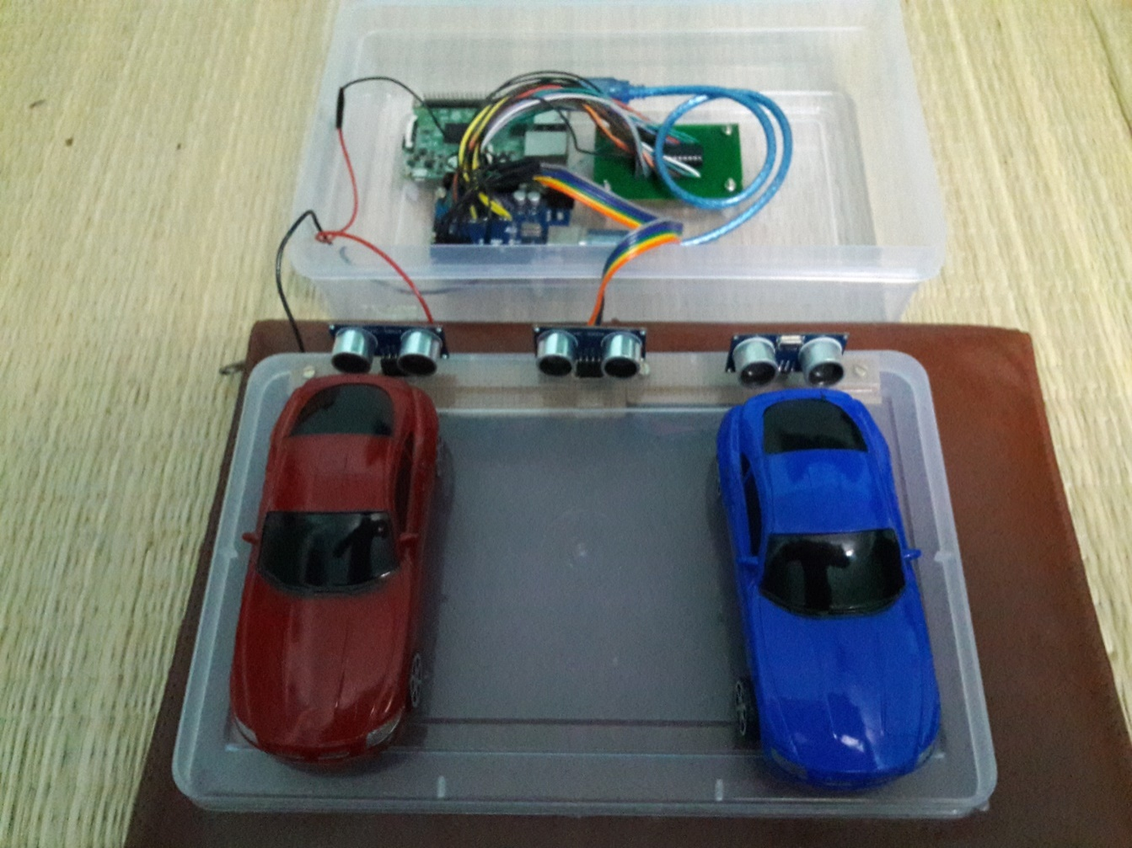
Fig 8.3 Hardware Implementation

CONCLUSION
This paper proposed a parking system integrated with SamsungIoT ARTIK Cloud which helps to improve the performance by reducing number of users that fail to find a parking space and minimizes the costs of moving to the parking space. The proposed system is successfully implemented in real situation. The result shows that we can implement this system in large scale parking system by connecting more devices of different parking stations. Power usage of components is very low this could help to implement even rural areas also. By the Proposed system IoT car parking can be achieved even in street parking areas. By use of Cloud Integration helps to replace large database and servers.Web Apps is developed to identify the status of parking slots .By all our system mainly focus on reducing the time in finding the parking lots and also it avoids the unnecessary travelling through filled parking lots in a parking area. Thus it reduces the fuel consumption which in turn reduces carbon footprints in an atmosphere.

REFERANCES

[1] Abirup Khanna and Rishi Anand (2016)-“IoT based Car Parking” Published in Internet of Things and Applications(IOTA).
[2] K E Shouby and P Lynggard(2015)–“Smart Home and Smart City Solutions enabled by 5G,IoT,AAI and CoT Services” Published in IEEE IoT Conference.
[3] Choeychuen(2015)–“Automatic parking lot mapping for available parking space detection”. In Proceedings of the 5th International Conference on Knowledge and Smart Technology (KST), Chonburi, Thailand.
[4] T. Taleb and A. Kunz(2014) - “Machine Type Communications in 3GPP Networks: Potential, Challenges, and Solutions,” to appear, IEEE Magazine.
[5] http://www.mdpi.com/journal/sensors.(2014)-Sensor/14,22372-22393; doi:10.3390/s141222372.
[6] Bilodeau V.P(2013) -“Intelligent Parking Technology Adoption”. Ph.D. Thesis, University of Southern Queensland
[7] Li,T.S, Ying-Chieh, Y.; Jyun-Da, W.; Ming-Ying, H.; Chih-Yang, C(2013)- “Multifunctional intelligent autonomous parking controllers for carlike mobile robots”. IEEE Trans. Ind. Electron. 57, 1687–1700.
[8] Faheem1, S.A. Mahmud, G.M. Khan, M. Rahman and H. Zafar(2013)–“A Survey of Intelligent Car Parking System” IEEE Magazine.
[9] KaivanKarimi and Gary Atkinson(2013)–“What the Internet of Things (IoT) Needs to Become a Reality”, White Paper, FreeScale and ARM
[10] S. Alam, M. M. R. Chowdhury, and J. Noll(2012)- “Senaas: An event-driven sensor virtualization approach for internet of things cloud,” in Networked Embedded Systems for Enterprise Applications (NESEA).

