AN INTELLIGENT AGRICULTURE WATER IRRIGATION SYSTEM
CHAPTER 1
INTRODUCTION
1.1 GENERAL
Irrigation is a scientific process of artificially supplying water to the land or soil that is being cultivated. Traditionally in dry regions having no or little rainfall water had to be supplied to the fields either through canals or hand pumps, tube wells. But this method had severe problems such as increase in workload of farm labor and often it lead to problem such as over irrigation or under-irrigation, and leaching of soil. Further there were issues like weeding, lesser yield of crop as an effect of above mentioned problems. Hence there was a need for a way to test the soil condition before supplying water to the fields. This mechanism would reduce the workload of the farmer and help maintain proper soil conditions for improved and better crop production. Hence with the advance of technology it was possible to design systems that eliminated the direct involvement of the farmer with respect to irrigation of their field.

1.2 OBJECTIVE OF THE PROJECT
The proposed project includes system structure, hardware circuits and software program for GSM based automatic irrigation system. In this project, soil sensor, float sensor and temperature sensor is used. The main aim of this system is to develop low cost automatic irrigation system to monitor the condition of the soil. This system reduces manpower and water wastage.

2.2 PROBLEM IDENTIFICATION IN EXISTING SYSTEM
From the literature survey, it is observed when using remote control sensing problem may arise while using zigBee Bluetooth the area of coverage is limited in existing system the usage of zigBee will cover small distance of area. for Particular distance only we can use zigBee In using remote control,sensing problem will arise with the sensors. Another way of using GPRS we have to connect internet , that leads to data loss. But in our project we use GSM for sending sms and control automatically or manually without any data loss.

CHAPTER 3
PROPOSED SYSTEM
3.1 WORKING PRINCIPLE:
The soil moisture sensor ,temperature sensor and Float sensors are monitoring the agriculture field. Then this data sent to the microcontroller unit. It displays through the LCD. The value of the sensor range can be observed by the user in two ways. One is automatic mode and manual which is done through GSM. In manual mode, the user can control the motor when it is need to turn ON. Thus our project is designed for low cost automatizing of irrigation system in a smart way.
PIC microcontroller is interfaced with soil moisture sensor, water level sensor, GSM, LCD, Temperature sensor and water pump. First initialize GSM and wait until it obtains the network. The green light indicates GSM is ON and red light indicates the network strength. Once it obtains complete network there will be delay in blinking of red light. Then initialize LCD, it will display all the statements given in code such as title, and the status of field regarding pump and tank storage. Using the inputs from soil moisture sensor and water level sensor we turn ON the water pump manually as well as automatically When the soil is moisturized and soil moisture sensor senses moisture presence it keeps the pump off and when it senses absence of moisture it switches on the pump and supply water to field. Then we need to continuously monitors the sensors and based on that we take some actions. It supplies water until it again sense the presence of moisture, once it senses moisture is present is switches of the pump. Water level sensor gives the presence of water in tank whether it is high or low.

Temperature sensor gives room temperature. This whole process is automatic process of irrigation system using wireless sensor networks and GSM module. This is done using GSM which can be used from any place framer is. Then he clicks on pump off it sends a message and informs to switch off the pump which will then intimate by sending a SMS that pump is switched off. Then farmer clicks on pump ON here 2 activities take place: If the field is wet and when farmer switches on the pump, it will inform to switch on and intimates by sending a SMS that pump is ON but it senses that field is wet and switches the pump off and intimates pump off by sending SMS. If the field is wet and when farmer clicks on switch ON pump it will inform to switch ON pump and intimates by sending a SMS that pump is on. If farmer wants to know the status of field whether the soil is dry or wet and tank storage is low or high, farmer can get to know these details by clicking on status. Farmer will receive a message as tank is empty/full and water storage is high/low.

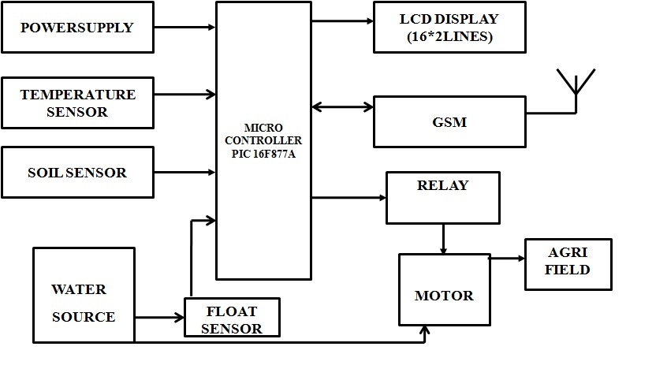
Fig. 3.1 Block diagram of proposed system

PORTB and the TRISB Register
PORTB is an 8-bit wide, bidirectional port. The corresponding data direction register is TRISB. Setting a TRISB bit (= 1) will make the corresponding PORTB pin an input (i.e., put the corresponding output driver in a High-Impedance mode). Clearing a TRISB bit (= 0) will make the corresponding PORTB pin an output (i.e., put the contents of the output latch on the selected pin). Three pins of PORTB are multiplexed with the In-Circuit Debugger and Low-Voltage Programming function: RB3/PGM, RB6/PGC and RB7/PGD. Each of the PORTB pins has a weak internal pull-up. A single control bit can turn on all the pull-ups.

This is performed by clearing bit RBPU (OPTION_REG<7>). The weak pull-up is automatically turned off when the port pin is configured as an output. The pull-ups are disabled on a Power-on Reset
Table 4.2 Port B Pin Detail
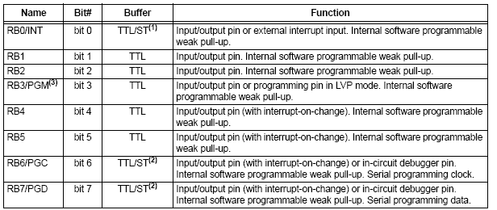
PORTC and the TRISC Register
PORT C is an 8-bit wide, bidirectional port. The corresponding data direction register is TRISC. Setting a TRISC bit (= 1) will make the corresponding PORTC pin an input (i.e., put the corresponding output driver in a High-Impedance mode). Clearing a TRISC bit (= 0) will make the corresponding PORTC pin an output (i.e., put the contents of the output latch on the selected pin). PORTC is multiplexed with several peripheral functions. PORTC pins have Schmitt Trigger input buffers. When the I2C module is enabled, the PORTC<4:3> pins can be configured with normal I2C levels, or with SM Bus levels, by using the CKE bit (SSPSTAT<6>). When enabling peripheral functions, care should be taken in defining TRIS bits for each PORTC pin. Some peripherals override the TRIS bit to make a pin an output.

While other peripherals override the TRIS bit to make a pin an input. Since the TRIS bit override is in effect while the peripheral is enabled, read-modify write instructions (BSF, BCF, XORWF) with TRISC as the destination, should be avoided. The user should refer to the corresponding peripheral section for the correct TRIS bit settings.
Table 4.3 Port C Pin Detail
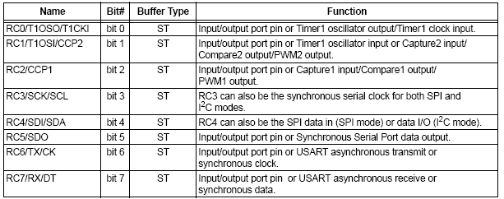
PORT-D PIN DETAILS
PORTD is an 8-bit port with Schmitt Trigger input buffers. Each pin is individually configurable as an input or output. PORTD can be configured as an 8-bit wide microprocessor port (Parallel Slave Port) by setting control bit, PSPMODE (TRISE<4>). In this mode, the input buffers are TTL.

Table 4.4 Port D Pin Detail
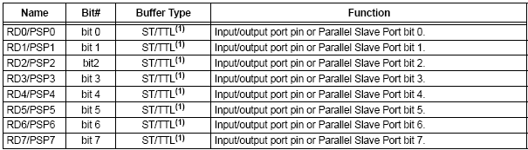
PORT-E PIN DETAILS
PORT D has three pins (RE0/RD/AN5, RE1/WR/AN6 and RE2/CS/AN7) which are individually configurable as inputs or outputs. These pins have Schmitt Trigger input buffers. The PORTE pins become the I/O control inputs for the microprocessor port when bit PSPMODE (TRISE<4>) is set. In this mode, the user must make certain that the TRISE<2:0> bits are set and that the pins are configured as digital inputs. Also, ensure that ADCON1 is configured for digital I/O. In this mode, the input buffers are TTL. Register 4-1 shows the TRISE register which also controls the Parallel Slave Port operation. PORTE pins are multiplexed with analog inputs. When selected for analog input, these pins will read as ‘0’s. TRISE controls the direction of the RE pins, even when they are being used as analog inputs. The user must make sure to keep the pins configured as inputs when using them as analog inputs.

Table 4.5 Port E Pin Detail
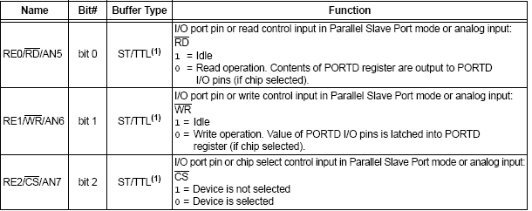
4.1.5 Memory Origination:
PIC16F84 has two separate memory blocks, one for data and the other for program. EEPROM memory and GPR registers in RAM memory make up a data block, and FLASH memory makes up a program block.
4.1.5.1 Program Memory
Program memory has been realized in FLASH technology which makes it possible to program a microcontroller many times before it's installed into a device and even after its instalment if eventual changes in program or process parameters should occur. The size of program memory is 1024 locations with 14 bits width where locations zero and four are reserved for reset and interrupt vector.

4.1.5.2 Data Memory
Data memory consists of EEPROM and RAM memories. EEPROM memory consists of 64 eight bit locations whose contents are not lost during loosing of power supply. EEPROM is not directly addressable, but is accessed indirectly through EEADR and EEDATA registers. As EEPROM memory usually serves for storing important parameters (for example, of a given temperature in temperature regulators) , there is a strict procedure for writing in EEPROM which must be followed in order to avoid accidental writing. RAM memory for data occupies space on a memory map from location 0x0C to 0x4F which comes to 68 locations. Locations of RAM memory are also called GPR registers which is an abbreviation for General Purpose Registers. GPR registers can be accessed regardless of which bank is selected at the moment.
4.1.6 SFR Registers
Registers which take up first 12 locations in banks 0 and 1 are registers of specialized function assigned with certain blocks of the microcontroller. These are called Special Function Registers.
4.1.7 Memory Banks
Beside this 'length' division to SFR and GPR registers, memory map is also divided in 'width' to two areas called 'banks'. Selecting one of the banks is done via RP0 and RP1 bits in STATUS registers.

4.1.8 Program Counter
Program counter (PC) is a 13 bit register that contains the address of the instruction being executed. By its incrementing or change microcontroller executes program instructions step-by step. Stack PIC16F84 has a 13-bit stack with 8 levels, or in other words, a group of 8 memory locations of 13 -bits width with special function. Its basic role is to keep the value of program counter after a jump from the main program to an address of a subprogram . In order for a program to know how to go back to the point where it started from, it has to return the value of a program counter from a stack. When moving from a program to a subprogram, program counter is being pushed onto a stack (example of this is CALL instruction). When executing instructions such as RETURN, RETLW or RETFIE which were executed at the end of a subprogram, program counter was taken from a stack so that program could continue where was stopped before it was interrupted. These operations of placing on and taking off from a program counter stack are called PUSH and POP, and are named according similar instructions on some bigger microcontrollers.
4.1.9 Interrupt:
Interrupts are a mechanism of a microcontroller which enables it to respond to some events at the moment when they occur, regardless of what microcontroller is doing at the time. This is a very important part, because it provides connection between a microcontroller and environment which surrounds it. Generally, each interrupt changes the program flow, interrupts it and after executing an interrupt subprogram (interrupt routine) it continues from that same point on.

4.2 TEMPERATURE SENSOR
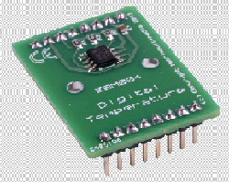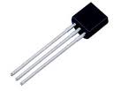
Fig 4.2 Temperature Sensor
National Semiconductor’s LM35 IC has been used for sensing the temperature. Itis an integrated circuit sensor that can be used to measure temperature with an electrical output proportional to the temperature (in oC). The temperature can be measured more accurately with it than using a thermistor. The sensor circuitry is sealed and not subject to oxidation, etc.
Features:
- 0.5°C accuracy guaranteed (at +25°C)
- Rated for full −55° to +150°C range
- Low cost due to wafer-level trimming
- Operates from 4 to 30 volts
- Less than 60 μA current drain
- Low self-heating, 0.08°C in still air

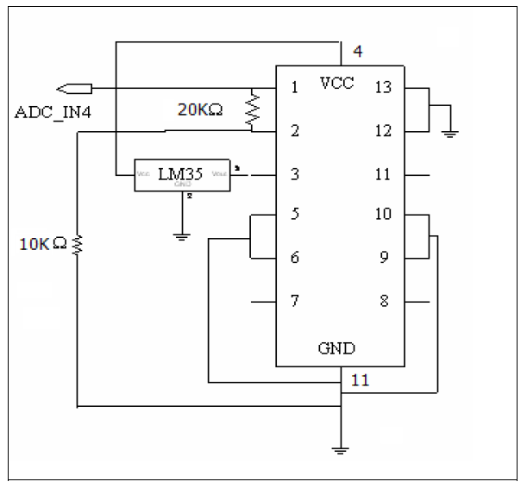
Fig 4.3 Circuit Diagram for LM35
Functional description:
- The sensor has a sensitivity of 10mV / oC.
- The output of LM35 is amplified using a LM324 single power supply (+5V) op-amp.
- The op-amp is designed to have a gain of 5.
- The circuitry measures temperatures with a resolution of up to 0.5 degree Celsius.

CHAPTER 6

CONCLUSION
A methodological approach has been followed in designing the Sensors based system for measurement and control of the plant growth parameter, i.e. soil moisture. The irrigation system will controlled via GSM. The results obtained from the measurement have shown that the system performance is quite reliable and accurate. Field experience has shown that soil moisture sensors are very useful in diagnosing the changes needed and to fine-tune irrigation practices. Relatively minor regulations in irrigation practices can pay large dividends in terms of increased yields or water savings. The key to proper irrigation management using soil moisture sensors is regular monitoring of the sensors to track the soil moisture level and provide irrigation when the readings are in the determined range for the particular soil type.

