A SMART CARD BASED PREPAID ELECTRICITY SYSTEM
CHAPTER 1
INTRODUCTION
The present traditional billing system has many problems like problem of payment collection, energy thefts etc. due to which the traditional billing system is slow, costly and unreliable. The present billing system has chances of error and it is also time or home our consuming. The Project suggests a design of digital energy meter for improved metering and billing system. Poly-phase prepaid energy metering system has also been proposed and developed based on local prepayment and card reader.
The Project suggests prepaid energy mater using a microcontroller from microchip technology In PIC family, used due to low cost of microcontrollers. So it is essential to develop a billing system which solves the problem of billing manually and also reduces the man power. The GSM used so that the consumer would receive messages about the consumption of power and if it reaches the minimum amount, it would automatically alert the consumer to recharge. This technology holds goods for all electricity distribution companies, private communities, IT parks and self-containing housing projects. The implementation of this paper will help in better energy management, conservation of energy and also in doing away with the unnecessary hassles over incorrect billing.The traditional billing system are discrete, inaccurate, costly, and slow and lack flexibility as well as reliability. Therefore, several attempts were made to automate the billing system. Even though accurate and fast reading are obtained, bill payment is still performed based on the old billing procedure. They require an individual/agent to physically come and take down the reading and report to household/office the amount one has to pay.All the steps taken so far, regarding the improvement of the revenue collection did not yield satisfactory results. It is reported that the most that the most faulty sub system is the metering and meter reading system.

1.1 METHODOLOGY
This is a very good microcontroller based application. This unit will accept the number of units recharged by the concerned department person, counts the number of units consumed by the customer and as soon as the customer exits the recharged amount, it will disconnect the power supply to the customer until the next recharge.
Whenever the number of units in the microcontroller becomes zero microcontroller sense a signal to “contact maker/breaker circuit” which is nothing but the relay and this relay cuts off the power supply to the customer until next recharge. This mechanism, essentially, requires the users to pay for the electricity before its consumption. In this way, consumers hold credit and then use the electricity until the credit is exhausted. Insert the card into the programmer. Unit price per watt is multiplied with the consumed unit to give the current bill. The current bill amount is the deducted from the recharged amount. When the total amount recharged is used up and then the power supplied to the load is stopped.
1.2 OBJECTIVE
To understand, analyse, design and develop an on line prepaid energy meter which provides both the suppliers and the consumers with better services regarding meter billing and payment. The system can be made more users friendly by using smart card technology. Further work can be done in reading the consumed energy from energy meter wirelessly using GSM technology.

1.3 EXISTING SYSTEM
In the existing system the recharge our user credit account by using sending SMS to service provider. Information about the power consumed and remaining balance available is given to the user through GSM. The system will disconnect the power supply when the full unit of energy is consumed. In existing system some problems are identified. They require an individual person or agent to physically come and take down the readings and report to the house hold/office the amount one has to pay.

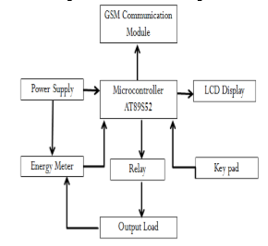
Fig 1.3 Diagram of existing system

1.4 PROPOSED SYSTEM
This proposed system consists of Digital EB meter, prepaid card, PIC microcontroller, GSM modem, Relay, Alarm. In this home Digital EB meter are controlled through the interfacing circuit which is connected to the PIC microcontroller. The smart card which is more securable.
The prepaid card has recharge the amount using through mobile according to the user convenient via to GSM modem. Smart card based prepaid electricity is a unique and new concept which saves lot of time and power for electricity department .user can recharge the card whenever the power required .people now can buy electricity in advance, using the so called prepaid electricity in the form of smart cards. The proposed prepaid smart card can also be used to manage electricity consumptions in hotel room. Thus, people can consume only as much power as they really need. When the power is consumed before the exceeding level alarm will indicate automatically and message will provide to the customer mobile through GSM. When the power is fully consumed we can get our credit from the service provider through SMS.
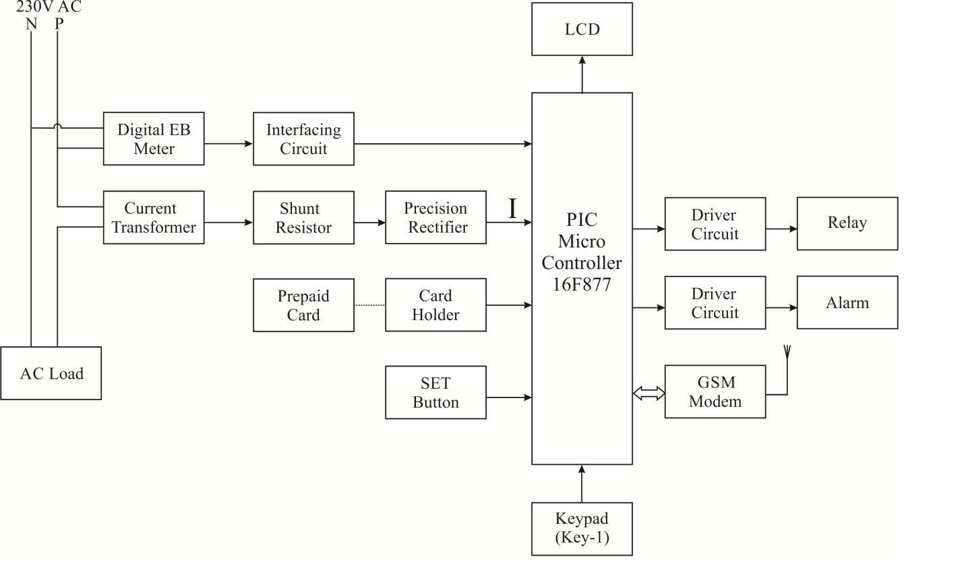
Fig 1.4 Block diagram of proposing system

Trouble Shooting

When the power supply is given to the module, with the pin 3 (VL) connected to ground, all the pixels of a character gets activated in the following manner:All the characters of a single line display, as in CDM 16108.The first eight characters of a single line display, operated in the two-line display mode, as in CDM 16116.
The first line of characters of a two-line display as in CDM 16216 and 40216. The first and third line of characters of a four-line display operated in the two-line display mode, as in CDM 20416.If the above mentioned does not occur; the module should be initialized by software. Make sure that the control signal
Improper Character Display
When the characters to be displayed are missing between, the data read/write is too fast. A slower interfacing frequency would rectify the problem. When uncertainty is there in the start of the first characters other than the specified ones are rewritten, check the initialization and the software routine.
In a multi-line display, if the display of characters in the subsequent lines doesn’t takes place properly, check the DD RAM addresses set for the corresponding display lines. When it is unable to display data, even though it is present in the DD RAM, either the display on/off flag is in the off state or the display shift function is not set properly. When the display shift is done simultaneous with the data write a operation, the data may not be visible on the display.

Crystalonics Display
Crystalonics dot matrix (alphanumeric) liquid crystal displays are available in TN, STN types, with or without backlight. The use of C-MOS LCD controller and driver ICs result in low power consumption. These modules can be interfaced with a 4-bit or 8-bit microprocessor /Micro controller.
The built-in controller IC has the following features:
- Correspond to high speed MPU interface (2MHz)
- 80 x 8 bit display RAM (80 Characters max)
- 9,920 bit character generator ROM for a total of 240 character fonts. 208 character fonts (5 x 8 dots) 32 character fonts (5 x 10 dots)
- 64 x 8 bit character generator RAM 8 character generator RAM 8 character fonts (5 x 8 dots) 4 characters fonts (5 x 10 dots)

- Programmable duty cycles
  - 1/8 – for one line of 5 x 8 dots with cursor
  - 1/11 – for one line of 5 x 10 dots with cursor
  - 1/16 – for one line of 5 x 8 dots with cursor
- Wide range of instruction functions display clear, cursor home, display on/off, cursor on/off, display character blink, cursor shift, display shift.

2.9 FUNCTIONAL DESCRIPTION OF THE CONTROLLER IC

Registers
The controller IC has two 8 bit registers, an instruction register (IR) and a data register (DR). The IR stores the instruction codes and address information for display data RAM (DD RAM) and character generator RAM (CG RAM). The IR can be written, but not read by the MPU.
The DR temporally stores data to be written to /read from the DD RAM or CG RAM. The data written to DR by the MPU is automatically written to the DD RAM or CG RAM as an internal operation.
When an address code is written to IR, the data is automatically transferred from the DD RAM or CG RAM to the DR. data transfer between the MPU is then completed when the MPU reads the DR. likewise, for the next MPU read of the DR, data in DD RAM or CG RAM at the address is sent to the DR automatically. Similarly, for the MPU write of the DR, the next DD RAM or CG RAM address is selected for the write operation.
Busy Flag
When the busy flag is1, the controller is in the internal operation mode, and the next instruction will not be accepted.
When RS = 0 and R/W = 1, the busy flag is output to DB7.
The next instruction must be written after ensuring that the busy flag is 0.

Address Counter
The address counter allocates the address for the DD RAM and CG RAM read/write operation when the instruction code for DD RAM address or CG RAM address setting is input to IR, the address code is transferred from IR to the address counter.
After writing/reading the display data to/from the DD RAM or CG RAM, the address counters increments/decrements by one the address, as an internal operation. The data of the address counter is output to DB0 to DB6 while R/W = 1 and RS = 0.both data and text are stored in the memory.
However, these two qualities are stored in different areas of memory, and accessed 4Gbytes of memory, from address 0x0000 0000 to 0xffff ffff.
Display Data RAM (DD RAM)
The characters to be displayed are written into the display data RAM (DD RAM), in the form of 8 bit character codes present in the character font table. The extended capacity of the DD RAM is 80 x 8 bits i.e. 80 characters.
Character Generator ROM (CG ROM)
The character generator ROM generates 5 x 8 dot 5 x 10 dot character patterns from 8 bit character codes. It generates 208, 5 x 8 dot character patterns and 32, 5 x 10 dot character patterns.
Character Generator RAM (CG RAM)
In the character generator RAM, the user can rewrite character patterns by program. For 5 x 8 dots, eight character patterns can be written, and for 5 x 10 dots, four character patterns can be written.

2.10 INTERFACING THE MICROPROCESSOR / CONTROLLER
The module, interfaced to the system, can be treated as RAM input/output, expanded or parallel I/O. Since there is no conventional chip select signal, developing a strobe signal for the enable signal (E) and applying appropriate signals to the register select (RS) and read/write (R/W) signals are important. All module timings are referenced to specific edges of the ‘E’ signal. The ‘E’ signal is applied only when a specific module transaction is desired. Microcontroller is main circuit of the project which control all the peripherals efficiently. The information about the data are stored in EEPROM memory.
The module is selected by gating a decoded module – address with the host – processor’s read/write strobe. The resultant signal, applied to the LCDs enable (E) input, clocks in the data. The ‘E’ signal must be a positive going digital strobe, which is active while data and control information are stable and true. The falling edge of the enable signal enables the data instruction register of the controller. All module timings are referenced to specific edges of the ‘E’ signal. The ‘E’ signal is applied only when a specific module transaction is desired.
The read and write strobes of the host, which provides the ‘E’ signals, should not be linked to the module’s R/W line. An address bit which sets up earlier in the host’s machine cycle can be used as R/W.

When the host processor is so fast that the strobes are too narrow to serve as the ‘E’ pulse
- Prolong these pulses by using the hosts ‘Ready’ input
- Prolong the host by adding wait states
- Decrease the Hosts Crystal frequency.

In spite of doing the above mentioned, if the problem continues, latch both the data and control information and then activate the ‘E’ signal. When the controller is performing an internal operation he busy flag (BF) will set and will not accept any instruction. The user should check the busy flag or should provide a delay of approximately 2ms after each instruction. The module presents no difficulties while interfacing slower MPUs.The liquid crystal display module can be interfaced, either to 4-bit or 8-bitMPUs.
For 4-bit data interface, the bus lines DB4 to DB7 are used for data transfer, while DB0 to DB3 lines are disabled. The data transfer is complete when the 4-bit data has been transferred twice. The busy flag must be checked after the 4-bit data has been transferred twice. Two more 4-bit operations then transfer the busy flag and address counter data. For 8-bit data interface, all eight-bus lines (DB0 to DB7) are used. The falling edge of the enable signal enables the data instruction register of the controller. All module timings are referenced to specific edges of the ‘E’ signal. The ‘E’ signal is applied only when a specific module transaction is desired.
2.11 CURRENT TRANSFORMER
Current transformers used in metering equipment for three-phase 400 ampere electricity supply. A current transformer (CT) is a measurement device designed to provide a current in its secondary coil proportional to the current flowing in its primary. Current transformers are commonly used in metering and protective relaying in the electrical power industry where they facilitate the safe measurement of large currents, often in the presence of high voltages. The current transformer safely isolates measurement and control circuitry from the high voltages typically present on the circuit being measured.
Current transformers are often constructed by passing a single primary turn (either an insulated cable or an uninsulated bus bar) through a well-insulated toroidal core wrapped with many turns of wire. The CT is typically described by its current ratio from primary to secondary. For example, a 4000:5 CT would provide an output current of 5 amperes when the primary was passing 4000 amperes.
The secondary winding can be single ratio or have several tap points to provide a range of ratios. Care must be taken that the secondary winding is not disconnected from its load while current flows in the primary, as this will produce a dangerously high voltage across the open secondary and may permanently affect the accuracy of the transformer.
Specially constructed wideband CTs are also used, usually with an oscilloscope, to measure high frequency waveforms or pulsed currents within pulsed power systems. One type provides a voltage output that is proportional to the measured current; another, called a Rogowski coil, requires an external integrator in order to provide a proportional output. This circuit is designed to monitor the supply current. The supply current that has to monitor is step down by the current transformer. The step down current is converted by the voltage with the help of shunt resistor.
2.12 PREPAID CARD
A smart card, chip card, or integrated circuit(s) card (ICC), is defined as any pocket-sized card with embedded integrated circuits. Although there is a diverse range of applications, there are two broad categories of ICCs.
Memory cards contain only non-volatile memory storage components, and perhaps some specific security logic. Microprocessor cards contain memory and microprocessor components.
The standard perception of a "smart card" is a microprocessor card of credit card dimensions (or smaller, e.g. the mini GSM SIM card) with various tamper-resistant properties (e.g. a secure crypto-processor, secure file system, human-readable features) and is capable of providing security services (e.g. confidentiality of information in the memory). Not all chip cards contain a microprocessor (e.g. the memory cards), therefore not all chip cards are necessarily also smart cards. However, the public usage the terminology is often inconsistent.
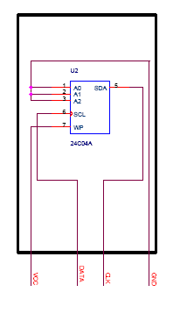
Fig 2.2 prepaid card

Circuit Description
The IS24C04 is a low cost 4,096-bit serial EEPROM. It is fabricated using ISSI’s advanced CMOS EEPROM technology and operates from a single supply. The IS24C04 is internally organized as two 256 x 8 memory banks. The IS24C04 features a serial interface and software protocol allowing operation on a simple 2-wire bus. Up to eight IS24C04s may be connected to the 2-wire bus by programming the A0, A1, and A2 inputs.
The IS24C04 features a SERIAL communication, and supports bidirectional data transmission protocol allowing operation on a simple two-wire bus between the different devices connected somewhere on the system bus. The two-wire bus was defined as a serial data line (SDA), and a serial clock line (SCL). (Refer to Figure 1. Typical System Bus Configuration.)
The protocol defines any device that sends data onto the SDA bus as a transmitter, and the receiving device as a receiver. The device controlling the data transmission is named MASTER device, and the controlled device is named SLAVE device. In all cases, the IS24C04 will be a slave device, since it never initiates any data transfers. Up to four IS24C04 can be connected to the bus. Device's physical address inputs A0-A2 must be connected to either Vcc or GND.
Following a START condition, the MASTER (transmitter) device must initiate the “Device Addressing Byte” including device type identifier, device address, and a read or write operation to select a slave device (receiver) connected to the system bus. The receiver will then respond with an Acknowledge by pulled the SDA line LOW. The increasing computational power placed on the chip along with advance in cryptography has made the smart card a very powerful tool for identification. This project features smart card secure solution for a novel prepaid electricity system.
The Acknowledge is used to indicate successful data transfers. The transmitting device will release the data bus (SDA goes HIGH) after transmitting eight bits (one data bit is transferred at the falling edge of each clock cycle). During the ninth clock cycle, the receiver will pull the SDA line LOW to acknowledge the transmitter that it received the eight bits of data.
Smart cards may also be used as electronic wallets. The smart card chip can be "loaded" with funds to pay parking meters and vending machines or at various merchants. Cryptographic protocols protect the exchange of money between the smart card and the accepting machine. No connection to the issuing bank is necessary, so the holder of the card can use it even if not the owner. Examples are Proton, Geldkarte, Chipknip and Mon€o. The German Geldkarte is also used to validate customer age at vending machines for cigarettes.
KEYPAD
A numeric keypad, or number pad for short, is the small, palm-sized, seventeen key section of a computer keyboard, usually on the very far right. The numeric keypad features digits 0 to 9, addition (+), subtraction (-), multiplication (*) and division (/) symbols, a decimal point (.) and Num Lock and Enter keys. Laptop keyboards often do not have a number pad, but may provide number pad input by holding a modifier key (typically lapelled "Fn") and operating keys on the standard keyboard.
Particularly large laptops (typically those with a 17 inch screen or larger) may have space for a real number pad, and many companies sell separate number pads which connect to the host laptop by a USB connection.

.

CHAPTER 5

CONCLUSION

The progress in science & technology is a non-stop process. New things and new technology are being invented. As the technology grows day by day, we can imagine about the future in which thing we may occupy every place.
The proposed system based on PIC microcontroller is found to be more compact, user friendly and less complex, which can readily be used in order to perform. Several tedious and repetitive tasks. Though it is designed keeping in mind about the need for industry, it can extended for other purposes such as commercial & research applications. Due to the probability of high technology (PIC microcontroller) used this” ” is fully software controlled with less hardware circuit. The feature makes this system is the base for future systems. The principle of the development of science is that “nothing is impossible”. So we shall look forward to a bright & sophisticated world.
5.1 FUTURE SCOPE
Every consumer can recharge RFID tag assigned and recharge its meter at various ranges. Bills are sending through post, instead of this we can add a printer in every house and if we give print command from the server, it will print the bill and the user can get the bill over there only.

