Utilizing Players’ Playtime Records for Churn Prediction Mining Playtime Regularity

ABSTRACT
Churn prediction is an important topic in the freeonline game industry. Reducing the churn rate of a game signifi-cantly helps with the success of the game. Churn prediction helpsa game operator identify possible churning players and keep them engaged in the game via appropriate operational strategies, marketing strategies, and/or incentives. Playtime related featuresare some of the widely used universal features for most churnprediction models. In this paper, we consider developing newuniversal features for churn predictions for long-term playersbased on playtime. In particular, we measure playtime regularityusing the notion ofentropyandcross-entropyfrom informationtheory. After computing playtime regularity of players fromthe data sets of six free online games of different types, weleverage information from the playtime regularity in the form ofuniversal features for churn prediction. Experiments show thatthe proposed features are better at predicting churners comparedto the baseline features, implying that the proposed features couldutilize the information extracted from playtime more effectivelythan the related baseline playtime features.

SYSTEM ANALYSIS
EXISTING SYSTEM:
- We model the long-term player in-game time spendingregularity based on the data of players’ in-game timespending distribution.
- We inspect churners’ and non-churners’ evolvement ofin-game time spending regularity across two free onlinegames.
- Then we the propose features based on playertime spending regularity of long-term players.
- We conduct experiments to evaluate our developed features across the two free online games’ data sets and show that these features could help achieve a better prediction performance than the baseline features.

DISADVANTAGE OF EXISTING SYSTEM:
- The combination of the static feature and rate feature ofentropy of thedailyplaytime distributions.
- We call thistype of features the1st type of the proposed features.
- The combination of the static feature and rate feature of cross-entropy of the daily playtime distributions.
- We call this type of features the 2nd type of the proposed features.
- The combination of the static feature and rate feature of entropy of the hourly playtime distributions.
- We call thistype of features the3rd type of the proposed features.
- The combination of the static feature and rate feature of cross-entropy of the hourly playtime distributions.
- We call this type of features the4th type of the proposed features.

PROPOSED SYSTEM:

- we propose prediction models using new features extracted from mining players’ in-game time spending regularity.
- After experiments are conducted, the corresponding result shows that our developed features are better at predicting churners, compared to the baseline features.
- Even without other game-specific features (e.g., login records, in-game events frequency, and payment information),we can still leverage the information from our examination of player in-game time spending regularity in the form of features and achieve satisfactory prediction performance.

ADVANTAGES OF PROPOSED SYSTEM:
- We evaluate the performance of the classifiers that aretrained with the data of the entiremplaying periods on thetest data set
- Wetrain classifiers using the training data set and evaluate theirperformance using the test data set.
- LSTM is trained usingmean squared error as a loss-function and an Adam optimizer.

LITERATURE SURVEY:
TITLE | AUTHORS | DESCRIPTION
Predicting player dis engagement and first purchase with event-frequency based data rep-resentation | H. Xie, S. Devlin, D. Kudenko, and P. Cowling, | This work intends to use frequency of game events as data representations to predict both players' disengagement from game and the decisions of their first purchases. This method is able to provide better generality because events exist in every game and no knowledge of any event but their frequency is needed.
Predicting player churn in the wild | F. Hadiji, R. Sifa, A. Drachen, C. Thurau, K. Kersting, and C. Bauck-hage, | This paper presents the first cross-game study of churn prediction in Free-to-Play games. Churn in games is discussed and thoroughly defined as a formal problem, aligning with industry standards.
Rapid Prediction of Player Retention in Free-to-PlayMobile Games | A. Drachen, E. T. Lundquist, Y. Kung, P. S. Rao, D. Klabjan, R. Sifa,and J. Runge, | This paper explores the problem of rapid retention prediction in this context. Heuristic modeling approaches are introduced as a way of building simple rules for predicting short-term retention.
Churn prediction forhigh-value players in casual social games | J. Runge, P. Gao, F. Garcin, and B. Faltings, | This paper focuses on predicting churn for highvalue players of casual social games and attempts to assess the business impact that can be derived from a predictive churn model.

Architecture diagram:
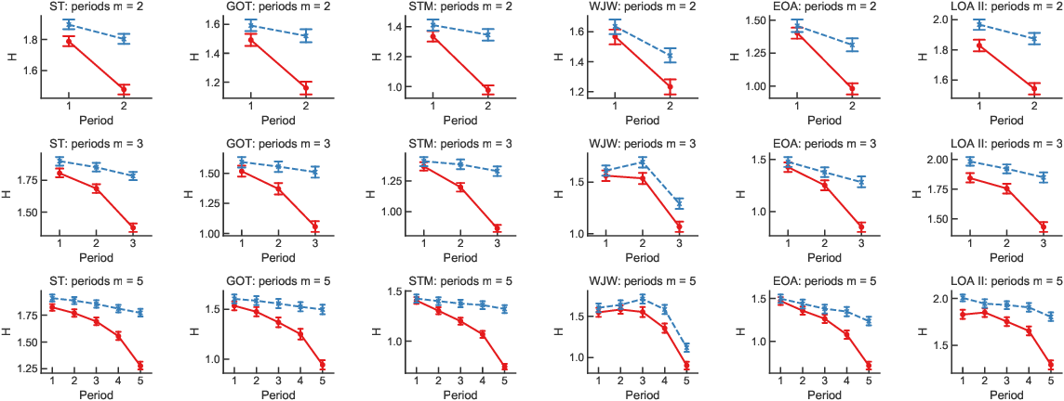

SOFTWARE REQUIREMENTS:

- Operating System : Windows 10
- Platform : DOT NET TECHNOLOGY
- Front End : ASP.Net 4.0
- Back End : SQL SERVER 2014

HARDWARE REQUIREMENTS
- Keyboard
- Mouse
- Hard disk 500GB
- Ram 4 Gb

REFERENCE
[1] H. Xie, S. Devlin, D. Kudenko, and P. Cowling, “Predicting playerdisengagement and first purchase with event-frequency based data rep-resentation,” in2015 IEEE Conference on Computational Intelligenceand Games (CIG), Aug. 2015, pp. 230–237.
[2] F. Hadiji, R. Sifa, A. Drachen, C. Thurau, K. Kersting, and C. Bauck-hage, “Predicting player churn in the wild,” in2014 IEEE Conferenceon Computational Intelligence and Games, Aug. 2014, pp. 1–8.
[3] A. Drachen, E. T. Lundquist, Y. Kung, P. S. Rao, D. Klabjan, R. Sifa,and J. Runge, “Rapid Prediction of Player Retention in Free-to-PlayMobile Games,”arXiv:1607.03202 [cs, stat], Jul. 2016.
[4] J. Runge, P. Gao, F. Garcin, and B. Faltings, “Churn prediction forhigh-value players in casual social games,” in2014 IEEE Conferenceon Computational Intelligence and Games, Aug. 2014, pp. 1–8.
[5] R. Sifa, S. Srikanth, A. Drachen, C. Ojeda, and C. Bauckhage, “Pre-dicting Retention in Sandbox Games with Tensor Factorization-basedRepresentation Learning,” in2016 IEEE Conference on ComputationalIntelligence and Games, Sep. 2016, pp. 1–8.
[6] M. Tamassia, W. Raffe, R. Sifa, A. Drachen, F. Zambetta, andM. Hitchens, “Predicting player churn in destiny: A Hidden Markovmodels approach to predicting player departure in a major online game,”in2016 IEEE Conference on Computational Intelligence and Games,Sep. 2016, pp. 1–8.
[7] P. Bertens, A. Guitart, and Á. Periáñez, “Games and big data: A scalablemulti-dimensional churn prediction model,” in2017 IEEE Conferenceon Computational Intelligence and Games, Aug. 2017, pp. 33–36.
[8] J. Jeon, D. Yoon, S. Yang, and K. Kim, “Extracting gamers’ cognitivepsychological features and improving performance of churn predictionfrom mobile games,” in2017 IEEE Conference on ComputationalIntelligence and Games, Aug. 2017, pp. 150–153.
[9] E. Lee, B. Kim, S. Kang, B. Kang, Y. Jang, and H. K. Kim, “ProfitOptimizing Churn Prediction for Long-term Loyal Customer in Onlinegames,”IEEE Transactions on Games, pp. 1–1, 2018.
[10] K.-J. Kim, D. Yoon, J. Jeon, S.-i. Yang, S.-K. Lee, E. Lee, Y. Jang, D.-W.Kim, P. P. Chen, A. Guitart, P. Bertens, Á. Periáñez, F. Hadiji, M. Müller,Y. Joo, J. Lee, and I. Hwang, “Game Data Mining Competition on ChurnPrediction and Survival Analysis using Commercial Game Log Data,”arXiv:1802.02301 [cs], Feb. 2018.
[11] M. Miloševi ́c, N. Živi ́c, and I. Andjelkovi ́c, “Early churn predictionwith personalized targeting in mobile social games,”Expert Systemswith Applications, vol. 83, pp. 326–332, Oct. 2017.
[12] Á. Periáñez, A. Saas, A. Guitart, and C. Magne, “Churn Prediction inMobile Social Games: Towards a Complete Assessment Using SurvivalEnsembles,” in2016 IEEE International Conference on Data Scienceand Advanced Analytics (DSAA), Oct. 2016, pp. 564–573.
[13] X. Liu, M. Xie, X. Wen, R. Chen, Y. Ge, N. Duffield, and N. Wang, “ASemi-Supervised and Inductive Embedding Model for Churn Predictionof Large-Scale Mobile Games,”arXiv:1808.06573 [cs, stat], Aug. 2018.
[14] W. Yang, T. Huang, J. Zeng, G. Yang, J. Cai, L. Chen, S. Mishra, andY. E. Liu, “Mining Player In-game Time Spending Regularity for ChurnPrediction in Free Online Games,” in2019 IEEE Conference on Games(CoG), Aug. 2019, pp. 1–8.
[15] M. Rowe, “Mining User Development Signals for Online CommunityChurner Detection,”ACM Trans. Knowl. Discov. Data, vol. 10, no. 3,pp. 21:1–21:28, Jan. 2016.
[16] T. M. Cover and J. A. Thomas,Elements of Information Theory (2. Ed.).Wiley, 2006.

[17]W.Yang,T.Huang,J.Zeng,L.Chen,S.Mishra,andL.Youjian,“UtilizingPlayers’PlaytimeRecordsforChurnPrediction:MiningPlaytimeRegularity,”Available:https://github.com/wanshanyang/Churner_Prediction_by_Playtime/,2020.
[18] P. S. Fader, B. G. Hardie, and K. L. Lee, “RFM and CLV: UsingIso-Value Curves for Customer Base Analysis,”Journal of MarketingResearch, vol. 42, no. 4, pp. 415–430, Nov. 2005.
[19] T. Fawcett, “An introduction to ROC analysis,”Pattern recognitionletters, vol. 27, no. 8, pp. 861–874, 2006.
[20] A. P. Bradley, “The use of the area under the ROC curve in the evaluationof machine learning algorithms,”Pattern recognition, vol. 30, no. 7, pp.1145–1159, 1997.

