Integrating an Ensemble Surrogate Model’s Estimation into Test data Generation

ABSTRACT
For the path coverage testing of a Message-Passing Interface (MPI) program, test data generation based on an evolutionary optimization algorithm (EOA) has been widely known. However, during the use of the above technique, it is necessary to evaluate the fitness of each evolutionary individual by executing the program, which is generally computationally expensive. In order to reduce the computational cost, this paper proposes a method of integrating an ensemble surrogate model’s estimation into the process of generating test data. The proposed method first produces a number of test inputs using an EOA, and forms a training set together with their real fitness. Then, this paper trains an ensemble surrogate model (ESM) based on the training set, which is employed to estimate the fitness of each individual.Finally, a small number of individuals with good estimations are selected to further execute the program, so as to have their real fitness for the subsequent evolution. This paper applies the proposed method to seven benchmark MPI programs, which is compared with several state-of-the-art approaches. The experimental results show that the proposed method can generate test data with significantly low computational cost.

SYSTEM ANALYSIS
EXISTING SYSTEM:
- We developed a simplified version of Energy Exa scale Earth System (E3SM) land model (ELM), or sELM, to simulate carbon cycle processes relevant for Earth system models in a computationally efficient framework .
- Surrogate modeling assisted by a neural network (NN)also suffers from high computational costs when applied to a large-scale problem with many QoIs.
- The sELM is a regional-scale terrestrial ecosystem model that simulates terrestrial water, energy, and biogeochemical processes in terrestrial surfaces . Simulation of sELM is important for improving our under-standing of ecosystem responses to climate change.
DISADVANTAGE OF EXISTING SYSTEM:
- When executing Algorithm 4, all the RBFNs will have an inadequate difference if the value of Npis too small. Atthis time, the ESM may result in the over-fitting or under-fitting problem. Conversely, a large computational resources will be required to implement the ESM.
- These concurrent algorithms have not provided effective strategies for solving the problem of high computational cost when generating test data.
- The number of individual e-valuations when solving an optimization problem, Sun etal. proposed a strategy for estimating the fitness ofan individual based on the Euclidean distance.
PROPOSED SYSTEM:
- We use very few simulation model runs to build an accurate and quickly evaluated surrogate system of a large-scale problem based on advanced machine-learning methods.
- we propose using singular value de composition (SVD) to reduce model output dimensions and to improve the computational efficiency of both building and evaluating the surrogates.
- we propose an SVD-enhanced, Bayesian-optimized, and NN-based surrogate method and aim to build an accurate and fast-to-evaluate surrogate system of a large-scale model using few model runs to improve computational efficiency in surrogate modeling and thus advance the data–model integration.
ADVANTAGES OF PROPOSED SYSTEM:
- MPI programs have advantages of high efficiency, good portability, and simple implementation.
- We proposed an effective method to improve the efficiency of generating test data by combining the advantages of both bug-driven and coverage-guided technique.
- When using the proposed method to generate test data that cover the target paths, if such operations as forming the training set, training an ESM, and selecting superior individuals to execute a program are helpful for improving the efficiency of generating test data, then it will be shown that the proposed method is advantageous.

LITERATURE SURVEY:
TITLE | AUTHORS | DESCRIPTION
A high-performance, portable implementation of the mpi mes-sage passing interface standard | W. Gropp, E. Lusk, N. Doss, and A. Skjellum, | In this paper, we describe MPICH, unique among existing implementations in its design goal of combining portability with high performance.
Interoperability of gaspi and mpiin large scale scientific applications | D. Akhmetova, L. Cebamanos, R. Iakymchuk, T. Rotaru, M. Rahn, S. Markidis, E. Laure, V. Bartsch, andC. Simmendinger | In this article, we address this challenge by providing our study and preliminary performance results regarding interoperating GASPI and MPI on  the performance crucial parts of the Ludwig and iPIC3D applications.
Scheduling sequence selection for generating test data to cover paths of mpi programs | B. Sun, J. Wang, D. Gong, and T. Tian, | We propose a method of selecting a superior and feasible scheduling sequence for generating test data in the criterion of path coverage against each target path of an MPI program.
Automatic generation of basis test paths using variable length genetic algorithm | A. S. Ghiduk, | we introduce a new genetic algorithm for generating test paths.  In this algorithm the length of the chromosome varies from iteration to another according  to the change in the length of the path

Architecture diagram:
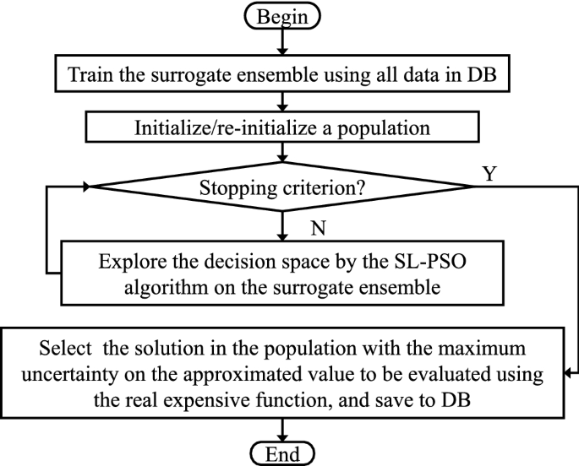

SOFTWARE REQUIREMENTS:

- Operating System : Windows 10
- Platform : DOT NET TECHNOLOGY
- Front End : ASP.Net 4.0
- Back End : SQL SERVER 2014

HARDWARE REQUIREMENTS
- Keyboard
- Mouse
- Hard disk 500GB
- Ram 4 Gb

REFERENCE
- [1] G. Hager and G. Wellein,Introduction to high performance computing for scientists and engineers. CRC Press,2010
- [2] W. Gropp, E. Lusk, N. Doss, and A. Skjellum, “A high-performance, portable implementation of the mpi mes-sage passing interface standard,”Parallel computing,vol. 22, no. 6, pp. 789–828, 1996.
- [3] D. Akhmetova, L. Cebamanos, R. Iakymchuk, T. Ro-taru, M. Rahn, S. Markidis, E. Laure, V. Bartsch, andC. Simmendinger, “Interoperability of gaspi and mpiin large scale scientific applications,” inInternationalConference on Parallel Processing and Applied Mathematics.Springer, 2017, pp. 277–287.
- [4] B. Sun, J. Wang, D. Gong, and T. Tian, “Scheduling sequence selection for generating test data to cover paths of mpi programs ,” Information and Software Technology,vol. 114, pp. 190–203, 2019.
- [5] A. S. Ghiduk, “Automatic generation of basis test paths using variable length genetic algorithm ,” Information Processing Letters, vol. 114, no. 6, pp. 304–316, 2014.
- [6] S. Souza, S. R. Vergilio, P. Souza, A. Simao, andA. C. Hausen, “Structural testing criteria for message-passing parallel programs,” Concurrency and Computa-tion: Practice and Experience, vol. 20, no. 16, pp. 1893–1916, 2008.
- [7] P. S. Souza, S. R. Souza, and E. Zaluska, “Structural testing for message-passing concurrent programs: an extended test model ,” Concurrency and Computation:Practice and Experience, vol. 26, no. 1, pp. 21–50, 2014.
- [8] T. Tian and D. Gong, “Test data generation for path coverage of message-passing parallel programs based on co-evolutionary genetic algorithms ,” Automated Soft-ware Engineering, vol. 23, no. 3, pp. 469–500, 2016.
- [9] H. Tong, C. Huang, J. Liu, and X. Yao, “Voronoi-based efficient surrogate-assisted evolutionary algorithm for very expensive problems ,” arXiv preprint arX-iv:1901.05755, 2019.
- [10] C. Sun, J. Zeng, J. Pan, S. Xue, and Y. Jin, “A new fitness estimation strategy for particle swarm optimization ,” Information Sciences, vol. 221, pp. 355–370, 2013.

