Evaluation of Fault Level of Sensitive Equipment Caused by Voltage Sag via Data Mining

ABSTRACT

So far, there is no literature to evaluate the fault level of sensitive equipment(FLSE) caused by voltage sag from the perspective of the power grid. In practice, although the FLSE are dominated by the voltage sag of node, the voltage sag of the node is associated with whole power grid, including the voltage grade and location of the node, the distance between the concerned node and location of fault, and the weather and date at the time of fault, which are all named as voltage sag properties (VSP). In view of this gap, this paper evaluates the FLSE using the long-time monitoring data of VSP of some regional power grid by data mining method based on multi dimensional matrix simplification and the improved gray target theory .The data mining process can be divided into three steps: 1) construct a data base consisted of VSP and FLSE using long-time monitoring data, 2) mine the association rules between VSP and FLSE by multidimensional matrix simplification, and 3)match some actual scenario with the mined association rules by the improved gray target theory .Performance and effectiveness of the proposed method are verified through the simulation and field case.

SYSTEM ANALYSIS
EXISTING SYSTEM:

- VOLTAGE SAGS are one of the most harmful power quality disturbances for sensitive end-users.
- Enormous resources are lost every year due to industrial equipment malfunctions as a consequence of voltage sags.
- Most of the severe voltage sags are caused by Voltage sags have been registered by usual Digital Fault Recorders (DFRs) installed on the transmission lines.
- The recording is setup for both over-current and under-voltage events.
- Voltage sags were characterized by the minimum rms voltage and the duration faults on the transmission and distribution grids.
DISADVANTAGE OF EXISTING SYSTEM:
- The gray target theory is proposed for solving the multi-polar and multi-attribute mode decision problem.
- According to the polarity of each index , the bull's-eye can be determined in the target.
- In the mining process of association rules, VSP require to be transformed into qualitative values, so the mining association rules need to be represented by qualitative values of different dimensions.
- The magnitude and duration of the sag are randomly located in any region of the tolerance curve.
PROPOSED SYSTEM:

- This paper introduces the concept of cost of the un served energy”, assuming that this represent an end user’s cost.
- The cost of the utility was assumed to be the cost of reparations plus the loss of revenue
- The effect of voltage sags on industrial loads has been the focus of previous papers and several mitigation methods to improve equipment’s ride-through capability have been proposed.
- When several voltage sags were registered within one minute, only the one with the minimum magnitude was considered.

ADVANTAGES OF PROPOSED SYSTEM:
- This paper employs the energy loss function and the tolerance curve of sensitive equipment to calculate the failure rate of equipment caused by voltage sag.
- The advantage of the method is that the failure rate can be calculated only based on one voltage sag event without the need for long-term voltage sag data .
- Propose the improved gray target theory to make the matching result more accurate and avoid the multiple matching results.
- Performance and effectiveness are verified through the field case.

LITERATURE SURVEY:
TITLE | AUTHORS | DESCRIPTION
Voltage sag assessment in a large chemical industry | GOSWAMI A K. | Voltage sag has received more attention at the industrial and commercial facilities because of the malfunctioning of various sensitive equipments, which leads to finance‐related issues.
Voltage Sag Acceptability Assessment Using Multiple Magnitude-Duration Function | Tan R H G, Rama chandaramurthy V K | A multiple magnitude-duration (MMD) function is proposed for voltage sag acceptability assessment. The MMD function is a statistical representation of voltage sag derived from its rms analysis
Premium power valuation method based on customer perception of utility for high-technology manufacturing customers | Xiao X Y, Ma Y Q, Zhang Y, et al. | The investment of premium power depends on the premium power value (PPV) perceived by the customers. One valuation method of PPV based on customers' perceived power utility (PPU) and willingness to pay (WTP) is proposed in this study.
Sensitivity of Programmable Logic Controllers to Voltage Sags | Xu Y, Wu Y, Zhang M, et al. | The sensitivity of the power supply and discrete input modules are researched first, and then, the effect of the key characteristics of voltage sag, namely, magnitude, duration, points-on-wave of sag initiation, odd harmonics, multiple sags and continuous sags, are tested

Architecture diagram:

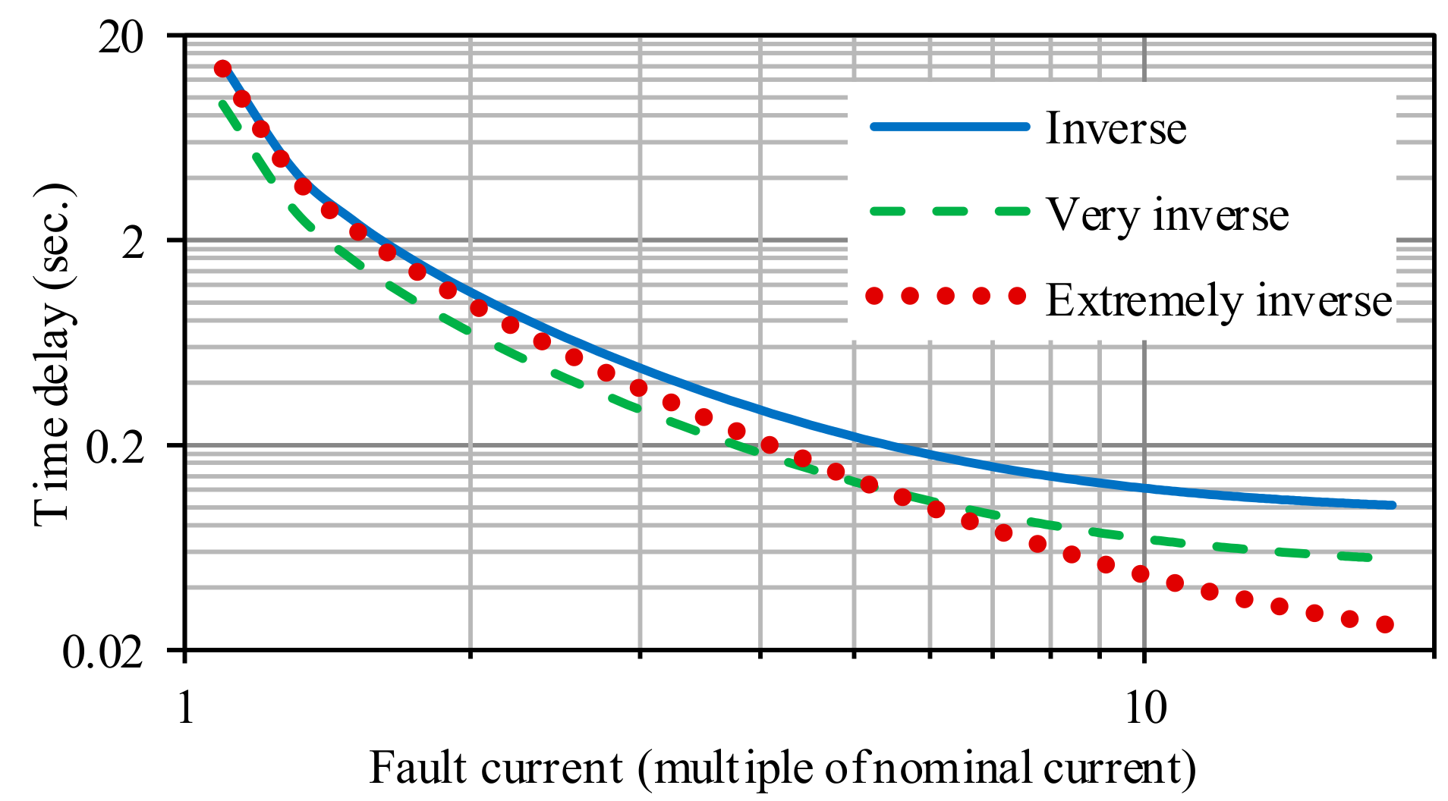

SOFTWARE REQUIREMENTS:

- Operating System : Windows 10
- Platform : DOT NET TECHNOLOGY
- Front End : ASP.Net 4.0
- Back End : SQL SERVER 2014

HARDWARE REQUIREMENTS
- Keyboard
- Mouse
- Hard disk 500GB
- Ram 4 Gb

REFERENCE
[1]GOSWAMI A K. Voltage sag assessment in a large chemical industry[J]. IEEE Transactions on Industry Applications, 2012, 48(5): 1739-1746.
[2]Tan R H G, Rama chandaramurthy V K. Voltage Sag Acceptability Assessment Using Multiple Magnitude-Duration Function[J]. IEEE Transactions on Power Delivery, 2012.
[3]Xiao X Y, Ma Y Q, Zhang Y, et al. Premium power valuation method based on customer perception of utility for high-technology manufacturing customers[J]. IEEE Transactions on Power Delivery, 2015, 31(4): 1655-1662.
[4]Xu Y, Wu Y, Zhang M, et al. Sensitivity of Programmable Logic Controllers to Voltage Sags[J]. IEEE Transactions on Power Delivery, 2018, 34(1): 2-10.
[5]Xu Y, Lu W, Li C, et al. Sensitivity of Low-Voltage Variable-Frequency Devices to Voltage Sags[J]. IEEE Access, 2018, 7: 2068-2079.
[6]Zeng Z L, Xiao X Y, Wang Y. Maximum Hybrid Entropy Assessment of Equipment Failure Probability Caused by Voltage Sags[J]. Advanced Materials Research, 2013, 616-618:574-579.
[7]Xiao X Y, Ma C, Yang H G, et al. Failure probability analysis of sensitive equipment due to voltage sags using fuzzy-random assessment method[J]. IEEE Transactions on Power Delivery, 2010, 25(4): 2970-2975.
[8]Li H Q, Xiao X Y, Wang Y, et al. Probability evaluation method of equipment failure due to voltage sags considering multi-uncertain properties[J]. International Journal of Electrical Power & Energy Systems, 2011, 33(3): 608-614.
[9]Behera C, Reddy G H, Chakrapani P, et al. Assessment of Equipment Trip Probability Due to Voltage Sags Based on Fuzzy Possibility Distribution Function[J]. IEEE Access, 2018, 6: 76889-76899.
[10]Elphick S, Ciufo P, Drury G, et al. Large scale proactive power-quality monitoring: An example from Australia[J]. IEEE Transactions onPower Delivery, 2016, 32(2): 881-889

