Co-Residence Data Theft Attacks on N-Version Programming Based Cloud Services with Task Cancelation

ABSTRACT

Powered by virtualization, the cloud computing has brought good merits of cost effective and on-demand resource sharing among many users. On the other hand, cloud users face security risks from co-residence attacks when using this virtualized platform. Particularly, a malicious attacker may create side channels to steal data from a target user’s virtual machine (VM) that co-resides with the attacker’s VM on the same physical server. This article models a cloud service undergoing the co-residence data theft attacks. The threshold voting based N-version programming (NVP) is implemented to improve the service reliability, where multiple service component versions (SCVs) are activated in parallel to perform the requested service. The final output is determined upon receiving a threshold number of identical outputs from the SCVs, immediately followed by canceling all outstanding SCVs to reduce expenses. Probabilistic models are first introduced to evaluate performance metrics of the considered service, including the data theft probability, service success probability, expected service operation time, and expected utility. Optimization problems are further solved to find the optimal number of SCVs maximizing the expected utility. Interactions among different model parameters and VM allocation policies, as well as their effects on the considered performance metrics and on the optimization solutions are studied through examples.

CHAPTER-1
INTRODUCTION

Security is one of the major concerns that arise from the use of cloud computing systems. From the customer’s perspective, while migrating to the cloud brings a number of advantages, including higher availability, better scalability and lower maintenance overhead, it also means customers are exposed to additional risks brought about by the other tenants with whom they share the resources. In cloud environments, it is almost unavoidable that any user shares one or multiple types of resources with other users (Figure1.1), e.g., computing, networking and storage. An important question to ask is whether these neighbors are trust worthy; orcan they compromise the integrity of others?

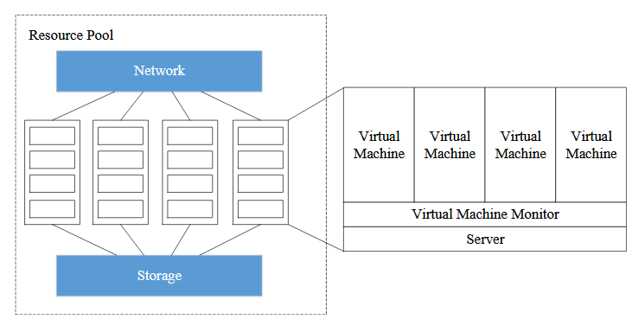

Resource sharing in cloud computing

This thesis concentrates on one form of cloud security problem: the co-resident attack[1](also known as co-location, co-residence, or co-residency attack), where malicious users intend to co-locate their virtual machines (VMs) with target VMs on the same physical server, and then exploit side channels to extract private information from the victim.

Take web traffic estimation for example. Suppose that a VM is hosting a web server. As shown in Figure 1.2, it has been demonstrated in [1]that there is a strong correlation between the traffic rates to the web server and the time to perform certain cache read operation son a co-resident VM, i.e., a VM running on the same physical server(for more detail, please refer to Section 2.3.2). By exploiting this typeof side channel, malicious users can estimate the number of HTTP requests that a website is processing per minute. Such kind of information is normally not known, especially to direct competitors. For clever attackers, even seemingly innocuous information like workload statistics can be useful. For example, they can identify when the system is most vulnerable based on the workload data, and launch further attacks, such as Denial-of-Service attacks. Therefore, it is crucial to design effective and practical countermeasures against this kind of threat.

Definition of Co-resident Attacks
The co-resident attacks discussed here comprise the following two steps. First, the attacker has a clear set of target VMs, and their goal is to co-locate their VMs with these targets on the same physical servers. Second, after co-residence is achieved, the attacker will construct different types of side channels to obtain sensitive information from the victim. Note that this is different from where the attacker does not have specific targets, and their goal is to obtain an unfair share of the cloud platform’s capacity.

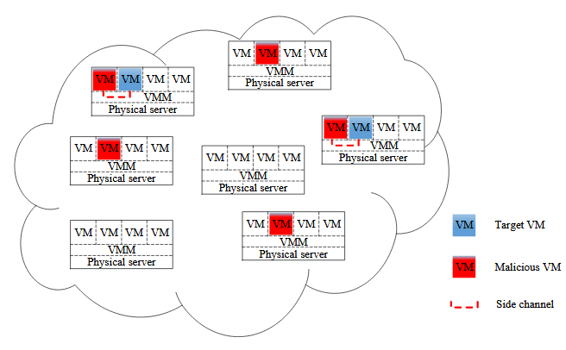

Illustration of co-resident attacks

ESSENTIAL CHARACTERISTICS OF CLOUD COMPUTING
On-demand service:
A consumer can unilaterally provide computing capabilities, such as server time and network storage, as needed automatically without requiring human interaction with each service provider. Broad network access: Capabilities are available over the network and accessed through standard mechanisms that promote use by heterogeneous client platforms (e.g., mobile phones, laptops, and PDAs).
Resource pooling:
The provider’s computing resources are pooled to serve multiple consumers using a multi-tenant model, with different physical and virtual resources dynamically assigned and reassigned according to consumer demand.
Rapid elasticity:
Capabilities can be rapidly and elastically provisioned, in some cases automatically, to quickly scale out and rapidly released to quickly scale in. Measured Service:
Cloud systems automatically control and optimize resource use by leveraging a metering capability at some level of abstraction appropriate to the type of service (e.g., storage, processing, bandwidth, and active user accounts). Resource usage can be monitored, controlled, and reported providing transparency for both the provider and consumer of the utilized service.
Virtualization:
Virtualization is a technique of resource sharing that is based on the principle of dividing physical resources(HW) or operating systems(SW)for cost control measures and more efficient utilization of resources.

Types of virtualization
Full virtualization:
A technique used to provide a certain kind of virtual machine environment, namely, one that is complete simulation of the underlying hardware. Para-virtualization: A technique that presents software to the virtual machines that is similar but not identical to that of the underlying hardware.
Emulation:
Hardware emulation is all about using standard virtualization software (also called a Hyper Visor) to form a emulated hardware environment (Called VMM -- Virtual Machine Monitor), for guest operating systems to function on.
OS virtualization:
OS allows multiple secure virtual servers to be run. Guest OS is the same as the host OS, but appears isolated. Application virtualization: Application is gives its own copy of components that are not shared.

BASIC CHALLENGES IN CLOUD COMPUTING
Four issues stand out with cloud computing: threshold policy, interoperability issues, hidden costs, and unexpected behavior.

Threshold policy:
To test if the program works, develop, or improve and implement, a threshold policy in a pilot study before moving the program to the production environment. Check how the policy detects sudden increases in the demand and results in the creation of additional instances to fill in the demand. Also check to determine how unused resources are to be de-allocated and turned over to other work.

Interoperability issues:
The problems of achieving interoperability of applications between two cloud
Computing vendors. Need to reformat data or change the logic in applications.

Hidden costs :
Cloud computing does not tell what hidden costs are. In an instance of incurring network costs, companies who are far from the location of cloud providers could experience latency, particularly when there is heavy traffic.

Unexpected behavior:
The tests to be made to show unexpected results of validation or releasing unused
Resources. Need to fix the problem before running the application in the cloud.
Also other issues are:
Cloud providers must work together to ensure that the challenges to cloud adoption are addressed through open collaboration and the appropriate use of Standards.
Cloud providers must not use their market position to lock customers into their particular platforms and limiting their choice of providers.
Cloud providers must use and adopt existing standards wherever appropriate. The IT industry has invested heavily in existing standards and standards organizations; there is no need to duplicate or reinvent them.
When new standards (or adjustments to existing standards) are needed, we must be judicious and pragmatic to avoid creating too many standards. We must ensure that
Standards promote innovation and do not inhibit it. Any community effort around the open cloud should be driven by customer needs, not merely the technical needs of cloud providers, and should be tested or verified against real customer requirements.

CLOUD SECURITY AND ITS ISSUES

Cloud Security:
Security remains the biggest barrier preventing companies from entering into the cloud. Security is a continuous consideration in IT-related projects. Unlike many other traits in technological contexts, security is notoriously hard to quantify or even compare qualitatively. For this reason, security evaluation of cloud offerings will mostly hinge on company reputation and, eventually, real-world track records –but even real world track records are difficult to compare between companies, because security breaches may not be publicly disclosed unless compelled by regulation. Like SLAs, companies might specify contractual compensation for certain kinds of provider negligence leading to security failures, but such provisions may be worth very little since security failures are not as easily observable as service availability failures.
Businesses using cloud services want to ensure that their data is secure from both external attackers as well as internal snoopers (employees of the cloud provider). Although data theft and snooping is mitigated by properly encrypting data to be stored within the cloud, encryption cannot prevent denial-of-service attacks such as data deletion or corruption. Some early research users of Amazon S3 suggest, “Users should employ some kind of data authentication technology to assure themselves that data returned by S3 is the same as the data that was stored there. Technology such as an HMAC or a digital signature would protect users from both accidental data modification by Amazon and from malicious modification by third parties who managed to crack a password or intercept a password reset email message” .

Service integrity is another security issue: businesses want to ensure their running services are not subject to denial-of-service attacks or hijacked. The latter can be very insidious, as a third party might (for example) gain control of a business’s e-commerce site and besmirch its reputation. This situation is the digital equivalent of identity theft. Isolation is a related concern –cloud providers serve many customers and they all share common hardware and infrastructure. Although resource virtualization prevents customers from having to explicitly coordinate resource sharing, the cloud provider must ensure that multiple customers do not interfere with each other, maliciously or otherwise.

Parameters affecting cloud security

There are numerous security issues for cloud computing as it encompasses many technologies including networks, databases, operating systems, virtualization, resource scheduling, transaction management, load balancing, concurrency control and memory management.

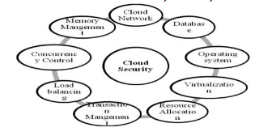

Parameters that affects cloud security
Security issues for many of these systems and technologies are applicable to cloud computing. For example, the network that interconnects the systems in a cloud has to be secure. Furthermore, virtualization paradigm in cloud computing results in several security concerns. For example, mapping the virtual machines to the physical machines has to be carried out securely. Data security involves encrypting the data as well as ensuring that appropriate policies are enforced for data sharing. In addition, resource allocation and memory management algorithms have to be secure. Finally, data mining techniques may be applicable to malware detection in clouds.

CHAPTER 2
2. SYSTEM ANALYSIS
2.1 EXISTING SYSTEM

Third-party cloud computing represents the promise of out-sourcing as applied to computation. Services, such as Microsoft’s Azure and Amazon’s EC2, allow users to instant ate virtual machines (VMs) on demand and thus purchase precisely the capacity they require when they require it. In turn, the use of virtualization allows third-party cloud providers to maximize the utilization of their sunk capital costs by multiplexing many customer VMs across a shared physical infrastructure.
2.1.1 DRAWBACKS OF EXISTING SYSTEM ARE

- Thus is likely to be demanded by customers with strong privacy requirements.

- We argue that the best solution is for cloud providers to expose this risk explicitly and give some placement control directly to customers.

2.2. PROPOSED SYSTEM

In this paper, we show that this approach can also introduce new vulnerabilities. Using the Amazon EC2 service as a case study, we show that it is possible to map the internal cloud infrastructure, identify where a particular target VM is likely to reside, and then instantiate new VMs until one is placed co-resident with the target. We explore how such placement can then be used to mount cross-VM side-channel attacks to extract information from a target VM on the same machine.

2.2.1. ADVANTAGES OF PROPOSED SYSTEM

- Some of these risks are self-evident and relate to the new trust relationship between customer and cloud provider. For example, customers must trust their cloud providers to respect the privacy of their data and the integrity of their computations.

- Cloud infrastructures can also introduce non-obvious threats from other customers due to the subtleties of how physical resources can be transparently shared between virtual machines (VMs).

CONCLUSION

Cloud, is prone to manifold security threats varying from network level threats to application level threats. In order to keep the cloud secure, these security threats need to be controlled. Moreover data residing in the cloud is also prone to a number of threats and various issues like security issues, accessibility issues, confidentiality, and integrity of data. Both the cloud service provider and the customer should make sure that the cloud is safe enough from all the external threats, so there will be a strong and mutual understanding between the customer and the cloud service provider. In addition to this, cloud service providers must ensure that all the SLA’s are met and human errors on their part should be minimized, enabling smooth functioning. In this paper various security concerns related to the three basic services provided by a Cloud computing environment are considered and the solutions to prevent them have been discussed.

REFERENCE
[1] J. von Neumann, “Probabilistic logics and the synthesis of reliable organisms from unreliable components,” in Automata Studies (Annals of Mathematics Studies, No. 34). Princeton, NJ, USA: Princeton Univ.Press, 1956, pp. 43–98.

[2] A. Avizienis, “The N-version approach to fault-tolerant software,” IEEE Trans. Softw. Eng., vol. 11, no. 2, pp. 1491–1501, Dec. 1985.

[3] W. Kuo and R. Wan, “Recent advances in optimal reliability allocation,” IEEE Trans. Syst., Man, Cybern. A, Syst., Humans, vol. 37, no. 2, pp. 143–156, Mar. 2007.

[4] L. Xing, G. Levitin, and Y. Xiang, “Defending N-version programming service components against co-resident attacks in IoT cloud systems,” IEEE Trans. Services Comput., early access, Mar. 13, 2019, doi: 10.1109/TSC.2019.2904958.

[5] Z. Qiu and J. F. Pérez, “Enhancing reliability and response times via replication in computing clusters,” in Proc. IEEE Conf. Comput. Commun. (INFOCOM), 2015, pp. 1355–1363.

[6] T. Wang, W. Zhang, C. Ye, J. Wei, H. Zhong, and T. Huang, “FD4C: Automatic fault diagnosis framework for Web applications in cloud computing,” IEEE Trans. Syst., Man, Cybern., Syst., vol. 46, no. 1, pp. 61–75, Jan. 2016.

[7] M. H. Ghahramani, M. Zhou, and C. T. Hon, “Toward cloud computing QoS architecture: Analysis of cloud systems and cloud services,” IEEE/CAA J. Automatica Sinica, vol. 4, no. 1, pp. 6–18, Jan. 2017.
[8] Z. Tao et al., “A survey of virtual machine management in edge computing,” Proc. IEEE, vol. 107, no. 8, pp. 1482–1499, Aug. 2019.

[9] X. Qiu, Y. Dai, Y. Xiang, and L. Xing, “A hierarchical correlation model for evaluating reliability, performance, and power consumption of a cloud service,” IEEE Trans. Syst., Man, Cybern., Syst., vol. 46, no. 3, pp. 401–412, Mar. 2016

[10] P. Zhang and M. Zhou, “Dynamic cloud task scheduling based on a two-stage strategy,” IEEE Trans. Autom. Sci. Eng., vol. 15, no. 2, pp. 772–783, Apr. 2018.

[11] M. M. Alani, “Securing the cloud: Threats, attacks and mitigation techniques,” J. Adv. Comput. Sci. Technol., vol. 3, no. 2, pp. 202–213, 2014

[12] M. Godfrey and M. Zulkernine, “Preventing cache-based side-channel attacks in a cloud environment,” IEEE Trans. Cloud Comput., vol. 2, no. 4, pp. 395–408, Oct.–Dec. 2014.

[13] T. Ristenpart, E. Tromer, H. Shacham, and S. Savage, “Hey, you, get off of my cloud: Exploring information leakage in third-party compute clouds,” in Proc. 16th ACM Conf. Comput. Commun. Security, 2009, pp. 199–212.

[14] G. Nalinipriya, P. J. Varalakshmi, K. G. Maheswari, and R. Anita, “An extensive survey on co-resident attack in dynamic cloud computing environment,” Int. J. Appl. Eng. Res., vol. 11, no. 5, pp. 3019–3023, 2016.

