Evaluation Goals for Online Process Mining : a Concept Drift Perspective

ABSTRACT
Online process mining refers to a class of techniques for analyzing in real-time event streams generated by the execution of business processes. These techniques are crucial in the reactive monitoring of business processes, timely resource allocation and detection/prevention of dysfunctional behavior. This paper fills the gap by identifying a set of evaluation goals for online process mining and examining their fulfillment in the state of the art. Many interesting advances have been made by the research community in recent years , but there is no consensus on the exact set of properties these techniques have to achieve.We discuss parameters and techniques regulating the balance between conflicting goals and outline research needed for their improvement.Concept drift detection is crucial in this sense but, as demonstrated by our experiments, it is only partially supported by current solutions

SYSTEM ANALYSIS
EXISTING SYSTEM:
- we have presented the first online mechanism for detecting and managing concept drift, combined with the process mining approach in based on abstract interpretation and Petri net models.
- Our experiments on process mining bench mark data twisted to incorporate drift show that our method detects abrupt changes quickly and accurately.
- We have also described how to apply the mechanism for a richer set of tasks: characterizing and locating change , unraveling the process change, and revising the mined models
- we use an adaptive window technique which has been proved to be very effective for similar purposes
DISADVANTAGE OF EXISTING SYSTEM:
- The problem of bounding the memory usage is not addressed (7G1), moreover, the time of accumulation implies a delay in the response (7G2)
- In order to address the problem of computing the conformance of incomplete cases, in an approach for assessing the optimal alignment of sub-traces is proposed.
- He authors are aware of this problem and propose either Random Sampling with Reservoir or Decay-based data structures similarly to the solutions provided respectively in for process discovery.
- This way it is possible to manage the trade-off between memory consumption (3G1) and accuracy(–G4). It is clear that CDD in non-stationary environments is a precondition to not lose accuracy.
PROPOSED SYSTEM:
- we present the first online mechanism for detecting and managing concept drift, which is based on abstract interpretation and sequential sampling, together with recent learning techniques on data streams.
- we concentrate on the control-flow part, i.e., the causal relations between the events of a process.
- This paper presents an online technique to detect concept drift by sequential monitoring of the logs of a system. It is a multi-stage technique that uses the theory of abstract interpretation

ADVANTAGES OF PROPOSED SYSTEM:
- The amount of memory that can be used during data analysis is much smaller than the entire series
- The events accumulated are used to generate an abstract interpretation of their behavior using a convex polyhedron that offers an upper approximation.
- When new cases are acquired , online analysis matches them with the polyhedron to estimate their divergence to the previously observed behavior, supporting the online assessment of concept drift
- To improve the accuracy of change-point detection, statistical tests were introduced to set the optimal size of the window of analysis but disregarding then memory management.

LITERATURE SURVEY:
TITLE | AUTHORS | DESCRIPTION
Online process discovery to detect concept drifts in ltl-based declarative process models | F. M. Maggi, A. Burattin, M. Cimitile, and A. Sperduti, | our approach is able to provide meaningful infor-  mation about the most significant concept drifts, i.e., changes occurring in a process during its execution. We report about experimental results obtained using logs pertaining the health insurance claims handling in a travel agency.
Business process analytics | M. Zur Muehlen and R. Shapiro, | Business Process Management analytics is the family of methods and tools that can be applied to these event streams in order to support decision making in organizations.
Action research for operations management | P. Coughlan and D. Coghlan, | The reflection explores a small number of action research studies undertaken across multiple fields and disciplines in business and management and advances distinct common denominators that can guide further research and action and aid future reflection.
Streaming process discovery and conformance checking | A. Burattin , | Discovering a process model from such event data and verification of the quality of discovered models are important steps in process mining.

Architecture diagram:
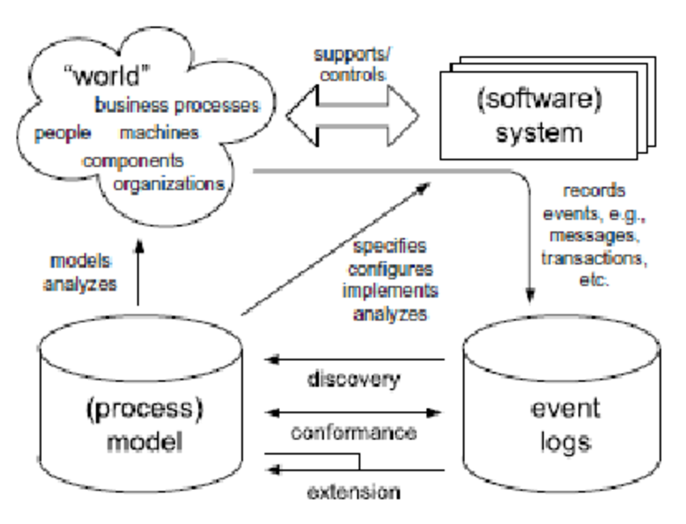

SOFTWARE REQUIREMENTS:

- Operating System : Windows 10
- Platform : DOT NET TECHNOLOGY
- Front End : ASP.Net 4.0
- Back End : SQL SERVER 2014

HARDWARE REQUIREMENTS
- Keyboard
- Mouse
- Hard disk 500GB
- Ram 4 Gb

REFERENCE
- [1] F. M. Maggi, A. Burattin, M. Cimitile, and A. Sperduti, “Online process discovery to detect concept drifts in ltl-based declarative process models,” in OTM Confederated International Conferences ” On the Move to Meaningful Internet Systems ”. Springer, 2013, pp.94–111.
- [2]M. Zur Muehlen and R. Shapiro, “Business process analytics,” in Handbook on Business Process Management 2.Springer, 2015, pp.243–263.
- [3]P. Coughlan and D. Coghlan, “Action research for operations management,” International journal of operations & production management, vol. 22, no. 2, pp. 220–240, 2002.
- [4]A. Burattin, “Streaming process discovery and conformance checking,” in Encyclopedia of Big Data Technologies. Springer, 2018.
- [5]S. J. van Zelst, B. F. van Dongen, and W. M. van der Aalst, “Event stream-based process discovery using abstract representations ,” Knowledge and Information Systems, vol. 54, no. 2, pp. 407–435, 2018..
- [6]L. Rutkowski, M. Jaworski, and P. Duda, Basic Concepts of DataStream Mining. Cham: Springer International Publishing, 2020,pp. 13–33.
- [7]A. Burattin, A. Sperduti, and W. M. van der Aalst, “Control-flow discovery from event streams,” in Evolutionary Computation (CEC),2014 IEEE Congress on. IEEE, 2014, pp. 2420–2427.
- [8]M. Hassani, S. Siccha, F. Richter, and T. Sidle, “Efficient process discovery from event streams using sequential pattern mining,”in2015 IEEE Symposium Series on Computational Intelligence, Dec2015, pp. 1366–1373.
- [9]M. Hassani, S. J. van Zelst, and W. M. P. van der Aalst, “On the application of sequential pattern mining primitives to process discovery: Overview, outlook and opportunity identification ,” Wiley Interdisciplinary Reviews: Data Mining and Knowledge Discovery, vol. 0, no. 0, p. e1315, 2019.
- [10] V. Leno, A. Armas-Cervantes, M. Dumas, M. La Rosa ,and F. M. Maggi, “Discovering process maps from event streams,” in Proceedings of the 2018 International Conference on Software and System Process, ser. ICSSP ’18.New York,NY, USA: ACM, 2018, pp. 86–95.

