Classifying User Experience Based on the Intention to Communicate

ABSTRACT
Experience mining is considered a substantial extension of opinion mining. Experience mining covers the description of all events that are related to the user's perception in the interaction with the object.
There is information about the user`s experience that cannot be obtained with polarity analysis or sentiment analysis. The information obtained from those analyses is the positive or negative evaluation of a product/service.
But in opinion analysis there is more useful information for other users.
In this work we propose a method to obtain expressions of user experiences that are difficult to obtain by some of the current methods.
The contributions of this work are: 1) Classification of information of user experiences according to the intention of communication: the categories are: "Evaluation", "Sensation" "Recommendation" and “Target Users". 2) A rule-based method: rules take into account the lexical classification of words to classify sentences based on communicative intention. The results obtained show that the method based on classification rules can provide useful information about the user experience to other users

SYSTEM ANALYSIS
EXISTING SYSTEM:
- Por ejemplo, "... el 50% de los usuarios opinan que el restaurante X es bueno ...".También con estos métodos se puede obtener información más específica sobre el valor que le dan los usuarios a ciertas características de un producto/servicio, por ejemplo "... el servicio de limpieza del hotel no es bueno ...". Este análisis más específico se denomina “análisis de sentimientos”.
- Presenta un método para obtener información de consejos creíbles y relevantes que dan los usuarios en las redes sociales.

DISADVANTAGE OF EXISTING SYSTEM:
- Sin embargo, la clasificación de opiniones sufre algunos problemas. Al analizar ciertas sentencias, estas no pueden sercatalogadas en alguna clase (positiva o negativa) debido a que son opiniones contradictorias o ambiguas.
- Otro problema es la identificación del contexto en el que se emitió la opinión.
- Las restantes fuer on clasificadas por las 3 personas en diferentes categorías.
- Para resolver este problema, estas oraciones fueron clasificadas nuevamente por otras 3 personas para lograr un consenso a través del sistema de votación.

PROPOSED SYSTEM:
- we propose a method to obtain expressions of user experiences that are difficult to obtain by
- Social media, including social networks, makes it ever more important for companies to ensure their online exposure ties directly to their brand image and messaging.
- Along with television, radio, and print, social media is part of the communications ecosystem that works as a whole to create an enjoyable and seamless consumer experience across multiple channels.
- Likewise, integrated marketing communications is increasingly incorporating social media into the promotional mix to reach consumers on the web and on mobile devices.

ADVANTAGES OF PROPOSED SYSTEM:

- There is information about the user`s experience that cannot be obtained with polarity analysis or sentiment analysis.
- The information obtained from those analyses is the positive or negative evaluation of a product/service.
- But in opinion analysis there is more useful information for other users.
- In this work we propose a method to obtain expressions of user experiences that are difficult to obtain by some of the current methods

LITERATURE SURVEY:
TITLE | AUTHORS | DESCRIPTION
Opinion mining and informationfusion: a survey | J. A. Balazs and J.D. Velásquez | In this paper we present a survey on Information Fusion applied to Opinion Mining. We first define Opinion Mining and describe its most fundamental aspects, later explain Information Fusion and finally review several Opinion Mining studies that rely at some point on the fusion of information.
New avenues in opinion mining and senti-ment analysis | E. Cambria, B. Schuller, Y. Xia and C. Havasi. | the “social web” provides new tools to efficiently create and share ideas with everyone connected to the World Wide Web.
Web opinion mining and sentimental analysis | E. M. Taylor, C. Rodriguez, J.D. Velásquez, G. Ghosh and S. Banerjee. | It embraces the problem of extracting, analyzing and aggregating web data about opinions.
Contextual semantics for sentiment analysis of Twitter | H. Saif, Y. He, M. Fernandez and H Alani. | we present Senti Circles, a lexisentiment polarities of words regardless of their context, Senti Circles takes into account .con-based approach for sentiment analysis on Twitter. Different from typical lexicon-based approaches, which offer a fixed and static prior

Architecture diagram:

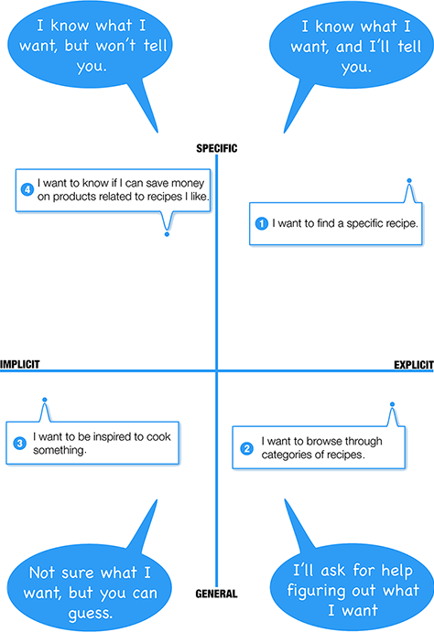

SOFTWARE REQUIREMENTS:

- Operating System : Windows 10
- Platform : DOT NET TECHNOLOGY
- Front End : ASP.Net 4.0
- Back End : SQL SERVER 2014

HARDWARE REQUIREMENTS
- Keyboard
- Mouse
- Hard disk 500GB
- Ram 4 Gb

REFERENCE
[1]J. A. Balazs and J.D. Velásquez. Opinion mining and information fusion: a survey. Information Fusion, 27, 95-110. 2016.
[2]E. Cambria, B. Schuller, Y. Xia and C. Havasi. New avenues in opinion mining and senti-ment analysis. IEEE Intelligent Systems, 28(2), 15-21. 2013.
[3]Z. Tong, Z. Xiao, H. Liu, and M. Chen. A Novel Parallel LSA-SVMA lgorithm Based on Semantic Distance for Blog. International Journal of Pattern Recognition and Artificial Intelligence, 30(09), 1660002. 2016.
[4]E. M. Taylor, C. Rodriguez, J.D. Velásquez, G. Ghosh and S. Banerjee. Web opinion mining and sentimental analysis. In Advanced Techniques in Web Intelligence-2 (pp. 105-126). Springer Berlin Hei-delberg. 2013.
[5]W. Albert and T. Tullis. Measuring the user experience: collecting, analyzing, and presenting usability metrics 2013.
[6]T. Olsson, E. Lagerstam, T. Kärkkäi-nen and K. Väänänen-Vainio-Mattila. Expected user experience of mobile augmented reality services: a user study in the context of shopping centres. Personal and ubiquitous computing, 17(2), 287-304. 2013.
[7]S. Aciar, D. Zhang, S. Simoff adn J. Debenham. Informed recommender: Basing recommendations on consumer product reviews. IEEE Intelligent systems, 22(3). 2007.
[8]A.Veenendaal, E. Daly, E. Jones, Z. Gang, S. Vartak and R. Patwardhan. Polarity Analysis of Restaurant Review Comment Board. Computer Science and Emerging Research Journal, 2. 2014.
[9]F. O. Gallego. Torii: Attribute-based Polarity Analysis with Big Datasets. In Proceedings of the 39th International ACM SIGIR conference on Research and Development in Information Retrieval(pp. 1187-1187). ACM. July 2016.
[10]S. Rosenthal, N. Farra and P. Na-kov. SemEval-2017 task 4: Sentiment analysis in Twitter. In Proceedings of the 11th International Workshop on Semantic Evaluation (SemEval-2017) (pp. 502-518). 2017

