A fuzzy mining approach for energy efficiency in a Big Data framework

ABSTRACT
The discovery and exploitation of hidden informa-tion in collected data has gained attention in many areas, particularly in the energy field due to their economic and environmental impact.Data mining techniques have then emerged as a suitable toolbox for analysing the data collected in modern network management systems in order to obtain a meaningful insight into consumption patterns and equipment operation. However, the enormous amount of data generated by sensors, occupational and meteorological data involve the use of new management systems and data processing. Big Data presents great opportunities for implementing new solutions to manage these massive data sets.In addition, these data present values whose nature complicates and hides the understanding and interpretation of the data and results. Therefore the use of fuzzy methods to adequately transform the data can improve their interpretability.This paper presents an automatic fuzzification method implemented using the Big Data paradigm, which enables, in a later step, the detection of interrelations and patterns among different sensors and weather data recovered from an office building

SYSTEM ANALYSIS
EXISTING SYSTEM:
- Event detection is an important part in many Wireless Sensor Network (WSN) applications such as forest fire and environmental pollution.
- In this kind of applications,
- The event must be detected early in order to reduce the threats and damages.

DISADVANTAGE OF EXISTING SYSTEM:

- firstly, the results can vary a lot depending on the applied division, and secondly, this division may not be very intuitive for its later analysis of results.
- Fuzzy sets have been proven to adequately represent data with soft borders, increasing the interpretability of results by associating meaningful linguistic labels to the generated fuzzy sets.
- Other approaches use interval programming methods to tackle the uncertainty that the data may contain

PROPOSED SYSTEM:
In this paper we propose a fuzzification algorithm to ade-quately pre-process the data in order to apply, in a later step , fuzzy data mining techniques to discover potentially useful information that may be hidden in the data.

ADVANTAGES OF PROPOSED SYSTEM:

- we propose toautomatically fuzzify data collected by sensors and afterwardsapply fuzzy association rule mining to discover potentiallyuseful patterns in the field of energy management in buildings.
- To improve the interpretability of the datawe can modify the knowledge extraction algorithm throughthe use of fuzzy logic to create, for example, linguistic labelsfor sensors with numerical values that also provide meaningfulsemantics for the user.

LITERATURE SURVEY:
TITLE | AUTHORS | DESCRIPTION
Swarm intel-ligence approaches to estimate electricity energy demand in turkey | M. S. Kiran, E. ̈Ozceylan, M. G ̈und ̈uz, and T. Paksoy | This paper proposes two new models based on artificial bee colony (ABC) and particle swarm optimization (PSO) techniques to estimate electricity energy demand in Turkey.
Long-term load forecasting :models based on mars, ANN and LR methods | G. Nalcaci, A. ̈Ozmen, and G. Weber | In this paper we suggest three models based on multivariate adaptive regression splines (MARS), artificial neural network (ANN) and linear regression (LR) methods to model electrical load overall in the Turkish electricity distribution network, and this not only by long-term but also mid- and short-term load forecasting.
A hybrid computational method based on convex optimization for outlier problems: Application to earthquake ground motion prediction. | F. Yerlikaya- ̈Ozkurt, A. Askan, and G. Weber | This paper presents an accelerated variant of the hybrid proximal extragradient (HPE) method for convex optimization, referred to as the accelerated HPE (A-HPE) framework.
Analysis of interval programming in different environments and its application to fixed-charge transportation problem | S. Midya and S. K. Roy | In this paper, we analyze the interval programming using interval and rough interval(RI). Interval programming is one of the tools to tackle uncertainty in mathematical programming.

Architecture diagram:

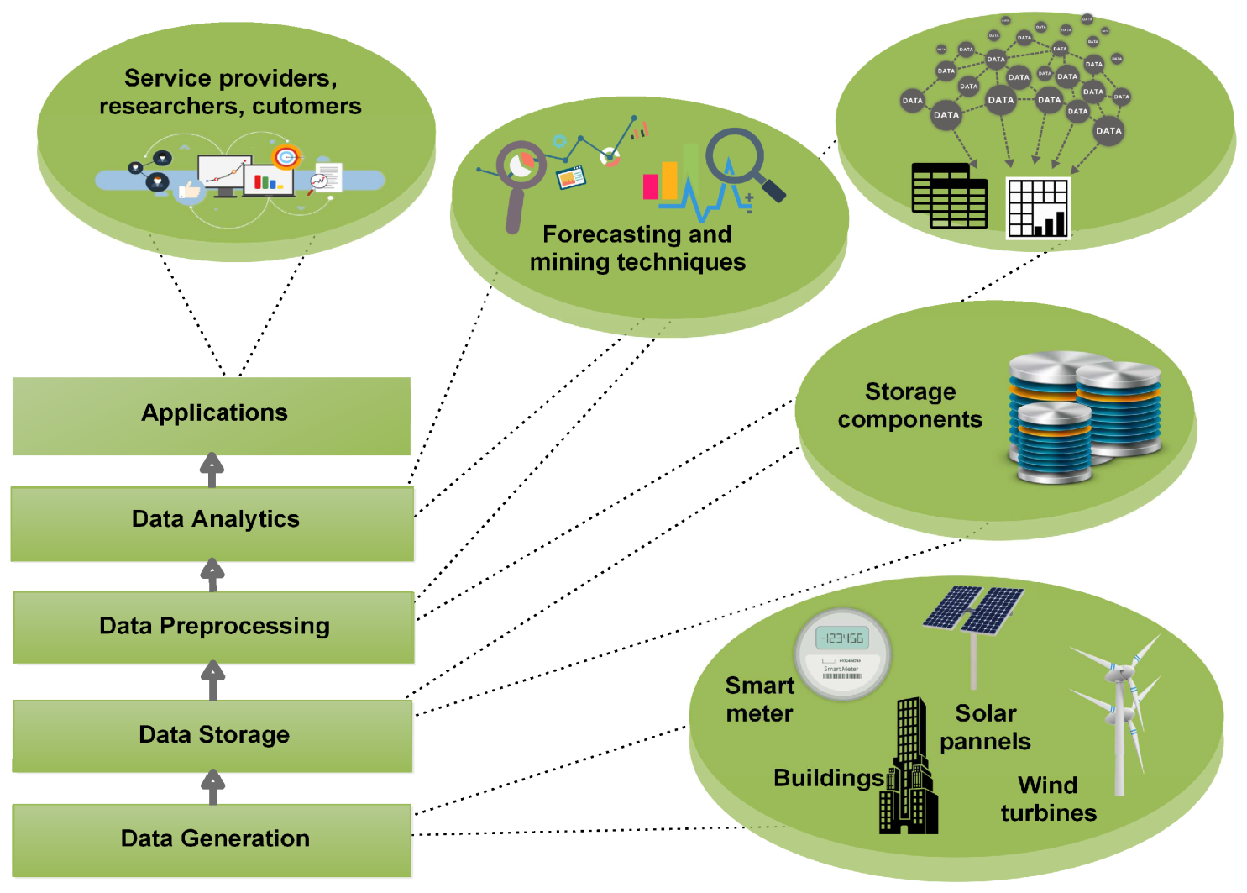

SOFTWARE REQUIREMENTS:

- Operating System : Windows 10
- Platform : DOT NET TECHNOLOGY
- Front End : ASP.Net 4.0
- Back End : SQL SERVER 2014

HARDWARE REQUIREMENTS
- Keyboard
- Mouse
- Hard disk 500GB
- Ram 4 Gb

REFERENCE
- [1] M. S. Kiran, E. ̈Ozceylan, M. G ̈und ̈uz, and T. Paksoy, “Swarm intel-ligence approaches to estimate electricity energy demand in turkey,”Knowl.-Based Syst., vol. 36, pp. 93–103, 2012.
- [2] G. Nalcaci, A. ̈Ozmen, and G. Weber, “Long-term load forecasting:models based on mars, ANN and LR methods,”CEJOR, vol. 27, no. 4,pp. 1033–1049, 2019.
- [3] F. Yerlikaya- ̈Ozkurt, A. Askan, and G. Weber, “A hybrid computationalmethod based on convex optimization for outlier problems: Applicationto earthquake ground motion prediction,”Informatica, Lith. Acad. Sci.,vol. 27, no. 4, pp. 893–910, 2016.
- [4] S. Midya and S. K. Roy, “Analysis of interval programming in differentenvironments and its application to fixed-charge transportation problem,”Discrete Math., Alg. and Appl., vol. 9, no. 3, pp. 1750040:1–1750040:17,2017.
- [5] H. Karau, A. Konwinski, P. Wendell, and M. Zaharia,Learning Spark:Lightning-Fast Big Data Analysis. ” O’Reilly Media, Inc.”, 2015.
- [6] Z. Yu, B. C. Fung, and F. Haghighat, “Extracting knowledge frombuilding-related data. a data mining framework,”Building Simulation,vol. 6, no. 2, pp. 207–222, 2013.
- [7] Z. J. Yu, F. Haghighat, and B. C. Fung, “Advances and challenges inbuilding engineering and data mining applications for energy-efficientcommunities,”Sustainable Cities and Society, vol. 25, pp. 33–38, 2016.
- [8] M. Molina-Solana, M. Ros, M. D. Ruiz, J. G ́omez-Romero, andM. Martin-Bautista, “Data science for building energy management: areview,”Renewable and Sustainable Energy Reviews, vol. 70, pp. 598–609, 2017.
- [9] C. Fan and F. Xiao, “Mining gradual patterns in big building operationaldata for building energy efficiency enhancement,”Energy Procedia,vol. 143, pp. 119–124, 2017.
- [10] T. Ahmad, H. Chen, Y. Guo, and J. Wang, “A comprehensive overviewon the data driven and large scale based approaches for forecasting ofbuilding energy demand: A review,”Energy and Buildings, vol. 165,pp. 301–320, 2018.

