IoT based Fingerprint Voting System

ABSTRACT
Biometric Fingerprint systems are used in the Voting machine for voter confirmation. fingerprint voting machine is designed where there is no need for the user to carry his ID which contains his essential details, so that the controller fetches the data from the fingerprint module and then compares it with already registered fingerprints of the voters. If this data matches then the person is allowed to cast is vote if not then the person is barred from polling his vote. By using push buttons voting will be done, the message regarding polling booth location and serial number information send to mobile numbers before a day of voting by using GSM module.MIT application is used for outside voters this is easier application to build electronic projects. Results are displayed in LCD as well as in think speak IOT platform as a graph according to the applications think speak is open source IOT platform Is used to save and store data. To connect this server esp2866 Wi-Fi module is used.

CHAPTER-1
INTRODUCTION
Voting is the right of each citizen to cast the vote and select their leader. India is a democratic country and each citizen has the right to vote and show their option. People also have the right to change the ruling party in upcoming election by voting for the candidate. Voting is not done to elect the government leaders, but also conducted to elect the leaders in schools, colleges, banks, society, etc.Biometrics is a way used to recognize a person based on his physical nature. The fingerprint, iris, face, voice, etc. are the mainly used biometrics to recognize a person. There are two key functions for biometrics, first is one to one matching and other is one too many matchings. In one to many matching the biometric sample is compared with the already stored samples. In one to one matching, it compares with the previously stored sample. Biometric method results in a faster security, and more convenient method for user verification. Biometric method is better than password security. Fingerprint is unique for each individual so it can be used as a mark of signature, verification and authentication.Fingerprint is the biometric which is used in this project. Finger-print will be different for each individual. In this project, fingerprint is used for the authentication of the user and allows him to cast vote based on his fingerprint image. Finger-print matching can be divided into three types: correlation-based matching, minutiae-based matching, pattern-based (or image-based) matching. In correlation-based matching, two fingerprint images are superimposed and therefore the correlation between corresponding pixels is computed for various alignments. In minutiae-based matching, minutiae from the two fingerprints are extracted and stored in a two-dimensional plane as a set..

Evaluation of Voting Equipment
In the recent years, voting equipment which were widely adopted may be divided into five types.
- Paper-based voting:
The voter gets a blank ballot and use a pen or a marker to indicate he want to vote for which candidate. Hand counted ballots is a time and labor consuming process, but it is easy to manufacture paper ballots and the ballots can be retained for verifying, this type is still the most common way to vote.
2)Lever voting machine:
Lever machine is peculiar equipment, and each lever is assigned for a corresponding candidate. The voter pulls the lever to poll for his favorite candidate. This kind of voting machine can countup the ballots automatically. Because its interface is not user-friendly enough, giving some training to voters is necessary.
3) Direct recording electronic voting machine:
This type, which is abbreviated to DRE, integrates with keyboard, touchscreen, or buttons for the voter press to poll. Some of them lay in voting records and counting the votes is very quickly. But the other DRE without keep voting records are doubted about its accuracy.
4)Punch card:
The voter uses metallic hole-punch to punch a hole on theblank ballot. It can count votes automatically, but if the voter‟s perforation is incomplete, the result is probably determined wrongfully.
5)Optical voting machine:
After each voter fills a circle correspond to their favorite candidate on the blank ballot,this machine selects the darkest mark on each ballot for the vote then computes the total result. This kind of machine counts up ballots rapidly. However, if the voter fills over the circle, it will lead to the error result of optical scan.

CHAPTER 2
2. SYSTEM ANALYSIS
2.1 EXISTING SYSTEM

In the existing system, the election process was preceding like cast the vote by showing the voter ID card at the polling booth and by pressing the button against the party symbol. But in that there is chance of rigging. So, to avoid this we are incorporating the embedded systems into the election system by registering the fingerprints of every voter before election.

2.1.1 DRAWBACKS OF EXISTING SYSTEM
- Many physically challenged people have complained that the touch base screen is not efficient enough to capture the vote accurately. Sometimes it leads to the voter ending up voting for someone else unintentionally.
- Although it takes the time to count votes that were captured using paper ballot but people fully trust the process as high technology are also vulnerable to hackers attack.
- The biggest change with technology is that no matter how much data it records but a single virus can destroy the entire data storage.
- The electronic voting machines which were used during the elections are susceptible to damage which will result in loss of data.
2.2. PROPOSED SYSTEM
In the proposed system, we are incorporating the fingerprint module and by using this system, before election we are going to register the fingerprint of the every voter and at the time of voting one must show his finger at the fingerprint module to cast his vote. Since finger print was unique for every person and there is no chance of rigging and once the fingerprint was matched then only the person can able to cast his vote.

2.2.1. ADVANTAGES OF PROPOSED SYSTEM
- No manual errors
- No false voting
- Need not to remember any password
- Need not to carry any card

CHAPTER 3
SYSTEM DESIGN AND DEVELOPEMENT
3.1 DATA FLOW DIAGRAM

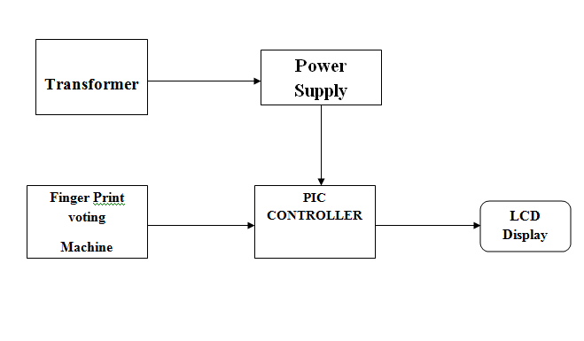

3.2 SYSTEM ARCHICTURE

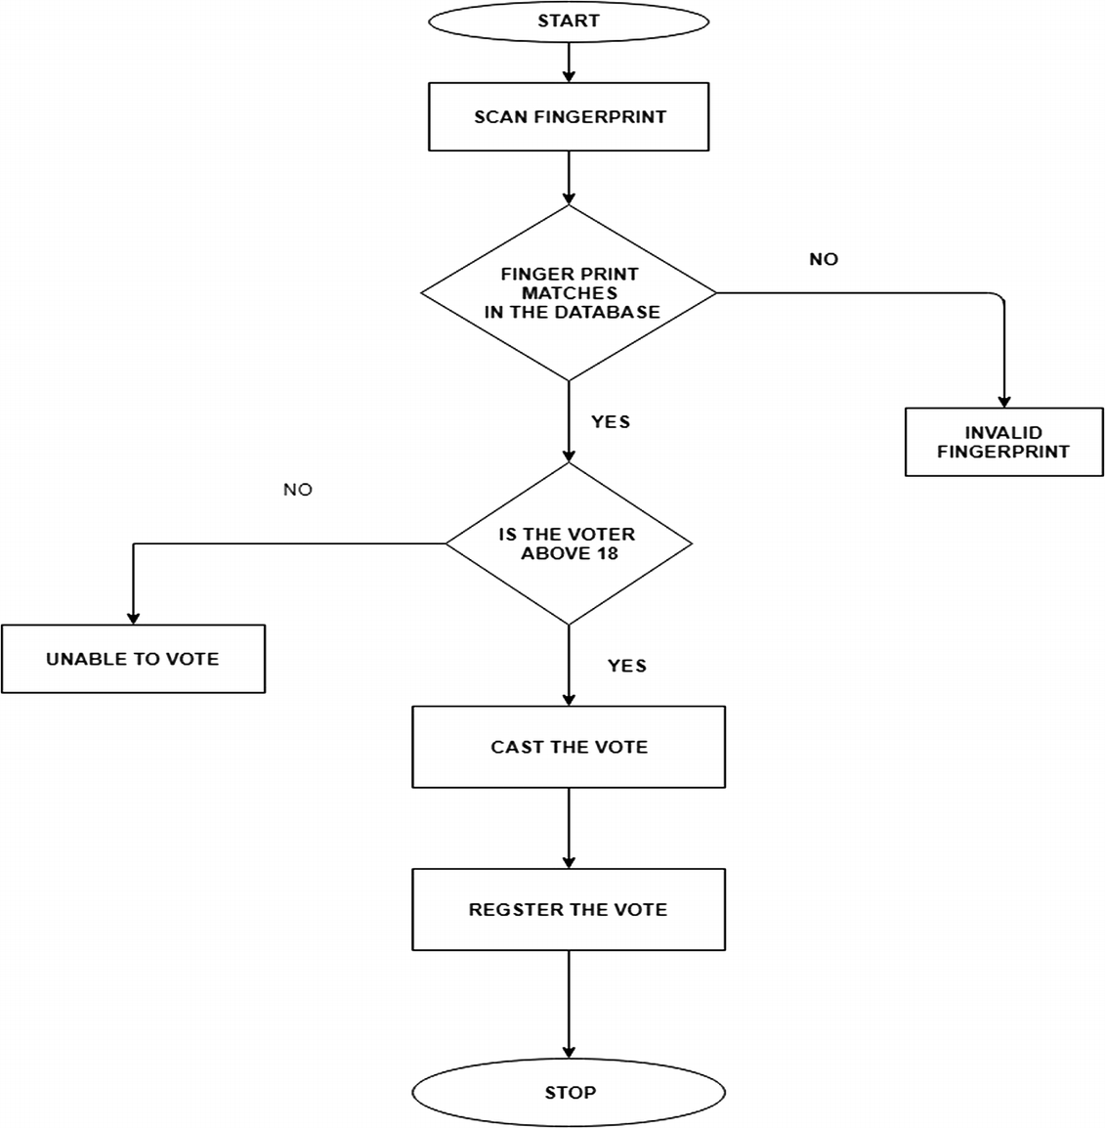

CHAPTER 4
TESTING AND IMPLEMENTATION

  - TESTING
Implementation is the stage of the project when the theoretical design is turned into a working system. This is the final and important phase in the system life cycle It is actually the process of converting the new system into a operational one.

4.1.1Unit Testing
Unit testing comprises the set of tests performed by an individual programmer prior to integration of the unit into a larger system. The module interface is tested to ensure that information properly flows into and out of the program unit. The local data structure is examined to ensure that data stored temporarily maintains its integrity during all steps in an algorithm’s execution. Boundary conditions are tested to ensure that the module operates properly at boundaries established to limit or restrict processing. All independent paths through the control structure are tested. All error-handling paths are tested.

4.1.2 Block Box Testing
Black-box testing is a method of software testing that examines the functionality of an application without peering into its internal structures or workings. This method of test can be applied virtually to every level of software testing: unit, integration, system and acceptance. It is sometimes referred to as specification-based testing.

4.2 SYSTEM IMPLEMENTATION
Implementation is the stage of the project when the theoretical design is turned into a working system. This is the final and important phase in the system life cycle It is actually the process of converting the new system into a operational one.

CHAPTER 5
CONCLUSION
The concept proposed here is a voting system based on IoT. As India is a democratic country, all the citizens have the right to choose a person to lead them. World is becoming completely digitized. As a part of digitization, here voting is also digitized. One of the benefits of this project is that it reduces the time taken to announce the result. Here, the system is made more secure by introducing biometric and aadhar number verification. This system allows one person to vote only once. Multiple voting is not allowed. This system can be used for postal voting also.

CHAPTER-6
REFERENCE

[1] Balaji, Speech of Shri V S Sampath, CEC for Defence Estates Day Lecture 2014.
[2] R. Haenni, E. Dubuis, and U. Ultes-Nitsche,“Research on e-voting technologies.“ .
[3] G.V.L. N. Rao. Democracy at Risk! Citizens for Veri_ability, Transparency & Accountability in Elections, New Delhi,
[4] Election Commission of India.
[5] A. K. Agarwala, D. T. Shahani, and P. V. Indiresan.Report of the expert committee for evaluation of the upgraded electronic voting machine (EVM). Sept.2006.
[6] Wikipedia. Results of the 2009 Indian general election by parliamentary constituency Sanjay Kumar, Manpreet Singh,”DESIGN OF A SECURE ELECTRONIC VOTIN SYSTEM USING FINGERPRINT TECHNIQUE”,.
[7] Press Trust of India.
[8] Timaedeepkaurameja, jasleenkarubassi ,D amanjeet kaur" Implementation of electronic voting machine through FPGA”.
[9] Hari K. Prasad J. Alex haldermanRopGonggrijp "security analysis of India's electronic voting machine,”.

