A Fiber-Wireless Sensor Networks QoS Mechanism for Smart Grid Applications
ABSTRACT
Smart grid applications, such as teleportation, synchrophasors, remote condition monitoring, and control of assets, require timely and reliable data communication systems. Many communication architectures and solutions have been proposed to provide support for these smart grid applications, including ber networks, wireless mobile networks, wireless sensor networks (WSNs), and so on. The use of heterogeneous solutions is an attractive architecture option since it combines the advantages of two or more communication systems to meet the delay and reliability requirements of the smart grid. Fiber-wireless sensor networks (Fi-WSNs) are gaining popularity as a reliable communication infrastructure in many other applications. This is due to the low cost, reliability, availability, the distributed nature of the WSNs, and the high bandwidth and reliability of the optical ber networks. Although the Fi-WSNs systems can provide a good delay performance, they may not meet the requirements of the above smart grid delay-critical applications. In this paper, we propose a novel adaptive and cross-layer service differentiation mechanism for the Fi-WSNs. The proposed mechanism implements an adaptive scheduling mechanism and allows WSNs to cooperate with the optical network unit (ONU) to reduce the delay for high priority trafc. We determine the effects of the proposed mechanism on the quality of service (QoS) of delay critical smart grid monitoring applications in terms of the end-to-end delay and reliability. We show through simulations that our proposed QoS mechanism can reduce the end-to-end delay in the Fi-WSN system and in the long-reach passive optical networks (LR-PONs). We also show that our mechanism can outperform the existing techniques under the same traffic and network conditions.

INTRODUCTION

CHAPTER 1
INTRODUCTION
The conventional electrical power grid is undergoing a massive change. In this conventional power grid, electricity is typically generated through fossil-fuel based power generation units (e.g., nuclear, hydro, and coal based power generation units) and then transmitted it to the consumers via a huge network of transmission lines [1]. Moreover, the ﬂow of electric power is unidirectional i.e., from generation units to the consumers. With the ever-increasing user demand of electricity, old infrastructure, reliability issues, and prominence of renewable energy resources (RERs), the conventional power grid is no longer a viable solution and thus require transformation to a better grid a.k.a., smart grid (SG).
The smart grid environment is characterized by real-time, reliable and secure data communication and control among the power grid assets, including power generation units, transmission systems, distribution systems and consumers [1]. These power grid assets are highly distributed and spread over a wide geographical area. Therefore, the highly distributed nature of these assets calls for the use of heterogeneous communication systems where the advantages of individual systems are combined to support specic applications. To this end, the combination of a highly distributed communication system such as the Wireless Sensors Networks (WSNs) with the high bandwidth optical fiber networks forms the Fiber Wireless Sensor Networks (Fi-WSN) system. Fi-WSNs can provide real-time and reliable control functionality for many smart grid applications [2]. Fi-WSNs are also being considered in health care applications like telemedicine; which involves tele monitoring of patients at a distance [3]. Furthermore, Fi-WSNs are being deployed in transportation for applications like smart parking; which are used to distinguish vehicles from pedestrians [4]. WSNs comprise of low-cost sensor nodes that communicate through wireless links and that are used to monitor different physical conditions in widely dispersed locations. WSNs have lower costs than wired sensors networks because the cost of wiring is eliminated. In addition, WSNs are considered to be more available because sensor nodes can continuously sense and transmit data to a central node, known as the sink [5]. Furthermore, WSNs have a self-healing property where the network can automatically heal itself when interruptions take place, both thanks to redundancy and algorithms that can reconfigure the network. Despite the above features, WSNs have several disadvantages including signal interference by environmental factors, low data rate, low transmission ranges, low power availability and low computational power. Optical fiber networks, on the other hand, have high bandwidth and can transmit data for longer ranges when passive devices are used. The main disadvantages of optical fiber networks for smart grid applications are the limited availability (i.e. coverage), excessive installation costs, inflexibility and can be subjected to cuts and physical interruptions especially in harsh environments (such as substations, power generation and transmission subsystems). Fi-WSNs technology is a promising tool for Neighborhood Area Networks (NANs) or Field Area Networks (FANs) to provide communication, monitoring and control functionality between various smart grid assets. FANs can be used to monitor and control Distributed Generation (DG) systems, Distributed Storage (DS) systems, central generation, transmission lines, substations, etc. While NANs are basically used to build an Advanced Metering Infrastructure (AMI) systems.

Despite the promising features of Fi-WSNs systems, there are several challenges confronting their architecture such as routing and channel assignment, the bandwidth difference between the WSNs and the ber network, optimum Fi-WSNs gateway design and the availability of standards for Fi-WSNs. Routing and channel assignment can be implemented by either the Personal Area Network (PAN) coordinator in the wireless network or a device (Optical Line Terminal (OLT)) in the optical network [6]. Furthermore, routing and channel assignment techniques can be used to provide Quality of Service (QoS) differentiation in these networks. The bandwidth difference and gateway design issues can create a traffic bottleneck at the WSN's gateway, which could lead to data packet losses and overowing buffer [6]. In this paper, we focus on Fi-WSNs systems used in delay-critical FANs, using channel assignment and gateway design to implement our QoS mechanism.
In this paper, we develop and evaluate a novel adaptive and cross-layer QoS mechanism for the Fi-WSNs, namely, Cross Layer WSN-Modified Optical Coding (XWMOC) for delay critical smart grid applications. We do that by implementing two QoS approaches in the WSNs and in the Ethernet Passive Optical Network (EPON). XWMOC implements an adaptive scheduling mechanism and allows WSNs to cooperate with the Optical Network Unit (ONU) to reduce the delay for high priority trafc. We implement the QoS in the WSNs by using a cross-layer interaction between the application and Medium Access Control (MAC) layers to reduce the delay of High Priority (HP) data packets. Furthermore, we implement the QoS in the EPON by introducing a service differentiation to an Optically Coded (OC) ONU using two priority queues. Here, we achieve adaptive scheduling based on the time of data packets arrival to the ONU queue. We also investigate the impact of our proposed mechanism on the Long-Reach Passive Optical Networks (LR-PONs). Furthermore, we present two case studies to compare the XWMOC delays to existing smart grid applications' delay tolerance and also a case study to determine the impact of QoS on delay critical smart grid monitoring applications.

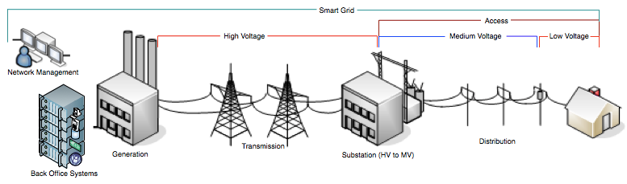

A smart grid is a form of electricity network using digital communication technology. In order to save energy, reduce costs, and increase reliability and transparency, it delivers electricity from suppliers to consumers using two way digital communications [5]. The Smart Grid outside the home touches the whole power grid and related infrastructure, from back office (BO) IT systems used for billing and managing the grid to power generation, transmission and distribution, and eventually the connection to the home, as shown in Fig.
System Architecture:
It defines the smart grid communications architecture framework with its key segments and constituent elements. The figure 2 shows the building blocks of an end-to-end smart grid communications system, including the terminologies used to define the multiple network segments and boundaries for proper interoperability. It also shows SLA (Service Level Agreement) performance metrics compliance at the interface boundaries [7]. It is stated that this segmentation and boundary offers a modular and flexible approach to define interoperable segments, interfaces and elements and ensures that service performance and end-to-end network management is met all the way across multiple interoperable network segments. Each element of the smart grid communications architecture Wide Area Networks (WAN) – It consist of (i) the core network/backbone, (ii) regional and/or Metropolitan Area Network (MAN).

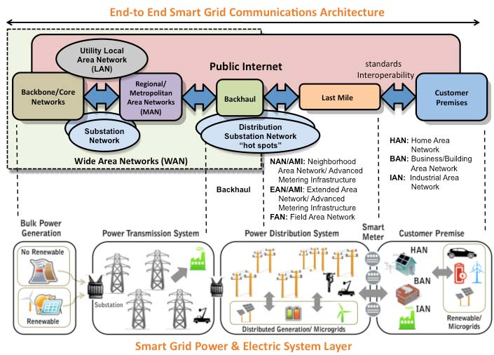

This part includes a hybrid mix of networks including fiber optics, PLC (Power Line Carrier) systems, copperwire line, and several wireless technologies. This WAN is needed to support utility applications for the safe and reliable operation of the electric utility infrastructure, which are SCADA/EMS, protective relaying for high voltage lines, generating plant automation, distribution feeder automation and physical security [8].

Utility Local Area Network (LAN) – To manage operations, control and enterprise processes and services such as billing and automation, meter reading, outage management, demand response, load control, etc, it is comprised of utility operations and enterprise LANs. It interconnects to the WAN through secure wired or wireless communications. It also interconnects to the Internet to exchange customer data to third party providers.
• Backhaul – It is the spur that connects the WAN (major POPs (point-of-presences)) to the last mile network. It aggregates and transport customers’ smart grid telemetry data, substations automation critical parameters data, distribution plant intelligent devices data field information, mobile workforce information from/to the utility head end to/from the last mile network.
Last Mile –The last mile is a two-way wireless or wired communications network overlaid on top of the power distribution system. Depending on the utility network system characteristics, services offered, network topology and demographics and the vendor technology utilized, it is usually named as Neighborhood Area Network (NAN) or Advanced Metering Infrastructure (AMI). The last mile could be an integrated and multipurpose network technology alternative for AMI (smart meters, Demand Response, etc) services, Distribution Automation (IEDs in the field) and substation automation.
Customer Premise – It is comprised of the residential or Home Area Network (HAN), Business/building Area Network (BAN), and Industrial Area Network (IAN). These networks are also connected to the ancillary elements outside the customer premises like the Plug-in Vehicle (PEV), solar/wind energy (microgrids) sources and storage devices. It can also be connected to the public Internet network through a “service provider provided energy management gateways” or Energy Services Interfaces (ESI).
IP-Based Networks :
There is a wide expectation that Internet Protocol (IP) based networks will serve as a key element for the smart grid networks. IP-based networks enable bandwidth sharing among applications and increased reliability with dynamic routing capabilities [3].For some applications that have specific QoS requirements, other technologies, such as MPLS (Multi Protocol Label Switching), may be used for the provisioning of dedicated resources. Figure 3 represents IP communications architecture between the utility enterprise data center (at the head end) and the end Smart Grid devices in ANSI C12.22 standard. This standard provides an application layer standard for network communications, designed to transport data tables in electric metering over any physical medium.

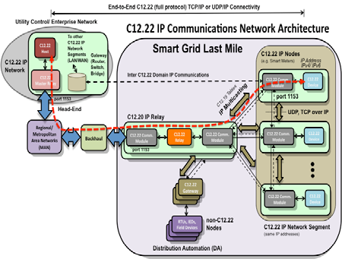

It shows an example of the C12.22 Master Relay connecting to a C12.22 IP Node at the edge of the network. It also shows the multiple network segments (Enterprise Network, MAN/Regional, Backhaul, Last Mile) and C12.22 elements (C12.22 IP Relay) it transverses to connect to the end devices (smart meters and/or DA field devices) and establish the end-to-end IP communications path between them [9]. It points out the QoS provisioning as follows: “Quality of service (QoS) tags can be provided by C12.22, under a configuration parameter, to mark urgent messages, which in turn can be mapped onto IP protocols to enable enhanced levels of message delivery and QoS across an end-to-end Smart Grid IP networking. For instance, the QoS engine could be placed at some point of the last mile network, whenever the Access Points (APs) (C12.22 IP Relay) require more distributed processing intelligence, to differentiate and prioritize Demand Response (DR) signals from meter reading and other non-critical telemetry applications”.

Communication Requirements:
The Smart Grid will generate numerous data points from a variety of system devices and many customers [8]. Those data from meters, appliances, substations, and/or distribution systems need to be integrated and analyzed for the safe and reliable operation of the grid system. Functional information for the operation of the grid system includes load factors, energy usage patterns, equipment condition, and voltage levels. To determine the architecture of communications infrastructure, the timing and data requirements should be collected first [10]. Five main activities are specified as follows:
Data gathering:
Data collection from many sources on the power grid such as sensors, meters, and voltage detection, in the customer premises such as sensors for high-consuming appliances and from external sources such as weather is necessary. The number of devices, the amount of data and frequency of communications with the devices are also necessary to be determined. Acceptable latency and required bandwidth for every type of data should also be considered.
Additional data for analysis or forecasting:
Some additional data transfer for the analysis of the problem, if occurs, for the operation of grid system should be considered. Different data for forecasting, for engineering or other use may be required.
Security requirement and security overhead:
Smart grid is vulnerable to cyber attacks and security is critically important to the safe and efficient operation of the infrastructure systems. The security system imposes an additional traffic on the network and bandwidth consumption for the security overhead should be considered.

Monitoring, management, and action:
In order for the system operators to initiate appropriate actions, accurate information should be sent on the behavior of the grid. The latency on those actions is influenced by the traffic level on the communications network. Many smart grid applications, including distribution automation, outage alarming and load control signaling, require very low latency, while others, such as metering, are more latency-insensitive.
QoS requirements:
The communications infrastructure is necessary to make the smart grid observable, controllable, automated, and integrated. Based on their experiences in working with utilities on smart grid designs and implementations, four trends emerging in the way the smart grid will be built, operated, and controlled are specified as follows .
Shift from centralized to peer-to-peer control:
The existing utility communications infrastructure generally has star networks with centralized command and control. As the smart grid communications will be more decentralized with distributed command and control, this will require peer-to-peer communications.
Shift from centralized generation to distributed energy resources:
As the distributed energy resources such as bio-mass generation, solar panels, and wind turbines grow, we need to integrate large numbers of remote devices from those sites.

Shift from few end points with little intelligence to many end points with large amounts of intelligence:
In the smart grid system, new large volumes of data can be generated by new intelligent end point devices, including devices in the customer premises. This presents a trade-off decision problem in terms of bandwidth and latency versus cost between distributed intelligence and telecommunication network in the design of a smart grid.

these messages come in unpredictable bursts and floods that need to be transmitted and processed with very low latency.
According to Nescient [12], the proposed system architecture shall support a diverse set of QoS classes with wide range of rate, delay, and delay-jitter requirements. NASPInet accommodates five classes of data services for supporting different types of applications as follows:

Class A: supports the needs of high performance feedback control applications. This class of data should have very low latency and a fast data rate. A high level of data availability is required.

Class B: supports the needs of feed-forward control applications, such as state estimator enhancement. This class of data is less strict than for Class A data for latency requirement. High availability of the data is also required.

Class C: supports view-only applications such as visualization by power system operators. This class of data is less stringent than Class B data for the accuracy and latency requirements.

Class D: supports the needs of post-mortem event analysis and other off-line studies. This service class requires a high degree of data completeness and accuracy. However, it is somewhat delay-tolerant.

Class E: primarily supports the needs for testing and R&D applications. This class shall be given the lowest priority of all Nescient data traffic.

The Nescient architecture is supposed to support a set of predefined QoS, and the application services shall be mapped onto these classes for resource management purposes. The proposed system encompasses a set of algorithms for resource monitoring, QoS mapping, admission control, resource reservation, and resource negotiation. The QoS mapping function shall map application level QoS into system level QoS in terms of bandwidth, delay, jitter, CPU demand, and other such items. The admission control function shall determine if an incoming flow can be admitted into the network without QoS degradation of the already admitted flows. Table 1 summarizes the attributes for each of the five data service classes identified above.

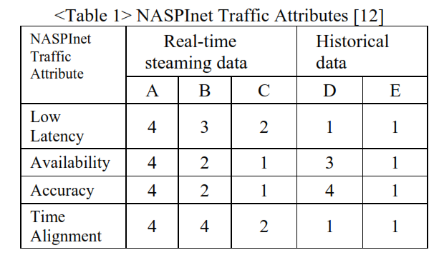
In the Table 1, five classes of data were grouped into two
Groups: real-time streaming data and historical data. Real time streaming data may be real-time control and visualization applications, such as closed-loop voltage control and feed-forward remedial action control. Historical data may be non-real- time applications, such as post-disturbances analysis and off-line studies. The NASPInet shall implement QoS assurance based on the resource management scheme, including resource condition monitoring, resource usage monitoring, QoS performance monitoring, QoS provisioning, and traffic management. The resource condition monitoring is supposed to detect and report any failure and out-of service conditions for any of its resources. The resource usage monitoring information shall include but not limited to detailed loading information (instant, peak, and average) of each resource. The NASPI net is supposed to provide a traffic management mechanism for QoS assurance based on the traffic prioritization of different data service classes. Therefore data delivery based on the priority traffic levels should be supported. Alcatel-Lucent provides the following table listing some of the most important smart grid applications and their qualitative network requirements [13].
NETWORK MODEL
We consider a network G(N ,L), where N and L denote the set of nodes and links, respectively. We assume that all links are bidirectional, composed of two unidirectional links. We refer to undirected links as simply links. We refer to directed links as edges. We denote an undirected link connecting nodes x and y as x–y and the directed link (edge) from x to y as x → y. Let Ψ denote the set of shared risk link group (SRLG) failures. A failure ψ ∈ Ψ is a set of directed links that may fail at the same time. When link x–y fails, we assume that both directed edges x → y and y → x fail. Therefore, for any ψ ∈ Ψ, (x → y ∈ ψ) ⇒ (y → x ∈ ψ)
Some nodes, referred to as monitors, in the network may have the ability to send, receive, and analyze test signals. A monitoring tour, or simply an m-tour, is a directed path that starts and ends at a monitor. If the tour starts and ends at the same monitor, then it is referred to as a closed m-tour, otherwise it is referred to as a open m-tour
The monitoring tour may travel a link in both directions. Let T denote the set of m-tours established in the network. A tour t ∈ T is said to be affected by a failure ψ if the tour traverses any of the edges in ψ. A failure ψ will result in some set of m-tours to fail. The set of tours affected by ψ is referred to as the syndrome for ψ. Thus, our goal is to construct m-tours such that every failure will have a unique syndrome. In other words, every failure may be uniquely localized by observing the set of m-tours that have failed. When employing multiple monitors, every monitor is assumed to broadcast the detected alarms to other monitors or send them to a central location for localization. Our construction will ensure that every edge is part of at least one m-tour. Thus, if none of the m-tours have failed, then none of the links have failed.
In [13], the necessary and sufficient conditions on the properties of monitoring cycles/paths for uniquely localizing SRLG failures are provided. Similarly, in order to uniquely localize failure ψ, (1) it is necessary that at least one m-tour traverses at least one edge in ψ; and (2) for every other failure ψ 0 there exists an m-tour that is affected by ψ and not ψ 0 or vice versa.
Example
Consider the network shown in Figure 2(a), where node 1 is assumed to be the monitor. We construct five tours. T1: 1–2– 1, T2: 1–3–1, T3: 1–4–1, T4: 1–2–3–2–1, and T5: 1–4–3–4–1

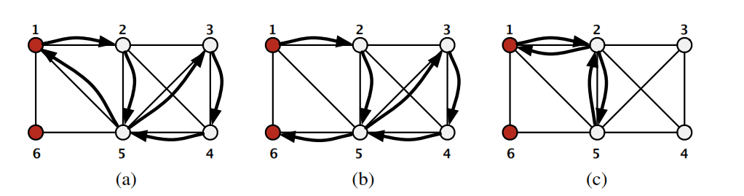
We consider five single link failures and two SRLG failures. Figure 2(b) shows the tours affected by the five single-link and two SRLG failures. Observe that every single-link and SRLG failure results in a unique combination of tours to fail.If we restrict the construction to only monitoring cycles and/or paths, then such an approach would have required at least three monitors to localize the five single-link and two SRLG failures. Monitors at nodes 2 and 4 are necessary as they have degree two and a monitor at node 3 is also necessary as the removal of ψ1 or ψ2 would not allow a monitoring cycle/path to be established between nodes 2 and 4. Thus, the use of monitoring tours helps in significantly reducing the number of monitors required in the network as a tour can traverse .
LOCALIZING WITH ONE MONITOR:
We first derive the necessary and sufficient condition on the network topology to uniquely localize all SRLG failures involving up to k arbitrary link failures
nvolving up to k arbitrary link failures. Note that when only monitoring cycles/paths are employed, it is necessary and sufficient for a network to be (k+ 2)-edgeconnected to uniquely localize all SRLG failures involving up to k links. However, tours may traverse a link in both directions, thus relaxing these necessary and sufficient requirements.
Theorem 1. In order to uniquely localize any SRLG failure involving up to k arbitrary links with only one monitor and m-tours, it is sufficient that the network is k-edge-connected.
Proof. Consider a k-edge-connected network. Since the network is connected, we can construct an m-tour traversing any link. Assume two failures ψ1 and ψ2 that have the same syndrome. Our goal is to construct an m-tour that is affected by ψ1 and not by ψ2 or vice versa.
First, let us consider the case that ψ1 ⊂ ψ2. Since ψ1 is a proper subset of ψ2, (1) the maximum number of links in ψ1 is k−1; and (2) ψ2 has at least one link in it that is not in ψ1. As the network is assumed to be k edge connected, removal of all the links in ψ1 will not disconnect the graph. Moreover, the graph obtained by removing all the links in ψ1 contains at least one link in ψ2. Thus, we compute a tour traversing the monitor and the link unique to ψ2 in the residual graph. This tour will be affected by ψ2 and not by ψ1. Now, let us consider the case that neither ψ1 is a subset of ψ2 nor ψ2 is a subset of ψ1. Therefore, the maximum number of links that can common to both ψ1 and ψ2 is k−1. Consider the graph obtained by removing the links that are common to ψ1 and ψ2. The residual graph is connected, as the original network is k edge connected and we have have removed at most k−1 links. From this residual graph, consider the removal of links that are unique to ψ1. The resultant graph has at most two components2 .
We denote the component that contains the monitor by Cm and the other component (if present) as C 0 m. We have two cases: (1) Some link in ψ2 \ ψ1 is present in Cm; or (2) No link that is unique to ψ2 is present in Cm. For the first case, we may simply compute a tour traversing the monitor and the link unique to ψ2. Such a tour will be affected by ψ2 and not by ψ1. If no link unique to ψ2 is contained in Cm, we simply consider the component Cm along with the links unique to ψ1. This augmented component still remains connected, contains links in ψ1 that are not in ψ2, and does not contain any link in ψ2. In this augmented component, we compute a tour that traverses the monitor and a link unique to ψ1. Such a tour is affected by ψ1 and not by ψ2.
uniquely localizing any SLRG failure involving up to k links, it is not necessary. Consider the example network shown in Figure 2(a). Even though the network is only two-edgeconnected, all SRLG failures involving up to three links may be uniquely localized with only one monitor and m-tours. Although the necessary condition on the network topology may not be elegantly stated in terms of the given network, however the same may be done on a transformation of the original graph, referred to as link graph a link in both directions.
Network Tomography & Compressed Sensing over Graphs:
For a given network, identification of congested links from end-to-end path measurements is one of the key problems in network tomography [9], [8]. In many settings of today’s IP networks, there is one or a few links along the path which cause the packet losses in the path. Finding the locations of such congested links is sufficient for most of the practical applications.
This problem can be understood as a graph-constrained group testing as follows. We model the network as a graph G = (V, E) where the set V denotes the network routers/hosts and the set E denotes the communication links (see Fig. 1). Suppose, we have a monitoring system that consists of one or more end hosts (so called vantage points) that can send and receive packets. Each vantage point sends packets through the network by assigning the routes and the end hosts.
All measurement results (i.e., whether each packet has reached its destination) will be reported to a central server whose responsibility is to identify the congested links. Since the network is given, not any route is a valid one. A vantage point can only assign those routes which form a path in the graph G. The question of interest is to determine the number of measurements that is needed in order to identify the congested links in a given network.
We primarily deal with Boolean operations on binary valued variables in this paper, namely, link states are binary valued and the measurements are Boolean operations on the link states. Nevertheless, the techniques described here can be extended to include non-Boolean operations and non-binary variables as well. Specifically, suppose there are a sparse set of links that take on non-zero values. These non-zero values could correspond to packet delays, and packet loss probabilities along each link. Measurements along each path provide aggregate delay or aggregate loss along the path. The set of paths generated by m random walks forms a m × |E| routing matrix M. For an appropriate choice of m and graphs studied in this paper, it turns out (see [12]) that such routing matrices belongs to the class of so called expander matrices. These expander type properties in turn obey a suitable type of restricted-isometry-property (1-RIP) [13]. Such properties in turn are sufficient for recovering sparse vectors using `1 optimization techniques. Consequently, the results of this paper have implications for compressed sensing on graphs.

Sensor Networks:

