WEAKLY SUPERVISED DEEP LEARNING FOR CUSTOMER REVIEW SENTIMENT ANALYSIS

ABSTRACT
In recent times the concept of smart cities have gained grate popularity. The ever increasing population has led to chaotic city traffic. As a result of the process of searching a parking lot becomes tedious. It is time consuming task leading to discomfort. The fuel consumption is on an increasing side due to such scenarios. The increase in vehicular traffic creates a negative impact on the environment. In the wake of smart city times these issues lead us to the need of a ‘smart’ solution. In order to resolve these issues and satisfy the increasing demand for the parking areas, parking management organizations are trying to implement better and technologically advanced solutions. A smart car parking application will enable real time parking availability monitoring and reservation thereby providing better services to the end users as well as reduce the workload of the parking administrator. A mobile application is also provided that allows an end user to check the availability of parking space and book a parking slot accordingly. The project also describes a high –level view of the system architecture.

CHAPTER 2
2. SYSTEM ANALYSIS
  - EXISTING SYSTEM

- Lexicon-based methods typically take the tack of first constructing a sentiment lexicon of opinion words e.g. “wonderful”, “disgusting”.
- Furthermore, lexicon-based methods cannot well handle implicit opinions.
- Objective statements such as “I bought the mattress a week ago, and a valley appeared today”. As pointed out in this is also an important form of opinions.
- Factual information is usually more helpful than subjective feelings.
- Lexicon-based methods can only deal with implicit opinions in an ad-hoc way.
2.1.1 DRAWBACKS OF EXISTING SYSTEM :
- Feature engineering also costs a lot of human efforts, and a feature set suitable for one domain may not generate good performance for other domains.
- This kind of algorithm needs complex lexicon construction and rule design.
- The existing systems cannot well handle objective statements; it only handles single word based sentiment analysis.
2.2. PROPOSED SYSTEM
- A novel deep learning framework for review sentence sentiment classification is proposed.
- The framework treats review ratings as weak labels to train deep neural networks.
- For example, with 5-stars scale ,we can deem ratings above 3-stars as positive and below 3-star as negative weak labels.
- The framework generally consists of two steps. In the first step, rather than predicting sentiment labels directly, we try to learn a Learning space.
2.2.1. ADVANTAGES OF PROPOSED SYSTEM
- The Proposed work leverages the vast amount of weakly labeled review sentences for sentiment analysis.
- It is much more effective than the previously developed works.
- The proposed work finds the sentiment not only based on the rating that user gives but also taking into consideration of reviews that they are post.
- In fact it mainly takes an account of review, even though user gave ratings.
2.3 FEASIBILITY STUDY
The feasibility Analysis is an analytical program through project manager determines the project success ratio and through feasibility study project manager able to see either project. The key considerations involved in the feasibility analysis are:
- Economic Feasibility
- Technical Feasibility
- Operational Feasibility
- Environmental Feasibility
2.3.1 ECONOMICAL FEASIBILITY
Hence this project is economically feasible there is no need to involve any cost for this project.
2.3.2 TECHNICAL FEASIBILITY
Software Technologies used are PHP and MySql. In the educational institutions, it is possible to update the system in future. No special hardware is required for the purpose of using this system. Hence it is declared that this project is technically feasible.
2.3.3 OPERATIONAL FEASIBILITY
As the admin work mainly to maintain the Patient and Doctor .Doctor will predict patient cancer disease. Hence it is easy to operate with training. Therefore it is operationally feasible for implementation.
2.3.4 ENVIRONMENTAL FEASIBILITY
This project environment is correct as a admin has developed this system and no expenditure is involved under any head and this process is part of admin document management, this project environment is accessible.
2.4 SYSTEM REQUIREMENTS
- System : Pentium IV 2.4 GHz.
- Hard Disk : 40 GB.
- Monitor : 15 inch VGA Color.
- Mouse : Logitech Mouse.
- Ram : 512 MB
- Keyboard : Standard Keyboard

2.4.1 HARDWARE REQUIREMENTS
The Hardware of the computer consists of physical component such as Input Devices, Storage Devices, Processing & Control units and Output Devices. Computer includes external storage unit to store data in programs.
The Hardware Configuration involved in this project
- System : Pentium IV 2.4 GHz.
- Hard Disk : 40 GB.
- Monitor : 15 inch VGA Color.
- Mouse : Logitech Mouse.
- Ram : 512 MB
- Keyboard : Standard Keyboard

2.4.2 SOFTWARE REQUIREMENTS
Software is a group of programs that computers need to do a particular task. It is an essential requirement of Computer System. The Software used to develop the project is
- Operating System : Windows XP.
- Platform : DOT NET TECHNOLOGY
- Front End : ASP.Net 3.5
- Back End : SQL SERVER 2005

CHAPTER 3
SYSTEM DESIGN AND DEVELOPEMENT
SYSTEM ARCHICTURE

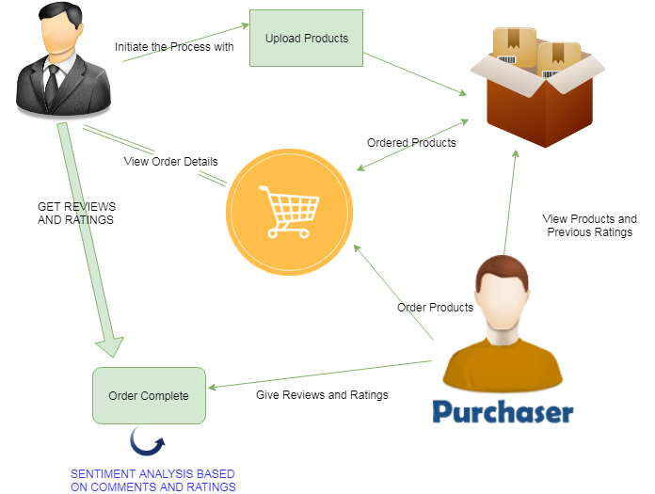

CHAPTER 4
TESTING AND IMPLEMENTATION

  - TESTING
Implementation is the stage of the project when the theoretical design is turned into a working system. This is the final and important phase in the system life cycle It is actually the process of converting the new system into a operational one.

4.1.1Unit Testing
Unit testing comprises the set of tests performed by an individual programmer prior to integration of the unit into a larger system. The module interface is tested to ensure that information properly flows into and out of the program unit. The local data structure is examined to ensure that data stored temporarily maintains its integrity during all steps in an algorithm’s execution. Boundary conditions are tested to ensure that the module operates properly at boundaries established to limit or restrict processing. All independent paths through the control structure are tested. All error-handling paths are tested.

4.1.2 Block Box Testing
Black-box testing is a method of software testing that examines the functionality of an application without peering into its internal structures or workings. This method of test can be applied virtually to every level of software testing: unit, integration, system and acceptance. It is sometimes referred to as specification-based testing.

4.2 SYSTEM IMPLEMENTATION
Implementation is the stage of the project when the theoretical design is turned into a working system. This is the final and important phase in the system life cycle It is actually the process of converting the new system into a operational one.

CHAPTER 5
CONCLUSION:
In this paper, a recommendation model is proposed by mining sentiment information from social user’s reviews. We fuse user sentiment similarity, interpersonal sentiment influence, and item reputation similarity into a unified matrix factorization framework to achieve the sentiment classification task. In particular, we use social users’ sentiment to denote user preferences. Besides, we build a new relationship named interpersonal sentiment influence between the user and friends, which reflect show users’ friends influence users in a sentimental angle. What is more, as long as we obtain user’s textual reviews, we can quantitively measure user’s sentiment, and we leverage items’ sentiment distribution among users to infer item’s reputation. The experiment results demonstrate that the three sentimental factors make great contributions to the sentiment classification. Also, it shows significant improvements over existing approaches on a real-world dataset.

CHAPTER-6
REFERENCE
- [1] R. Salakhutdinov, and A. Mnih, “Probabilistic matrix factorization,” in NIPS, 2008.
- [2] X. Yang, H. Steck, and Y. Liu, “Circle-based recommendation in online social networks, ” in Proc. 18th ACM SIGKDD Int. Conf. KDD, New York, NY, USA, Aug. 2012, pp. 1267–1275.
- [3] M. Jiang, P. Cui, R. Liu, Q. Yang, F. Wang, W. Zhu, and S. Yang, “Social contextual recommendation,” in proc. 21st ACM Int. CIKM, 2012, pp. 45-54.
- [4] M. Jamali and M. Ester, “A matrix factorization technique with trust propagation for recommendation in social networks,” in Proc. ACM conf. RecSys, Barcelona, Spain. 2010, pp. 135-142.
- [5] Z. Fu, X. Sun, Q. Liu, et al., “Achieving Efficient Cloud Search Services: Multi-Keyword Ranked Search over Encrypted Cloud Data Supporting Parallel Computing,” IEICE Transactions on Communications, 2015, 98(1):190-200.
- [6] G. Ganu, N. Elhadad, A Marian, “Beyond the stars: Improving sentiment classifications using Review text content,” in 12th International Workshop on the Web and Databases (WebDB 2009). pp. 1-6.
- [7] J. Xu, X. Zheng, W. Ding, “Personalized recommendation based on reviews and ratings alleviating the sparsity problem of collaborative filtering,” IEEE International Conference on e-business Engineering. 2012, pp. 9-16.
- [8] X. Qian, H. Feng, G. Zhao, and T. Mei, “Personalized recommendation combining user interest and social circle,” IEEE Trans. Knowledge and data engineering. 2014,pp. 1763-1777.
- [9] H. Feng, and X. Qian, “Recommendation via user’s personality and social contextual,” in Proc. 22nd ACM international conference on information & knowledge management. 2013, pp. 1521-1524.
- [10] Z. Fu, K. Ren, J. Shu, et al., “Enabling Personalized Search over Encrypted Outsourced Data with Efficiency Improvement,” IEEE Transactions on Parallel & Distributed Systems, 2015:1-1.

