TOWARDS END-TO-END LANE DETECTION: AN INSTANCE SEGMENTATION APPROACH

ABSTRACT- Present day vehicles are joining an expanding number of driver help highlights, among which programmed path keeping. The last option permits the vehicle to appropriately situate itself inside the street paths, which is additionally vital for any ensuing path takeoff or direction arranging choice in completely independent vehicles. Customary path discovery strategies depend on a mix of exceptionally specific, hand-made highlights what's more heuristics, ordinarily followed by post-handling procedures, that are computationally costly and inclined to versatility because of street scene varieties. Later methodologies influence profound learning models, prepared for pixel-wise path division, in any event, when no markings are available in the picture due to their enormous responsive field. Regardless of their benefits, these techniques are restricted to identifying a pre-characterized, fixed number of paths, for example inner self paths, and can not adapt to path changes. In this paper, we go past the previously mentioned constraints and propose to project the path discovery issue as an occurrence division issue - in which every path shapes its own case - that can be prepared start to finish. To parametrize the sectioned path occurrences prior to fitting the path, we further propose to apply a learned point of view change, adapted on the picture, rather than a fixed "higher perspective" change. Thusly, we guarantee a path fitting which is powerful against street plane changes, dissimilar to existing methodologies that depend on a fixed, predefined change. In synopsis, we propose a fast track location calculation, running at 50 fps, which can deal with a variable number of paths and adapt to path changes. We check our strategy on the tuSimple dataset and accomplish cutthroat outcomes.

1. INTRODUCTION

Completely independent vehicles are the fundamental focal point of PC vision and advanced mechanics research these days, both at an intellectual and modern level. The objective for each situation is to show up at a full comprehension of the climate around the vehicle using different sensors and control modules. Camera-based path discovery is a significant stage towards such natural discernment as it permits the vehicle to appropriately situate itself inside the street paths. It is likewise significant for any resulting path takeoff or direction arranging choice. All things considered, performing exact camera-based path identification progressively is a key empowering agent of completely independent driving. Conventional path location techniques depend on a mix of profoundly specific, carefully assembled highlights and heuristics to recognize path sections. Well known decisions of such hand-created signs incorporate shading based highlights, the construction tensor, the bar channel, edge highlights, and so forth, which are conceivably joined with a hough change and molecule or Kalman channels. Subsequent to recognizing the path sections, post-handling procedures are utilized to sift through misdetections and gather portions to frame the last paths. For an itemized outline of path recognition frameworks we allude the per user to. As a rule, these conventional methodologies are inclined to heartiness issues because of street scene varieties that can not be quickly demonstrated by such model-based frameworks.
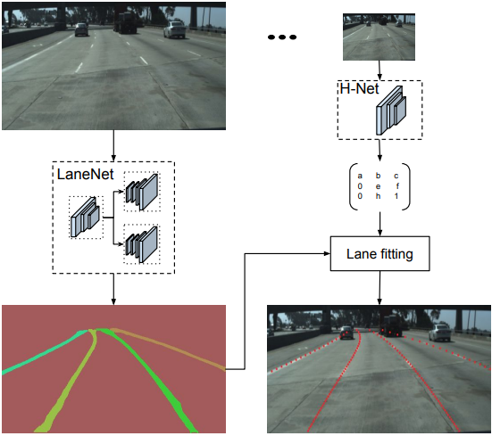
Later techniques have supplanted the hand-made highlight finders with profound organizations to learn thick expectations, for example pixel-wise path divisions. Gopalan et al. utilize a pixel-pecking order include descriptor to demonstrate context oriented data and a supporting calculation to choose applicable context oriented highlights for distinguishing path markings. Along these lines, Kim and Lee consolidate a Convolutional Neural Network (CNN) with the RANSAC calculation to distinguish paths beginning from edge pictures. Note that in their technique the CNN is mostly utilized for picture improvement and provided that the street scene is complicated, for example it incorporates side of the road trees, wall, or on the other hand convergences. Huval et al. show how existing CNN models can be utilized for thruway driving applications, among which a start to finish CNN that performs path location and characterization. He et al. present the Dual-View CNN (DVCNN) that utilizes a front-view and a top-view picture all the while to prohibit misleading discoveries and eliminate non club-molded structures individually. Li et al. propose the utilization of a perform various tasks profound convolutional network that spotlights on observing mathematical path ascribes, like area and direction, along with a Recurrent Neural Network (RNN) that distinguishes the paths. Most as of late, Lee et al. show how a perform various tasks organization can mutually deal with path and street stamping discovery and acknowledgment under unfriendly climate and low enlightenment conditions. Aside from the capacity of the previously mentioned organizations to fragment out path markings better, their huge responsive field permits them to likewise gauge paths even in situations when no markings are available in the picture. At a last stage, notwithstanding, the created parallel path divisions actually should be unraveled into the different path occasions.

3.PROBLEM STATEMENT :

In this paper, we go past the previously mentioned restrictions and propose to project the path identification issue as an occurrence division issue, in which every path frames its own case inside the path class. By parting the path discovery issue into the previously mentioned two undertakings, we can completely use the force of the path division branch without it appointing various classes to various paths. Thusly, we reduce the issue of path changes and we can deal with a variable number of paths, dissimilar to. Specifically, the neural organization takes as information the picture furthermore is advanced with a misfortune work that is custom-made to the path fitting issue. An expanded, perform multiple tasks design to project the path discovery issue as a case division task, that handles path changes and permits the induction of an inconsistent number of paths.

4. LITERATURE REVIEW

M. Aly,
“Real time Detection of Lane Markers in Urban Streets”
We can dispose of the point of view impact in the picture, thus paths that seem to meet at the skyline line are currently vertical and equal.

Sachin Sharma and Dr. D. J. Shah
“A Much Advanced and Efficient Lane Detection Algorithm for Intelligent Highway Safety”
Many methodologies have been applied to path discovery, which can be named either highlight based or model based.

M. Bai, R. Urtasun,
“Deep watershed transform for instance segmentation”
A critical restriction of the watershed change is its affinity to over-portion the picture.

A. Bar-Hillel, R. Lerner, D. Levi, G. Raz,
“Recent progress in road and lane detection: a survey”
Street tone and surface, street limits, and path markings are the super perceptual signals for human driving.

5.SYSTEM ARCHITECTURE :

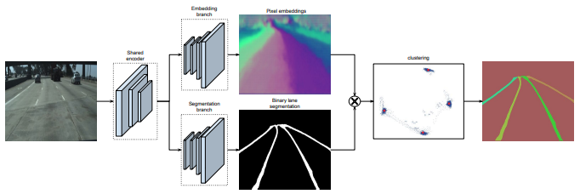
6.EXISTING SYSTEM

The CNN models low complexity nearby examples with two separate heads, the first predicts the presence of central issues, and the second refines the area of central issues in the neighborhood reach and connects central issues of a similar path line. Most existing strategies embrace all around concentrated on systems, for example, semantic division and article discovery to parse path markers and change the organization yield into parametric bends through post-handling. The heatmap yielded by the primary head communicates the likelihood that key point shows up, which settle the presence of nearby bends. A particular element map was anticipated to demonstrate the place of a path marker on each line.

7.DISADVANTAGE OF EXISTING SYSTEM:
In this paper, we go past the previously mentioned restrictions and propose to project the path discovery issue as an example division issue, in which every path frames its own case inside the path class. Specifically, the neural organization takes as info the picture and is upgraded with a misfortune work that is customized to the path fitting issue. A stretched, perform various tasks engineering to project the path recognition issue as a case division task, that handles path changes and permits the induction of an erratic number of paths. We train a neural organization start to finish for path location, such that adapts to the previously mentioned issue of path turning as well as the impediments on the quantity of paths.

8. PROPOSED METHODOLOGY
In this work, we propose CondLaneNet, an original top-to-down path recognition structure that recognizes the path cases first and afterward progressively predicts the line shape for each example. We have significantly worked on the capacity of path instancelevel separation by the proposed contingent path identification system and column insightful detailing. To beat this issue, anchor-based strategies and line astute discovery techniques were proposed. CurveLanes is an as of late proposed benchmark with instances of perplexing geographies, for example, fork lines and thick lines. In view of the neighborhood data, two disentangling calculations with various inclinations are proposed to foresee worldwide math of path markers.

ADVANTAGE:
To increment execution, both as far as speed and precision, these two sections are mutually prepared in a perform multiple tasks organization. To expand the nature of the fit while holding computational productivity, it is normal to change over the picture into a "10,000 foot perspective" utilizing a point of view change and play out the bend fitting there. To cure what is going on we likewise apply a point of view change onto the picture prior to fitting a bend, yet as opposed to existing techniques that depend on a decent change framework for doing the viewpoint change, we train a neural organization to yield the change coefficients. An inborn benefit of the proposed technique is that the path fitting is strong against street plane changes and is explicitly advanced for better fitting the paths.

CONCLUSION :

In this paper we have introduced a technique for end-toend path discovery at 50 fps. Motivated by ongoing occurrence division procedures, our technique can identify a variable number of paths and can adapt to path change moves, as opposed to other related profound learning draws near. To parametrize the fragmented paths utilizing low request polynomials, we have prepared an organization to create the boundaries of a viewpoint change, molded on the picture, in which path fitting is ideal. This organization is prepared involving a custom misfortune work for path fitting. Dissimilar to the famous "higher perspective" approach, our strategy is hearty against ground-plane's incline changes, by adjusting the boundaries for the change likewise. Affirmation: The work was upheld by Toyota, and was done at the TRACE Lab at KU Leuven (Toyota Research on Automated Cars in Europe - Leuven).

REFERENCES

[1] M. Aly, Real time Detection of Lane Markers in Urban Streets. Intelligent Vehicles Symposium, pp. 7-12, 2008.

[2] M. Bai, R. Urtasun, Deep watershed transform for instance segmentation. CoRR abs/1611.08303, 2016.

[3] A. Bar-Hillel, R. Lerner, D. Levi, G. Raz, Recent progress in road and lane detection: a survey. Mach. Vis. Appl., vol. 25, no. 3, pp. 727-745, 2014.

[4] A. Borkar, M. Hayes, M. T. Smith, A Novel Lane Detection System With Efficient Ground Truth Generation. IEEE Trans. Intelligent Transportation Systems, vol. 13, no. 1, pp. 365-374, 2012.

[5] B. De Brabandere, D. Neven, L. Van Gool. CoRR abs/1708.02551, 2017.

[6] L. Chen, G. Papandreou, I. Kokkinos, K. Murphy, A. Yuille, Deeplab: Semantic image segmentation with deep convolutional nets, atrous convolution, and fully connected crfs. CoRR abs/1606.00915, 2016.

[7] K.-Y. Chiu, S.-F. Lin, Lane detection using color-based segmentation. Intelligent Vehicles Symposium, pp. 706-711, 2005.

[8] R. Danescu, S. Nedevschi, Probabilistic Lane Tracking in Difficult Road Scenarios Using Stereovision. IEEE Trans. Intelligent Transportation Systems, vol. 10, no. 2, pp. 272-282, 2009.

[9] H. Deusch, J. Wiest, S. Reuter, M. Szczot, M. Konrad, K. Dietmayer, A random finite set approach to multiple lane detection. ITSC, pp. 270-275, 2012.

[10] C. Gackstatter, P. Heinemann, S. Thomas, G. Klinker, Stable road lane model based on clothoids. Advanced Microsystems for Automotive Applications, pp. 133-143, 2010.

