Seizure detection using wearable sensors and machine learning: Setting a benchmark

ABSTRACT
Tracking seizures is crucial for epilepsy monitoring and treatment evaluation. Current epilepsy care relies on caretaker seizure diaries, but clinical seizure monitoring may miss seizures. Wearable devices may be better tolerated and more suitable for long-term ambulatory monitoring. This study evaluates the seizure detection performance of custom-developed machine learning (ML) algorithms across a broad spectrum of epileptic seizures utilizing wrist-and ankle-worn multisignal biosensors. The sensor recorded body temperature, electrodermal activity, accelerometry (ACC), and photoplethysmography, which provides blood volume pulse (BVP). We used electroencephalographic seizure onset and offset as determined by a board-certified epileptologist as a standard comparison.Automatic seizure detection using ML from multimodal wearable sensor data is feasible across a broad spectrum of epileptic seizures.

CHAPTER 2
2. SYSTEM ANALYSIS
  - EXISTING SYSTEM

- Epilepsy manifests through seizures which occurs uncontrollably. Several types of seizures exist based on semiology, symptomatic experience and electrophysiological signatures.
- Many challenges exist in designing a reliable system for forecasting seizures from noninvasively recorded data. Training, testing, and validating a forecasting algorithm requires ultra-long duration recordings with an adequate number of seizures.
- Self-reported seizure diaries are the most accessible validation, but the poor reliability of such diaries is widely recognized.
2.1.1 DRAWBACKS OF EXISTING SYSTEM :
- To demonstrate the impact of introducing self-awareness in wearable technologies, we consider the epileptic seizure detection problem, as a case study.
- A machine learning algorithm, which is particularly selected and trained for the target problem, is used to extract the model and detect possible bio-medical abnormalities or pathologies.
- We investigate if this self-aware technique has any negative impact in terms of classification and seizure detection performance.
2.2. PROPOSED SYSTEM
- We propose a new generation of self-aware wearable systems to cope with the stringout energy constraints of these bio-medical systems, while at the same time enhancing the detection quality they provide.
- In particular, to reduce the energy without sacrificing quality of detection, we propose a two-mode classifier.
- We also observe that while this approach improves both sensitivity and specificity, the latter changes more significantly, which indicates that the true positive is increased significantly due to our proposed model refinement.
2.2.1. ADVANTAGES OF PROPOSED SYSTEM
- The main challenge in wearable systems is to increase the battery lifetime, while maintaining the machine-learning performance of the system.
- Self-awareness is perhaps the key to design intelligent systems that can continuously monitor their own performance, adapt to changes, and improve autonomously.
- The high performance of SVM in terms of the accuracy of detecting seizures, SVM is also suitable to be implemented on resource-constrained embedded systems.

Literature Survey:
TITLE | AUTHORS | DESCRIPTION
The epidemiology of epilepsy | Beghi E. | While all people with epilepsy experience seizures, not all individuals with seizures have epilepsy.
Diagnostic challenges in epilepsy: seizure under-reporting and seizure detection | Elger CE, Hoppe C. | As therapeutic interventions focus on reduction or elimination of seizures, the accurate documentation of seizure occurrence is essential.
Epilepsy: accuracy of patient seizure counts. | Hoppe C, Poepel A, Elger CE. | Patients Consecutive sample of 91 adult inpatients with focal epilepsies undergoing video-electro encephalographic monitoring.
Wearable seizure detection devices in refractory epilepsy | Verdru J, Van Paesschen W. | This article provides an up-to-date overview and comparison between wearable seizure detection devices (WSDDs), taking into account the newly proposed standards for testing and clinical validation of devices.

2.3 FEASIBILITY STUDY
The feasibility Analysis is an analytical program through project manager determines the project success ratio and through feasibility study project manager able to see either project. The key considerations involved in the feasibility analysis are:
- Economic Feasibility
- Technical Feasibility
- Operational Feasibility
- Environmental Feasibility
2.3.1 ECONOMICAL FEASIBILITY
Hence this project is economically feasible there is no need to involve any cost for this project.
2.3.2 TECHNICAL FEASIBILITY
Software Technologies used are PHP and MySql. In the educational institutions, it is possible to update the system in future. No special hardware is required for the purpose of using this system. Hence it is declared that this project is technically feasible.
2.3.3 OPERATIONAL FEASIBILITY
As the admin work mainly to maintain the Patient and Doctor .Doctor will predict patient cancer disease. Hence it is easy to operate with training. Therefore it is operationally feasible for implementation.

2.3.4 ENVIRONMENTAL FEASIBILITY
This project environment is correct as a admin has developed this system and no expenditure is involved under any head and this process is part of admin document management, this project environment is accessible.
2.4 SYSTEM REQUIREMENTS
- System : Pentium IV 2.4 GHz.
- Hard Disk : 40 GB.
- Monitor : 15 inch VGA Color.
- Mouse : Logitech Mouse.
- Ram : 512 MB
- Keyboard : Standard Keyboard

2.4.1 HARDWARE REQUIREMENTS
The Hardware of the computer consists of physical component such as Input Devices, Storage Devices, Processing & Control units and Output Devices. Computer includes external storage unit to store data in programs.
The Hardware Configuration involved in this project
- System : Pentium IV 2.4 GHz.
- Hard Disk : 40 GB.
- Monitor : 15 inch VGA Color.
- Mouse : Logitech Mouse.
- Ram : 512 MB
- Keyboard : Standard Keyboard

2.4.2 SOFTWARE REQUIREMENTS
Software is a group of programs that computers need to do a particular task. It is an essential requirement of Computer System. The Software used to develop the project is
- Operating System : Windows XP.
- Platform : DOT NET TECHNOLOGY
- Front End : ASP.Net 3.5
- Back End : SQL SERVER 2005

CHAPTER 3
SYSTEM DESIGN AND DEVELOPEMENT
SYSTEM ARCHICTURE

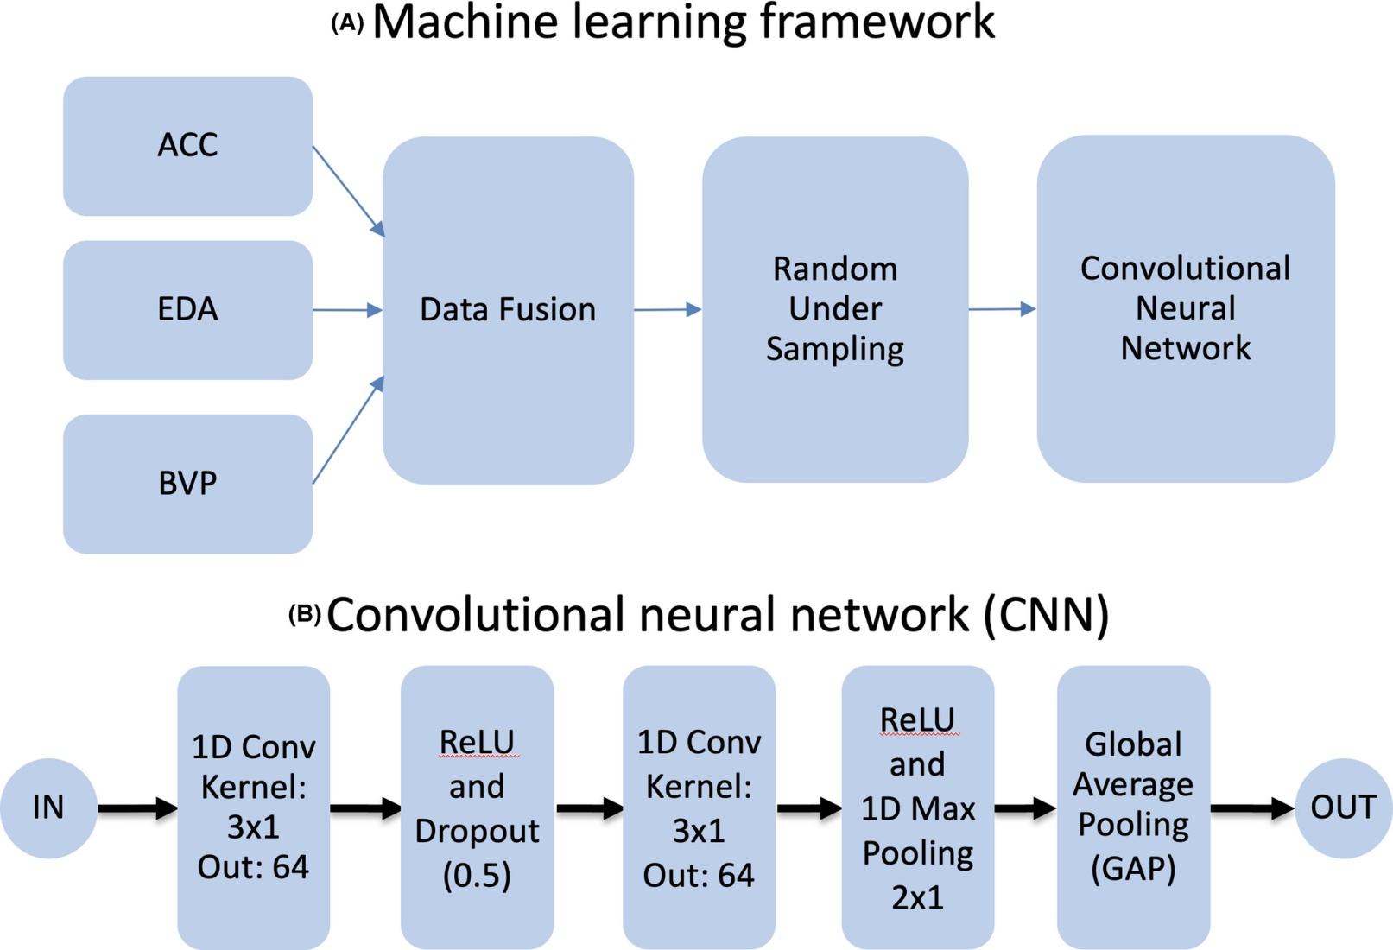

CHAPTER 4
TESTING AND IMPLEMENTATION

  - TESTING
Implementation is the stage of the project when the theoretical design is turned into a working system. This is the final and important phase in the system life cycle It is actually the process of converting the new system into a operational one.

4.1.1Unit Testing
Unit testing comprises the set of tests performed by an individual programmer prior to integration of the unit into a larger system. The module interface is tested to ensure that information properly flows into and out of the program unit. The local data structure is examined to ensure that data stored temporarily maintains its integrity during all steps in an algorithm’s execution. Boundary conditions are tested to ensure that the module operates properly at boundaries established to limit or restrict processing. All independent paths through the control structure are tested. All error-handling paths are tested.

4.1.2 Block Box Testing
Black-box testing is a method of software testing that examines the functionality of an application without peering into its internal structures or workings. This method of test can be applied virtually to every level of software testing: unit, integration, system and acceptance. It is sometimes referred to as specification-based testing.

4.2 SYSTEM IMPLEMENTATION
Implementation is the stage of the project when the theoretical design is turned into a working system. This is the final and important phase in the system life cycle It is actually the process of converting the new system into a operational one.

CHAPTER 5
CONCLUSION:
Automatic epileptic seizure detection of a broad variety of seizure types using ML and wearable data is feasible. Preliminary results show better than chance seizure detection across a range of nine seizure types. Future improvements may consider clinical chronoepileptological variables, such as seizure duration and etiology or syndrome, as well as alternative data balancing, pre-and post processing, fusion, and ensemble learning methods. Thus, although our findings suggest feasibility, future adjustments may further improve detection performance.

CHAPTER-6
REFERENCE
- 1. Beghi E. The epidemiology of epilepsy. Neuroepidemiology. 2020;54(2):185–91.
- 2. Sander JW. The epidemiology of epilepsy revisited. Curr Opin Neurol. 2003;16(2):165–70.
- 3. Elger CE, Hoppe C. Diagnostic challenges in epilepsy: seizure under-reporting and seizure detection. Lancet Neurol. 2018;17(3):279–88.
- 4. Hoppe C, Poepel A, Elger CE. Epilepsy: accuracy of patient seizure counts. Arch Neurol. 2007;64(11):1595–9.
- 5. Voelker R. Smart watch detects seizures. JAMA. 2018;319(11):1086.
- 6. Poh MZ, Swenson NC, Picard RW. A wearable sensor for unobtrusive, long-term assessment of electrodermal activity. IEEE Trans Biomed Eng. 2010;57(5):1243–52.
- 7. Harrer S, Shah P, Antony B, Hu J. Artificial intelligence for clinical trial design. Trends Pharmacol Sci. 2019;40(8):577–91.
- 8. Allen J. Photoplethysmography and its application in clinical physiological measurement. Physiol Meas. 2007;28(3):R1–39.

