DEVELOPMENT OF IOT BASED SMART ENERGY METER READING AND MONITORING SYSTEM

ABSTRACT- In the greater part of the agricultural nations, the work of gathering power utility meter perusing and distinguishing unlawful utilization of power is a truly challenging and tedious assignment which requires a ton of HR. Energy meter perusing and observing framework utilizing Internet of Things (IoT) present a proficient and practical method for moving the data of energy consumed by the purchaser remotely as well as it gives offices to distinguish the unlawful utilization of the power. Point of this study is to quantify power utilization in the family and create its bill naturally utilizing IoT and telemetric correspondence strategies. Likewise this study means to identify and control the energy robbery. The Arduino microcontroller is utilized to organize the exercises with advanced energy meter framework and to associate the framework to a WiFi organization and in this way to the Internet and Server. A uninvolved infrared sensor is locked in with the framework to identify when any illicit change occur in the metering framework. In such case, framework will send an alarm to the server as well as it has the office to disengage and yet again associate the power supply consequently. The proposed framework is able to do consistently screen and being told with regards to the quantity of units consumed to the energy supplier and consumer.The energy utilizations are determined naturally and the bill is refreshed on the web by utilizing an organization of Internet of Things. This computerization can lessen the requirements of the manual works.
1. INTRODUCTION

Power is one of the fundamental necessities of person for their life. It is a non-environmentally friendly power source consequently we should utilize it wisely for its feasible use. In a nation like Sri Lanka, the greater part of the buyers are upset and happy with the administrations of power providers; in light of conventional meter perusing techniques which requires gigantic number of labor and long working hours to gather metering information for charging process. Manual charging process is now and again delayed by different reasons. Human employable conventional metering strategy can prompt be erroneous. Power burglary is additionally a provoking issue to the power board in Sri Lanka. Sri Lanka power board announced that close 30% of its complete stockpile of power was lost because of power robbery. During the year 2011, authorities from power board have gotten 2935 wrongdoers who utilized power wrongfully and procured around 199 million LKR by forcing punishments on them. In this manner, the Electricity Board authorities are determining to take extreme regulations, for example, pulling out power supplies to houses or enterprises who have occupied with power burglary. The financial effects of robbery decrease the pay from the offer of power and increment the need of cheating to customers. Just creating more power isn't to the point of meeting present day power prerequisites. Power utilization and misfortunes must be firmly observed and figured out how to productively use the created influence. The Internet of Things (IoT) licenses object to be controlled and detected somewhat through existing correspondence network that makes opportunities for more straightforward combination between the actual world and PC based frameworks. These exercises are bringing about superior effectiveness, exactness and financial advantage . This proposed IoT based shrewd energy meter perusing and observing framework in this review, measures power utilization of every family and produce its bill consequently utilizing IoT and telemetric correspondence strategies like microcontroller. Additionally this study gives a viable system to distinguishing and controlling power burglary in family site in view of infrared sensor and IoT.
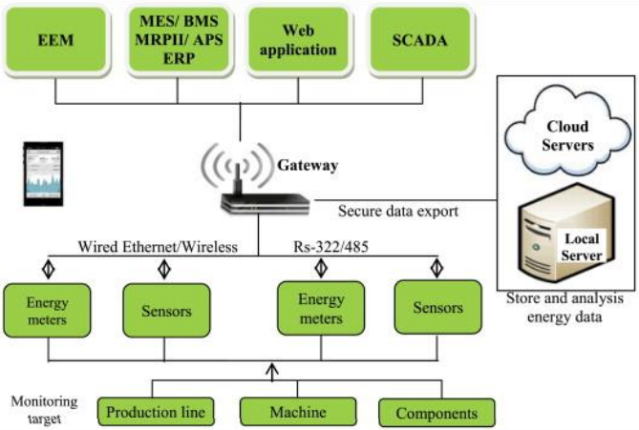
Figure 1.1 Energy Monitoring Using IoT

PROBLEM STATEMENT
Energy productive activity and proactive upkeep in view of force investigation information requires energy utilization design in individual hardware or handling/producing. This requires the assortment of adequate information for investigation which requires constant procurement and move of information from various sources; high handling power and capacity of immense arrangements of information.

LITERATURE REVIEW

Jain, A., & Bagree, M. (2011).
“A prepaid meter using mobile communication”
This paper recommends a prepaid energy meter acting like a prepaid cell phone.
Mohamed Mufassirin, M. M., Hanees, A. L., & Shafana, M. S. (2016).
“Energy theft detection and controlling system model using wireless communication media”
A high level of power pay is lost because of force burglary and ill-advised administration.
Mufassirin, M., & Hanees, A. L. (2014).
“GSM based Automated Energy Meter Reading for Electricity Bill Processing”
Planning and carrying out business frameworks in light of Wireless correspondence innovation has been a gigantic area of interest among numerous analysts and engineers.
Pooja, D. T., & Kulkarni, S. B. (2016).
“IoT Based Energy Meter Reading”
It objective is to create bill consequently by checking the power unit's utilization in a house and in a method for decreasing the difficult work.

5.SYSTEM ARCHITECTURE :

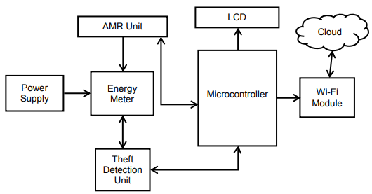

6.EXISTING SYSTEM

Because of manual work, existing power charging framework has significant downsides. This framework will give the data on meter perusing, power cut when power utilization surpasses past as far as possible utilizing IoT. In some possibility, each new innovation that are found can be utilized to supplant any exist innovation that are outdated. It is proposed to beat every one of the drawbacks in the generally existing energy meter. The shopper should be worked with by giving them an ideal arrangement that is the idea of IoT (Internet of Things) Based Energy Meter.
7.DISADVANTAGE OF EXISTING SYSTEM:
In this exploration, the proposed prepaid meter was a decent answer for income assortment from customer, yet it builds the work of the charging system which is exceptionally risky to shoppers. The financial effects of burglary diminish the pay from the offer of power and increment the need of cheating to purchasers. A remote advanced power meter would offer more prominent accommodation to the meter understanding assignment. Bluetooth innovation is a potential remote answer for this issue.
8. PROPOSED METHODOLOGY
The energy meter has numerous issues related to it and one of the key issues is there is no full duplex correspondence to tackle this issue, a shrewd energy meter is proposed in light of Internet of Things. The proposed framework consumes less energy and it will diminish manual work. In this paper, the Smart Energy Metering(SEM) is clarified as the fundamental reason for SEM is vital for gathering data on energy utilization of domestic devices and screen the natural boundaries and offer the expected types of assistance to home clients.
ADVANTAGE:
Power utilization and misfortunes must be firmly checked and figured out how to effectively use the produced influence. These exercises are bringing about superior proficiency, precision and monetary advantage. Whenever contrast and the current GSM based and other customary energy metering and checking framework, the propose framework is more proficient and savvy. Assuming remote organizations are utilized, sensors can be considerably more deftly positioned all through the shop floor.

CONCLUSION :

IoT based savvy energy meter perusing and observing framework was proposed in this paper. The framework gives numerous critical benefits, like remote information transmission, low-responsibility, remote observing and controlling, against robbery instrument and less-costs. The framework would give a straightforward method for gathering the meter perusing and identify an electrical power burglary with no human contribution. The utilization of inserted microcontroller and Wi-Fi module builds the solidness of remote information transmission. By utilizing this framework the client can whenever check their consumed unit and bill in the Internet in which paper isn't needed for charging which saves paper and printing cost. The bill can be paid utilizing on the web client service framework.

REFERENCES

[1] Gartner. (2013, 04 28). Information Technology Research and Advisory Ccompany. Retrieved from Gartner: www.gartner.com/technology/research/hype-cycles/

[2] Jain, A., & Bagree, M. (2011). A prepaid meter using mobile communication. International Journal of Engineering Research & Technology (IJERT), 160-166.
[3] Mohamed Mufassirin, M. M., & Hanees, A. L. (2018). Cost Effective Wireless Network Based Automated Energy Meter Monitoring System for Sri Lanka Perspective. International Journal of Information Technology and Computer Science(IJITCS), 68- 75.

[4] Muhammed, A. A., & Hanees, A. L. (2018). IOT Based Waste Collection Monitoring System Using Smart Phones. 8th International Symposium - 2018. South Eastern University of Sri Lanka. "In Press"

[5] Pooja, D. T., & Kulkarni, S. B. (2016). IoT Based Energy Meter Reading. International Journal of Recent Trends in Engineering & Research (IJRTER), 586-591.

[6] Tan, H. G., Lee, C. H., & Mok, V. H. (2007). Automatic power meter reading system using GSM network. 8th International Power Engineering Conference (pp. 465-469). IEEE.

