AUTHENTICATION AND KEY AGREEMENT BASED ON ANONYMOUS IDENTITY FOR PEER-TO-PEER

ABSTRACT- Cross-cloud data migration is one of the prevailing challenges faced by mobile users, which is an essential process when users change their mobile phones to a different provider. However, due to the insufficient local storage and computational capabilities of the smart phones, it is often very difficult for users to backup all data from the original cloud servers to their mobile phones in order to further upload the downloaded data to the new cloud provider. To solve this problem, we propose an efficient data migration model between cloud providers and construct a mutual authentication and key agreement scheme based on elliptic curve certificate-free cryptography for peer-topeer cloud. The proposed scheme helps to develop trust between different cloud providers and lays a foundation for the realization of cross-cloud data migration. Mathematical verification and security correctness of our scheme is evaluated against notable existing schemes of data migration, which demonstrate that our proposed scheme exhibits a better performance than other state of- the-art scheme in terms of the achieved reduction in both the computational and communication cost.

1. INTRODUCTION

Today's Internet is based mainly on rigorous customer server communication. This makes the communication channels to and from certain central servers a bottleneck in the system. The number of online users today exceeds the number of people the Internet architecture can accommodate at the same time. Who has not had slow connections and, worse, denial of service because of overcrowding in the network? There are at least two possibilities to increase the performance of Internet communication. One is to expand the network and central servers' capacity. Another opportunity is to design a new communication network architecture, an Internet 3rd generation. Instead of requiring a centralised server, this style of internet architecture enables the ability to directly connect all participating nodes (peers) to communicate and distribute information. It also reduces and disseminates more symmetrical Internet traffic inside the network. This study will cover the architecture of typical peer-to-peer networks and how safety in these environments is guaranteed, focussing on their authentication techniques.
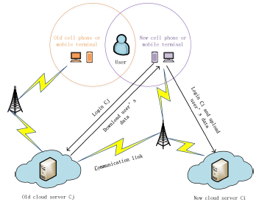
System Model
In our model, users when changing their mobile devices, should first register and login to both the cloud server Ci (the new provider) and the cloud server Cj (the original mobile phone provider). The two cloud servers are now in a peer scenario. The user distributes part of the private key to both the cloud servers through a secure channel. Then, Ci and Cj exchanges related information, and Ci sends a request message to Cj to initiate the mutual authentication and key agreement process.
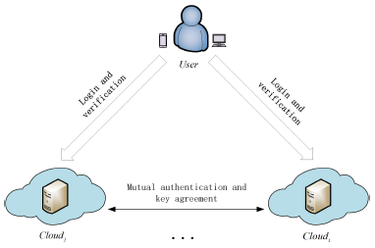
Elliptic Curve Cryptography (ECC)
The Elliptical Curve Cryptography (ECC) was introduced by Victor S. Miller and Neal Koblitz in the 80s, but it was only in the late 90's that it began its application. ECC is based on the usage of finite field elliptic curves. Elliptical curve cryptosystems are predicated on the intractability of certain mathematical issues, just as any other public key system.
Implicit Certificates
If a certificate does not send the metadata (Ix) directly, the size of the certificate is only the size of the reconstruction parameter Zx. As the cryptographic element of a certificate implicitly is the size of an elliptical curve point, the implicit certificate is significantly less than a relatively explicit certificate. In extremely restricted situations such as RFID tags for radiofrequency identification, when memory or bandwidth is scarce, smaller certificates are beneficial.

2.PROBLEM STATEMENT :

Attackers may also lie and send false information. On the other hand, the unregulated amount of nodeIDs per user is also a major problem. However, there are two fundamental disadvantages to the schemes based on identity cryptosystems. First, identity-based authentication systems are affected by a key problem of escrow, where a key needed to encrypt/decode is kept in a cache to ensure that an authorised person can access the key under particular circumstances. Specifically, ECC is based on the ECDLP problem that asserts that it is inoperative to compute the discrete logarithm of a random elliptical curve in relation to a base point of an elliptical curve. Our solution is able to deal with a fundamental trust problem while transiting data between cloud servers and the anonymity of cloud servers.

3. LITERATURE REVIEW

Cloudmon: a resource-efficient iaas cloud monitoring system based on networked intrusion detection system virtual appliances- B. Li, J. Li, and L.Liu
The networked intrusion detection system virtual appliance NIDS-VA, also known as virtualized NIDS, plays an important role in the protection and safeguard of IaaS cloud environments. However, it is nontrivial to guarantee both of the performance of NIDS-VA and the resource efficiency of cloud applications because both are sharing computing resources in the same cloud environment. To overcome this challenge and trade-off, we propose a novel system, named CloudMon, which enables dynamic resource provision and live placement for NIDS-VAs in IaaS cloud environments.

Area-based mobile multicast group key management scheme for secure mobile cooperative sensing- J. Cui, H. Zhong, W. Luo, and J. Zhang
In our model, a special Security Coprocessor (SC) is embedded in the hardware of the mobile device. SC can prevent any outside access to its internal memory space. It is resistant to security vulnerabilities in that it can preserve and calculate cryptographic keys securely.
Portability and interoperability between clouds: challenges and case study- D. Petcu
The greatest challenge beyond trust and security for the long-term adoption of cloud computing is the interoperability between clouds. In the context of world-wide tremendous activities against the vendor lock-in and lack of integration of cloud computing services, keeping track of the new concepts and approaches is also a challenge. We considered useful to provide in this paper a snapshot of these concepts and approaches followed by a proposal of their classification.A new approach in providing cloud portability is also revealed.

4.SYSTEM ARCHITECTURE

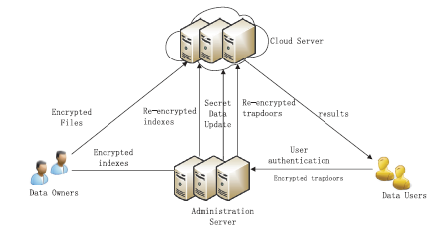

5.EXISTING SYSTEM

In the modern computing environment, smart cards are being used extensively, which are intended to authenticate a user with the system or server. Owing to the constrictions of computational resources, smart card-based systems require an elective design and eficient security scheme. In this paper, a smart card authentication protocol based on the concept of elliptic curve signcryption has been proposed and developed, which provides security attributes, including confidentiality of messages, non-repudiation, the integrity of messages, mutual authentication, anonymity, availability, and forward security. Moreover, the analysis of security functionalities shows that the protocol developed and explained.

6. PROPOSED METHODOLOGY

In this paper is secure from password guessing attacks, user and server impersonation, replay attacks, de-synchronization attacks, insider attacks, known key attacks, and man-in-the-middle attacks. The results have demonstrated that the proposed SH256 Algorithm security protocol reduces the computational overhead on Chiper Text Data. It can, thus, be inferred from the results that using elliptic curve Cryptography in the authentication mechanism reduces the computational cost and communication overhead by a significant amount.

CONCLUSION :

This paper proposed a novel scheme to transfer user data between different cloud servers based on a key agreement protocol. Through the mathematical analysis and comparative evaluation presented in this paper, the advantages of our scheme are proved from three aspects: security performance, calculation costs and communication costs. Our proposed scheme can efficiently solve the primary problem of trust during data migration between cloud servers and further can provide anonymity for the identity of cloud servers. On the premise of protecting the privacy of cloud service providers, our proposed scheme indirectly protects the privacy of users. In addition, the identity traceability provided by our proposed scheme also enables users to effectively constrain the cloud service providers.
As a future work, we plan to explore and develop a protocol that allows multiple users to share data across different cloud servers, with the motivation of enhancing the efficiency of data sharing among multiple users.

REFERENCES

[1] C. I. network information center, “The 44th china statistical report on internet development,” http://www.cnnic.net.cn/hlwfzyj/hlwxzbg/hlwtjbg/ 201908/P020190830356787490958.pdf, 2019.

[2] B. Li, J. Li, and L. Liu, “Cloudmon: a resource efficient iaas cloud monitoring system based on networked intrusion detection system virtual appliances,” Concurrency and Computation: Practice and Experience, vol. 27, no. 8, pp. 1861–1885, 2015.

[3] J. Cui, H. Zhou, H. Zhong, and Y. Xu, “Akser: attribute-based keyword search with efficient revocation in cloud computing,” Information Sciences, vol. 423, pp. 343–352, 2018.

[4] J. Cui, H. Zhong, W. Luo, and J. Zhang, “Area-based mobile multicast group key management scheme for secure mobile cooperative sensing,” Science China Information Sciences, vol. 60, no. 9, p. 098104, 2017.

[5] J. Cui, H. Zhou, Y. Xu, and H. Zhong, “Ooabks: Online/offline attribute based encryption for keyword search in mobile cloud,” Information Sciences, vol. 489, pp. 63–77, 2019.

[6] D. Petcu, “Portability and interoperability between clouds: challenges and case study,” in European Conference on a Service-Based Internet. Springer, 2011, pp. 62–74.

[7] T. Binz, F. Leymann, and D. Schumm, “Cmotion: A framework for migration of applications into and between clouds,” in 2011 IEEE International Conference on Service-Oriented Computing and Applications (SOCA). IEEE, 2011, pp. 1–4.

[8] M. N. Shirazi, H. C. Kuan, and H. Dolatabadi, “Design patterns to enable data portability between clouds’ databases,” in 2012 12th International Conference on Computational Science and Its Applications. IEEE, 2012, pp. 117–120.

[9] X. Liang, Z. Cao, H. Lin, and J. Shao, “Attribute based proxy reencryption with delegating capabilities,” in Proceedings of the 4th International Symposium on Information, Computer, and Communications Security, 2009, pp. 276–286.

[10] K. Liang, M. H. Au, J. K. Liu, W. Susilo, D. S. Wong, G. Yang, Y. Yu, and A. Yang, “A secure and efficient cipher text-policy attribute based proxy re-encryption for cloud data sharing,” Future Generation Computer Systems, vol. 52, pp. 95–108, 2015.

