A Wireless Sensor Interface for the Quantification of Tremor Using Off the Shelf Components

ABSTRACT
Deep brain stimulation (DBS) surgery involves placing an electrode in the subthalamic nucleus to suppress the motor symptoms, such as tremor, of patients with Parkinson's disease (PD). Currently physicians use the standard Unified Parkinson's Disease Rating Scale (UPDRS) to describe the tremor intraoperatively and post operatively. This scale involves subjective anchor-based observations by the clinical expert. In this study, a wireless accelerometer system is presented that was built from off the shelf components to objectively quantify tremor scores. The system consists of a Teensy 3.1 microcontroller and two 3-axis accelerometers. It wirelessly transmits the readings through a Bluetooth module. The data is received by a custom C++ program that parses and transmits the data. The system is used to record data from patients with PD during and after DBS surgery. We show example data recorded from several PD patients and study the correlation of sensor readings with the DBS ON and OFF states. We provide initial data showing that such a system can be effectively used in the clinic for the objective quantification of motor symptoms of PD patients.

CHAPTER 2
2. SYSTEM ANALYSIS
  - EXISTING SYSTEM

- In this paper, we developed two new task-independent approaches based on gradient tree boosting and LSTM networks to estimate tremor (resting and action) severity using wearable sensor data collected while patients performed a variety of daily living activities (ADL).
- However, the majority of the existing approaches are task-dependent, meaning that they require the subjects to perform the standardized tasks as in the UPDRS-III to elicit tremor.
- However, the existing task-independent approaches have been able to provide moderate to good performance because of the limitations of the underlying algorithms to characterize patterns of tremor from patients’ free body movements.
2.1.1 DRAWBACKS OF EXISTING SYSTEM :
- It is capable of reviewing continuous long-term recordings with synchronized video.
- However, human studies in clinical environments such as the operating room (OR) and epilepsy monitoring unit (EMU), posed additional challenges to the data acquisition system such as its portability and adaptability due to limited time and space.
- Interfacing with the digital glove is separately achieved using the API provided by the manufacturer.
- It is especially useful when the dataset comprised multi-modality dataset such as EEG, EMG and ECG which need to be explored in different subbands.
2.2. PROPOSED SYSTEM
- This paper presents a portable platform to collect and review behavioral data simultaneously with neuro physiological signals.
- The whole system is comprised of four parts: a sensor data acquisition interface, a socket server for realtime data streaming, a Simulink system for real-time processing and an offline data review and analysis toolbox.
- To the best of our knowledge, freely available toolboxes such as EEGLab and BioSigPlot are not capable of continuously reviewing such large datasets with synchronous video play back.
- The data server also interfaces with the digital glove and captures HD video from webcam.
2.2.1. ADVANTAGES OF PROPOSED SYSTEM
- The LSTM-based method provided lower performance.
- The method with the highest performance was used in the second experiment to estimate the resting and action tremor subscores separately.
- We investigated whether the LSTM method could provide better performance for the action tremor.
- Although the method provides high performance for the total tremor estimation, its performance is not evenly distributed for all the tremor subscores.
- Our investigations indicates that the performance is better for cases with a lower tremor subscore than the ones with a higher tremor subscore.
2.3 FEASIBILITY STUDY
The feasibility Analysis is an analytical program through project manager determines the project success ratio and through feasibility study project manager able to see either project. The key considerations involved in the feasibility analysis are:
- Economic Feasibility
- Technical Feasibility
- Operational Feasibility
- Environmental Feasibility
2.3.1 ECONOMICAL FEASIBILITY
Hence this project is economically feasible there is no need to involve any cost for this project.
2.3.2 TECHNICAL FEASIBILITY
Software Technologies used are PHP and MySql. In the educational institutions, it is possible to update the system in future. No special hardware is required for the purpose of using this system. Hence it is declared that this project is technically feasible.
2.3.3 OPERATIONAL FEASIBILITY
As the admin work mainly to maintain the Patient and Doctor .Doctor will predict patient cancer disease. Hence it is easy to operate with training. Therefore it is operationally feasible for implementation.
2.3.4 ENVIRONMENTAL FEASIBILITY
This project environment is correct as a admin has developed this system and no expenditure is involved under any head and this process is part of admin document management, this project environment is accessible.
2.4 SYSTEM REQUIREMENTS
- System : Pentium IV 2.4 GHz.
- Hard Disk : 40 GB.
- Monitor : 15 inch VGA Color.
- Mouse : Logitech Mouse.
- Ram : 512 MB
- Keyboard : Standard Keyboard

2.4.1 HARDWARE REQUIREMENTS
The Hardware of the computer consists of physical component such as Input Devices, Storage Devices, Processing & Control units and Output Devices. Computer includes external storage unit to store data in programs.
The Hardware Configuration involved in this project
- System : Pentium IV 2.4 GHz.
- Hard Disk : 40 GB.
- Monitor : 15 inch VGA Color.
- Mouse : Logitech Mouse.
- Ram : 512 MB
- Keyboard : Standard Keyboard

2.4.2 SOFTWARE REQUIREMENTS
Software is a group of programs that computers need to do a particular task. It is an essential requirement of Computer System. The Software used to develop the project is
- Operating System : Windows XP.
- Platform : DOT NET TECHNOLOGY
- Front End : ASP.Net 3.5
- Back End : SQL SERVER 2005

CHAPTER 3
SYSTEM DESIGN AND DEVELOPEMENT
SYSTEM ARCHICTURE

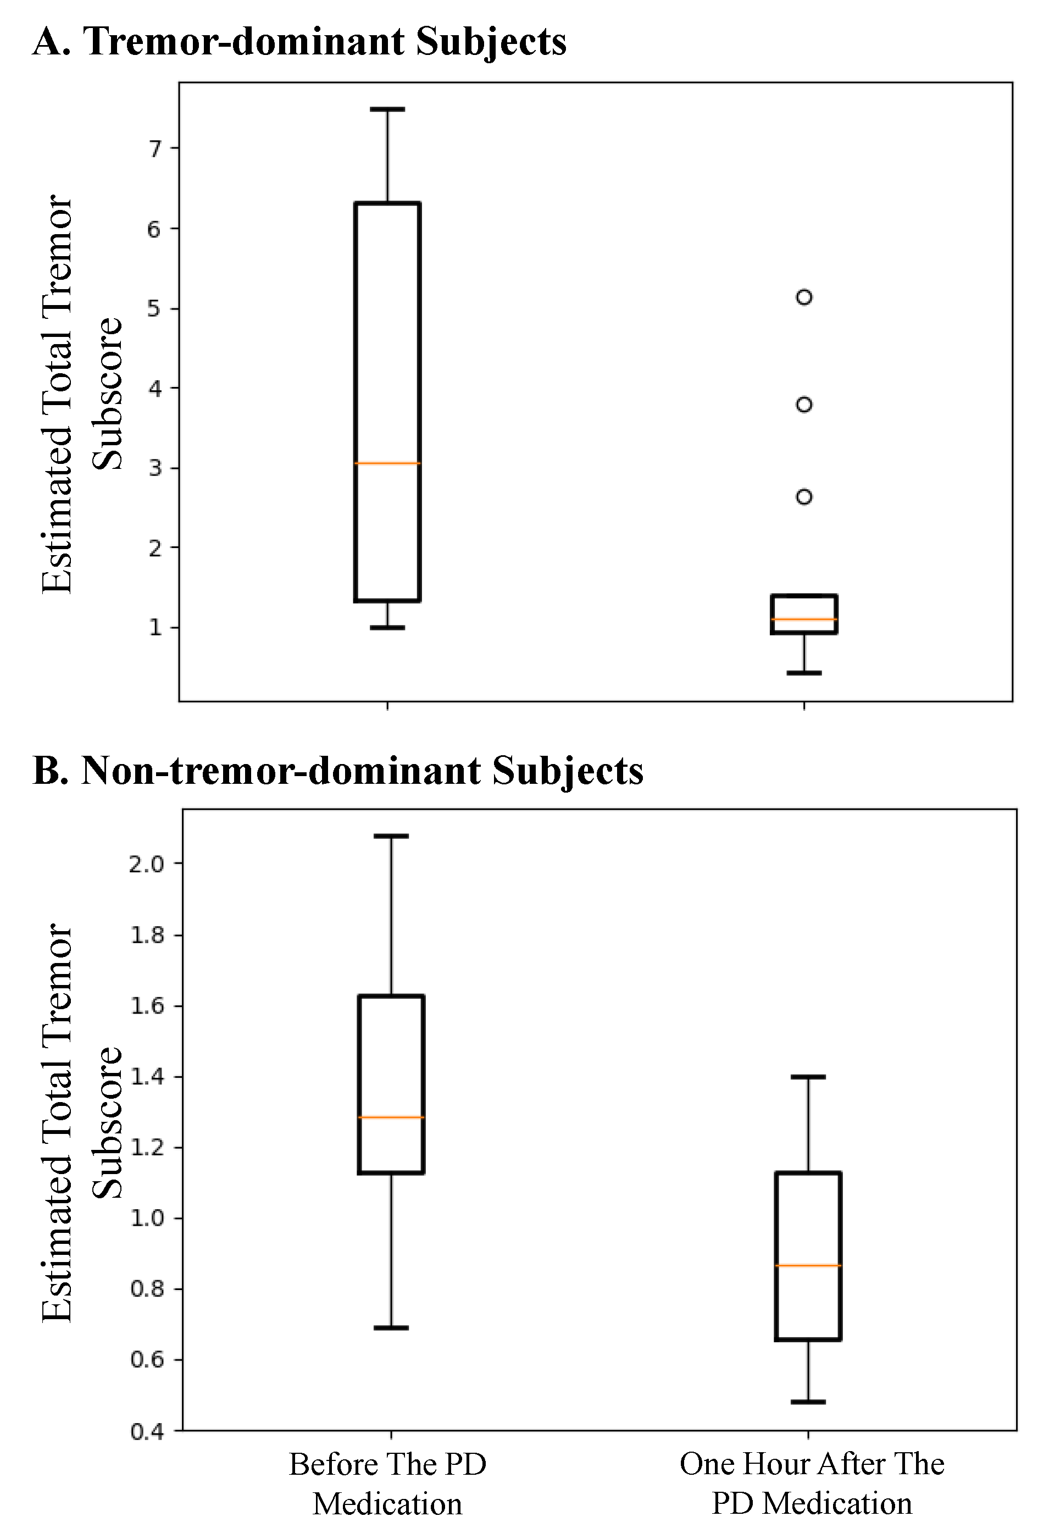

CHAPTER 4
TESTING AND IMPLEMENTATION

  - TESTING
Implementation is the stage of the project when the theoretical design is turned into a working system. This is the final and important phase in the system life cycle It is actually the process of converting the new system into a operational one.

4.1.1Unit Testing
Unit testing comprises the set of tests performed by an individual programmer prior to integration of the unit into a larger system. The module interface is tested to ensure that information properly flows into and out of the program unit. The local data structure is examined to ensure that data stored temporarily maintains its integrity during all steps in an algorithm’s execution. Boundary conditions are tested to ensure that the module operates properly at boundaries established to limit or restrict processing. All independent paths through the control structure are tested. All error-handling paths are tested.

4.1.2 Block Box Testing
Black-box testing is a method of software testing that examines the functionality of an application without peering into its internal structures or workings. This method of test can be applied virtually to every level of software testing: unit, integration, system and acceptance. It is sometimes referred to as specification-based testing.

4.2 SYSTEM IMPLEMENTATION
Implementation is the stage of the project when the theoretical design is turned into a working system. This is the final and important phase in the system life cycle It is actually the process of converting the new system into a operational one.

CHAPTER 5
CONCLUSION:
We developed a machine learning algorithm to automatically estimate tremor severity from subjects’ free body movements. Our method consisted of a feature extraction and regression model. The former extracted 78 features from every 5-s segment of data while the latter estimated a tremor subscore for every 10-min duration of the data. Two regression models were considered in this study. One model used gradient tree boosting and the other was based on LSTM deep learning. The developed models were assessed using data from 24 PD subjects who had one wearable sensor on their most affected wrist and one on the most affected ankle as performed a variety of free body movements. Our evaluations demonstrated that gradient tree boosting resulted in the highest correlation (r = 0.96 with held-out testing and r = 0.93 using leave-one-out cross-validation) reported in the literature when using unconstrained body movements’ data. In addition, we investigated the potential of the gradient tree boosting model in estimating resting and action tremor. The model estimated resting tremor with a high correlation to the UPDRS-III assessment while action tremor was estimated with a moderate correlation. These results support that the developed tremor estimation method, combined with wearable sensors, provide a reliable approach for estimating tremor severity as PD subjects experience in a typical day, thereby providing necessary information for effective therapeutic management of patients suffering from Parkinsonian tremor.

CHAPTER-6
REFERENCE
- 1.S. Patel, H. Park, P. Bonato, L. Chan and M. Rodgers, "A review of wearable sensors and systems with application in rehabilitation", Journal of NeuroEngineering and Rehabilitation, vol. 9, no. 1, pp. 21, 2012.
- 2.C. Goetz, B. Tilley, S. Shaftman, G. Stebbins, S. Fahn, P. Martinez-Martin, et al., "Movement Disorder Society-sponsored revision of the Unified Parkinson's Disease Rating Scale (MDS-UPDRS): Scale presentation and clinimetric testing results", Movement Disorders, vol. 23, no. 15, pp. 2129-2170, 2008.
- 3.M. Bacher, E. Scholz and H. Diener, "24 Hour continuous tremor quantification based on EMG recording", Electroencephalography and Clinical Neurophysiology, vol. 72, no. 2, pp. 376-183, 1989.
- 4.A. Salarian, H. Russmann, C. Wider, P. Burkhard, F. Vingerhoets and K. Aminian, "Quantification of Tremor and Bradykinesia in Parkinson's Disease Using a Novel Ambulatory Monitoring System", IEEE Transactions on Biomedical Engineering, vol. 54, no. 2, pp. 313-322, 2007.
- 5.J. Hoff, A. v/d Plas, E. Wagemans and J. van Hilten, "Accelerometric assessment of levodopa-induced dyskinesias in Parkinson's disease", Movement Disorders, vol. 16, no. 1, pp. 58-61, 2001.
- 6.D. Hobson, "Clinical Manifestations of Parkinson's Disease and Parkinsonism", Can J Neurol Sci., vol. 30, no. 1, pp. 52-59, 2003.

