Remote control and instrumentation of Android devices

ABSTRACT
This paper presents the extensions added to the measurement and monitoring tool TestelDroid, to support remote control and instrumentation of Android devices. The extensions include support for Standard Commands for Programmable Instruments (SCPI), cOntrol and Management Framework (OMF) and OMF Measurement Library (OML). SCPI is the most widespread interface for measurement equipment control in many areas, for example, electronics or telecommunications. On the other hand, the support of technologies like OMF and OML provides powerful orchestration framework languages which reduces the time required to define experiments.

CHAPTER 2
2. SYSTEM ANALYSIS
  - EXISTING SYSTEM

- It is an effective method when large blocks of the same color exist, like in patterns.
- The features served by the ADB system are implemented and tested and can access to system resources, on the other hand the possibility of extending the existent features can be increaded using local sockets.
- Android Debug Bridge Client is a tool existent in the Android SDK that allows to the developer to exchange data and requests with an Android device.
- These features can be adapted to be used inside a remote client.
2.1.1 DRAWBACKS OF EXISTING SYSTEM :
- There was a problem with the control of the front axle which was constructed through a system of gears.
- This requirement is conditioned by the problems in the transfer of information, and therefore requires manage resources efficiently.
- The limiting factor of bandwidth is a problem due to the amount of that that is sent, above all because of the latency in the network.
- This is a problem, because remote interaction does not advance with the new devices.
- However, it has a problem of performance due to lack of efficient communication middleware, thus penalizing sync speed.
2.2. PROPOSED SYSTEM
- The main idea behind the proposed architecture was the design of a system to be used as a platform which provides the services needed to perform remote control of mobile devices.
- Design and realization of the mobile application for the Android operating system and mobile robot was realised for the purpose of engineering education.
- Wi-Fi has also a greater reach, but for the purpose of this work it was not important.
- The prototype generated as implementation of the proposed architecture will be provided also as free software.
2.2.1. ADVANTAGES OF PROPOSED SYSTEM
- When the Android device is connected to Internet, a voice commands can be used in the mobile application to control the robot.
- On the Android side has to be available an application with interface to be used by the user to send commands to the robot.
- The App Inventor development environment was used to develop a mobile application to remotely control the robot which is built from Lego Mind storms NXT kit.
- This purpose was used function get Display Resolution, in which is used get Size method, which returns the display size in pixels.
- The display resolution is stored in the format width x height and then used to determine the centre and for display of trackball.
2.3 FEASIBILITY STUDY
The feasibility Analysis is an analytical program through project manager determines the project success ratio and through feasibility study project manager able to see either project. The key considerations involved in the feasibility analysis are:
- Economic Feasibility
- Technical Feasibility
- Operational Feasibility
- Environmental Feasibility
2.3.1 ECONOMICAL FEASIBILITY
Hence this project is economically feasible there is no need to involve any cost for this project.
2.3.2 TECHNICAL FEASIBILITY
Software Technologies used are PHP and MySql. In the educational institutions, it is possible to update the system in future. No special hardware is required for the purpose of using this system. Hence it is declared that this project is technically feasible.

2.3.3 OPERATIONAL FEASIBILITY
As the admin work mainly to maintain the Patient and Doctor .Doctor will predict patient cancer disease. Hence it is easy to operate with training. Therefore it is operationally feasible for implementation.
2.3.4 ENVIRONMENTAL FEASIBILITY
This project environment is correct as a admin has developed this system and no expenditure is involved under any head and this process is part of admin document management, this project environment is accessible.
2.4 SYSTEM REQUIREMENTS
- System : Pentium IV 2.4 GHz.
- Hard Disk : 40 GB.
- Monitor : 15 inch VGA Color.
- Mouse : Logitech Mouse.
- Ram : 512 MB
- Keyboard : Standard Keyboard

2.4.1 HARDWARE REQUIREMENTS
The Hardware of the computer consists of physical component such as Input Devices, Storage Devices, Processing & Control units and Output Devices. Computer includes external storage unit to store data in programs.
The Hardware Configuration involved in this project
- System : Pentium IV 2.4 GHz.
- Hard Disk : 40 GB.
- Monitor : 15 inch VGA Color.
- Mouse : Logitech Mouse.
- Ram : 512 MB
- Keyboard : Standard Keyboard

2.4.2 SOFTWARE REQUIREMENTS
Software is a group of programs that computers need to do a particular task. It is an essential requirement of Computer System. The Software used to develop the project is
- Operating System : Windows XP.
- Platform : DOT NET TECHNOLOGY
- Front End : ASP.Net 3.5
- Back End : SQL SERVER 2005

CHAPTER 3
SYSTEM DESIGN AND DEVELOPEMENT
SYSTEM ARCHICTURE

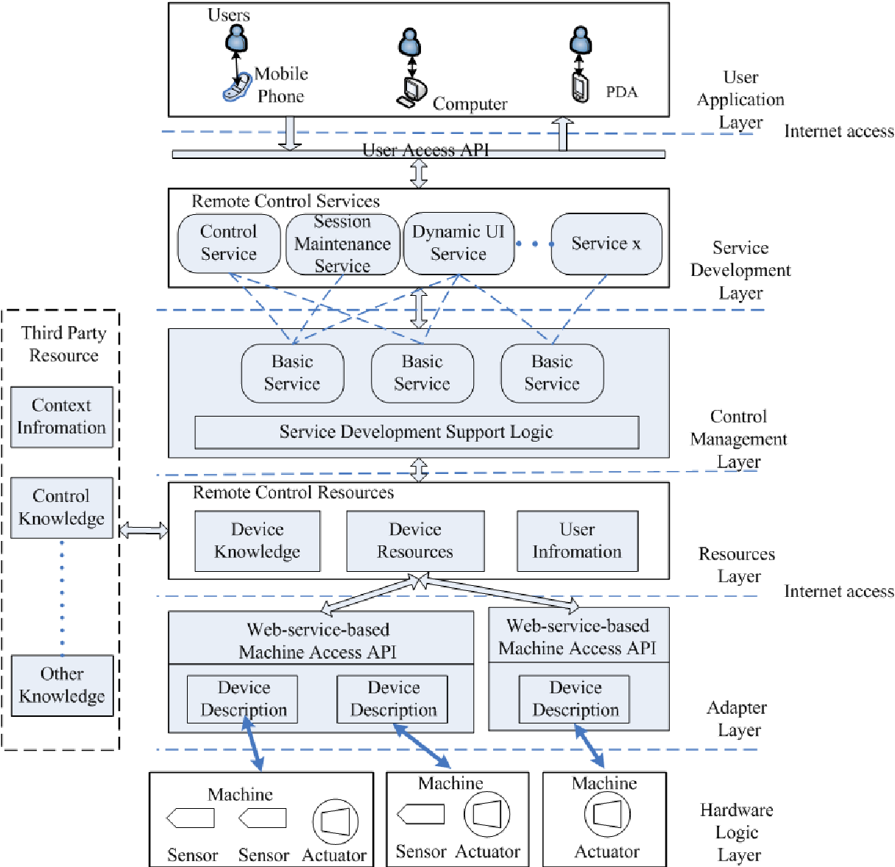

CHAPTER 4
TESTING AND IMPLEMENTATION

  - TESTING
Implementation is the stage of the project when the theoretical design is turned into a working system. This is the final and important phase in the system life cycle It is actually the process of converting the new system into a operational one.

4.1.1Unit Testing
Unit testing comprises the set of tests performed by an individual programmer prior to integration of the unit into a larger system. The module interface is tested to ensure that information properly flows into and out of the program unit. The local data structure is examined to ensure that data stored temporarily maintains its integrity during all steps in an algorithm’s execution. Boundary conditions are tested to ensure that the module operates properly at boundaries established to limit or restrict processing. All independent paths through the control structure are tested. All error-handling paths are tested.

4.1.2 Block Box Testing
Black-box testing is a method of software testing that examines the functionality of an application without peering into its internal structures or workings. This method of test can be applied virtually to every level of software testing: unit, integration, system and acceptance. It is sometimes referred to as specification-based testing.

4.2 SYSTEM IMPLEMENTATION
Implementation is the stage of the project when the theoretical design is turned into a working system. This is the final and important phase in the system life cycle It is actually the process of converting the new system into a operational one.

CHAPTER 5
CONCLUSION:
The goal of our work was to describe the types of communication between the model and the mobile device and to create a model from Lego Mindstorms that will be controlled using a mobile application. An application for the PC was in the C# language created for testing which was initially programmed for receiving data from the NXT brick. Result of this part was that from the NXT brick was send string of words which has been successfully received in the program created in the PC. Then C# function was programmed to send a text string to the NXT device which is displayed on the screen. By this way was verified bidirectional communication via Bluetooth.

CHAPTER-6
REFERENCE
- 1.OMA, "OMA Device Management", Tech. Rep. V2.0 Open Mobile Alliance (UMA), Jan. 2015.
- 2.A. Alvarez, A. Diaz, P. Merino and F. Rivas, "Field measurements of mobile services with android smartphones", Consumer Communications and Networking Conference (CCNC) 2012 IEEE, pp. 105-109, Jan 2012.
- 3.A. Diaz, P. Merino, F. Rivas, U. Kulkarni, J. Vadavi, S. Joshi, et al., "Mobile and ubiquitous objects", Pervasive Computing IEEE, vol. 5, pp. 57-59, July 2006.
- 4.A. Diaz, P. Merino and F. J. Rivas, "Mobile Application Profiling for Connected Mobile Devices", IEEE Pervasive Computing, vol. 9, pp. 54-61, 2010.
- 5.A. Díaz, P. Merino and F. Javier Rivas, "QoS analysis of video streaming service in live cellular networks", Comput. Commun., vol. 33, pp. 322-335, Feb. 2010.
- 6.A. Díaz Zayas and P. Merino Gómez, "Evaluation of handover implementations in commercial GPRS/UMTS/HSDPA networks", Global Telecommunications Conference (GLOBECOM 2010) 2010 IEEE, pp. 1-5, Dec 2010.
- 7.A. Díaz Zayas and P. Merino Gómez, "A testbed for energy profile characterization of ip services in smartphones over live networks", Mob. Netw. Appl., vol. 15, pp. 330-343, June 2010.
- 8.T. Rakotoarivelo, M. Ott, G. Jourjon and I. Seskar, "OMF: a control and management framework for networking testbeds", ACM SIGOPS Operating Systems Review, vol. 43, no. 4, pp. 54-59, 2010.
- 9.C. Dwertmann, E. Mesut, G. Jourjon and M. Ott, "Mobile experiments made easy with OMF/Orbit", SIGCOMM (Barcelona Spain), aug 2009.
- 10.IEEE, "IEEE standard serial interface for programmable instrumentation", IEEE Std 1174–2000, pp. 1-30, 2001.

