Android4Auto: A proposal for integration of Android in vehicle infotainment systems

ABSTRACT
This paper presents a proposal for integration of Android into vehicle infotainment systems. The proposed system offers infotainment functionality, while enabling users to use the device as a regular Android device. The proposal includes a specification of a Java API that should be used to access in-vehicle related content from Android applications.

CHAPTER 2
2. SYSTEM ANALYSIS
  - EXISTING SYSTEM

- The existing communication in infotainment system is supported by service provider relayed data transmission.
- The existing system in mid range car, the display are analogy for speedometer, tachometer and other indicators, like car malfunction with some engine fault are indicated by a light blinking.
- It is therefore desirable to enable interactive services to co-exist on a shared hardware platform that has access to other components that influence timing and safety critical control of the vehicle.
- Our approach supports the co-existence of the Quest RTOS with Android, to manage timing-critical components of the vehicle.
2.1.1 DRAWBACKS OF EXISTING SYSTEM :
- The network model also includes line of sight problem while performing massive data streaming from neighboring vehicles.
- However, with a dynamic topology and heavy traffic on cloud, this calculation is quite challenging and novel problem.
- Line of sight problems are required to be considered as routing destination of different vehicles may be different and hence if the vehicle travels in their respective routes than proposed system attempts to hold the communication.
- It can be seen that variable ranges of channel capacity do not have much significant impact on the throughput.
2.2. PROPOSED SYSTEM
- The prime purpose of the proposed system is to evolve up with a framework for generating error-free data over the services running in infotainment system considering the case study of vehicular network.
- The proposed system also deals with optimization of the resources by using simplified network encoding system that has direct effect on saving channel capacity.
- The core logic of the proposed system is to evolve up with a framework that facilitates faster transmission of heavier data files over a bigger stream in critical online services.
- All these parameters in modeling will ensure that proposed system offers complete applicability on streaming services on any defined infotainment system.
2.2.1. ADVANTAGES OF PROPOSED SYSTEM
- We used the second method to update the Micom firmware, but with a slightly modified version of the original firmware.
- Our Micom firmware reverse engineering efforts suggest that an attacker can potentially update the Micom firmware using methods similar to those used in a previous study.
- We identified multiple heap memory corruption vulnerabilities that could be potentially used for exploitation purposes.
- We are exploring more real-time I/O and notification capabilities in Android for complete deployment of the interactive automotive system in a working high-performance electric vehicle.
2.3 FEASIBILITY STUDY
The feasibility Analysis is an analytical program through project manager determines the project success ratio and through feasibility study project manager able to see either project. The key considerations involved in the feasibility analysis are:
- Economic Feasibility
- Technical Feasibility
- Operational Feasibility
- Environmental Feasibility
2.3.1 ECONOMICAL FEASIBILITY
Hence this project is economically feasible there is no need to involve any cost for this project.
2.3.2 TECHNICAL FEASIBILITY
Software Technologies used are PHP and MySql. In the educational institutions, it is possible to update the system in future. No special hardware is required for the purpose of using this system. Hence it is declared that this project is technically feasible.

2.3.3 OPERATIONAL FEASIBILITY
As the admin work mainly to maintain the Patient and Doctor .Doctor will predict patient cancer disease. Hence it is easy to operate with training. Therefore it is operationally feasible for implementation.
2.3.4 ENVIRONMENTAL FEASIBILITY
This project environment is correct as a admin has developed this system and no expenditure is involved under any head and this process is part of admin document management, this project environment is accessible.
2.4 SYSTEM REQUIREMENTS
- System : Pentium IV 2.4 GHz.
- Hard Disk : 40 GB.
- Monitor : 15 inch VGA Color.
- Mouse : Logitech Mouse.
- Ram : 512 MB
- Keyboard : Standard Keyboard
2.4.1 HARDWARE REQUIREMENTS
The Hardware of the computer consists of physical component such as Input Devices, Storage Devices, Processing & Control units and Output Devices. Computer includes external storage unit to store data in programs.
The Hardware Configuration involved in this project
- System : Pentium IV 2.4 GHz.
- Hard Disk : 40 GB.
- Monitor : 15 inch VGA Color.
- Mouse : Logitech Mouse.
- Ram : 512 MB
- Keyboard : Standard Keyboard

2.4.2 SOFTWARE REQUIREMENTS
Software is a group of programs that computers need to do a particular task. It is an essential requirement of Computer System. The Software used to develop the project is
- Operating System : Windows XP.
- Platform : DOT NET TECHNOLOGY
- Front End : ASP.Net 3.5
- Back End : SQL SERVER 2005

CHAPTER 3
SYSTEM DESIGN AND DEVELOPEMENT
SYSTEM ARCHICTURE

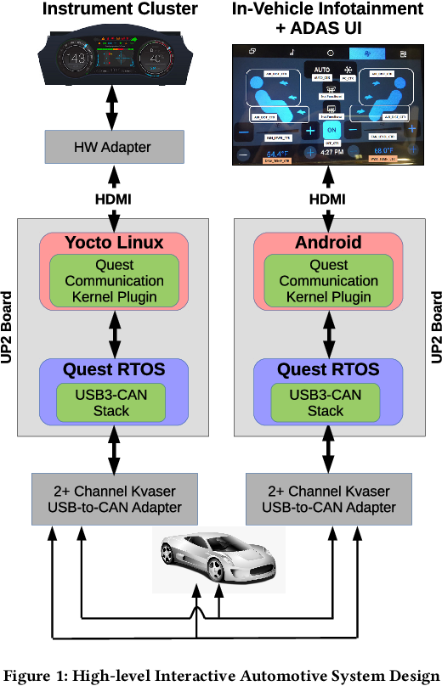

CHAPTER 4
TESTING AND IMPLEMENTATION

  - TESTING
Implementation is the stage of the project when the theoretical design is turned into a working system. This is the final and important phase in the system life cycle It is actually the process of converting the new system into a operational one.

4.1.1Unit Testing
Unit testing comprises the set of tests performed by an individual programmer prior to integration of the unit into a larger system. The module interface is tested to ensure that information properly flows into and out of the program unit. The local data structure is examined to ensure that data stored temporarily maintains its integrity during all steps in an algorithm’s execution. Boundary conditions are tested to ensure that the module operates properly at boundaries established to limit or restrict processing. All independent paths through the control structure are tested. All error-handling paths are tested.

4.1.2 Block Box Testing
Black-box testing is a method of software testing that examines the functionality of an application without peering into its internal structures or workings. This method of test can be applied virtually to every level of software testing: unit, integration, system and acceptance. It is sometimes referred to as specification-based testing.

4.2 SYSTEM IMPLEMENTATION
Implementation is the stage of the project when the theoretical design is turned into a working system. This is the final and important phase in the system life cycle It is actually the process of converting the new system into a operational one.

CHAPTER 5
CONCLUSION:
This paper has discussed about a novel design of the infotainment system that is carried out on the top of a vehicular cloud system. The contributions of the proposed system are as follows: i) the study implements the complete algorithm over the graph which makes the network topology construction easier and simpler to maintain, which is required during dynamic topology of vehicle, ii) the applicability of the proposed system can be highly acclaimed as it is implemented over map system where visualization of results are validated, iii) the complete modeling is carried out considering the constraint of the existing infotainment system which shows better practicality of proposed system.

CHAPTER-6
REFERENCE
- 1.GENIVI home page, June 2015, [online] Available: http://www.genivi.org/.
- 2.I. Son, K. Han, D. Park, M. Di and J. Cho, "A study on implementation of IVI applications for connected vehicle using HTML 5", 2014 International Conference on IT Convergence and Security (ICITCS), pp. 1-4, Oct. 2014.
- 3.T. Yamabe, S. Ikegami, A. Ishizaki, S. Kitagami and R. Kiyohara, "Car navigation user interface based on a smartphone", 2014 Seventh International Conference on Mobile Computing and Ubiquitous Networking (ICMU), pp. 85-86, Jan. 2014.
- 4.N. Gandhewar and R. Sheikh, "Google Android: An emerging software platform for mobile devices", International Journal on Computer Science and Engineering, pp. 12-17, 2010.
- 5.A. Tahat, A. Said, F. Jaouni and W. Qadamani, "Android-based universal vehicle diagnostic and tracking system", 2012 IEEE 16th International Symposium on Consumer Electronics (ISCE), pp. 813-819, June 2012.
- 6.A.V. Khanapuri, A. Shastri, G. D'souza and S. D'souza, "On road: A car assistant application", 2015 International Conference on Technologies for Sustainable Development (ICTSD), pp. 1-7, Feb. 2015.

