Review of Automatic Detection and control of Disease for Grape Field

ABSTRACT
This project gives the idea about Detection of various disease on grape field. Also provide the information about how to control this disease. India exported so many tons of grape every year. So, Grape played vital role in economic condition of country. But, because of disease the Grape quality is decrease so that we cannot exported this grape in foreign. In the Grape field there are various type of disease are attacking. From this various disease the Downey mildew disease is do the more effect on the Grape plant. This various disease affect the grape field because of some factor. These factors are Temperature, Humidity, Rain and Wind flow. This project provides the information to the farmer when the changes take place in environment by using the electronic system. Because of changed environment so many disease are attacking on Grape plant. Means this project gives information of environmental condition to the farmer and on the basis of these changes the farmer take precaution and control the attack of disease.

CHAPTER 2
2. SYSTEM ANALYSIS
  - EXISTING SYSTEM

- These various challenges regarding image analysis and result interpretation during automatic detection of plant diseases using UAVs, challenges regarding their usage and application in the field exist.
- Multispectral and NIR cameras create vegetative indices that rely on near-infrared or other bands of light.
- They can be differentiated into two groups based on bandwidth: narrowband and broadband.
- They can capture images in both visible and near infrared regions, but they may be limited while detecting subtle changes in the biophysical and biochemical parameters.
2.1.1 DRAWBACKS OF EXISTING SYSTEM :
- In this paper, the grape leaf diseases identification can be formulated as a multi-class classification problem.
- Deep learning techniques have recently achieved impressive successes in various computer vision problems, which inspires us to apply them to grape diseases identification task.
- Early stopping mechanism is used to deal with the problem of over-fitting and speed up the training process.
- Most of the aerial images for monitoring crop health issues use multispectral cameras as they are used to calculate indices such as NDVI and others including NIR.
2.2. PROPOSED SYSTEM
- The proposed model is built using the open source Keras framework on top of Tensor Flow.
- The United Model proposed for grape leaf disease identification is based on two popular deep learning architectures i.e., GoogLeNet and ResNet.
- The proposed model can be used for the development of mobile systems and devices.
- The proposed United Model is a combination of two popular models and is of huge number the parameters.
- It is important to find out an effective pruning mechanism for model compression to reduce computational resources.
2.2.1. ADVANTAGES OF PROPOSED SYSTEM
- The size of the dataset used in this work, ResNet50 becomes our first choice to be another basic network of the United Model, which also has high performance in classification tasks.
- The performance of each model is assessed on the test dataset.
- In this study, we conjecture different CNN models to generate complementary features and we boost the performance by combining the complementary features.
- Another direction of future work is to compress the model while keeping the same performance.
- The representational ability of UnitedModel is strengthened by way of high-level feature fusion, which makes it achieve the best performance in the grape diseases identification task.
2.3 FEASIBILITY STUDY
The feasibility Analysis is an analytical program through project manager determines the project success ratio and through feasibility study project manager able to see either project. The key considerations involved in the feasibility analysis are:
- Economic Feasibility
- Technical Feasibility
- Operational Feasibility
- Environmental Feasibility
2.3.1 ECONOMICAL FEASIBILITY
Hence this project is economically feasible there is no need to involve any cost for this project.
2.3.2 TECHNICAL FEASIBILITY
Software Technologies used are PHP and MySql. In the educational institutions, it is possible to update the system in future. No special hardware is required for the purpose of using this system. Hence it is declared that this project is technically feasible.
2.3.3 OPERATIONAL FEASIBILITY
As the admin work mainly to maintain the Patient and Doctor .Doctor will predict patient cancer disease. Hence it is easy to operate with training. Therefore it is operationally feasible for implementation.
2.3.4 ENVIRONMENTAL FEASIBILITY
This project environment is correct as a admin has developed this system and no expenditure is involved under any head and this process is part of admin document management, this project environment is accessible.
2.4 SYSTEM REQUIREMENTS
- System : Pentium IV 2.4 GHz.
- Hard Disk : 40 GB.
- Monitor : 15 inch VGA Color.
- Mouse : Logitech Mouse.
- Ram : 512 MB
- Keyboard : Standard Keyboard
2.4.1 HARDWARE REQUIREMENTS
The Hardware of the computer consists of physical component such as Input Devices, Storage Devices, Processing & Control units and Output Devices. Computer includes external storage unit to store data in programs.
The Hardware Configuration involved in this project
- System : Pentium IV 2.4 GHz.
- Hard Disk : 40 GB.
- Monitor : 15 inch VGA Color.
- Mouse : Logitech Mouse.
- Ram : 512 MB
- Keyboard : Standard Keyboard

2.4.2 SOFTWARE REQUIREMENTS
Software is a group of programs that computers need to do a particular task. It is an essential requirement of Computer System. The Software used to develop the project is
- Operating System : Windows XP.
- Platform : DOT NET TECHNOLOGY
- Front End : ASP.Net 3.5
- Back End : SQL SERVER 2005

CHAPTER 3
SYSTEM DESIGN AND DEVELOPEMENT
SYSTEM ARCHICTURE

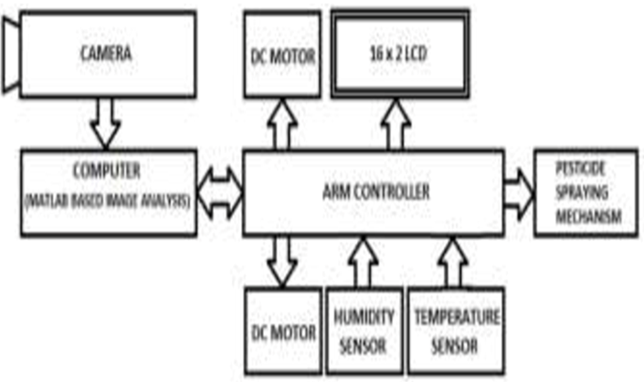

CHAPTER 4
TESTING AND IMPLEMENTATION

  - TESTING
Implementation is the stage of the project when the theoretical design is turned into a working system. This is the final and important phase in the system life cycle It is actually the process of converting the new system into a operational one.

4.1.1Unit Testing
Unit testing comprises the set of tests performed by an individual programmer prior to integration of the unit into a larger system. The module interface is tested to ensure that information properly flows into and out of the program unit. The local data structure is examined to ensure that data stored temporarily maintains its integrity during all steps in an algorithm’s execution. Boundary conditions are tested to ensure that the module operates properly at boundaries established to limit or restrict processing. All independent paths through the control structure are tested. All error-handling paths are tested.

4.1.2 Block Box Testing
Black-box testing is a method of software testing that examines the functionality of an application without peering into its internal structures or workings. This method of test can be applied virtually to every level of software testing: unit, integration, system and acceptance. It is sometimes referred to as specification-based testing.

4.2 SYSTEM IMPLEMENTATION
Implementation is the stage of the project when the theoretical design is turned into a working system. This is the final and important phase in the system life cycle It is actually the process of converting the new system into a operational one.

CHAPTER 5
CONCLUSION:
This system is used to prevent the grape field from so many disease. This system provides the information about the weather condition. When weather is changed then so many disease are affect the grape field. So, this system gives the idea about the humidity, temperature, Wind flow & rainfall. Hence, because of this system farmer take the prior precaution of the grape crop before the disease affect on the grap field. Because of this system the production of the grape fields increase & also the economy of farmer & country increase. The cost of this system is less & easy to handle.

CHAPTER-6
REFERENCE
- [1] Sindhuja sankaran, Ashish Mishra, Reza Ehsani, Cristina Davis, 2010, a review of advanced techniques for detecting plant diseases, Computers and Electronics in Agriculture 72.
- [2] Cesare Gessler, Ilaria, Pertot & Michele Perazzolli, 2011, plasmopara viticola: a review knowledge on Downey mildew of grapevine& effective disease management.
- [3] Jaime lloret, Ignacio Bosch, Sandra Sendra, Arturo Serrano, 2011, wireless sensor network for vineyard monitoring that uses image processing, ISSN 1424-8220.
- [4] G.Staudt and H.H.Kassemeyer,1995,Evaluation of Downy mildew resistance in various accessions of wild Vitis species.
- [5]Stuart.P.Falk,Roger.C.Pearson,David.M.Gadoury,Robert,C.Seem&Abraham Sztejnberg,1996,Fusarium proliferation as a Biocontrol agent against grape Downey mildew.
- [6] Maurus V. Brown1 and James N. Moore2, Patrick Fenn3, Ronald W. McNew4,1999, Comparison of Leaf Disk, Greenhouse and Field Screening Procedures for Evaluation of Grape Seedlings for Downy Mildew Resistance.
- [7] M.Jermini,P.Blaise,C.Gessler,2010, Quantitative effect of leaf damage, caused by Downey mildew on growth & yield quality of grapevine’morlot’.
- [8] Joost H.M. Stassen, identification & functional analysis of Downey mildew effectors in lettuce &Arabidopsis.
- [9] Ron Becker, Sally miller,fact sheet: managing Downey mildew in organic & conventional vine crops.

