Bakery Management System

ABSTRACT
Information Communication Technology (ICI) has played a major role in the day to day running of companies, organizations and institutions and general life. Through the use of information technology these companies are able to perform daily activities efficiently and accurately. The bakery sector too has benefited from this advancement in information Technology. The BMIS project outlines the formulation of a computerized management information System of any bakery particularly hot loaf bakery. The project highlights the following; Problems faced by the current system in carrying out a management information systems, use of php and it’s related technologies of apache server and JavaScript in validation as an efficient tools for designing and developing a bakery management information systems that helps to solve the problems faced by the current system, Ways of making sure that the data or inputs of the current system can be verified and validated. It involves the development of a centralized database system using MySQL. It also involves the process of making access to whatever information as fast as possible. This involves real time reports. It also shows how the whole system can be made secure to avoid an unauthorized access to its various resources. Here role based authentication provided by The Apache server is put into use, therefore the project looks at the various ways and technologies that can be used to accomplish the goal of the whole project. That is to provide a computerized management Information system that facilitates or enhances effectiveness and efficiency of all bakery system.

CHAPTER 2
2. SYSTEM ANALYSIS
  - EXISTING SYSTEM

- An information system is useful to keep managers informed of how well the department or organization is performing and to let them know where problems exist.
- The customer will continue with the existing system and thereby defeat the purpose of the developed system.
- It is therefore a waste of resources to build information systems without sufficiently satisfying the target user.
- These bakeries mainly evaluated raw materials by a random check. Bakeries applying BRC always used the same design of production plan and fixed their product order.
- They used margins for quiet days and took failures and unexpected orders into account in the planning.
2.1.1 DRAWBACKS OF EXISTING SYSTEM :
- The political factors have a serious impact on country and business. Factors effecting the business usually include stability of government, tax laws and tariff and so on.
- This kind of unstable environment mostly has a huge impact on the food business.
- The system has a customer’s database that solves the problem of registering daily customers (agents), daily finished products, stock takings and sales in terms of returns, deliveries, product sales and rates.
- The other big problem accounted was the central server that has been on and off hence it has not been possible in time schedule.
2.2. PROPOSED SYSTEM
- They did not improve procedures or evaluate procedures for the purpose of improving them.
- They instructed their employees by supervision and/or demonstration but used no information. Mixed bakeries evaluated product quality by supervision.
- Although several studies also indicate that quality management is related to contextual factors, the specific characteristics ofthe agri-food industry contribute to a higher complexity of contextual factors.
- We assume that this relation will also hold for the differences within the groups, although we were not able to investigate this due to lack of data.
2.2.1. ADVANTAGES OF PROPOSED SYSTEM
- These requirements include; user needs, performance expectations, and other specifications.
- This will provide a competitive advantage because customer satisfaction leads to increased customer loyalty, reduced customer acquisition costs, reduced price elasticity of demand, and increased profit margins.
- The advantage of this method of data collection is that there is high response rate since the production manager and sales manager were able and willing to fill and give the required data like bakery background, production trend and sales requirements.
- The term information system refers to the information technology that is used by people to accomplish a specific organization or individual objective.
2.3 FEASIBILITY STUDY
The feasibility Analysis is an analytical program through project manager determines the project success ratio and through feasibility study project manager able to see either project. The key considerations involved in the feasibility analysis are:
- Economic Feasibility
- Technical Feasibility
- Operational Feasibility
- Environmental Feasibility
2.3.1 ECONOMICAL FEASIBILITY
Hence this project is economically feasible there is no need to involve any cost for this project.
2.3.2 TECHNICAL FEASIBILITY
Software Technologies used are PHP and MySql. In the educational institutions, it is possible to update the system in future. No special hardware is required for the purpose of using this system. Hence it is declared that this project is technically feasible.
2.3.3 OPERATIONAL FEASIBILITY
As the admin work mainly to maintain the Patient and Doctor .Doctor will predict patient cancer disease. Hence it is easy to operate with training. Therefore it is operationally feasible for implementation.
2.3.4 ENVIRONMENTAL FEASIBILITY
This project environment is correct as a admin has developed this system and no expenditure is involved under any head and this process is part of admin document management, this project environment is accessible.
2.4 SYSTEM REQUIREMENTS
- System : Pentium IV 2.4 GHz.
- Hard Disk : 40 GB.
- Monitor : 15 inch VGA Color.
- Mouse : Logitech Mouse.
- Ram : 512 MB
- Keyboard : Standard Keyboard

2.4.1 HARDWARE REQUIREMENTS
The Hardware of the computer consists of physical component such as Input Devices, Storage Devices, Processing & Control units and Output Devices. Computer includes external storage unit to store data in programs.
The Hardware Configuration involved in this project
- System : Pentium IV 2.4 GHz.
- Hard Disk : 40 GB.
- Monitor : 15 inch VGA Color.
- Mouse : Logitech Mouse.
- Ram : 512 MB
- Keyboard : Standard Keyboard

2.4.2 SOFTWARE REQUIREMENTS
Software is a group of programs that computers need to do a particular task. It is an essential requirement of Computer System. The Software used to develop the project is
- Operating System : Windows XP.
- Platform : DOT NET TECHNOLOGY
- Front End : ASP.Net 3.5
- Back End : SQL SERVER 2005

CHAPTER 3
SYSTEM DESIGN AND DEVELOPEMENT
SYSTEM ARCHICTURE

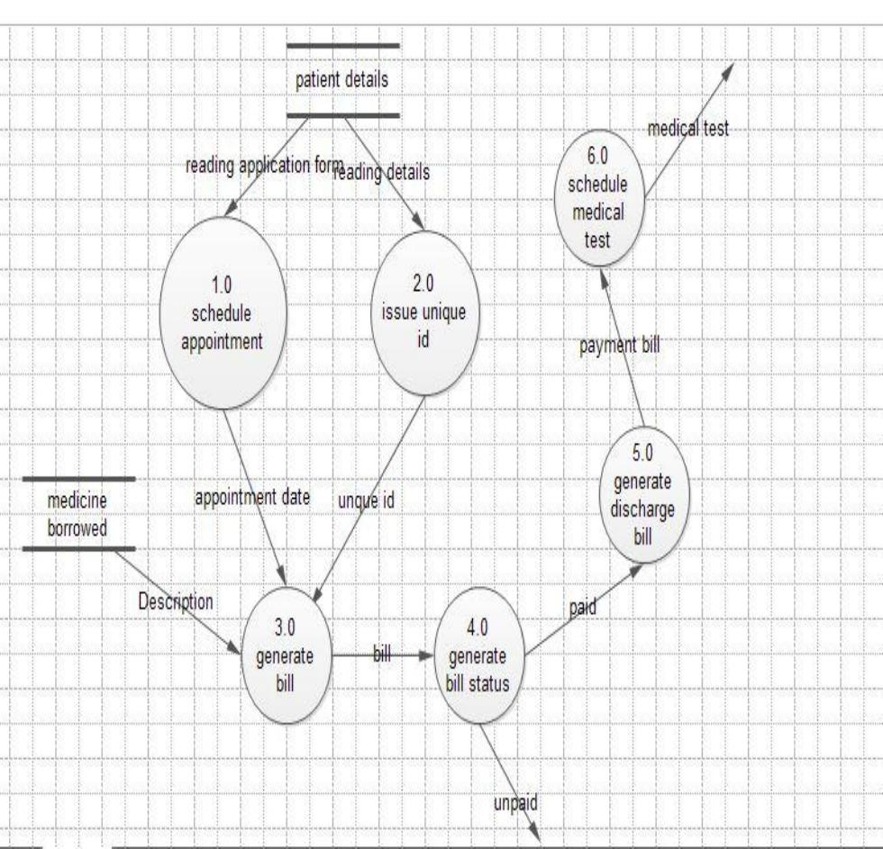

CHAPTER 4
TESTING AND IMPLEMENTATION

  - TESTING
Implementation is the stage of the project when the theoretical design is turned into a working system. This is the final and important phase in the system life cycle It is actually the process of converting the new system into a operational one.

4.1.1Unit Testing
Unit testing comprises the set of tests performed by an individual programmer prior to integration of the unit into a larger system. The module interface is tested to ensure that information properly flows into and out of the program unit. The local data structure is examined to ensure that data stored temporarily maintains its integrity during all steps in an algorithm’s execution. Boundary conditions are tested to ensure that the module operates properly at boundaries established to limit or restrict processing. All independent paths through the control structure are tested. All error-handling paths are tested.

4.1.2 Block Box Testing
Black-box testing is a method of software testing that examines the functionality of an application without peering into its internal structures or workings. This method of test can be applied virtually to every level of software testing: unit, integration, system and acceptance. It is sometimes referred to as specification-based testing.

4.2 SYSTEM IMPLEMENTATION
Implementation is the stage of the project when the theoretical design is turned into a working system. This is the final and important phase in the system life cycle It is actually the process of converting the new system into a operational one.

CHAPTER 5
CONCLUSION:
The BMIS has achieved all the mentioned Objectives of the system; the system is able to generate reports and searches when needed. The system is able to post, update and delete data from the database. The system also can search for a particular record from the database. Thus, the system has been a success to both the system developer/designer and there is hope that the system will make the work of the Bakery very easy, since it’s a computerized system.

