Pharmacy management system

ABSTRACT
Generally, the electronic technology has been implemented to automate the traditional systems. So, different copy of management systems in different scope were presented. These systems include the services provided to company as well as people, such as, healthcare. The traditional data management systems for pharmacy as example, suffer from the capacity, time consuming, medicines accessibility, managing the medicines store as well as the need of qualified staff according to the requirements of employer expectations. In this paper, a hospital e-pharmacy system is proposed in order to facilitate the job, outdo the mentioned problems. A data management system to the Iraqi hospital's pharmacy is proposed which is divided into two main parts: database, and Graphical User Interface (GUI) frames. The database built using SQL Server contains the pharmacy information related to the medicines, patient information….etc. the GUI frames ease the use of the proposed system by unskilled users. The proposal system is responsible on monitoring and controlling the work of pharmacy in hospital in terms of management of medicine issuing ordering and hospital reports.

CHAPTER 2
2. SYSTEM ANALYSIS
  - EXISTING SYSTEM

- The person who has access to this part of the system can insert new medicine, update existed one and check the medicines quantities.
- This is pharmacy management system; it is used to manage most pharmacy related activities in the pharmacy.
- The primary aim of is to improve accuracy and enhance safety and efficiency in the pharmaceutical store.
- In other words that the pharmacist will have more time in counseling his/her customers, where the goal of patient counseling is one of the important solution to avoid medication error.
- Developing an application for android devices that works on the same database which is the mini of (MySql).
2.1.1 DRAWBACKS OF EXISTING SYSTEM :
- One of the goals of this work is to produce an integrated data management system to hospital pharmacy that can fixed most of the traditional system problems.
- At this part of system the pharmacist managing the medicines issuing and showing the issued ones to an inpatient.
- This kind of work may lead to mistake by workers and lead to a major problems.
- This kind of problems the urgent need is to develop a Pharmacy management system that will prove beneficial for the Pharmacy.
- The pharmacist about drugs that are close to expiry, preventing those drugs from being sold and also providing solution to the earlier stated problems.
2.2. PROPOSED SYSTEM
- The proposed system is equipped with alarm that alerts the admin about all medicines which are reached the minimum quantity and medicines that expired.
- The proposed system managing as most as possible the whole job of hospital pharmacy.
- The proposed system was tested in terms of registration function by entering new records for inpatient and outpatient, release and update function.
- Developing the proposed system from windows based application to web based application to be more global and the connections with the pharmacies and warehousing in distance can be offered and guaranteed.

2.2.1. ADVANTAGES OF PROPOSED SYSTEM
- The pharmacy systems are considered as a computer systems which are used to managing and storing the medicines in pharmacy.
- These systems are replaced the manual systems with high efficient functions such as: stock management and control, medicine labeling, knowing the medication history of the patient and supporting the process of hospital's pharmacy.
- The system is working inside a hospital in an efficient way.
- The e-pharmacy system increases accuracy, efficiency, and the working speed comparing with the manual system.
- The system needs efficient training courses to the users to be allowed and able working on it.
Literature Survey:
TITLE | AUTHORS | DESCRIPTION
Hospital Pharmacy Management | Carlisle George, | Pharmacy practice has evolved from preparation and distribution of medicines to more patient-oriented, clinical pharmacy practice.
Exploring employer job requirements: an analysis of pharmacy job announcements | J.S. Wheeler, T. Ngo, J. Cecil, N. Borja-Hart | The primary objective of this study was to identify the most common qualifications employers require as stated in job advertisements.
Introduction to Healthcare Information Technology | Mark Ciampa, and Mark Revels, | The healthcare industry is growing at a rapid pace and undergoing some of its most significant changes as the use of electronic health records increase.
Drug Management System | Nurul Muhammed, | This system therefore will resolve and replace the current system process besides increasing the inventory management system in order to produce an effective and efficient system.
2.3 FEASIBILITY STUDY
The feasibility Analysis is an analytical program through project manager determines the project success ratio and through feasibility study project manager able to see either project. The key considerations involved in the feasibility analysis are:
- Economic Feasibility
- Technical Feasibility
- Operational Feasibility
- Environmental Feasibility
2.3.1 ECONOMICAL FEASIBILITY
Hence this project is economically feasible there is no need to involve any cost for this project.
2.3.2 TECHNICAL FEASIBILITY
Software Technologies used are PHP and MySql. In the educational institutions, it is possible to update the system in future. No special hardware is required for the purpose of using this system. Hence it is declared that this project is technically feasible.
2.3.3 OPERATIONAL FEASIBILITY
As the admin work mainly to maintain the Patient and Doctor .Doctor will predict patient cancer disease. Hence it is easy to operate with training. Therefore it is operationally feasible for implementation.
2.3.4 ENVIRONMENTAL FEASIBILITY
This project environment is correct as a admin has developed this system and no expenditure is involved under any head and this process is part of admin document management, this project environment is accessible.
2.4 SYSTEM REQUIREMENTS
- System : Pentium IV 2.4 GHz.
- Hard Disk : 40 GB.
- Monitor : 15 inch VGA Color.
- Mouse : Logitech Mouse.
- Ram : 512 MB
- Keyboard : Standard Keyboard
2.4.1 HARDWARE REQUIREMENTS
The Hardware of the computer consists of physical component such as Input Devices, Storage Devices, Processing & Control units and Output Devices. Computer includes external storage unit to store data in programs.
The Hardware Configuration involved in this project
- System : Pentium IV 2.4 GHz.
- Hard Disk : 40 GB.
- Monitor : 15 inch VGA Color.
- Mouse : Logitech Mouse.
- Ram : 512 MB
- Keyboard : Standard Keyboard
2.4.2 SOFTWARE REQUIREMENTS
Software is a group of programs that computers need to do a particular task. It is an essential requirement of Computer System. The Software used to develop the project is
- Operating System : Windows XP.
- Platform : DOT NET TECHNOLOGY
- Front End : ASP.Net 3.5
- Back End : SQL SERVER 2005

CHAPTER 3
SYSTEM DESIGN AND DEVELOPEMENT
SYSTEM ARCHICTURE

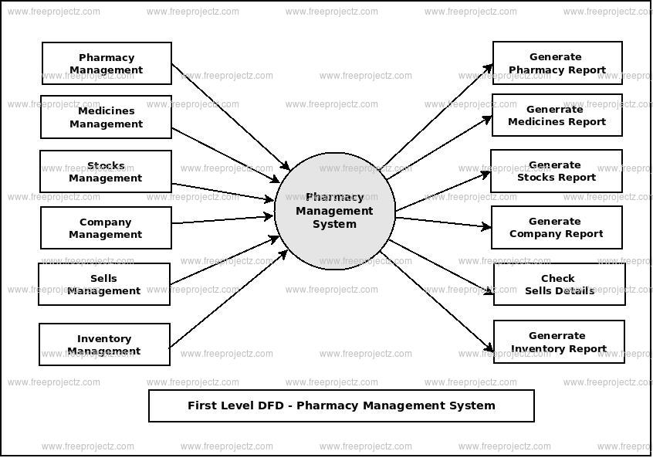

CHAPTER 4
TESTING AND IMPLEMENTATION

  - TESTING
Implementation is the stage of the project when the theoretical design is turned into a working system. This is the final and important phase in the system life cycle It is actually the process of converting the new system into a operational one.

4.1.1Unit Testing
Unit testing comprises the set of tests performed by an individual programmer prior to integration of the unit into a larger system. The module interface is tested to ensure that information properly flows into and out of the program unit. The local data structure is examined to ensure that data stored temporarily maintains its integrity during all steps in an algorithm’s execution. Boundary conditions are tested to ensure that the module operates properly at boundaries established to limit or restrict processing. All independent paths through the control structure are tested. All error-handling paths are tested.

4.1.2 Block Box Testing
Black-box testing is a method of software testing that examines the functionality of an application without peering into its internal structures or workings. This method of test can be applied virtually to every level of software testing: unit, integration, system and acceptance. It is sometimes referred to as specification-based testing.

4.2 SYSTEM IMPLEMENTATION
Implementation is the stage of the project when the theoretical design is turned into a working system. This is the final and important phase in the system life cycle It is actually the process of converting the new system into a operational one.

CHAPTER 5
CONCLUSION:
A data management system in Iraqi hospital's pharmacy was presented. The presented system manages and controls the medicine issuing cycle of a pharmacy inside a hospital. The introduced system includes database built using SQL server and GUI design utilizing Visual Studio (C#(. The purpose of using the database was to present different benefits, such as reducing data redundancy, reducing updating errors, increasing consistency, great data integrity, and improving data access to users through the use of a host and query languages and improved data security. At the other hand, the designed GUI frames facilitated the working on the system by allowing the user to interact with the system through graphical icons. In other meaning, the system can be managed with unskilled users. The introduced system has been tested by applying many case studies, such as registering a patient (inpatient/outpatient), issuing medicines to this patient, and requesting medicines from a warehouse. The obtained results of this test showed the outperformance of the investigated system in terms of less faults and more effective actions.

CHAPTER-6
REFERENCE
- [1] Carlisle George, “Hospital Pharmacy Management”, Management Science of Health, 2012 (Book).
- [2] J.S. Wheeler, T. Ngo, J. Cecil, N. Borja-Hart "Exploring employer job requirements: an analysis of pharmacy job announcements", J. Am. Pharm. Assoc., 57 (6) (2017), pp. 723-728
- [3] Stephen Goundrey-Smith, “Pharmacy Management Systems”, Springer, 2013. (Book).
- [4] Mark Ciampa, and Mark Revels, “Introduction to Healthcare Information Technology”, Course Technology, 2012.
- [5] Gimbar, Renee P., Jennie B. et al., "Unique approaches to a medication history in an immigrant population: A case report", Journal of the American Pharmacists Association , Volume 57 , Issue 6 , 739.
- [6] Nurul Muhammed, “Drug Management System”, BSc project, University Malaysia Pahang, 2010.
- [7] Basile Spyropoulos, Incorporating the Internet of Things in the Modern Hospital: Attempting a “Taxonomy” of Pertinent Equipment and Services, American Journal of Management Science and Engineering. Vol. 2, No. 6, 2017, pp. 160-169.
- [8] Ratsimbazafimahefa HR., Sadeghipour F., Trouiller P. et al., " Description and analysis of hospital pharmacies in Madagascar", Annales Pharmaceutiques Francaises, 2018, Vol. 76, No. 3, pp. :218-227.
- [9] Saja Dheyaa Khudhur and Muayad Sadik Croock, “Dental X-Ray Based Human Identification System for Forensic,” Engineering and Technology Journal, Vol. 35, No. 1, pp. 49-60, 2017.
- [10]Nahla Alwan, “Developing a Database System for the Laboratory Tests”, Eng. & Tech. Journal, Vol. 31, Part (A), No.18, pp 52-67, 2013.

