Department ebilling system

ABSTRACT
This paper deals with the design of Internet billing system, in which it is possible pay invoices electronically. This approach is implemented via virtual banks, in which the process of money transfer can be implemented. In other hand many applications can be realize such as; deposit e-money, withdrawal e-money and determine account balance. A Gate way translator is used to apply authentication rules, security and privacy.

CHAPTER 2
2. SYSTEM ANALYSIS
  - EXISTING SYSTEM

- It also depicts the technique, method, equipment, and technology that had been used in those existing systems and also those will be used in this research.
- BillMaster features customizable account records, flexible reporting options, and unlimited rate schedules and charge calculations.
- This utility billing software provides the tools to improve the billing process while boosting efficiency and productivity to better serve to the customers.
- Those benefits include the unlimited number of services, multi dial and multiple meters per service locations, penalty or delinquent and cut-off processing, online credit processes and hand-held meter reading interface.
2.1.1 DRAWBACKS OF EXISTING SYSTEM :
- It describes the scale and complexity of the problem which makes the construction of a multiservice platform such a difficult feat of software engineering.
- Recognizing this, virtually all interested parties are exploring various types of electronic payment (E-payment) system and issues surrounding e- payment system and digital currency.
- The strategic business issues which have shaped the design of MSBS.
- The security issue is implemented via; encrypted passwords using hash function (MD5), the hash function (MD5) and CRC32.
- This leads to the serious problem when the workers have to go to the house again and re-enter the meter value in order to correct it.
2.2. PROPOSED SYSTEM
- In their paper, the authors improved the e-payment system with a smart card proposed by S.Brands, and present an anonymity-revoking e-payment system.
- The authors propose a fair and secure billing system based on a proper combination of digital signature and hash chain mechanism.
- The proposed system can achieve authentication, nonrepudiation, and fairness, which are desirable security requirements for an undeniable mobile billing system.
- In CONSEPP the authors propose a lightweight method to avoid the need for merchant certificates.
- The user can pay the bills for water, electricity, Telephone, etc., through the use of this proposed system and benefit from the money transfer service.
2.2.1. ADVANTAGES OF PROPOSED SYSTEM
- If organizations are going to take advantage of new Internet technologies, then they must take a strategic perspective.
- It helps customers to compare various products in the range and class, study their features/performance and make an informed decision about the emergence of e-commerce has created new financial needs that in many cases cannot be effectively fulfilled by the traditional payment systems.
- Ecommerce, in a broad sense, is the use of computer networks to improve organizational performance.
- Increasing profitability, gaining market share, improving customer service, and delivering products faster are some of the organizational performance gains possible with e-commerce.
Literature Survey:
TITLE | AUTHORS | DESCRIPTION
A Systemic Approach for an Open Internet Billing System | Assimakopoulos Nikitas A., Anastasis N. Riggas & Giorgos K. Kotsimpos, | Industry experts predict that Internet Billing will fundamentally change the way companies interact with their customers.
E-commerce Security | Ghosh Anup K., | This paper examines E-Commerce security by first investigating the recent market trends for E-Businesses and the key role E-Commerce plays in the retail market.
Technologies For E-Commerce: An Overview | NN Murthy, BM Mehtre, KPR Rao, GSR Ramam, PKB Harigopal, and KS Babu, | In this paper, we present a brief description of the aforementioned technologies for e-commerce being developed at Center of Excellence for E-Commerce.
Ecommerce Fundamental and Applications | Chan Henry, Raymond Lee, Tharam Dillon and Elizabeth Chang , | A running case study depicting a Virtual Book Store (VBS), step-by-step programming exercises, and real-world examples round out this highly practical, easily accessible guide.

2.3 FEASIBILITY STUDY
The feasibility Analysis is an analytical program through project manager determines the project success ratio and through feasibility study project manager able to see either project. The key considerations involved in the feasibility analysis are:
- Economic Feasibility
- Technical Feasibility
- Operational Feasibility
- Environmental Feasibility
2.3.1 ECONOMICAL FEASIBILITY
Hence this project is economically feasible there is no need to involve any cost for this project.
2.3.2 TECHNICAL FEASIBILITY
Software Technologies used are PHP and MySql. In the educational institutions, it is possible to update the system in future. No special hardware is required for the purpose of using this system. Hence it is declared that this project is technically feasible.
2.3.3 OPERATIONAL FEASIBILITY
As the admin work mainly to maintain the Patient and Doctor .Doctor will predict patient cancer disease. Hence it is easy to operate with training. Therefore it is operationally feasible for implementation.
2.3.4 ENVIRONMENTAL FEASIBILITY
This project environment is correct as a admin has developed this system and no expenditure is involved under any head and this process is part of admin document management, this project environment is accessible.

2.4 SYSTEM REQUIREMENTS
- System : Pentium IV 2.4 GHz.
- Hard Disk : 40 GB.
- Monitor : 15 inch VGA Color.
- Mouse : Logitech Mouse.
- Ram : 512 MB
- Keyboard : Standard Keyboard
2.4.1 HARDWARE REQUIREMENTS
The Hardware of the computer consists of physical component such as Input Devices, Storage Devices, Processing & Control units and Output Devices. Computer includes external storage unit to store data in programs.
The Hardware Configuration involved in this project
- System : Pentium IV 2.4 GHz.
- Hard Disk : 40 GB.
- Monitor : 15 inch VGA Color.
- Mouse : Logitech Mouse.
- Ram : 512 MB
- Keyboard : Standard Keyboard

2.4.2 SOFTWARE REQUIREMENTS
Software is a group of programs that computers need to do a particular task. It is an essential requirement of Computer System. The Software used to develop the project is
- Operating System : Windows XP.
- Platform : DOT NET TECHNOLOGY
- Front End : ASP.Net 3.5
- Back End : SQL SERVER 2005

CHAPTER 3
SYSTEM DESIGN AND DEVELOPEMENT
SYSTEM ARCHICTURE

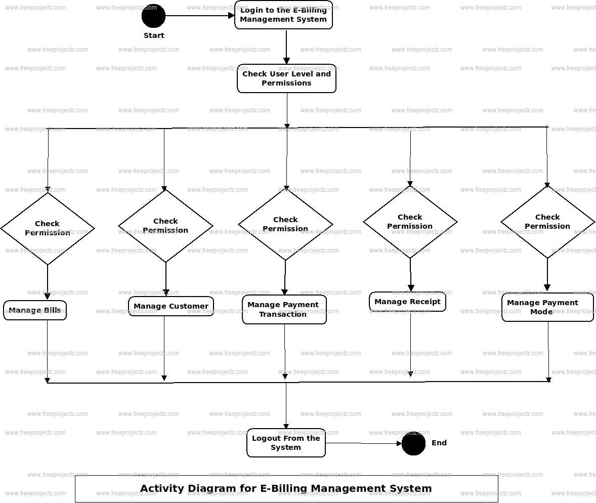

CHAPTER 4
TESTING AND IMPLEMENTATION

  - TESTING
Implementation is the stage of the project when the theoretical design is turned into a working system. This is the final and important phase in the system life cycle It is actually the process of converting the new system into a operational one.

4.1.1Unit Testing
Unit testing comprises the set of tests performed by an individual programmer prior to integration of the unit into a larger system. The module interface is tested to ensure that information properly flows into and out of the program unit. The local data structure is examined to ensure that data stored temporarily maintains its integrity during all steps in an algorithm’s execution. Boundary conditions are tested to ensure that the module operates properly at boundaries established to limit or restrict processing. All independent paths through the control structure are tested. All error-handling paths are tested.

4.1.2 Block Box Testing
Black-box testing is a method of software testing that examines the functionality of an application without peering into its internal structures or workings. This method of test can be applied virtually to every level of software testing: unit, integration, system and acceptance. It is sometimes referred to as specification-based testing.

4.2 SYSTEM IMPLEMENTATION
Implementation is the stage of the project when the theoretical design is turned into a working system. This is the final and important phase in the system life cycle It is actually the process of converting the new system into a operational one.

CHAPTER 5
CONCLUSION:
In this paper, we implemented Internet billing system; by construction of virtual banks which perform the processes of banks. Some of the concepts of security have been applied in this system to protect the system from unauthorized access. The security issue is implemented via; encrypted passwords using hash function (MD5), the hash function (MD5) and CRC32. These functions are used to generate the card number; the amount of money transferred cannot exceed a certain imitation. Users can do their payment via E-bank any time anywhere, in which access time is reduced as possible.

CHAPTER-6
REFERENCE
- [1] Assimakopoulos Nikitas A., Anastasis N. Riggas & Giorgos K. Kotsimpos, "A Systemic Approach for an Open Internet Billing System",2003, http://www.afscet.asso.fr/resSystemica/Crete02/Assimakopoulos,%20Ri ggas,%20Kotsibos.pdf
- [2] Ghosh Anup K., "E-commerce Security": Weak Links, Best Defenses, Wiley Computer Publishing,1998.
- [3] Singh Abhishek, OM Shankar, Vikash Kumar and Tapanray," Risk in E-Banking", CC BY-NC 3.0,2009, available at http://www.scribd.com/doc/22356535/Risk-in-E-Banking-PDF,visited on July 16,2011.
- [4] NN Murthy, BM Mehtre, KPR Rao, GSR Ramam, PKB Harigopal, and KS Babu, "Technologies For E-Commerce: An Overview", CMC Center-R&D, CMC Limited Old Mumbai Highway, Gachibowli Hyderabad – 500 019, Andhra Pradesh ,2000.
- [5] Sumanjeet Singh," Emergence of Payment Systems In The Age Of Electronic Commerce:The State Of Art ", Global Journal of International Business Research Vol, 2, No, 2, 2009.
- [6] Chan Henry, Raymond Lee, Tharam Dillon and Elizabeth Chang ,"Ecommerce Fundamental and Applications", Baffins Lane, Chichester, West Sussex, PO19 lUD, England,2001.
- [7] Watson Richard T. , Pierre Berthon,Leyland F. Pitt and George M. Zinkhan, "ElectronicCommerce :The Strategic Perspective", Creative Commons Attribution 3.0 License, 2007.
- [8] Media Abdul Razak Ali,M.Sc ,In a computer and software engineering department of the University of AL-mustansiriya, "Design and Implementation of SET Enabled E-commerce System",2005.
- [9] Crookes J ,"Multiservice Billing System - a platForm for the future", BT Technol JVol 14 No 3 July 1996.
- [10] Harte Lawrence, "Internet TV Billing Systems", Althos pupishing,2011, http://www.althos.com/tutorial/Internet-TV-station-tutorial-BillingSystems.html.

