Leave approvel management system

ABSTRACT
E-Leave Management System and Payroll (E-LMSP) project is a web application and mobile application which can be used for all the organization or company that will ease the employees leave management. This is due to the problem in using manual system which can cause damage, missing and can be costly as well. In addition, it also will cause delay in leave request when the respective officer not in the office. To solve leave delayed problem, this system provided with the automated function ease leave management process such as information of employees, approval of leave, types of leave, leave balances, payment, notification of email, report generation are element of this system. The system is design in such a simple and friendly user interface to ease the users to use. Every employee is provided with unique username, password and accessible either by an employee or admin for log into a system. Moreover, the functions of administrator for this system are to register the new employee, delete and update information of user in a database. Administrator is known as higher authorities that use to manage the leave whether want to approve or reject the leave of employees. This system also provides the function that help the administrator to auto calculate the salary for each employee based on leave request by employees. This system is developed by using Waterfall method to ensure it is deployed in the prescribed time. As a conclusion, this system is very useful for any companies or organization where there are have large number of employee and easier to track and manage employees leave.

CHAPTER 2
2. SYSTEM ANALYSIS
  - EXISTING SYSTEM

- In the existing it is individual to apply leave. It increases the paper work and record maintenance which is a tedious work.
- This software is supported to eliminate and in some cases, cut back the hardships faced by these existing systems.
- This technique is intended for the actual want of the corporation to hold out operations in a very swish and effective manner.
- In this existing system, NFC technology is used by which each employee will be able to access this application online and can request leave as per their needs.
- The proposed application offers multiple company accounts each of which has its company users.
2.1.1 DRAWBACKS OF EXISTING SYSTEM :
- The leave management system has been developed to override the issues prevailing within the active manual system.
- It does not ensures security of every record .
- It increases the redundancy of data and gives various facilities .
- It leads to loss of data .
- The staff has to write a letter to its superior for leave which makes it a tedious work for the staff.
2.2. PROPOSED SYSTEM
- In our system we are going to work on software only.
- The main objective of the proposed system is to automate the existing system.
- It decreases the paper work and easier record maintenance by having a database for leaves.
- It reduces the time and manual paper work for applying a leave.
- The leave management system reduces the work and risk of the Head of the department/Principal.
2.2.1. ADVANTAGES OF PROPOSED SYSTEM
- It is very faster.
- Provide user friendly.
- Less Time Consuming
2.3 FEASIBILITY STUDY
The feasibility Analysis is an analytical program through project manager determines the project success ratio and through feasibility study project manager able to see either project. The key considerations involved in the feasibility analysis are:
- Economic Feasibility
- Technical Feasibility
- Operational Feasibility
- Environmental Feasibility
2.3.1 ECONOMICAL FEASIBILITY
Hence this project is economically feasible there is no need to involve any cost for this project.
2.3.2 TECHNICAL FEASIBILITY
Software Technologies used are PHP and MySql. In the educational institutions, it is possible to update the system in future. No special hardware is required for the purpose of using this system. Hence it is declared that this project is technically feasible.
2.3.3 OPERATIONAL FEASIBILITY
As the admin work mainly to maintain the Patient and Doctor .Doctor will predict patient cancer disease. Hence it is easy to operate with training. Therefore it is operationally feasible for implementation.
2.3.4 ENVIRONMENTAL FEASIBILITY
This project environment is correct as a admin has developed this system and no expenditure is involved under any head and this process is part of admin document management, this project environment is accessible.
2.4 SYSTEM REQUIREMENTS
- System : Pentium IV 2.4 GHz.
- Hard Disk : 40 GB.
- Monitor : 15 inch VGA Color.
- Mouse : Logitech Mouse.
- Ram : 512 MB
- Keyboard : Standard Keyboard
2.4.1 HARDWARE REQUIREMENTS
The Hardware of the computer consists of physical component such as Input Devices, Storage Devices, Processing & Control units and Output Devices. Computer includes external storage unit to store data in programs.
The Hardware Configuration involved in this project
- System : Pentium IV 2.4 GHz.
- Hard Disk : 40 GB.
- Monitor : 15 inch VGA Color.
- Mouse : Logitech Mouse.
- Ram : 512 MB
- Keyboard : Standard Keyboard

2.4.2 SOFTWARE REQUIREMENTS
Software is a group of programs that computers need to do a particular task. It is an essential requirement of Computer System. The Software used to develop the project is
- Operating System : Windows XP.
- Platform : DOT NET TECHNOLOGY
- Front End : ASP.Net 3.5
- Back End : SQL SERVER 2005

CHAPTER 3
SYSTEM DESIGN AND DEVELOPEMENT
SYSTEM ARCHICTURE

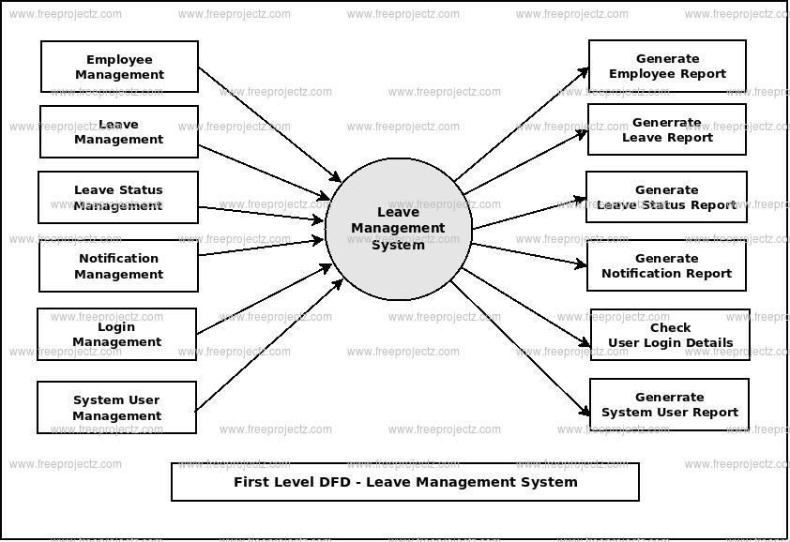

CHAPTER 4
TESTING AND IMPLEMENTATION

  - TESTING
Implementation is the stage of the project when the theoretical design is turned into a working system. This is the final and important phase in the system life cycle It is actually the process of converting the new system into a operational one.

4.1.1Unit Testing
Unit testing comprises the set of tests performed by an individual programmer prior to integration of the unit into a larger system. The module interface is tested to ensure that information properly flows into and out of the program unit. The local data structure is examined to ensure that data stored temporarily maintains its integrity during all steps in an algorithm’s execution. Boundary conditions are tested to ensure that the module operates properly at boundaries established to limit or restrict processing. All independent paths through the control structure are tested. All error-handling paths are tested.

4.1.2 Block Box Testing
Black-box testing is a method of software testing that examines the functionality of an application without peering into its internal structures or workings. This method of test can be applied virtually to every level of software testing: unit, integration, system and acceptance. It is sometimes referred to as specification-based testing.

4.2 SYSTEM IMPLEMENTATION
Implementation is the stage of the project when the theoretical design is turned into a working system. This is the final and important phase in the system life cycle It is actually the process of converting the new system into a operational one.

CHAPTER 5
CONCLUSION:
Leave Management System is useful for college to maintain the leave records of the staff/faculties and it also maintain leave applications of the staff. Our systems aim is to decrease paperwork and easier record maintenance by having a particular website for leave maintenance. Our approach deals with the record of leaves taken by faculties within the institute where higher authorities like HOD's and Director will approve/reject the leave applications requested by the employees. Our system also approaches to reduce the formalities and time delay facing by faculty members for the approval of leaves. Further up-gradation of the Leave Management System for various types of institutes with multiple hierarchies can help in reducing paperwork and help achieve error-free calculation of leaves.

CHAPTER-6
REFERENCE
- [1] S Selvi, Manas Rath, N K Sinha, S P Singh, N N J Hemrom, A Bhattacharya, A K Biswal , "HR e-Leave Tour Management System at RDCIS, SAIL International Conference on Information Technology, [June 2014]
- [2] Sai Ba Oo*, Nang Hlaing Myat Oo, Suparat Chainan, arpha Thongniam, Waralak Chongdarakul , School of Information and Technology, Mae Fah Luang University, "Cloud-based web application with NFC for employee attendance management system, [June 2018]
- [3] Pandore Yogesh Bandopant ,"E-Notifier: Transport Information Services in Colleges and Exploring Mobile Notification Journal of Advanced Research in Computer and Communication Engineering Vol.5, Issue 4",[April 2016]
- [4] https://ieeexplore.ieee.org/document/8281931

