Bus tracking customer service alert system

ABSTRACT
In this paper, we propose a real-time bus alert system which provides information about the bus arrived at the bus station travels to the desired destination of the blind or not. A blind unit is given to the blind person, in which keys are used for giving input for a destination. A bus unit is attached to the bus in which a unique RF-Id is encoded and transmitted continuously. When the blind unit comes in range of the emitted RF signal of the bus, the encoded RF signal is received and decoded. The decoded value is matched, and the result is given as audio output at the android phone. This alert system also assists the blind person to board the bus.

CHAPTER 2
2. SYSTEM ANALYSIS
  - EXISTING SYSTEM

- The vast majority of these assignments are paltry for the located, yet exceptionally troublesome for the outwardly debilitated.
- There are situations when a visually impaired individual has spent a few hours on the transport stop, since he couldn't perceive entry of the right vehicle.
- The world is loaded with risks and ponders which society accepts the utilization of vision to maintain a strategic distance from or appreciate.
- Being visually impaired limits their exposures to these marvels and expands their risk to the perils.
- More undermining than being cut off from business and societal trade is the contrary condition of general world awareness in regards to visually impaired individuals.
2.1.1 DRAWBACKS OF EXISTING SYSTEM :
- Vehicle tracking has become so advanced and simple with various upcoming technologies. But the cost effectiveness and its implementation have become high.
- The problem lies in maintaining high grade servers to backup the data for vehicle tracking and the use of internet to track these vehicles.
- The system proposed in this paper states smart way to public transport. Considering all the public issues and problems such as; time, easy of transport, safety and userfriendly environment this system is been designed.
- The proposed system addresses these very problems in an efficient and cost effective way.
2.2. PROPOSED SYSTEM
- Our proposed system is based on the Arduino UNO, GSM module, GPS module, and fuel level sensor.
- The proposed system's aim is to measure the fuel in the vehicle tank using a fuel level sensor.
- The ultrasonic sensor and IR sensor has better accuracy, and it is easy to calibrate and interface it with the Arduino controller, which is used. In this way, we can find the level of fuel in the tank.
- This is essential to improve the security purpose and also to provide safeguard for the fuels which is really useful for the operations controlling driver.
2.2.1. ADVANTAGES OF PROPOSED SYSTEM
- The bus tracking system is an efficient and cost-effective system.
- The main aim of our project is to provide the exact time forecast and the fuel monitoring system of the bus that provides a view of the bus to the passengers and also the exact arrival time of the bus along with the information to be sent to the Bus Owner as well.
- Fuel monitoring systems help the administrator to know the exact amount of fuel content of the bus, so fuel theft could be avoided, and the administrator could maintain the fuel more efficiently.
- The device is designed to decrease the fuel usage and efficient utilization of fuel consumption by enabling fleet operators.
2.3 FEASIBILITY STUDY
The feasibility Analysis is an analytical program through project manager determines the project success ratio and through feasibility study project manager able to see either project. The key considerations involved in the feasibility analysis are:
- Economic Feasibility
- Technical Feasibility
- Operational Feasibility
- Environmental Feasibility
2.3.1 ECONOMICAL FEASIBILITY
Hence this project is economically feasible there is no need to involve any cost for this project.
2.3.2 TECHNICAL FEASIBILITY
Software Technologies used are PHP and MySql. In the educational institutions, it is possible to update the system in future. No special hardware is required for the purpose of using this system. Hence it is declared that this project is technically feasible.
2.3.3 OPERATIONAL FEASIBILITY
As the admin work mainly to maintain the Patient and Doctor .Doctor will predict patient cancer disease. Hence it is easy to operate with training. Therefore it is operationally feasible for implementation.
2.3.4 ENVIRONMENTAL FEASIBILITY
This project environment is correct as a admin has developed this system and no expenditure is involved under any head and this process is part of admin document management, this project environment is accessible.
2.4 SYSTEM REQUIREMENTS
- System : Pentium IV 2.4 GHz.
- Hard Disk : 40 GB.
- Monitor : 15 inch VGA Color.
- Mouse : Logitech Mouse.
- Ram : 512 MB
- Keyboard : Standard Keyboard
2.4.1 HARDWARE REQUIREMENTS
The Hardware of the computer consists of physical component such as Input Devices, Storage Devices, Processing & Control units and Output Devices. Computer includes external storage unit to store data in programs.
The Hardware Configuration involved in this project
- System : Pentium IV 2.4 GHz.
- Hard Disk : 40 GB.
- Monitor : 15 inch VGA Color.
- Mouse : Logitech Mouse.
- Ram : 512 MB
- Keyboard : Standard Keyboard

2.4.2 SOFTWARE REQUIREMENTS
Software is a group of programs that computers need to do a particular task. It is an essential requirement of Computer System. The Software used to develop the project is
- Operating System : Windows XP.
- Platform : DOT NET TECHNOLOGY
- Front End : ASP.Net 3.5
- Back End : SQL SERVER 2005

CHAPTER 3
SYSTEM DESIGN AND DEVELOPEMENT
SYSTEM ARCHICTURE

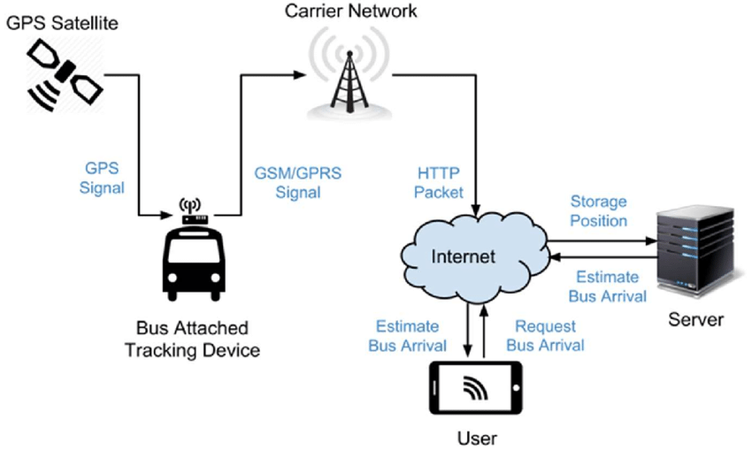

CHAPTER 4
TESTING AND IMPLEMENTATION

  - TESTING
Implementation is the stage of the project when the theoretical design is turned into a working system. This is the final and important phase in the system life cycle It is actually the process of converting the new system into a operational one.

4.1.1Unit Testing
Unit testing comprises the set of tests performed by an individual programmer prior to integration of the unit into a larger system. The module interface is tested to ensure that information properly flows into and out of the program unit. The local data structure is examined to ensure that data stored temporarily maintains its integrity during all steps in an algorithm’s execution. Boundary conditions are tested to ensure that the module operates properly at boundaries established to limit or restrict processing. All independent paths through the control structure are tested. All error-handling paths are tested.

4.1.2 Block Box Testing
Black-box testing is a method of software testing that examines the functionality of an application without peering into its internal structures or workings. This method of test can be applied virtually to every level of software testing: unit, integration, system and acceptance. It is sometimes referred to as specification-based testing.

4.2 SYSTEM IMPLEMENTATION
Implementation is the stage of the project when the theoretical design is turned into a working system. This is the final and important phase in the system life cycle It is actually the process of converting the new system into a operational one.

CHAPTER 5
CONCLUSION:
The system is developed as a better methodology for the visually impaired people to provide real-time navigation to distant places using the public transportation system independent of public help. This system helps the blind to detect and analyze the bus arriving at the bus station reaches the desired destination that has been selected by the blind person. System does not use any Internet-based application and global positioning system for implementation of the proposed system making it cost-effective and less power-consuming product for the longer usage of the device. The device is embedded to the canes of the blind person making easy and flexible for carrying the cane. Ultrasonic sensor helps the blind person to detect the obstacles that he faces during boarding and de-boarding the bus and uses the feature of audio output that is present in every bus station in the bus. The system can also be used in various other transportation systems for blind person. Device matches the destination set by the blind and bus destination data; if the destination is matched with selected destination, the system sends the caution message to android unit where text is converted audio output and played using headphones for the blind person.

CHAPTER-6
REFERENCE
- 1. Trung Pham Quoc, Min Chu Kim, Hyn Kwan Lee, Ki Hwan Eom “Wireless Sensor Network apply for the Blind U-bus System”, International Journal of u- and e-Service, Science and Technology Vol. 3, No. 3, September, 2010.
- 2. Lavanya M.E., Preethy W., Shameem A., Sushmitha R., “Passenger Bus Alert System for Easy Navigation of Blind”, International Conference on Circuits, Power and Computing Technologies [ICCPCT], 2013.
- 3. G. Sandeep Goud, Y. Raghavender Rao, G. Krishnaiah, D. N. Rao, “Passenger Bus Alert System for Easy Navigation of Blind”, IJEEC: International Journal of Electrical Electronics and Communication ISSN 2048-1069 Volume: 10, January, 2014.
- 4. Swapnil Gholap, Govind Ekshinge, Parag Naik, S.D. Chavan, “Navigation of Blind People Using Passenger Bus Alert System”, International Journal of Scientific and Research Publications, Volume 5, Issue 12, December 2015.

