Automobile Spares Sales and Service Alert System

ABSTRACT
In recent years, the prospect of the Vehicle market is worrisome. The development of automotive aftermarket business has become the core of 4s stores. And the spare parts in stock are the key part of the aftermarket. Therefore, it is very important for the development of the aftermarket to make a good classification of spare parts. Aiming at the problem of the variety of spare parts and Improper management, this paper built ABC Classification method for Automobile spare parts based on DEA taking the 4s store of Beijing Citroen brand as an example to optimize the classification method of spare parts in 4s store. The rationality of the method is proved by comparing with the traditional / original method.

CHAPTER 2
2. SYSTEM ANALYSIS
  - EXISTING SYSTEM

- A single echelon inventory system contains local stock points in different regions, where each local stock point is responsible for serving the demand in the region and no interaction exists between any two local stock points.
- When there are multiple spare parts, multiple demand patterns usually exist.
- The aforementioned differences indicate that existing inventory policies for the spare parts of capital goods are not likely to be optimal for that of consumer durable goods.
- Existing studies using descriptive, predictive, and prescriptive analytics are identified.
2.1.1 DRAWBACKS OF EXISTING SYSTEM :
- These characteristics can be used to help readers to understand the backgrounds and contents of the studies on spare parts inventory management problems.
- However, general probability distributions may bring more complexities into optimization problems.
- This indicates that most complicated problems are solved by heuristics without any guarantees on the solution’s optimality.
- In their problem, new items are produced either from manufacturing using externally supplied materials or from remanufacturing using returned items.
2.2. PROPOSED SYSTEM
- It should be noted that in some studies, multiple solution methods are proposed.
- Based on these differences, the following research gaps are identified, and corresponding extensions are proposed.
- We propose to use simple rules of thumb based on cost and failure rates.
- An improvement is made here in the construction of the musket which it may be interesting to Congress to know, should they at any time propose to procure any.
- In the primary processes of the companies we consider, a substantial set of capital assets (installed base) is used for multiple purposes.
2.2.1. ADVANTAGES OF PROPOSED SYSTEM
- Various performance measures are used to evaluate the outcomes brought by different inventory policies, maintenance schedules, etc.
- These performance measures are adopted by the inventory network owners to manage the spare parts inventory for different products.
- Both OEM and product users may focus on the supply chain performance metrics to meet their specified operation requirements for the spare parts supply chain.
- In contrast, in the latter, a target service level is defined for the demand weighted average of performance measures over all items.
- Spare parts inventory management studies adopting descriptive analytics mainly focus on particular cases, conduct simulations, and perform performance analysis based on the collected historical data.
2.3 FEASIBILITY STUDY
The feasibility Analysis is an analytical program through project manager determines the project success ratio and through feasibility study project manager able to see either project. The key considerations involved in the feasibility analysis are:
- Economic Feasibility
- Technical Feasibility
- Operational Feasibility
- Environmental Feasibility
2.3.1 ECONOMICAL FEASIBILITY
Hence this project is economically feasible there is no need to involve any cost for this project.
2.3.2 TECHNICAL FEASIBILITY
Software Technologies used are PHP and MySql. In the educational institutions, it is possible to update the system in future. No special hardware is required for the purpose of using this system. Hence it is declared that this project is technically feasible.
2.3.3 OPERATIONAL FEASIBILITY
As the admin work mainly to maintain the Patient and Doctor .Doctor will predict patient cancer disease. Hence it is easy to operate with training. Therefore it is operationally feasible for implementation.
2.3.4 ENVIRONMENTAL FEASIBILITY
This project environment is correct as a admin has developed this system and no expenditure is involved under any head and this process is part of admin document management, this project environment is accessible.
2.4 SYSTEM REQUIREMENTS
- System : Pentium IV 2.4 GHz.
- Hard Disk : 40 GB.
- Monitor : 15 inch VGA Color.
- Mouse : Logitech Mouse.
- Ram : 512 MB
- Keyboard : Standard Keyboard
2.4.1 HARDWARE REQUIREMENTS
The Hardware of the computer consists of physical component such as Input Devices, Storage Devices, Processing & Control units and Output Devices. Computer includes external storage unit to store data in programs.
The Hardware Configuration involved in this project
- System : Pentium IV 2.4 GHz.
- Hard Disk : 40 GB.
- Monitor : 15 inch VGA Color.
- Mouse : Logitech Mouse.
- Ram : 512 MB
- Keyboard : Standard Keyboard

2.4.2 SOFTWARE REQUIREMENTS
Software is a group of programs that computers need to do a particular task. It is an essential requirement of Computer System. The Software used to develop the project is
- Operating System : Windows XP.
- Platform : DOT NET TECHNOLOGY
- Front End : ASP.Net 3.5
- Back End : SQL SERVER 2005

CHAPTER 3
SYSTEM DESIGN AND DEVELOPEMENT
SYSTEM ARCHICTURE

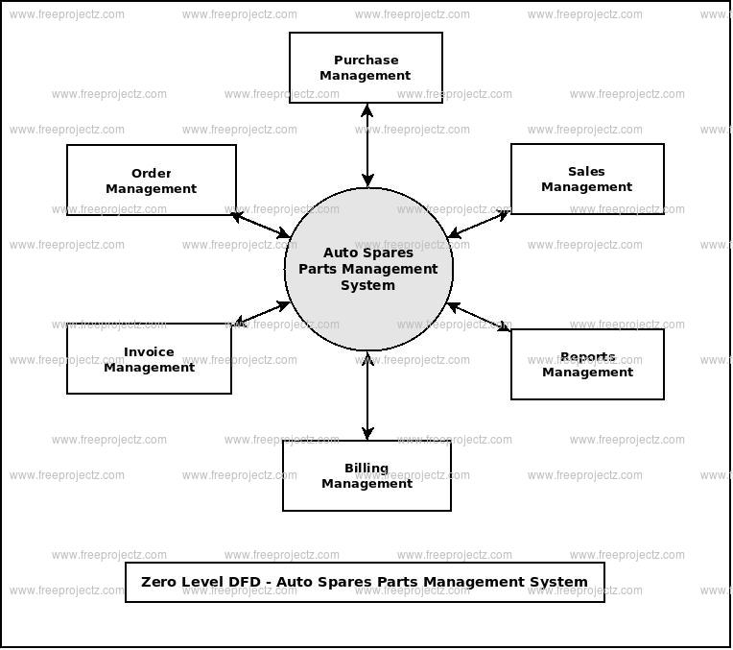

CHAPTER 4
TESTING AND IMPLEMENTATION

  - TESTING
Implementation is the stage of the project when the theoretical design is turned into a working system. This is the final and important phase in the system life cycle It is actually the process of converting the new system into a operational one.

4.1.1Unit Testing
Unit testing comprises the set of tests performed by an individual programmer prior to integration of the unit into a larger system. The module interface is tested to ensure that information properly flows into and out of the program unit. The local data structure is examined to ensure that data stored temporarily maintains its integrity during all steps in an algorithm’s execution. Boundary conditions are tested to ensure that the module operates properly at boundaries established to limit or restrict processing. All independent paths through the control structure are tested. All error-handling paths are tested.

4.1.2 Block Box Testing
Black-box testing is a method of software testing that examines the functionality of an application without peering into its internal structures or workings. This method of test can be applied virtually to every level of software testing: unit, integration, system and acceptance. It is sometimes referred to as specification-based testing.

4.2 SYSTEM IMPLEMENTATION
Implementation is the stage of the project when the theoretical design is turned into a working system. This is the final and important phase in the system life cycle It is actually the process of converting the new system into a operational one.

CHAPTER 5
CONCLUSION:
This paper uses the DEA-based ABC spare parts classification method to classify the automobile spare parts of Beijing Jintai Kaisheng Automobile Sales and Service Co., Ltd. and compares it with the traditional ABC classification method. The ABC classification method based on the outbound value of spare parts only considers the amount of the spare part occupation liquidity. But the DEA-based ABC classification method comprehensively considers the unit price, liquidity, specificity and demand forecasting rules in terms of capital, turnover rate, availability and difficulty of demand forecasting. Then the input DMU and the output DMU are determined, the related data are collected, the efficiency value is obtained using MATLAB, and classification is finally determined. The selection of special spare parts explains the difference in the results of the two classifications and proves the rationality of the ABC classification method based on DEA. At the same time, this article has some deficiencies. Because of the limited understanding of automotive spare parts, decision-making units are not considered comprehensively. Second, there is a degree of subjectivity on the data obtained by purchasers and Inventory managers.

CHAPTER-6
REFERENCE
- [1] G.H. Song “Discussion on the Control and Optimization of Parts Inventory Based on Automobile 4S”, 2015(27).
- [2] X.S.Yu “Application of ABC Classification Management Method in Automobile Maintenance Industry”, Logistics Technology, 2005(10):189-192.
- [3] Y.Q Xu “Comprehensive Application of ABC Method in 4s Inventory Management”, LogisticsTechnology, 2008(09):30-33.
- [4] Y. Zhao “Study on Automobile Spare Parts Optimization Model and Order Decision-Making of Tongliao Dongfeng Yueda Kia 4S”, Jilin University of Finance and Economics, 2014.
- [5] Nieola Saceani, MareoPna, Fredrik Persson”. Spare Parts classification and inventory Decisions Apreliminary study”, 2015.
- [6] Mohamed A. sharaf, Hussen AHelmv. Aelassifieation model forinventory management of spare parts. The international conference on Production engineering controlanddesign: 499-510.
- [7] C.X. Hu “Implementation and Improvement of ABC Taxonomy in Inventory Management”, Logistics Engineering and Management, 2010, 32(09):62-64.
- [8] Y.N. Jiang “Research on the demand forecast of parts and components for A-car 4S stores”, Beijing Jiaotong University, 2017.
- [9] N.F. Cui “Based on DEA spare parts ABC classification model”, Logistics Technology, 2007 (03):55-58.
- [10] M.Q. Wang “Interval efficiency value of decision unit in CCR model and its ranking”, Systems Engineering, 2008(04):109-112.

