Crime reporting using attribute based algorithm

ABSTRACT
Data mining is an important technique used in many fields with the purpose of acquiring valuable information from big data. This study aims to reveal the relations between the attributes of independent criminal records. The NIBRS database, which includes criminal records in USA that are recorded in 2013, is used in this study. The association rules created by the Apriori algorithm have been used to extract the relationships between features of criminal records. The experimental results show that the association rules created by the Apriori algorithm are useful for criminal analysis. This study reveals the relationships between the attributes of different criminal records and allows the authorities to establish relationships between new and old incidents.

CHAPTER 2
2. SYSTEM ANALYSIS
  - EXISTING SYSTEM

- Existing methods have used these databases to identify crime hotspots based on locations.
- On the other hand, the previous related work and their existing methods mainly identify crime hotspots based on the location of high crime density without considering either the crime type or the crime occurrence date and time.
- It was focusing on the existence of multi-scale complex relationships between both space and time.
- Other existing works explore relationships between the criminal activity and the socio-economics variables such as education, ethnicity, income level, and unemployment.
2.1.1 DRAWBACKS OF EXISTING SYSTEM :
- Crimes are a common social problem affecting the quality of life and the economic growth of a society.
- Because criminal cases have become more complicated than they were before, using new and up-to-date approaches in the analysis of cases and detailed detection of similarities between crime records constitute an important problem for criminology.
- Our study aims to find spatial and temporal criminal hotspots using a set of real-world datasets of crimes. We will try to locate the most likely crime locations and their frequent occurrence time.
- We intend to provide an analysis study by combining our findings of a particular crimes dataset with its demographics information.
2.2. PROPOSED SYSTEM
- The proposed study consists of five steps mainly as follows: data pre-processing, data encoding, creating transactions in the dataset, creating frequent itemsets which provide minimum support value and creating association rules which provide minimum confidence value out of the created itemsets.
- The purpose of this study is to predict the unknown characteristics of a specific case such as offender profile, crime weapon, victim profile and geographical zone by taking into consideration the known characteristics of past criminal cases.
- Our proposed approach aimed to focus on three main elements of crimes data, which are the type of crime, the occurrence time and the crime location.
2.2.1. ADVANTAGES OF PROPOSED SYSTEM
- It can help in the distribution of police at most likely crime places for any given time, to grant an efficient usage of police resources.
- Advantages of technology and analyzing the components of crime with the support of computer sciences have become important in solving the crime and detecting the offenders.
- We plan to apply more classification models to increase crime prediction accuracy and to enhance the overall performance.
- On the other hand, police forces can use this solution to increase the level of crime prediction and prevention.
- While our selected crime features have an independent effect on each other, this classifier was an ideal choice.
2.3 FEASIBILITY STUDY
The feasibility Analysis is an analytical program through project manager determines the project success ratio and through feasibility study project manager able to see either project. The key considerations involved in the feasibility analysis are:
- Economic Feasibility
- Technical Feasibility
- Operational Feasibility
- Environmental Feasibility
2.3.1 ECONOMICAL FEASIBILITY
Hence this project is economically feasible there is no need to involve any cost for this project.
2.3.2 TECHNICAL FEASIBILITY
Software Technologies used are PHP and MySql. In the educational institutions, it is possible to update the system in future. No special hardware is required for the purpose of using this system. Hence it is declared that this project is technically feasible.
2.3.3 OPERATIONAL FEASIBILITY
As the admin work mainly to maintain the Patient and Doctor .Doctor will predict patient cancer disease. Hence it is easy to operate with training. Therefore it is operationally feasible for implementation.
2.3.4 ENVIRONMENTAL FEASIBILITY
This project environment is correct as a admin has developed this system and no expenditure is involved under any head and this process is part of admin document management, this project environment is accessible.
2.4 SYSTEM REQUIREMENTS
- System : Pentium IV 2.4 GHz.
- Hard Disk : 40 GB.
- Monitor : 15 inch VGA Color.
- Mouse : Logitech Mouse.
- Ram : 512 MB
- Keyboard : Standard Keyboard
2.4.1 HARDWARE REQUIREMENTS
The Hardware of the computer consists of physical component such as Input Devices, Storage Devices, Processing & Control units and Output Devices. Computer includes external storage unit to store data in programs.
The Hardware Configuration involved in this project
- System : Pentium IV 2.4 GHz.
- Hard Disk : 40 GB.
- Monitor : 15 inch VGA Color.
- Mouse : Logitech Mouse.
- Ram : 512 MB
- Keyboard : Standard Keyboard

2.4.2 SOFTWARE REQUIREMENTS
Software is a group of programs that computers need to do a particular task. It is an essential requirement of Computer System. The Software used to develop the project is
- Operating System : Windows XP.
- Platform : DOT NET TECHNOLOGY
- Front End : ASP.Net 3.5
- Back End : SQL SERVER 2005

CHAPTER 3
SYSTEM DESIGN AND DEVELOPEMENT
SYSTEM ARCHICTURE

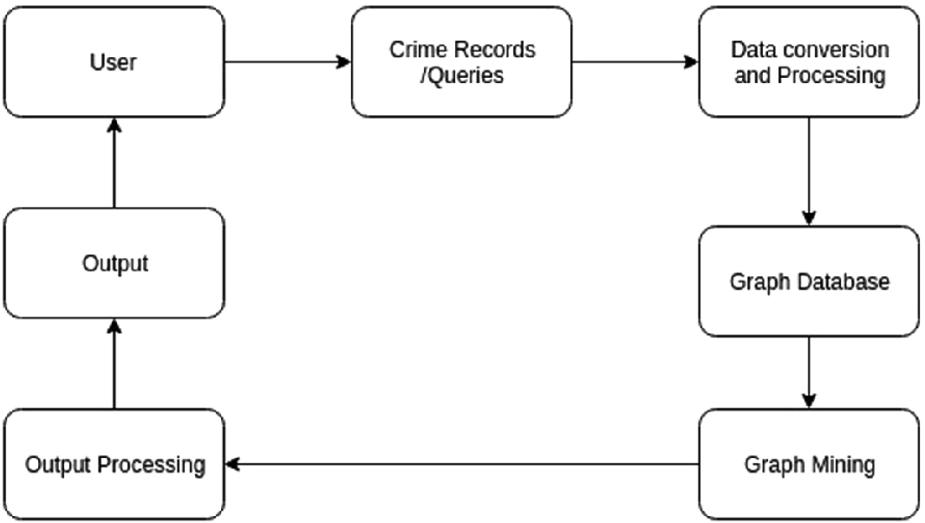

CHAPTER 4
TESTING AND IMPLEMENTATION

  - TESTING
Implementation is the stage of the project when the theoretical design is turned into a working system. This is the final and important phase in the system life cycle It is actually the process of converting the new system into a operational one.

4.1.1Unit Testing
Unit testing comprises the set of tests performed by an individual programmer prior to integration of the unit into a larger system. The module interface is tested to ensure that information properly flows into and out of the program unit. The local data structure is examined to ensure that data stored temporarily maintains its integrity during all steps in an algorithm’s execution. Boundary conditions are tested to ensure that the module operates properly at boundaries established to limit or restrict processing. All independent paths through the control structure are tested. All error-handling paths are tested.

4.1.2 Block Box Testing
Black-box testing is a method of software testing that examines the functionality of an application without peering into its internal structures or workings. This method of test can be applied virtually to every level of software testing: unit, integration, system and acceptance. It is sometimes referred to as specification-based testing.

4.2 SYSTEM IMPLEMENTATION
Implementation is the stage of the project when the theoretical design is turned into a working system. This is the final and important phase in the system life cycle It is actually the process of converting the new system into a operational one.

CHAPTER 5
CONCLUSION:
The rapid increase in crime cases has led to the development of new crime analysis techniques. One of the common crime analysis techniques used by law enforcement agencies today is the use of data mining techniques to create an offender profile, a victim profile and unknown characteristics of a newly occurring criminal case, which is committed by similar offender(s) in similar past criminal cases. In this study, strong association rules about crime cases are created by using association rule mining, which is one of data mining techniques. The NIBRS crime database, which consists of 48 different crime types and contains almost 5 million different crime incidents, is used in the study. Strong association rules about the attributes of records in NIBRS have been created via the developed program. This study is important in terms of using real crime data and covering a large number of criminal cases. Another highlight of the work is presenting a way for judicial authorities and law enforcement officers to figure out the undiscovered characteristics of similar criminal cases in the light of criminal investigations they have resolved in the past. This study differs from the others in the field for the reasons such as including many types of crime, examining multiple number of criminal records, using real criminal records and creating profiles in relation with the offender, victim and all the attributes of a case. As a result of the study, it is contemplated that the creation of crime databases has utmost importance for both scientific and forensic reasons. Therefore, creating such databases and enabling them to be accessed by researchers in countries will be beneficial for the enlightenment of criminal investigations and the solution of cases with unknown perpetrators.

CHAPTER-6
REFERENCE
- [1] U. Alacaptan, “Suçun unsurlari,” Ankara Üniversitesi Yayınları, vol. 372, pp. 2–3, 1975.
- [2] M. Orakcı and B. Ciylan, “Prediction of unknown elements in rape cases: Machine learning approach in crime analysis,” International Proceedings of The International Conference on Research in Education & Science, Muğla/Bodrum, May 19-22, 2016.
- [3] R. F. Sokullu-Akıncı, Kriminoloji, Beta Basım Yayım, Istanbul, 2016, ch. 12.
- [4] Tuik, “Ceza infaz kurumu istatistikleri, 2014,” TUİK Haber Bülteni, vol. 73-2009. 2008, 2014.
- [5] M. Orakcı, B. Ciylan, İ. Kök, and M. Sevri, “Suç analizinde veri madenciliği teknikleri ve makine öğrenmesi algoritmalarinin kullanilmasi,” presented at XVIII. Akademik Bilişim Conference, Aydın, February 3-5, 2016.
- [6] D. E. Brown, “The regional crime analysis program (RECAP): A framework for mining data to catch criminals,” International Proceedings of IEEE International Conference on Systems and Cybernectics, pp. 2848- 2853, 1998.
- [7] H. Takçı and Ş. Hayta, “Suç veri madenciliği yardimiyla hirsizlik suçlari hakkinda kural çikarimi,” International Proceedings of Elektrik – Elektronik – Bilgisayar ve Biyomedikal Mühendisliği Symposium, pp. 694-699, Bursa, 2014.
- [8] J. Hosseinkhani, M. Koochakzaei, S. Keikhaee, and Y. H. Amin, “Detecting suspicion information on the web using crime data mining techniques,” International Journal of Advanced Computer Science and Information Technology (IJACSIT), vol. 3, no. 1, pp. 32-41, 2014.
- [9] H. Hassani, X. Huang, E. S. Silva, and M. Ghodsi, “A review of data mining applications in crime. Statistical analysis and data mining,” The ASA Data Science Journal, vol. 9, no. 3, pp. 139-154, 2016.
- [10] M. Strano, “A neural network applied to criminal psychological profiling: An Italian initiative,” International Journal of Offender Therapy and Comparative Criminology, vol. 48, no. 4, pp. 495-503, 2004.

