Advertisement video editing project

ABSTRACT
Today marketers seek the ways and information facilities to create loyal customers, because it reduces the marketing and operations costs and increases the benefits. In every organization, whether manufacturing or service, customers are the most important factor of ensuring the survival of organization. If the organization succeeds in attracting customers and creating their loyalty, the field of its growth and long-term survival can be provided. It is possible to achieve this through studying and planning by management, and this will lead at the end to the comprehensive recognition of customer needs. Since focusing on factors of customers’ satisfaction has a significant effect in banking, so, identifying the categories and priorities of these factors is important. All hypotheses of this study are approved by both Student’s ttest and Friedman test. The results of study indicated that the factors of reliability, accountability and credit factors, respectively, have more importance in order of priority. In credit factors: variety of banking services (providing any kind of services which customers need); in accountability factors: speed in providing banking services; in reliability factors: proper behavior of staff is considered of the most priority.

CHAPTER 2
2. SYSTEM ANALYSIS
  - EXISTING SYSTEM

- The HDTV technology exists and some television stations have begun transmitting to users on limited channels now uses digital rather than analog signal transmission, utilizing the MPEG-2 and MPEG-4 file format and compression standard.
- It exists as an additional clip in the Project window.
- When you want to cross fade existing clips in the Timeline window, you have to extend the duration of one or more audio clips.
- With the Adobe Title Designer you can create text and graphics that you can import and superimpose over existing video or run alone as an independent clip.
- Open a new or existing project for which you want to create a new title clip.
2.1.1 DRAWBACKS OF EXISTING SYSTEM :
- When you diagnose problems related to interlaced fields, view the clips on an interlaced television display, because diagnosing field problems on a progressive-scan monitor is unreliable.
- The second was that the TV studios would have had enormous problems with flicker on their cameras when making programs.
- NTSC (often scurrilously referred to as Never Twice the Same colour) works perfectly in a video or closed circuit environment but can create problems of varying hue when used in a broadcast environment.
- This hue change problem is caused by shifts in the colour sub-carrier phase of the signal.
2.2. PROPOSED SYSTEM
- Most videos are prepared to serve a purpose, such as telling a story or providing information. Editing is a crucial step in ensuring that the video flows in a way which achieves the goal.
- A rolling trim's purpose is to adjust the meeting point of two neighbouring clips, but keeping the In point of the first clip or the Out point of the second clip fixed.
- If you are producing a video for a website or for a certain purpose, you may already know what format is required.
- With the increasing use of broadband communications and fast personal computers, the future of video distribution will involve the use of the Internet, and a technology known as streaming video, a technology ideal for sales presentations and tutorials.
2.2.1. ADVANTAGES OF PROPOSED SYSTEM
- An efficient editor with a good aesthetics sense can bring out the best output.
- It is often used to mean analog editing, because in digital editing it is both unnecessary and difficult. It is also known as assembly editing.
- Non-linear editing has to be digital (computers don't do analog) and it is often used just to mean digital video.
- It is called non-linear editing because you are not constrained to start at the beginning and finish at the end, as you generally do with linear editing.
- In this way, the editing work done on the less expensive workstation is used to create the final cut on the more expensive, higher-quality workstation.
2.3 FEASIBILITY STUDY
The feasibility Analysis is an analytical program through project manager determines the project success ratio and through feasibility study project manager able to see either project. The key considerations involved in the feasibility analysis are:
- Economic Feasibility
- Technical Feasibility
- Operational Feasibility
- Environmental Feasibility
2.3.1 ECONOMICAL FEASIBILITY
Hence this project is economically feasible there is no need to involve any cost for this project.

2.3.2 TECHNICAL FEASIBILITY
Software Technologies used are PHP and MySql. In the educational institutions, it is possible to update the system in future. No special hardware is required for the purpose of using this system. Hence it is declared that this project is technically feasible.
2.3.3 OPERATIONAL FEASIBILITY
As the admin work mainly to maintain the Patient and Doctor .Doctor will predict patient cancer disease. Hence it is easy to operate with training. Therefore it is operationally feasible for implementation.
2.3.4 ENVIRONMENTAL FEASIBILITY
This project environment is correct as a admin has developed this system and no expenditure is involved under any head and this process is part of admin document management, this project environment is accessible.
2.4 SYSTEM REQUIREMENTS
- System : Pentium IV 2.4 GHz.
- Hard Disk : 40 GB.
- Monitor : 15 inch VGA Color.
- Mouse : Logitech Mouse.
- Ram : 512 MB
- Keyboard : Standard Keyboard

2.4.1 HARDWARE REQUIREMENTS
The Hardware of the computer consists of physical component such as Input Devices, Storage Devices, Processing & Control units and Output Devices. Computer includes external storage unit to store data in programs.
The Hardware Configuration involved in this project
- System : Pentium IV 2.4 GHz.
- Hard Disk : 40 GB.
- Monitor : 15 inch VGA Color.
- Mouse : Logitech Mouse.
- Ram : 512 MB
- Keyboard : Standard Keyboard

2.4.2 SOFTWARE REQUIREMENTS
Software is a group of programs that computers need to do a particular task. It is an essential requirement of Computer System. The Software used to develop the project is
- Operating System : Windows XP.
- Platform : DOT NET TECHNOLOGY
- Front End : ASP.Net 3.5
- Back End : SQL SERVER 2005

CHAPTER 3
SYSTEM DESIGN AND DEVELOPEMENT
SYSTEM ARCHICTURE

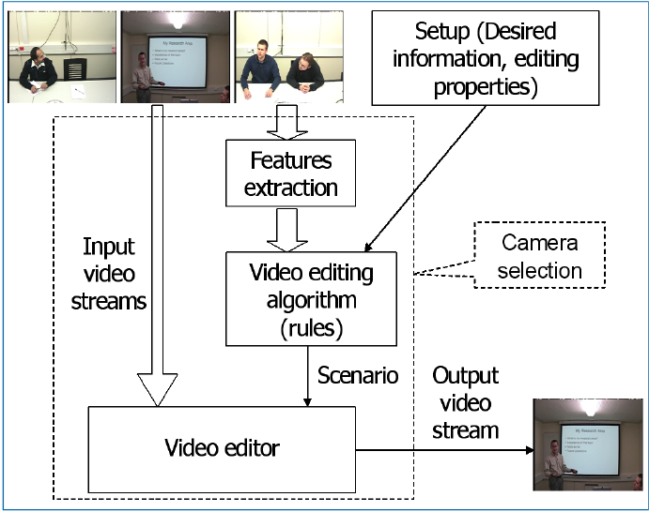

CHAPTER 4
TESTING AND IMPLEMENTATION

  - TESTING
Implementation is the stage of the project when the theoretical design is turned into a working system. This is the final and important phase in the system life cycle It is actually the process of converting the new system into a operational one.

4.1.1Unit Testing
Unit testing comprises the set of tests performed by an individual programmer prior to integration of the unit into a larger system. The module interface is tested to ensure that information properly flows into and out of the program unit. The local data structure is examined to ensure that data stored temporarily maintains its integrity during all steps in an algorithm’s execution. Boundary conditions are tested to ensure that the module operates properly at boundaries established to limit or restrict processing. All independent paths through the control structure are tested. All error-handling paths are tested.

4.1.2 Block Box Testing
Black-box testing is a method of software testing that examines the functionality of an application without peering into its internal structures or workings. This method of test can be applied virtually to every level of software testing: unit, integration, system and acceptance. It is sometimes referred to as specification-based testing.

4.2 SYSTEM IMPLEMENTATION
Implementation is the stage of the project when the theoretical design is turned into a working system. This is the final and important phase in the system life cycle It is actually the process of converting the new system into a operational one.

CHAPTER 5
CONCLUSION:
The student evaluation of teaching effectiveness data presented in this study suggests that students had a positive learning experience. Students get a sense of accomplishment when, in a single class period in computer lab, they start with nothing at the beginning of class, follow a tutorial during class, and by the end class have created a video or learned a new video editing skill. Video editing and motion graphics skills and concepts are an extension of graphic design skills and concepts. Ideally, students would have basic or fundamental graphic design skills before they start to animate graphics and create videos. But, with the help of Lynda.com tutorials and a focused weekly schedule like the schedule presented in Table 1, students can tackle video editing and motion graphics in a semester-long marketing course. It is true that there is more advanced video editing software such as Adobe Premiere Pro and Apple’s Final Cut. But, this software contains more features and is more complex. Would students find it helpful to learn this more complex software? It would be interesting to see research on whether or not marketing students found it helpful to learn Adobe Premiere Pro or Final Cut. As Adobe introduces new versions of Photoshop, Lynda.com will continue to add new tutorials to its website. As marketing professionals continue to use sites like Videohive, Audiojungle, and Graphicriver will continue to add new template files and stock footage for sale. Hopefully marketing students and marketing educators continue to use these resources to create positive learning experiences.

CHAPTER-6
REFERENCE
- 1. Buzzard, C., Crittenden, V. L., Crittenden, W. F., & McCarty, P. (2011). The Use of Digital Technologies in the Classroom: A Teaching and Learning Perspective. Journal of Marketing Education, 33(2), 131-139.
- 2. Chen, Y., Gupta, A., & Hoshower, L. (2004). Marketing students’ perceptions of teaching evaluations: An application of expectancy theory. Marketing Education Review, 14, 23-36.
- 3. Clayson, D. E. (2009). Student evaluations of teaching: Are they related to what students learn?: A meta-analysis and review of the literature. Journal of Marketing Education, 31, 16-30
- 4. Clarke III, I., & Flaherty, T. (2007). Fostering Information Literacy in the Marketing Curriculum by Engaging Students with Print Marketing Resources. Marketing Education Review, 17(1), 79-85.
- 5. Clow, K. E. (1999). Interactive distance learning: Impact on student course evaluations. Journal of Marketing Education, 21, 97-105.
- 6. Crittenden, V. L., & Crittenden, W. F. (2015). Digital and Social Media Marketing in Business Education: Implications for Student Engagement. Journal of Marketing Education, 37(3).
- 7. Green, T. (2015). Flipped Classrooms: An Agenda for Innovative Marketing Education in the Digital Era. Marketing Education Review, 25(3), 179-191.
- 8. Hannaford, W., Erffmeyer, R., & Tomkovick, C. (2002). Championing Technology in Marketing Education: Assessing the Value of a Discipline-Specific Technology Course. Marketing Education Review, 12(3), 47-57.
- 9. Malhotra, N. K. (2002). Integrating technology in marketing education: Perspective for the new millennium. Marketing Education Review, 12(3), 1-5.
- 10. McArthur, E., Kubacki, K., Pang, B. & Alcaraz, C. (2017). The Employers’ View of ‘Work-Ready’ Graduates: A Study of Advertisements for Marketing Jobs in Australia. Journal of Marketing Education, 39(2), 82-93.

