Advanced professional services automation

ABSTRACT
The paper deals with the newest ìkiller applicationî ñ professional service automation (PSA). The solution concept is explained, and the existing and potential users are identified as well as the benefits realized by users. Next the situation on the market is analyzed, main existing solutions are categorized and strength and weaknesses of the major categories are identified. Finally Autotask solution is used as an example to demonstrate the PSA solution functionality

CHAPTER 2
2. SYSTEM ANALYSIS
  - EXISTING SYSTEM

- To support the development, production, and use of an IT innovation, existing arrangements must be invoked and new arrangements often need to be made.
- This new focus suggests that the diffusion of an IT innovation hinges not just on existing institutional arrangements, but also on how institutional entrepreneurs can invoke or create more favorable arrangements.
- The market for a new technology itself constitutes a needed institutional arrangement, as early on, its existence and nature may not even be recognized.
- New IT often involves new actors and activities for which existing institutional arrangements cannot easily be invoked or needed arrangements do not yet exist.
2.1.1 DRAWBACKS OF EXISTING SYSTEM :
- The problem is that, because actors’ involvements change over time, certain so-called institutional entrepreneurs may not always be such, while those not so identified may on occasion be key players.
- PSA is argued to be a solution to problems unique to service-oriented organizations that previous, product-centric software did not address.
- However, even if a focused leading vendor had emerged in the PSA community, as SAP and Siebel did in the ERP and CRM communities respectively, we argue that PSA would still founder due to its problematic legitimation, to which we turn next.
- When a label is absent or in question, dissemination of the vision is made problematic and cognitive legitimation is undermined.
2.2. PROPOSED SYSTEM
- In the PSA community, we became observers for the most part, except that a vendor approached us hoping to demonstrate its products in our school’s executive education program, we were invited to post our research on a conference web site, and, further, an analyst proposed a joint research program with us on the business benefits of PSA.
- Besides changing the proposed benefits, some strategies include selling through the VAR channels, so customers are buying from someone they trust, or alliances with the already accepted vendors.
- The purpose of the CRM solution is to support all of the customer-centric processes within enterprise, mid-enterprise, and mid-market organizations including marketing, sales, and customer support.

2.2.1. ADVANTAGES OF PROPOSED SYSTEM
- A new breed of software that can track the complex and evolving information related to an IT staff, including schedules, skills, career goals, and knowledge base.
- They can also capture performance metrics and let workers map their own career development
- Recent scandals have created the need for organizations to more accurately track and report financials. With PSA, executives can now assess the performance of their enterprises in real time.
- In order to create the market for PSA among service-oriented firms, institutional entrepreneurs invoked the institutional logic that existed in manufacturing-oriented firms, that operational efficiency can be improved through automation.
2.3 FEASIBILITY STUDY
The feasibility Analysis is an analytical program through project manager determines the project success ratio and through feasibility study project manager able to see either project. The key considerations involved in the feasibility analysis are:
- Economic Feasibility
- Technical Feasibility
- Operational Feasibility
- Environmental Feasibility
2.3.1 ECONOMICAL FEASIBILITY
Hence this project is economically feasible there is no need to involve any cost for this project.
2.3.2 TECHNICAL FEASIBILITY
Software Technologies used are PHP and MySql. In the educational institutions, it is possible to update the system in future. No special hardware is required for the purpose of using this system. Hence it is declared that this project is technically feasible.
2.3.3 OPERATIONAL FEASIBILITY
As the admin work mainly to maintain the Patient and Doctor .Doctor will predict patient cancer disease. Hence it is easy to operate with training. Therefore it is operationally feasible for implementation.
2.3.4 ENVIRONMENTAL FEASIBILITY
This project environment is correct as a admin has developed this system and no expenditure is involved under any head and this process is part of admin document management, this project environment is accessible.
2.4 SYSTEM REQUIREMENTS
- System : Pentium IV 2.4 GHz.
- Hard Disk : 40 GB.
- Monitor : 15 inch VGA Color.
- Mouse : Logitech Mouse.
- Ram : 512 MB
- Keyboard : Standard Keyboard

2.4.1 HARDWARE REQUIREMENTS
The Hardware of the computer consists of physical component such as Input Devices, Storage Devices, Processing & Control units and Output Devices. Computer includes external storage unit to store data in programs.
The Hardware Configuration involved in this project
- System : Pentium IV 2.4 GHz.
- Hard Disk : 40 GB.
- Monitor : 15 inch VGA Color.
- Mouse : Logitech Mouse.
- Ram : 512 MB
- Keyboard : Standard Keyboard

2.4.2 SOFTWARE REQUIREMENTS
Software is a group of programs that computers need to do a particular task. It is an essential requirement of Computer System. The Software used to develop the project is
- Operating System : Windows XP.
- Platform : DOT NET TECHNOLOGY
- Front End : ASP.Net 3.5
- Back End : SQL SERVER 2005

CHAPTER 3
SYSTEM DESIGN AND DEVELOPEMENT
SYSTEM ARCHICTURE

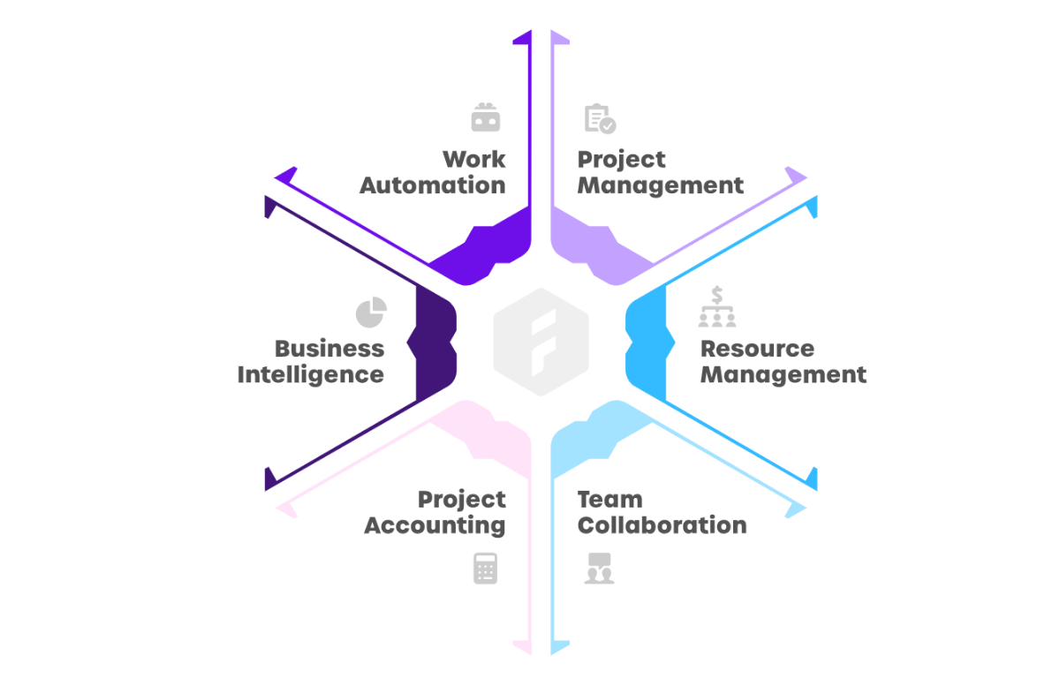

CHAPTER 4
TESTING AND IMPLEMENTATION

  - TESTING
Implementation is the stage of the project when the theoretical design is turned into a working system. This is the final and important phase in the system life cycle It is actually the process of converting the new system into a operational one.

4.1.1Unit Testing
Unit testing comprises the set of tests performed by an individual programmer prior to integration of the unit into a larger system. The module interface is tested to ensure that information properly flows into and out of the program unit. The local data structure is examined to ensure that data stored temporarily maintains its integrity during all steps in an algorithm’s execution. Boundary conditions are tested to ensure that the module operates properly at boundaries established to limit or restrict processing. All independent paths through the control structure are tested. All error-handling paths are tested.

4.1.2 Block Box Testing
Black-box testing is a method of software testing that examines the functionality of an application without peering into its internal structures or workings. This method of test can be applied virtually to every level of software testing: unit, integration, system and acceptance. It is sometimes referred to as specification-based testing.

4.2 SYSTEM IMPLEMENTATION
Implementation is the stage of the project when the theoretical design is turned into a working system. This is the final and important phase in the system life cycle It is actually the process of converting the new system into a operational one.

CHAPTER 5
CONCLUSION:
PSA is still an emerging market and still has a long way to go to reach the potential adoption rate. It is currently facing the chasm; however, there are already signs of crossing it. When the early majority is reached, we will see a tremendous growth. There is currently no clear market leader, but as the market develops, there will be intensive consolidation and few vendors will dominate the market. Vendors of solutions like Autotask, who realize first, that the value proposition must be changed and are able to offer and communicate it to the market, have the best chance to be one of those leaders. Customers have the most to gain from this development. There is no doubt, that to master the customer relationship management and become a truly customercentric organization, the PSA solution will soon become a requirement for every service oriented company.

CHAPTER-6
REFERENCE
- i) Taking Your Service Business to the Next Level, The Kyros Group, March 2002
- ii) Autotask Business Plan, March 2002
- iii) Professional Service Automation: End-User Research Study, Aberdeen Group, November 2001
- iv) Professional Service Automation: Integrated Solutions Optimize Services Supply Chain Performance and Increase Profitability, Aberdeen Group, January 2001
- v) PSA Consulting Organizations Are Optimistic About the Future but Face Operational Hurdles in Europe, IDC Press Release, 31 May 2001
- vi) Moore, Geoffrey A., ì High-Tech Marketing Illusion, Crossing the Chasmî, New York: Harper Collins Publishers, 1995
- vii) Professional Services Automation ñ Return on Investment Study Results, IDC White Paper, 2000
- viii) Tiazkun, S., PSA for the Little Guy, Professional Services Automation Applications Bulletin, IDC, March 2002
- ix) Vendor Profile: Autotask Group, Aberdeen Group, March 2002
- x) Autotask Sales Presentation, March 2002

