E-Sales on turkey purchase

ABSTRACT
Today, the number of technological devices such as computers, cell phones, tablets etc. has increased and their usage has become widespread. As a result of frequent use of these technologies depending on situation, these devices have developed even further and became a part of our lives. Development of Internet infrastructure and increase of its usage have led people to interact more with the Internet and it has become an indispensable aspect of our lives. The fact that the Internet offers new opportunities for businesses and consumers formed a basis for development of e-commerce. The purpose of this paper is to determine impacts of electronic commerce and Internet technology in Turkey on both companies and customers through literature reviews.

CHAPTER 2
2. SYSTEM ANALYSIS
  - EXISTING SYSTEM

- As it is forecast these mega-trends will have crucial implications for corporate activities and customer behaviours, a good many companies have already analysed them in order to shape their strategies and investments and preserve their commercial existence in the future.
- The programme also intends to increase domestic savings, to re-channel existing resources towards productive areas, and to improve the production capacity and technological accumulation of the economy.
- Economic power shifting from developed to developing countries creates an urgent need for retailers to revisit their existing positions within the market.
2.1.1 DRAWBACKS OF EXISTING SYSTEM :
- It is believed that all these facts will increase the spare time of people and, therefore, electronic commerce will have impacts on both economic and social lives of the society.
- However this problem, the decrease in employment caused by redundancies in the long term, can be compensated with the new employment opportunities created by information technologies (database specialist, biotechnology expert, web designer, solution architect, Internet strategy specialist, programming etc.).
- The concerns of people who refrain from performing all of these procedures and even those who carry out their transactions in electronic environments are tried to be eliminated with laws and regulations issued by governmental bodies.
2.2. PROPOSED SYSTEM
- The purpose of this report is to present extensive data to potential investors, regulators, and other stakeholders, while analysing the current state and future projections of traditional and organised retail in Turkey in light of emerging trends.
- However, shopping centers with different concepts and serving different purposes will be more advantageous in the future. Istanbul has turned into a regional hub for peripheral countries, further attracting foreign investors.
- The internet is not a domain which solely serves shopping purposes.
- The number of individuals who travel for shopping purposes has increased, as pointed out in the Global Shopping Report of the United Nations Tourism Organisation (UNWTO).
2.2.1. ADVANTAGES OF PROPOSED SYSTEM
- As an instrument that astounded everyone since the day it entered to our lives, television has been considered as one of the most efficient instruments due to its audiovisual property.
- Electronic commerce will reduce the time spent on performing tasks, and the time required to monitor the daily routine works, and thus the costs will decrease and consequently the efficiency will go up.
- It is possible for them to manage customer demands quickly and efficiently.
- Phone is the most important means used in e-commerce. The reason for this is the presence of smart phones that are commonly used by almost everybody.
2.3 FEASIBILITY STUDY
The feasibility Analysis is an analytical program through project manager determines the project success ratio and through feasibility study project manager able to see either project. The key considerations involved in the feasibility analysis are:
- Economic Feasibility
- Technical Feasibility
- Operational Feasibility
- Environmental Feasibility
2.3.1 ECONOMICAL FEASIBILITY
Hence this project is economically feasible there is no need to involve any cost for this project.
2.3.2 TECHNICAL FEASIBILITY
Software Technologies used are PHP and MySql. In the educational institutions, it is possible to update the system in future. No special hardware is required for the purpose of using this system. Hence it is declared that this project is technically feasible.
2.3.3 OPERATIONAL FEASIBILITY
As the admin work mainly to maintain the Patient and Doctor .Doctor will predict patient cancer disease. Hence it is easy to operate with training. Therefore it is operationally feasible for implementation.
2.3.4 ENVIRONMENTAL FEASIBILITY
This project environment is correct as a admin has developed this system and no expenditure is involved under any head and this process is part of admin document management, this project environment is accessible.
2.4 SYSTEM REQUIREMENTS
- System : Pentium IV 2.4 GHz.
- Hard Disk : 40 GB.
- Monitor : 15 inch VGA Color.
- Mouse : Logitech Mouse.
- Ram : 512 MB
- Keyboard : Standard Keyboard
2.4.1 HARDWARE REQUIREMENTS
The Hardware of the computer consists of physical component such as Input Devices, Storage Devices, Processing & Control units and Output Devices. Computer includes external storage unit to store data in programs.
The Hardware Configuration involved in this project
- System : Pentium IV 2.4 GHz.
- Hard Disk : 40 GB.
- Monitor : 15 inch VGA Color.
- Mouse : Logitech Mouse.
- Ram : 512 MB
- Keyboard : Standard Keyboard

2.4.2 SOFTWARE REQUIREMENTS
Software is a group of programs that computers need to do a particular task. It is an essential requirement of Computer System. The Software used to develop the project is
- Operating System : Windows XP.
- Platform : DOT NET TECHNOLOGY
- Front End : ASP.Net 3.5
- Back End : SQL SERVER 2005

CHAPTER 3
SYSTEM DESIGN AND DEVELOPEMENT
SYSTEM ARCHICTURE

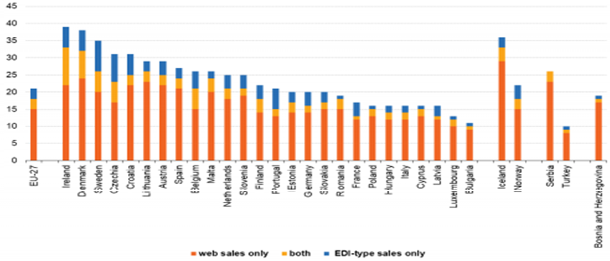

CHAPTER 4
TESTING AND IMPLEMENTATION

  - TESTING
Implementation is the stage of the project when the theoretical design is turned into a working system. This is the final and important phase in the system life cycle It is actually the process of converting the new system into a operational one.

4.1.1Unit Testing
Unit testing comprises the set of tests performed by an individual programmer prior to integration of the unit into a larger system. The module interface is tested to ensure that information properly flows into and out of the program unit. The local data structure is examined to ensure that data stored temporarily maintains its integrity during all steps in an algorithm’s execution. Boundary conditions are tested to ensure that the module operates properly at boundaries established to limit or restrict processing. All independent paths through the control structure are tested. All error-handling paths are tested.

4.1.2 Block Box Testing
Black-box testing is a method of software testing that examines the functionality of an application without peering into its internal structures or workings. This method of test can be applied virtually to every level of software testing: unit, integration, system and acceptance. It is sometimes referred to as specification-based testing.

4.2 SYSTEM IMPLEMENTATION
Implementation is the stage of the project when the theoretical design is turned into a working system. This is the final and important phase in the system life cycle It is actually the process of converting the new system into a operational one.

CHAPTER 5
CONCLUSION:
When compared to the previous years, the number of individuals using Internet for ordering or purchasing goods or services via the Internet for personal use increased. And this indicates that Turkish society showed progress in terms of electronic trade. In comparison with traditional marketing or commerce rates, the volume of electronic trade is increasing. The increase in the Internet subscriptions, people’s dependency on the Internet and other means of e-commerce, proliferation of cell phones, availability of smart phones in particular, campaigns of service provider phone operators especially regarding the Internet connection, cause e-commerce to have a profound place in the lives of Turkish people, just as it is worldwide. The availability of cell phones and Internet packages especially among young people and high school and university students in particular, makes this group dependent on the Internet. Since the universities now use automated systems, students carry out many of the procedures, their grading in particular, through e-commerce. Citizens began to carry out their procedures in an electronic environment through systems such as e-business, e-government, etc.

CHAPTER-6
REFERENCE
- 1. Başhan, F. (2011). İnternetİn Çeşİtlİ Yönlerİyle Türk Toplumunca Benİmsenmesİ: Karaman Örneğİ. İşletme Ana Bilim Dalı İşletme Bilim Dalı Yüksek Lisans Tezi. Karaman.
- 2. Budak, B. (2010). E-ticaret Internet ortamında ticaret. Istanbul: etap yayınevi, 19
- 3. Defining and Measuring E-Commerce: a Status Report,DSTI/ICCP/IIS(99)4/FINAL,OLIS : 07-Oct-1999,Dist.: 08-Oct-1999.
- 4. Ford, W., & Baum, M. S. (2000). Secure electronic commerce: building the infrastructure for digital signatures and encryption. Prentice Hall PTR.
- 5. Jahns, G. (2006). Bilgi İşlemenin Tarihçesi. Çevirmenler: Pınar Demİrcİoğlu ve İsmail Böğrekcİ,Jahns, Gerhard..
- 6. Kalakota, R., & Whinston, A. B. (1996). Frontiers of electronic commerce. MA: Addison-Wesley.
- 7. Kalayci, C. (2008). Elektronİk Tİcaret ve Kobİ’lere Etkİlerİ, Uluslararası İktisadi ve İdari İncelemeler Dergisi, 1(1).
- 8. Kirçova, İ. (2000). İnternette Pazarlama. Beta Basım Yayım, 6.
- 9. Mesafelİ Sözleşmeler Yönetmelİğİ. (27 November 2014). Official Gazette, 28(29188).
- 10. Munack, A. & Joseph, St. Michigan The History of Information Processing. Handbook of Agricultural Engineering Volume VI Information Technology. USA: ASABE.

