Donor application System

ABSTRACT
Organ donation as we all know is a good cause and can save many lives but in a developing country like India it is still not that popular. Although, the rate of donation has been increasing from the past few years but it is still not enough as only 0.01% of people donate their organs after death. The main reason is lack of awareness and this android application is to create awareness among people. This Android application aims at linking the donors or wanting to be donors to the seekers. The donors and the seekers will register through the app by filling the details about themselves and by uploading their medical reports. The donor will have to upload the donor card as well. The phone number will be verified by One Time Password (OTP). All the data is being stored in the Database. Our application mainly fulfils the purpose of urgency of an organ when required by the patient and puts all the functionality and connection between our donor and recipient.

CHAPTER 2
2. SYSTEM ANALYSIS
  - EXISTING SYSTEM

- Information regarding pre-existing conditions like Cancer, TB, AIDS is also required to be filled in the registration form itself.
- Due to existing myths surrounding brain death and lack of awareness, people tend to waste the opportunity of saving the life of others, due to which there is a waste of organ donation.
- All potential and existing donors should be asked to adhere to the blood donor selection criteria by providing accurate information and answers to all questions asked, both for the protection of their health and that of patients who receive transfusion.
- It exists in four distinct forms: sporadic, genetic (familial), iatrogenic and variant (vCJD).
2.1.1 DRAWBACKS OF EXISTING SYSTEM :
- The acceptance of individuals with current or past mental health problems as blood donors depends on an assessment of their ability to fully answer the donor questionnaire and interview and to give informed consent to the donation process, including the testing of their blood.
- The decision to defer blood donors with a history of travel or residence for defined cumulative exposure periods in specified countries or areas, as a measure to reduce the risk of transmitting vCJD by blood transfusion, should be based on the findings of the risk assessment and risk-benefit analysis and the impact on the blood supply.
2.2. PROPOSED SYSTEM
- There is no such market opportunity in this application, it’s an application which is meant for the lifesaving purpose and will be a revolutionary step for saving the lives of our people.
- The sole purpose of this project is to develop a computer system that will link all donors, control a blood transfusion service and create a database to hold data on stocks of blood in each area. Furthermore, people will be able to see which patients need blood supplies via the android application.
- Blood Donation System is an android based system that is designed to store, process, retrieve and analyze information concerned with the administrative and inventory management within a blood bank.
2.2.1. ADVANTAGES OF PROPOSED SYSTEM
- Easy connecting donors and recipients makes blood donation way more proficient.
- Prime motive of the app is to solve the perpetual shortfall of blood donors.
- It connects blood donors and recipients through a single and scalable platform.
- Effortless access: Users on this platform will be able to use the app with just One-click.
- Easy registrations through the mobile app will help getting quick access from both ends.
2.3 FEASIBILITY STUDY
The feasibility Analysis is an analytical program through project manager determines the project success ratio and through feasibility study project manager able to see either project. The key considerations involved in the feasibility analysis are:
- Economic Feasibility
- Technical Feasibility
- Operational Feasibility
- Environmental Feasibility
2.3.1 ECONOMICAL FEASIBILITY
Hence this project is economically feasible there is no need to involve any cost for this project.
2.3.2 TECHNICAL FEASIBILITY
Software Technologies used are PHP and MySql. In the educational institutions, it is possible to update the system in future. No special hardware is required for the purpose of using this system. Hence it is declared that this project is technically feasible.
2.3.3 OPERATIONAL FEASIBILITY
As the admin work mainly to maintain the Patient and Doctor .Doctor will predict patient cancer disease. Hence it is easy to operate with training. Therefore it is operationally feasible for implementation.
2.3.4 ENVIRONMENTAL FEASIBILITY
This project environment is correct as a admin has developed this system and no expenditure is involved under any head and this process is part of admin document management, this project environment is accessible.
2.4 SYSTEM REQUIREMENTS
- System : Pentium IV 2.4 GHz.
- Hard Disk : 40 GB.
- Monitor : 15 inch VGA Color.
- Mouse : Logitech Mouse.
- Ram : 512 MB
- Keyboard : Standard Keyboard
2.4.1 HARDWARE REQUIREMENTS
The Hardware of the computer consists of physical component such as Input Devices, Storage Devices, Processing & Control units and Output Devices. Computer includes external storage unit to store data in programs.
The Hardware Configuration involved in this project
- System : Pentium IV 2.4 GHz.
- Hard Disk : 40 GB.
- Monitor : 15 inch VGA Color.
- Mouse : Logitech Mouse.
- Ram : 512 MB
- Keyboard : Standard Keyboard

2.4.2 SOFTWARE REQUIREMENTS
Software is a group of programs that computers need to do a particular task. It is an essential requirement of Computer System. The Software used to develop the project is
- Operating System : Windows XP.
- Platform : DOT NET TECHNOLOGY
- Front End : ASP.Net 3.5
- Back End : SQL SERVER 2005

CHAPTER 3
SYSTEM DESIGN AND DEVELOPEMENT
SYSTEM ARCHICTURE

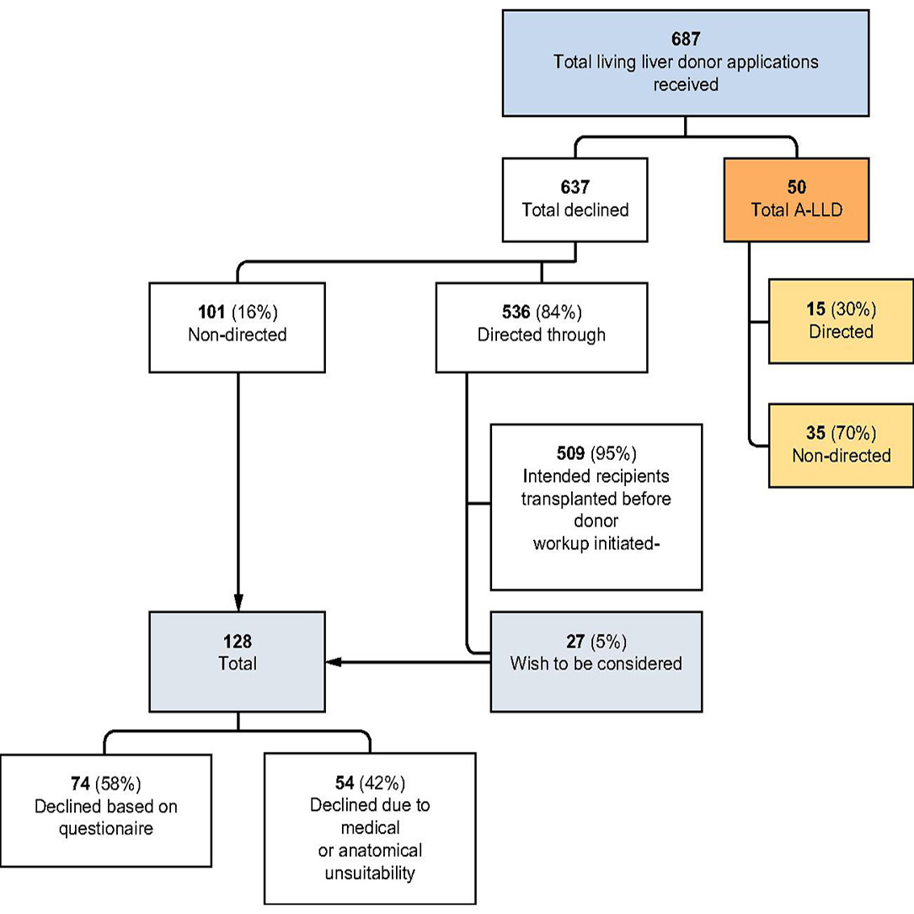

CHAPTER 4
TESTING AND IMPLEMENTATION

  - TESTING
Implementation is the stage of the project when the theoretical design is turned into a working system. This is the final and important phase in the system life cycle It is actually the process of converting the new system into a operational one.

4.1.1Unit Testing
Unit testing comprises the set of tests performed by an individual programmer prior to integration of the unit into a larger system. The module interface is tested to ensure that information properly flows into and out of the program unit. The local data structure is examined to ensure that data stored temporarily maintains its integrity during all steps in an algorithm’s execution. Boundary conditions are tested to ensure that the module operates properly at boundaries established to limit or restrict processing. All independent paths through the control structure are tested. All error-handling paths are tested.

4.1.2 Block Box Testing
Black-box testing is a method of software testing that examines the functionality of an application without peering into its internal structures or workings. This method of test can be applied virtually to every level of software testing: unit, integration, system and acceptance. It is sometimes referred to as specification-based testing.

4.2 SYSTEM IMPLEMENTATION
Implementation is the stage of the project when the theoretical design is turned into a working system. This is the final and important phase in the system life cycle It is actually the process of converting the new system into a operational one.

CHAPTER 5
CONCLUSION:
This application will be the most user-friendly platform to enroll people in such good activity and will save many lives of the people who are dying due to lack of organ donation. It will create a long-term lifesaving role for every citizen in our country. Our prime target is to provide organs to the seeker when they are in need and make it a life saver platform for those who are dying due to the lack of organs and also targets the human race and spreads the concept of saving life after one's death.

CHAPTER-6
REFERENCE
- 1)https://en.wikipedia.org/wiki/Organ_donation_in_India#Deceased_organ_donation_by_state
- 2) LAKSHMISRI SURYA , "STREAMLINING CLOUD APPLICATION WITH AI TECHNOLOGY", IJIERT - International Journal of Innovations in Engineering Research and Technology, Volume 5 Issue 10, ISSN : 2394-3696, Page No. 23-28
- 3) Sudhir Allam, "RESEARCH ON THE SECURE MEDICAL BIG DATA ECOSYSTEM BASED ON HADOOP", International Journal of Creative Research Thoughts (IJCRT), ISSN:2320-2882, Volume.7, Issue 1, pp.815-819, March 2019, Available at :http://www.ijcrt.org/papers/IJCRT1133997.pdf
- 4) https://www.indiatoday.in/mail-today/story/india-s-organ-crisis-deepens-1634029-2020-01-05
- 5) https://www.indiatoday.in/education-today/gk-current-affairs/story/organ-donation-body-parts-you-candonate-donor-laws-1576069-2019-08-01
- 6) Ravi Teja Yarlagadda, "Implementation of DevOps in healthcare systems", International Journal of Emerging Technologies and Innovative Research (www.jetir.org), ISSN:2349-5162, Vol.4, Issue 6, page no.537-541, June-2017.
- 7) https://www.organindia.org/deceased-organ-donation-data/
- 8) Sudhir Allam, "THE IMPACT OF ARTIFICIAL INTELLIGENCE ON INNOVATION- AN EXPLORATORY ANALYSIS", International Journal of Creative Research Thoughts (IJCRT), ISSN:2320-2882, Volume.4, Issue 4, pp.810-814, October 2016,
- 9) AN ANDROID APPLICATION FOR BLOOD AND ORGAN DONATION MANAGEMENT” by Department of Computer Science and Engineering, RMK Engineering College, Kavaraipettai, Chennai, Tamil Nadu, India-IRJET Volume: 06 Issue: 03 | Mar 2019
- 10) Lakshmisri Surya,Ravi Teja Yarlagadda, "AI ECONOMICAL SMART DEVICE TO IDENTIFY COVID-19 PANDEMIC, AND ALERT ON SOCIAL DISTANCING WHO MEASURES", International Journal of Creative Research Thoughts (IJCRT), ISSN:2320-2882, Volume.8, Issue 5, pp.4152-4156, May 2020.

