Employee System Maintenance and Leave Approval System

ABSTRACT
This project is aimed at developing an online leave management system that is of importance to either an organization. The Leave Management System (LMS) is an Intranet based application that can be accessed throughout the organization or a specified group/Dept. This system can be used to automate the workflow of leave applications and their approvals. The periodic crediting of leave is also automated. There are features like email notifications, automatic approval of leave, report generators etc in this system. Leave Management application will reduce paper work and maintains record in more efficient way.

CHAPTER 2
2. SYSTEM ANALYSIS
  - EXISTING SYSTEM

- In the existing paper work related to leave management, leaves are maintained using the attendance register for staff.
- The staff needs to submit their leaves manually to their respective authorities.
- This increases the paperwork & maintaining the records becomes tedious.
- Maintaining notices in the records also increases the paperwork.
- In the existing paper work related to leave management, leaves are maintained using the attendance register for staff.
2.1.1 DRAWBACKS OF EXISTING SYSTEM :
- It does not ensures security of every record .
- It increases the redundancy of data and gives various facilities .
- It leads to loss of data .
- The staff has to write a letter to its superior for leave which makes it a tedious work for the staff.

2.2. PROPOSED SYSTEM
- To automate the existing leave management in educational institutes.
- To decrease the paperwork and enable the process with efficient, reliable record maintenance by using centralized database, thereby reducing chances of data loss .
- To provide for an automated leave management system that intelligently adapts to HR policy of the organization and allows employees and their line managers to manage leaves and replacements for better scheduling of work load & processes.
- The main objective of the proposed system is to decrease the paperwork and help in easier record maintenance by having a particular centralized Database System, where Leaves and Notices are maintained.
2.2.1. ADVANTAGES OF PROPOSED SYSTEM
- This system can be used to automate the workflow of leave applications and their approvals.
- The periodic crediting of leave is also automated.
- There are features like email notifications, automatic approval of leave, report generators etc in this system.
- Leave Management application will reduce paper work and maintains record in more efficient way.
- It is used to develop console and graphical user interface application along with Windows Forms or WPF application , web sites , web application and web services in both native code together with managed code for all platforms.
2.3 FEASIBILITY STUDY
The feasibility Analysis is an analytical program through project manager determines the project success ratio and through feasibility study project manager able to see either project. The key considerations involved in the feasibility analysis are:
- Economic Feasibility
- Technical Feasibility
- Operational Feasibility
- Environmental Feasibility
2.3.1 ECONOMICAL FEASIBILITY
Hence this project is economically feasible there is no need to involve any cost for this project.
2.3.2 TECHNICAL FEASIBILITY
Software Technologies used are PHP and MySql. In the educational institutions, it is possible to update the system in future. No special hardware is required for the purpose of using this system. Hence it is declared that this project is technically feasible.
2.3.3 OPERATIONAL FEASIBILITY
As the admin work mainly to maintain the Patient and Doctor .Doctor will predict patient cancer disease. Hence it is easy to operate with training. Therefore it is operationally feasible for implementation.

2.3.4 ENVIRONMENTAL FEASIBILITY
This project environment is correct as a admin has developed this system and no expenditure is involved under any head and this process is part of admin document management, this project environment is accessible.
2.4 SYSTEM REQUIREMENTS
- System : Pentium IV 2.4 GHz.
- Hard Disk : 40 GB.
- Monitor : 15 inch VGA Color.
- Mouse : Logitech Mouse.
- Ram : 512 MB
- Keyboard : Standard Keyboard
2.4.1 HARDWARE REQUIREMENTS
The Hardware of the computer consists of physical component such as Input Devices, Storage Devices, Processing & Control units and Output Devices. Computer includes external storage unit to store data in programs.
The Hardware Configuration involved in this project
- System : Pentium IV 2.4 GHz.
- Hard Disk : 40 GB.
- Monitor : 15 inch VGA Color.
- Mouse : Logitech Mouse.
- Ram : 512 MB
- Keyboard : Standard Keyboard
2.4.2 SOFTWARE REQUIREMENTS
Software is a group of programs that computers need to do a particular task. It is an essential requirement of Computer System. The Software used to develop the project is
- Operating System : Windows XP.
- Platform : DOT NET TECHNOLOGY
- Front End : ASP.Net 3.5
- Back End : SQL SERVER 2005

CHAPTER 3
SYSTEM DESIGN AND DEVELOPEMENT
SYSTEM ARCHICTURE

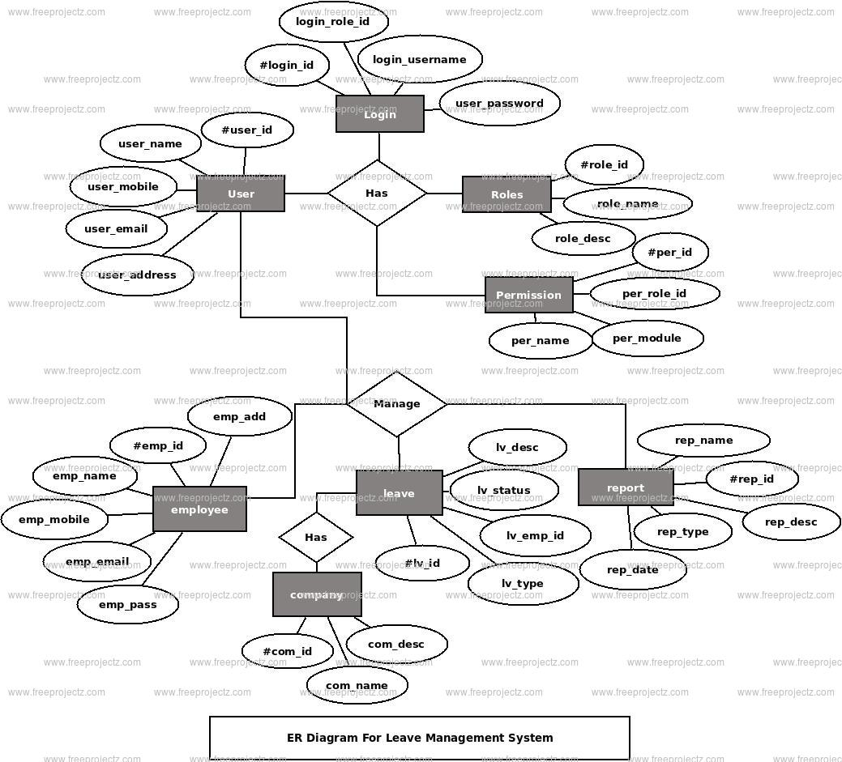

CHAPTER 4
TESTING AND IMPLEMENTATION

  - TESTING
Implementation is the stage of the project when the theoretical design is turned into a working system. This is the final and important phase in the system life cycle It is actually the process of converting the new system into a operational one.

4.1.1Unit Testing
Unit testing comprises the set of tests performed by an individual programmer prior to integration of the unit into a larger system. The module interface is tested to ensure that information properly flows into and out of the program unit. The local data structure is examined to ensure that data stored temporarily maintains its integrity during all steps in an algorithm’s execution. Boundary conditions are tested to ensure that the module operates properly at boundaries established to limit or restrict processing. All independent paths through the control structure are tested. All error-handling paths are tested.

4.1.2 Block Box Testing
Black-box testing is a method of software testing that examines the functionality of an application without peering into its internal structures or workings. This method of test can be applied virtually to every level of software testing: unit, integration, system and acceptance. It is sometimes referred to as specification-based testing.

4.2 SYSTEM IMPLEMENTATION
Implementation is the stage of the project when the theoretical design is turned into a working system. This is the final and important phase in the system life cycle It is actually the process of converting the new system into a operational one.

CHAPTER 5
CONCLUSION:
It is aimed at automating the existing manual system for applying the leave by the employee and process the leave through HOD and Principal. It helps in maintaining the records of the employees which will help human resource team to manage leave approval, leave cancellation and report generation. It is useful in organisations with large number of employees. It’s a faster approach as it takes less time when compared to a manual process.There is a proper management of database as the one handled by manual system is not always accurate and even there is a misplacement of databases which could cause a severe problem in near future.It is very reliable and it leads to an efficient report generation.

CHAPTER-6
REFERENCE
- [1]. www.wikipedia.com
- [2]. http://csharp.net-informations.com
- [3]. http://msdn.microsoft.com
- [4]. http://net-informations.com
- [5]. Notes on c# BY Herbert Scildht
- [6]. The Complete Guide to C# Programming by Er.V.K.Jain
- [7]. C# Programming by E. Balgurusamy

