Cibil system

ABSTRACT
A cibil system to keep tracks of peoples credit scores and dues. The system is similar to the real cibil system with an enhancement(Here the defaulter can view his status and can apply for improvement by good behavior). Our software system consists of admin login ,Cibil associates login and individual login. Here cibil associates are banks or companies who want to report faulty members. They may send faulty member data and this is passed on to the cibil admin. The cibil admin can view the data and approve it to be added after inspection. The system also consists of member login for which a member first needs to register. He can then check if he is listed in the black list and for what. The member may then apply for the removal along with the receipt of fine paid or other documents of proved good behavior.

CHAPTER 2
2. SYSTEM ANALYSIS
  - EXISTING SYSTEM

- The banks have to send the transaction data of every user to CIBIL from time to time (with certain frequency). Currently, the frequency of data collection by CIBIL is around 1 month.
- Banks and financial institutes partner with CIBIL and send this data to one central portal.
- As the banks have data related to the financial transactions, credit card usage and loans, the data collected is purely based on how the person has managed his transactions with the financial institutions and credit usage.
- In the present system a user can be reminded with the calculated CIBIL score based on the repayment of the loans that the user availed.
2.1.1 DRAWBACKS OF EXISTING SYSTEM :
- No human interaction.
- Requires internet connection.
2.2. PROPOSED SYSTEM
- The proposed law CIBIL associates include member banks and credit institutions or companies who want to report their faulty members.
- They may send faulty member data and this is passed on to the CIBIL admin.
- The system also consists of member login for which a member first needs to register. Thus the CIBIL system is a fully functional and user friendly project.
- In this work, two different types of Credit Scoring system have been proposed where one belongs to the scoring of the credit of an individual, which can be used by the individual to pursue loans or credit invoices.
2.2.1. ADVANTAGES OF PROPOSED SYSTEM
- Individuals can view their credit ratings without going to the company for enquiry.
- Individuals can even apply for improvement online.
- Saves user time and money.
- Automates the process of credit score calculation.
- Saves organization resources and efforts.
2.3 FEASIBILITY STUDY
The feasibility Analysis is an analytical program through project manager determines the project success ratio and through feasibility study project manager able to see either project. The key considerations involved in the feasibility analysis are:
- Economic Feasibility
- Technical Feasibility
- Operational Feasibility
- Environmental Feasibility
2.3.1 ECONOMICAL FEASIBILITY
Hence this project is economically feasible there is no need to involve any cost for this project.
2.3.2 TECHNICAL FEASIBILITY
Software Technologies used are PHP and MySql. In the educational institutions, it is possible to update the system in future. No special hardware is required for the purpose of using this system. Hence it is declared that this project is technically feasible.
2.3.3 OPERATIONAL FEASIBILITY
As the admin work mainly to maintain the Patient and Doctor .Doctor will predict patient cancer disease. Hence it is easy to operate with training. Therefore it is operationally feasible for implementation.
2.3.4 ENVIRONMENTAL FEASIBILITY
This project environment is correct as a admin has developed this system and no expenditure is involved under any head and this process is part of admin document management, this project environment is accessible.
2.4 SYSTEM REQUIREMENTS
- System : Pentium IV 2.4 GHz.
- Hard Disk : 40 GB.
- Monitor : 15 inch VGA Color.
- Mouse : Logitech Mouse.
- Ram : 512 MB
- Keyboard : Standard Keyboard
2.4.1 HARDWARE REQUIREMENTS
The Hardware of the computer consists of physical component such as Input Devices, Storage Devices, Processing & Control units and Output Devices. Computer includes external storage unit to store data in programs.
The Hardware Configuration involved in this project
- System : Pentium IV 2.4 GHz.
- Hard Disk : 40 GB.
- Monitor : 15 inch VGA Color.
- Mouse : Logitech Mouse.
- Ram : 512 MB
- Keyboard : Standard Keyboard

2.4.2 SOFTWARE REQUIREMENTS
Software is a group of programs that computers need to do a particular task. It is an essential requirement of Computer System. The Software used to develop the project is
- Operating System : Windows XP.
- Platform : DOT NET TECHNOLOGY
- Front End : ASP.Net 3.5
- Back End : SQL SERVER 2005

CHAPTER 3
SYSTEM DESIGN AND DEVELOPEMENT
SYSTEM ARCHICTURE

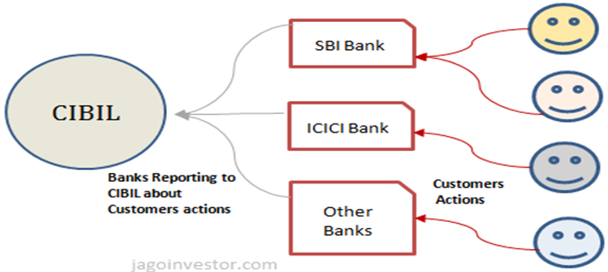

CHAPTER 4
TESTING AND IMPLEMENTATION

  - TESTING
Implementation is the stage of the project when the theoretical design is turned into a working system. This is the final and important phase in the system life cycle It is actually the process of converting the new system into a operational one.

4.1.1Unit Testing
Unit testing comprises the set of tests performed by an individual programmer prior to integration of the unit into a larger system. The module interface is tested to ensure that information properly flows into and out of the program unit. The local data structure is examined to ensure that data stored temporarily maintains its integrity during all steps in an algorithm’s execution. Boundary conditions are tested to ensure that the module operates properly at boundaries established to limit or restrict processing. All independent paths through the control structure are tested. All error-handling paths are tested.

4.1.2 Block Box Testing
Black-box testing is a method of software testing that examines the functionality of an application without peering into its internal structures or workings. This method of test can be applied virtually to every level of software testing: unit, integration, system and acceptance. It is sometimes referred to as specification-based testing.

4.2 SYSTEM IMPLEMENTATION
Implementation is the stage of the project when the theoretical design is turned into a working system. This is the final and important phase in the system life cycle It is actually the process of converting the new system into a operational one.

CHAPTER 5
CONCLUSION:
The web application collects various information about the user. Here the web application is mainly made for providing awareness over the CIBIL score and properly providing the various mechanisms to pay the due within the time. This application uses the block chain technology which gives the security to stay strong in your finance. This system is mainly accessed on the Permanent Account number (PAN card).the web Application would send the notification to the registered email id and the register mobile number, which is basically generated as the question type module. The questions are sending the clients on or before ten days of the due date. Based on the user answer it is further processed. If the client answer is “NO”, the web application works further on the personal detail of the Area of Interest, and display the various part time jobs that would able to earn money and repay the due amount within the time. However by paying the due amount within the time would able to maintain a constant CIBIL score. If the client answered the question as “YES”, then the client will be motivated and encouraged to pay the amount within the time.

