Florist online purchasing

ABSTRACT
With the rapid development of Internet, e-commerce had been widely using by more and more people, so had shopping online . The J2EE architecture was adopted in this paper. An florist’s shop online system was designed and implemented based on the analysis of the actual needs of users. Through running test for a period of time, the system could be operated steadily, and its function was complete. The system could achieve flower sales on line that was highly efficient and convenient, and the design purpose was achieved also.

CHAPTER 2
2. SYSTEM ANALYSIS
  - EXISTING SYSTEM

- The system administrator was exist in the initialization of system. They were added into the database manually in the database design.
- A two-step process was utilized: first, millennial consumers were invited to participate in focus group discussions where open-ended questions were used to elicit their existing perceptions toward floral products.
- The focus group responses were analyzed and paired with existing literature and information from other industries to create questions that were included in a nationwide online survey.
- Floral firms should explore the existing companies that use mobile phone GPS to track customers and offer tailored content (e.g. GPShopper, etc.).
2.1.1 DRAWBACKS OF EXISTING SYSTEM :
- As the important link in the flower sales system, the florist’s couldn't meet the needs of the vast number of consumers yet after the traditional sales mode just like flowers retail, flower art design etc.
- To development of an online flower shop sales system had become the urgent need to resolve problems.
- However, it was a complicated project to develop the florist’s shop online system, the further improvement of system must be done combined the problems appeared in the course of the actual use.
- It was consisted of a set of class and interface composition byJava language writing.
2.2. PROPOSED SYSTEM
- The purpose of the FMRF is to collect funds from industry sources to be used in the support of funding consumer research benefiting the entire floriculture industry.
- Many millennials indicated that they were not aware of or failed to consider the benefits associated with floral products.
- Firms can remind customers about the benefits associated with floral products. Specifically, flowers brighten up/refresh their homes and mindsets, improve air quality, and reduce stress.
- All the benefits associated with flowers make the products more meaningful since they serve a dual purpose (i.e. décor and benefits).
- This improves their value to the customer and may increase the customer’s likelihood of purchase.
2.2.1. ADVANTAGES OF PROPOSED SYSTEM
- An florist’s shop online system was designed and implemented based on the analysis of the actual needs of users.
- The system could achieve flower sales on line that was highly efficient and convenient, and the design purpose was achieved also.
- Flower product management to add, delete and show of classification about flower product .And it can be used recommend flower product to users based on flower product sales and each manufacturer prestige.
- User management to management member information and administrator information in web site.
- This can be a challenge for businesses since they need to weigh the pros of increased customer satisfaction with the cons of decreased efficiency.
2.3 FEASIBILITY STUDY
The feasibility Analysis is an analytical program through project manager determines the project success ratio and through feasibility study project manager able to see either project. The key considerations involved in the feasibility analysis are:
- Economic Feasibility
- Technical Feasibility
- Operational Feasibility
- Environmental Feasibility
2.3.1 ECONOMICAL FEASIBILITY
Hence this project is economically feasible there is no need to involve any cost for this project.

2.3.2 TECHNICAL FEASIBILITY
Software Technologies used are PHP and MySql. In the educational institutions, it is possible to update the system in future. No special hardware is required for the purpose of using this system. Hence it is declared that this project is technically feasible.
2.3.3 OPERATIONAL FEASIBILITY
As the admin work mainly to maintain the Patient and Doctor .Doctor will predict patient cancer disease. Hence it is easy to operate with training. Therefore it is operationally feasible for implementation.
2.3.4 ENVIRONMENTAL FEASIBILITY
This project environment is correct as a admin has developed this system and no expenditure is involved under any head and this process is part of admin document management, this project environment is accessible.
2.4 SYSTEM REQUIREMENTS
- System : Pentium IV 2.4 GHz.
- Hard Disk : 40 GB.
- Monitor : 15 inch VGA Color.
- Mouse : Logitech Mouse.
- Ram : 512 MB
- Keyboard : Standard Keyboard

2.4.1 HARDWARE REQUIREMENTS
The Hardware of the computer consists of physical component such as Input Devices, Storage Devices, Processing & Control units and Output Devices. Computer includes external storage unit to store data in programs.
The Hardware Configuration involved in this project
- System : Pentium IV 2.4 GHz.
- Hard Disk : 40 GB.
- Monitor : 15 inch VGA Color.
- Mouse : Logitech Mouse.
- Ram : 512 MB
- Keyboard : Standard Keyboard
2.4.2 SOFTWARE REQUIREMENTS
Software is a group of programs that computers need to do a particular task. It is an essential requirement of Computer System. The Software used to develop the project is
- Operating System : Windows XP.
- Platform : DOT NET TECHNOLOGY
- Front End : ASP.Net 3.5
- Back End : SQL SERVER 2005

CHAPTER 3
SYSTEM DESIGN AND DEVELOPEMENT
SYSTEM ARCHICTURE

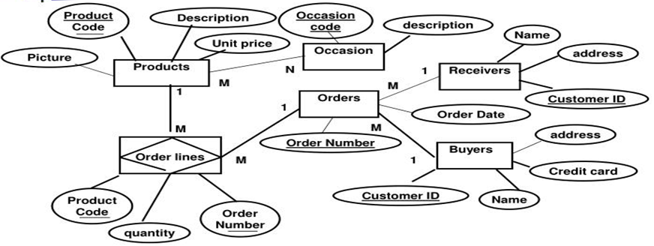

CHAPTER 4
TESTING AND IMPLEMENTATION

  - TESTING
Implementation is the stage of the project when the theoretical design is turned into a working system. This is the final and important phase in the system life cycle It is actually the process of converting the new system into a operational one.

4.1.1Unit Testing
Unit testing comprises the set of tests performed by an individual programmer prior to integration of the unit into a larger system. The module interface is tested to ensure that information properly flows into and out of the program unit. The local data structure is examined to ensure that data stored temporarily maintains its integrity during all steps in an algorithm’s execution. Boundary conditions are tested to ensure that the module operates properly at boundaries established to limit or restrict processing. All independent paths through the control structure are tested. All error-handling paths are tested.

4.1.2 Block Box Testing
Black-box testing is a method of software testing that examines the functionality of an application without peering into its internal structures or workings. This method of test can be applied virtually to every level of software testing: unit, integration, system and acceptance. It is sometimes referred to as specification-based testing.

4.2 SYSTEM IMPLEMENTATION
Implementation is the stage of the project when the theoretical design is turned into a working system. This is the final and important phase in the system life cycle It is actually the process of converting the new system into a operational one.

CHAPTER 5
CONCLUSION:
The florist’s shop online system was an important application of e-commerce sales model. It could realize online trading of flowers. In the rapid development of the Internet today, the florist’s shop online system would have a great market potential because the flowers had certain refreshing time. Based on elaborating the necessity of development of the florist’s shop online system, the J2EE technology to develop the system was introduced at first in this paper. then the user demand of the system was analysed deeply. A scientific and reasonable database was designed according to the customer demand. Finally, the design of the whole system and the key code of implementation part in the system realization was given. After a period of time in the system test and trial operation, it had been shown that the system had accomplished the desired basic goal. And it had a certain inspiration and reference significance to other similar online shopping system. However, it was a complicated project to develop the florist’s shop online system, the further improvement of system must be done combined the problems appeared in the course of the actual use.

CHAPTER-6
REFERENCE
- [1] Huangxianying. The design of servlet in the J2EE platform. Computer application research 2002.01:140-141
- [2] Duming,Lichaochun. the design and implementation of Struts+EJB in J2EE platform [J], Computer application research,2005(3):223-225,228
- [3] Feisike product research and development center.JSP application development steps.Beijing:Publishing house of electronics industry,2002
- [4] http://baike.baidu.com/view/3542.htm
- [5] http://baike.baidu.com/view/25611.htm
- [6] http://baike.baidu.com/view/4242783.htm

