Electronic goods stock delivery system

ABSTRACT
Effectiveness of electronic inventory system is very vital on customer service delivery. Without effectiveness, the customers will judge businesses harshly. The study evaluated the extent to which electronic inventory systems are used by supermarkets in Kenya. It also sought to determine the level to which lead-time variability resulting from the use of electronic inventory systems affects customer service delivery. The study also aimed at evaluating how the service quality created with electronic inventory systems has on customer service delivery in the selected supermarkets. A descriptive survey research design was adopted for the study with a target population of two thousand five hundred and forty nine respondents (2549) of which forty nine (49) were management staff and two thousand five hundred (2500) were customers of the five major supermarkets in Kenya. A census was conducted among the managers and supervisors while a sample of ninety two (92) was picked from the customers making the total sample size for the study three hundred and eighty one (141). For customers, Stratified-sampling design was used to achieve the desired representation from the total population and the sample size for each stratum was allocated proportionately. Data was collected using questionnaires, which were tested for reliability using Cronbach’s Alpha. Data collected was analyzed through Pearson’s correlation and the Chi-square test to test the hypothesis. From the analysis the researchers established that majority of the supermarket chains had integrated the use of electronic inventory systems which had enhanced effective customer service delivery. Lead time had also been influenced positively the use of electronic inventory systems as well as the quality of service delivery which in turn led to effective customer service delivery. The researchers recommended continuous improvement on the use of electronic inventory systems to ensure enhanced customer service delivery.

CHAPTER 2
2. SYSTEM ANALYSIS
  - EXISTING SYSTEM

- The turbulent global markets have created fragmented demand for goods and services making companies prioritize the demand of their customers.
- Inventory management is the process of efficiently overseeing the constant flow or units into and out of an existing inventory.
- It is an attempt to balance inventory needs and requirements with the need to minimize costs resulting from obtaining and holding inventory.
- This usually involves bringing a new product or service quickly into the market, delivery of the existing products or services to customers quickly after order placement and handling customer complaints quickly.
2.1.1 DRAWBACKS OF EXISTING SYSTEM :
- In a study on Implementing an Effective Inventory Management System it was found out that Inventory control problems often result from record and physical count discrepancies which may ultimately lead to higher than preferred inventory levels.
- This findings show that through use of electronic inventory systems supermarkets were able to solve their customers problems.
- The analysis was based on four major attributes of accuracy, responsiveness, reliability and problem solving and majority of the respondents agreed that through use of EIS the supermarkets had provide quality resulting in customer service delivery.
- The EIS systems have led to accuracy of service delivery, increase responsiveness to consumers’ needs, increased reliability and greater problem solving, improving on the quality of service delivery thus better customer service delivery.
2.2. PROPOSED SYSTEM
- The use of electronic inventory has led customers to expect products and services to be made available in increasingly shorter lead times.
- Shorter lead times offer a number of benefits which including decreasing stock holding costs and releasing money to be used for other activities in the organization.
- It also helps to lower inventory protecting an organization against risk or loss, damage and obsolescence.
- These systems will be used to manage inventory levels, reduce inventory costs, lead-time, increase inventory turns and customer service.
- They will promote flexibility, on time delivery hence leading to customer satisfaction.

2.2.1. ADVANTAGES OF PROPOSED SYSTEM
- The emerging technologies, businesses are still struggling to improve in their performance in inventory control as well as eliminate manual systems.
- Inventory management is the process of efficiently overseeing the constant flow or units into and out of an existing inventory.
- It is difficult to maintain internal accuracy in the inventory levels and meet customer requirements efficiently if inventory is not properly coordinated and maintained using electronic inventory systems.
- ERP management systems can improve costs, productivity, reduce time lag, reduce waste, and improve overall efficiency.
- Customer service delivery refers to the fulfillment of customer’s orders efficiently, effectively and at the minimum cost.
2.3 FEASIBILITY STUDY
The feasibility Analysis is an analytical program through project manager determines the project success ratio and through feasibility study project manager able to see either project. The key considerations involved in the feasibility analysis are:
- Economic Feasibility
- Technical Feasibility
- Operational Feasibility
- Environmental Feasibility

2.3.1 ECONOMICAL FEASIBILITY
Hence this project is economically feasible there is no need to involve any cost for this project.
2.3.2 TECHNICAL FEASIBILITY
Software Technologies used are PHP and MySql. In the educational institutions, it is possible to update the system in future. No special hardware is required for the purpose of using this system. Hence it is declared that this project is technically feasible.
2.3.3 OPERATIONAL FEASIBILITY
As the admin work mainly to maintain the Patient and Doctor .Doctor will predict patient cancer disease. Hence it is easy to operate with training. Therefore it is operationally feasible for implementation.
2.3.4 ENVIRONMENTAL FEASIBILITY
This project environment is correct as a admin has developed this system and no expenditure is involved under any head and this process is part of admin document management, this project environment is accessible.
2.4 SYSTEM REQUIREMENTS
- System : Pentium IV 2.4 GHz.
- Hard Disk : 40 GB.
- Monitor : 15 inch VGA Color.
- Mouse : Logitech Mouse.
- Ram : 512 MB
- Keyboard : Standard Keyboard
2.4.1 HARDWARE REQUIREMENTS
The Hardware of the computer consists of physical component such as Input Devices, Storage Devices, Processing & Control units and Output Devices. Computer includes external storage unit to store data in programs.
The Hardware Configuration involved in this project
- System : Pentium IV 2.4 GHz.
- Hard Disk : 40 GB.
- Monitor : 15 inch VGA Color.
- Mouse : Logitech Mouse.
- Ram : 512 MB
- Keyboard : Standard Keyboard
2.4.2 SOFTWARE REQUIREMENTS
Software is a group of programs that computers need to do a particular task. It is an essential requirement of Computer System. The Software used to develop the project is
- Operating System : Windows XP.
- Platform : DOT NET TECHNOLOGY
- Front End : ASP.Net 3.5
- Back End : SQL SERVER 2005

CHAPTER 3
SYSTEM DESIGN AND DEVELOPEMENT
SYSTEM ARCHICTURE

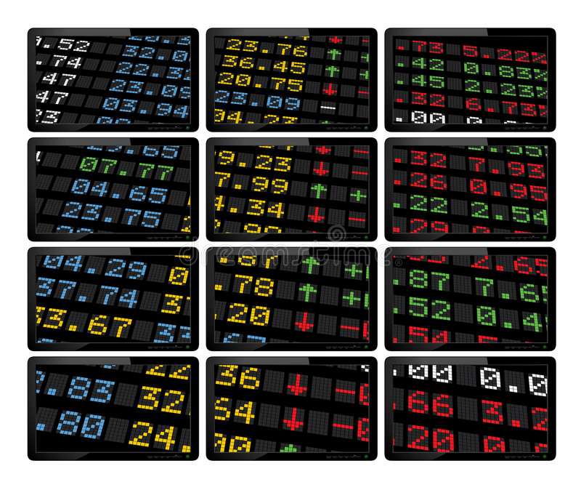

CHAPTER 4
TESTING AND IMPLEMENTATION

  - TESTING
Implementation is the stage of the project when the theoretical design is turned into a working system. This is the final and important phase in the system life cycle It is actually the process of converting the new system into a operational one.

4.1.1Unit Testing
Unit testing comprises the set of tests performed by an individual programmer prior to integration of the unit into a larger system. The module interface is tested to ensure that information properly flows into and out of the program unit. The local data structure is examined to ensure that data stored temporarily maintains its integrity during all steps in an algorithm’s execution. Boundary conditions are tested to ensure that the module operates properly at boundaries established to limit or restrict processing. All independent paths through the control structure are tested. All error-handling paths are tested.

4.1.2 Block Box Testing
Black-box testing is a method of software testing that examines the functionality of an application without peering into its internal structures or workings. This method of test can be applied virtually to every level of software testing: unit, integration, system and acceptance. It is sometimes referred to as specification-based testing.

4.2 SYSTEM IMPLEMENTATION
Implementation is the stage of the project when the theoretical design is turned into a working system. This is the final and important phase in the system life cycle It is actually the process of converting the new system into a operational one.

CHAPTER 5
CONCLUSION:
From the findings, the researchers can conclude that the use of electronic inventory systems in the supermarkets has been effective in customer service delivery thus making the shopping experience more satisfactory for the customer. EIS systems like the ERP, EDI, bar coding; EOQ and VMI have greatly been used. By these systems, the supermarkets have been able to offer better service to their customers such as quick order processing, better stock monitoring, accurate and automatic ordering, improved stock management, wide product variety, faster product introductions and reduced queues at the electronic point of sale. The study also concludes that aspects such as lead-time have been influenced by the use of EIS systems, which have contributed to shortened lead-time, supplier flexibility and thus faster provision of products to consumers increasing service delivery. Training all staff on the use of electronic inventory systems as well as better service delivery, listening to customers complaints, suggestions keenly, organize refresher courses for managers, and supervisors are necessary to increase the effectiveness of service delivery. Quality of service has also been impacted by the use of EIS. The EIS systems have led to accuracy of service delivery, increase responsiveness to consumers’ needs, increased reliability and greater problem solving, improving on the quality of service delivery thus better customer service delivery.

CHAPTER-6
REFERENCE
- Bailey, P., Farmer, D., Jessop, D. and Jones, D. (2005), Purchasing Principles and Management, 9th edition, New Jersey: Prentice Hall.
- Brady, M.K., Cronin, J.J. & Brand, R. R. (2002),Performance-only measures of service quality: a replication and extension, Journal of Business Research, 55, pp. 17–31.
- Burt .D., Pertcarage .S., Pinkerton .R., (2010). Supply Management, 8th Edition, Singapore: Mc-Graw Hill International.
- Chan, F., Qi J., Chan, K., Lau, C and Ralph L. (2003), “A conceptual model of performance measurement for supply chains,” Management Decision, Vol. 41 No.7, pp. 635-42.
- Chopra, S and Meindl, P. (2004), Supply Chain Management. 2nd Edition. Upper Saddle River: Pearson Prentice Hall,
- Dabholkar, P.; Thorpe, D. and Rentz, J. (1996). A Measure of Service Quality for Retail Stores: Scale Development and Validation, Journal of the Academy of Marketing Science, 24 (Winter), 3-16.
- De Vellis, R. (2003). Scale Developent: Theory and Applications. New York Park, California: Sage Publications
- Eckert, G. S. (2007). Inventory Management and it’s effects on Customer Satisfaction, Journal of Business and Public Policy I, page 3.
- Harrington, T., Lambert, D. and Vance, P. (1990). Implementing an Effective Inventory Management System International Journal of Physical Distribution & Logistics Management Volume: 20
- Irungu, B. and Wanjau, K. (2011). Effectiveness of Vendor managed inventory systems in Retail Supermarkets in Kenya. International Journal of Business and Public Management. Vol:1.

