Auditorium management system

ABSTRACT
This system is an auditorium management software projects. It includes all the features and functions needed to efficiently manage an auditorium. It includes an administrator account which is used to handle/control all the system functionality. The system keeps track of auditorium status and advance bookings. The system keeps records of auditorium bookings along with associated event details and customer contacts in a well maintained database. The administrator can easily check the auditorium bookings and timings in the system gui. The system also allows notifies when a new event timing draws near.

CHAPTER 2
2. SYSTEM ANALYSIS
  - EXISTING SYSTEM

- The imbalanced use of college sports venues resources has not been completely solved now. So lots of researches about the online booking system of college sports venues are seriously needed.
- Many college sports venues are opened for free.
- But because the usage of venues can't be known good, people often encounter that students of athletics are in the class or there is no place for sports when go to the venues directly.
- So a online booking system for college sports venues is necessary.
2.1.1 DRAWBACKS OF EXISTING SYSTEM :
- It reduces employment as the human efforts are being automated by this system.
- The use of the system has made up for the current luck of sports venues management, solved the problems of the online booking function of university sports venues, improved the efficiency of the venues and meet the needs of efficient use of the venues.
- The basic functions of the system are designed according to the general requirement analysis, including user's registration and login, online venue booking, online payment, personal center, message board and database construction.
2.2. PROPOSED SYSTEM
- The purpose of development of this system is to provide convenience to users when they booking venues, and to avoid flashy, so the system’ interface is simple but contain complete functions.
- College sports venues are not only an essential part of physical education, but also an important place for fitness activities of the faculties, students as well as nearly residents.
- With the rapid development of information technology, college sports venues realizing online booking has become a new trend.
2.2.1. ADVANTAGES OF PROPOSED SYSTEM
- The system is useful as it calculates an exact cost for requested number of days.
- It is convenient for user as he do not have to actually visit the place.
- This system is effective and saves time and cost of the users.
- Easy registration.
2.3 FEASIBILITY STUDY
The feasibility Analysis is an analytical program through project manager determines the project success ratio and through feasibility study project manager able to see either project. The key considerations involved in the feasibility analysis are:
- Economic Feasibility
- Technical Feasibility
- Operational Feasibility
- Environmental Feasibility
2.3.1 ECONOMICAL FEASIBILITY
Hence this project is economically feasible there is no need to involve any cost for this project.
2.3.2 TECHNICAL FEASIBILITY
Software Technologies used are PHP and MySql. In the educational institutions, it is possible to update the system in future. No special hardware is required for the purpose of using this system. Hence it is declared that this project is technically feasible.
2.3.3 OPERATIONAL FEASIBILITY
As the admin work mainly to maintain the Patient and Doctor .Doctor will predict patient cancer disease. Hence it is easy to operate with training. Therefore it is operationally feasible for implementation.
2.3.4 ENVIRONMENTAL FEASIBILITY
This project environment is correct as a admin has developed this system and no expenditure is involved under any head and this process is part of admin document management, this project environment is accessible.
2.4 SYSTEM REQUIREMENTS
- System : Pentium IV 2.4 GHz.
- Hard Disk : 40 GB.
- Monitor : 15 inch VGA Color.
- Mouse : Logitech Mouse.
- Ram : 512 MB
- Keyboard : Standard Keyboard
2.4.1 HARDWARE REQUIREMENTS
The Hardware of the computer consists of physical component such as Input Devices, Storage Devices, Processing & Control units and Output Devices. Computer includes external storage unit to store data in programs.
The Hardware Configuration involved in this project
- System : Pentium IV 2.4 GHz.
- Hard Disk : 40 GB.
- Monitor : 15 inch VGA Color.
- Mouse : Logitech Mouse.
- Ram : 512 MB
- Keyboard : Standard Keyboard
2.4.2 SOFTWARE REQUIREMENTS
Software is a group of programs that computers need to do a particular task. It is an essential requirement of Computer System. The Software used to develop the project is
- Operating System : Windows XP.
- Platform : DOT NET TECHNOLOGY
- Front End : ASP.Net 3.5
- Back End : SQL SERVER 2005

CHAPTER 3
SYSTEM DESIGN AND DEVELOPEMENT
SYSTEM ARCHICTURE

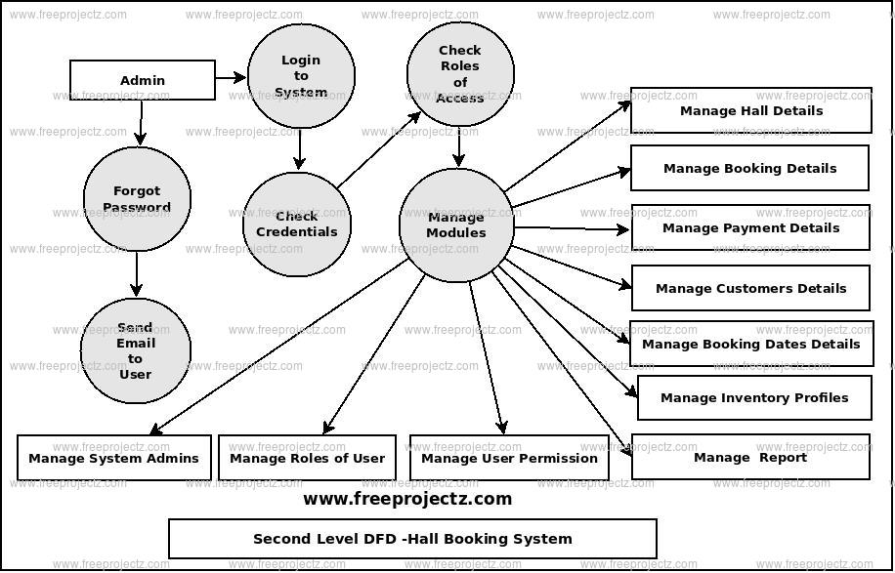

CHAPTER 4
TESTING AND IMPLEMENTATION

  - TESTING
Implementation is the stage of the project when the theoretical design is turned into a working system. This is the final and important phase in the system life cycle It is actually the process of converting the new system into a operational one.

4.1.1Unit Testing
Unit testing comprises the set of tests performed by an individual programmer prior to integration of the unit into a larger system. The module interface is tested to ensure that information properly flows into and out of the program unit. The local data structure is examined to ensure that data stored temporarily maintains its integrity during all steps in an algorithm’s execution. Boundary conditions are tested to ensure that the module operates properly at boundaries established to limit or restrict processing. All independent paths through the control structure are tested. All error-handling paths are tested.

4.1.2 Block Box Testing
Black-box testing is a method of software testing that examines the functionality of an application without peering into its internal structures or workings. This method of test can be applied virtually to every level of software testing: unit, integration, system and acceptance. It is sometimes referred to as specification-based testing.

4.2 SYSTEM IMPLEMENTATION
Implementation is the stage of the project when the theoretical design is turned into a working system. This is the final and important phase in the system life cycle It is actually the process of converting the new system into a operational one.

CHAPTER 5
CONCLUSION:
The use of the system can made up for the current luck of sports venues management; It can solve the problems of the online booking function of university sports venues; It can improve the efficiency of the venues and meet the needs of efficient use of the venues. In this study, there are a lot of shortcomings. For instance, there is no limit to the number of reservation; It failed to set up a punishment and give a reasonable credentials into the venues. In the later study, the system needs completely improved. The order number, place number and the time may be feedbacked to users by moblephone messages in the future. The system has a great deal of portability. The website can not only be bordered with web sites of school resources management, improving the management system, but also be extended to other sports venues of zhengzhou city or other colleges and universities, improving the use of stadiums resources.

CHAPTER-6
REFERENCE
- 1. W. Wang, W. Sun, http://news.xinhuanet.com/mrdx/2010-05/01/content_13451241.htm.
- 2. X. Dai, N. Zhang, Com. Mod. 11, 123-126 (2012).
- 3. X. Dai, N. Zhang, Int. Thin. Tech. 7, 69-71(2012).
- 4. H. Wei, Research and development of network service management platform of university sports facilities based on.NET Technology(Sichuan Normal University, 2011).
- 5. H. Zhang, The design and implementation of the management system of comprehensive sports facilities in Guizhou Normal University(Xiamen University, 2013).
- 6. C. Xia, J. Wuhan Eng Inst, 2, 48-50(2013).
- 7. R.Yuan, DIV + CSS Layout Essence of the Case( Tsinghua University Press, 2011).
- 8. H. Kong, X. Lu, Web Java design and practical tutorial - based on the application development of Eclipse environment(China Machine Press, 2012).
- 9. J. Zhao, Design and implementation of mobile business hall charging system based on MYECLIPSE development tools(University of Electronic Science and Technology of China, 2012).
- 10. C. Feng, Y. Chao, Tomcat and Java Web development Technology Description(Tsinghua University Press, 2008)

