Medical shop management

ABSTRACT
The purpose of Medical Shop Management System is to automate the existing manual system by the help of computerized equipments and full-fledged computer software, fulfilling their requirements, so that their valuable data/information can be stored for a longer period with easy accessing and manipulation of the same. The required software and hardware are easily available and easy to work with.Medical Shop Management System, as described above, can lead to error free, secure, reliable and fast management system. It can assist the user to concentrate on their other activities rather to concentrate on the record keeping. Thus it will help organization in better utilization of resources. The organization can maintain computerized records without redundant entries. That means that one need not be distracted by information that is not relevant, while being able to reach the information.The aim is to automate its existing manual system by the help of computerized equipments and full-fledged computer software, fulfilling their requirements, so that their valuable data/information can be stored for a longer period with easy accessing and manipulation of the same. Basically the project describes how to manage for good performance and better services for the Clients.

CHAPTER 2
2. SYSTEM ANALYSIS
  - EXISTING SYSTEM

- In the existing system the exams are done only manually but in proposed system we have to computerize the exams using this application.
- Lack of security of data.
- More man power.
- Time consuming.
- Consumes large volume of pare work.
- Needs manual calculations.
- No direct role for the higher officials
2.1.1 DRAWBACKS OF EXISTING SYSTEM :
- One more problem was that it was very difficult to find errors while entering the records.
- System analysis is a process of gathering and interpreting facts, diagnosing problems and the information about the Medical Shop Management System to recommend improvements on the system.
- It is a problem solving activity that requires intensive communication between the system users and system developers.
- The designer now functions as a problem solver and tries to sort out the difficulties that the enterprise faces.
- We understand the problem domain and produce a model of the system, which describes operations that can be performed on the system.
2.2. PROPOSED SYSTEM
- The aim of proposed system is to develop a system of improved facilities. The proposed system can overcome all the limitations of the existing system. The system provides proper security and reduces the manual work.
- Security of data.
- Ensure data accuracy’s.
- Proper control of the higher officials.
- Minimize manual data entry.
- Minimum time needed for the various processing.
- Greater efficiency.
- Better service.
- User friendliness and interactive.
- Minimum time required.
2.2.1. ADVANTAGES OF PROPOSED SYSTEM
- It determines the length of time system used by the system to process transaction data.
- This test is conducted prior to implementation to determine how long it takes to get a response to an inquiry, make a backup copy of a file, or send a transmission and get a response.
- This included the study of function, performance and constraints that may affect the ability to achieve an acceptable system.
- To increase efficiency of managing the Medical Shop, Stocks
- It deals with monitoring the information and transactions of Sales.
- The system generates types of information that can be used for various purposes.
2.3 FEASIBILITY STUDY
The feasibility Analysis is an analytical program through project manager determines the project success ratio and through feasibility study project manager able to see either project. The key considerations involved in the feasibility analysis are:
- Economic Feasibility
- Technical Feasibility
- Operational Feasibility
- Environmental Feasibility
2.3.1 ECONOMICAL FEASIBILITY
Hence this project is economically feasible there is no need to involve any cost for this project.
2.3.2 TECHNICAL FEASIBILITY
Software Technologies used are PHP and MySql. In the educational institutions, it is possible to update the system in future. No special hardware is required for the purpose of using this system. Hence it is declared that this project is technically feasible.
2.3.3 OPERATIONAL FEASIBILITY
As the admin work mainly to maintain the Patient and Doctor .Doctor will predict patient cancer disease. Hence it is easy to operate with training. Therefore it is operationally feasible for implementation.
2.3.4 ENVIRONMENTAL FEASIBILITY
This project environment is correct as a admin has developed this system and no expenditure is involved under any head and this process is part of admin document management, this project environment is accessible.
2.4 SYSTEM REQUIREMENTS
- System : Pentium IV 2.4 GHz.
- Hard Disk : 40 GB.
- Monitor : 15 inch VGA Color.
- Mouse : Logitech Mouse.
- Ram : 512 MB
- Keyboard : Standard Keyboard
2.4.1 HARDWARE REQUIREMENTS
The Hardware of the computer consists of physical component such as Input Devices, Storage Devices, Processing & Control units and Output Devices. Computer includes external storage unit to store data in programs.
The Hardware Configuration involved in this project
- System : Pentium IV 2.4 GHz.
- Hard Disk : 40 GB.
- Monitor : 15 inch VGA Color.
- Mouse : Logitech Mouse.
- Ram : 512 MB
- Keyboard : Standard Keyboard
2.4.2 SOFTWARE REQUIREMENTS
Software is a group of programs that computers need to do a particular task. It is an essential requirement of Computer System. The Software used to develop the project is
- Operating System : Windows XP.
- Platform : DOT NET TECHNOLOGY
- Front End : ASP.Net 3.5
- Back End : SQL SERVER 2005

CHAPTER 3
SYSTEM DESIGN AND DEVELOPEMENT
SYSTEM ARCHICTURE

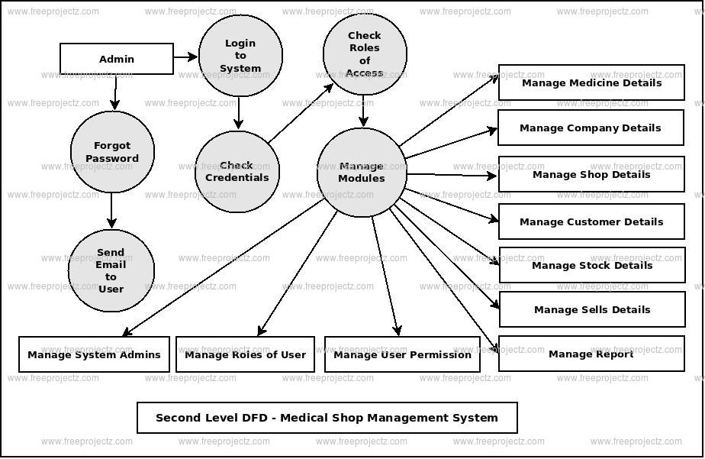

CHAPTER 4
TESTING AND IMPLEMENTATION

  - TESTING
Implementation is the stage of the project when the theoretical design is turned into a working system. This is the final and important phase in the system life cycle It is actually the process of converting the new system into a operational one.

4.1.1Unit Testing
Unit testing comprises the set of tests performed by an individual programmer prior to integration of the unit into a larger system. The module interface is tested to ensure that information properly flows into and out of the program unit. The local data structure is examined to ensure that data stored temporarily maintains its integrity during all steps in an algorithm’s execution. Boundary conditions are tested to ensure that the module operates properly at boundaries established to limit or restrict processing. All independent paths through the control structure are tested. All error-handling paths are tested.

4.1.2 Block Box Testing
Black-box testing is a method of software testing that examines the functionality of an application without peering into its internal structures or workings. This method of test can be applied virtually to every level of software testing: unit, integration, system and acceptance. It is sometimes referred to as specification-based testing.

4.2 SYSTEM IMPLEMENTATION
Implementation is the stage of the project when the theoretical design is turned into a working system. This is the final and important phase in the system life cycle It is actually the process of converting the new system into a operational one.

CHAPTER 5
CONCLUSION:
Our project is only a humble venture to satisfy the needs to manage their project work. Several user friendly coding have also adopted. This package shall prove to be a powerful package in satisfying all the requirements of the school. The objective of software planning is to provide a frame work that enables the manger to make reasonable estimates made within a limited time frame at the beginning of the software project and should be updated regularly as the project progresses.

CHAPTER-6
REFERENCE
- Google for problem solving
- http://www.javaworld.com/javaworld/jw-01-1998/jw-01Credentialreview.html
- Database Programming with JDBC and Java by O'Reilly
- Head First Java 2nd Edition
- http://www.jdbc-tutorial.com/
- Java and Software Design Concepts by Apress
- https://www.tutorialspoint.com/java/
- http://www.javatpoint.com/java-tutorial
- https://docs.oracle.com/javase/tutorial/
- http://www.wampserver.com/en/
- http://www.JSP.net/
- http://www.tutorialspoint.com/mysql/
- httpd.apache.org/docs/2.0/misc/tutorials.html

