File info tracking management system

ABSTRACT
Locating files is one of the biggest problems in universities nowadays. Time is wasted in searching files, energy is wasted chasing misspelled files, deadlines are missed. Due to this , I decided to make a system for file tracking that will solve all problems in the best way.File Tracking System is a internet application that manages all the file movement from one desk to another one and helps them in managing flow of files effectively and efficiently. All the files such as: reports, decisions, requests, reminders, and others can be processed and can also tracked by the system at any time. The system helps in online tracking or locating information and pendency monitoring more effectively by providing a plethora of data at a glance. It has large facilities for managing classification of all files. The system follows a steps of file unique numbering and enables file management, file status monitoring, etc. It also has a very powerful search form to locate a file and analyze the history of movement of that file. It also has a very powerful search form to locate a file/data and analyse the history of movement of that file. Other than this, the system will allow the administrator to create faculties of that university and assign to them all the departments . Each department must have a user who will be responsible for that department. In the other hand.

CHAPTER 2
2. SYSTEM ANALYSIS
  - EXISTING SYSTEM

- To systemize these operations and hence to keep track of those files, the National Informatics Centre (NIC) as a ICT Consultant has conducted thorough study of the existing system to come out with a web enabled system.
- To fulfill the requirement, a thorough study was conducted of the existing system. It was decided that the system should be a lightweight application requiring minimal inputs and user-friendly interface.
- The worker finds the existing file or document is time-consuming and file misallocation, paper usage is wasted; and more spaces for storing the document files at premises.
2.1.1 DRAWBACKS OF EXISTING SYSTEM :
- The impact of this research brings efficiency in searching the ISO document’s file in the university.
- Since offices nowadays spend too much time in organizing (archiving, finding) their files in a systematic way, without forgetting also the cost of papers, this web application will solve all of these problems by saving time and money.
- Therefore, to overcome the document misallocation problem, an Internet-of-Things (IoT) based file tracking prototype is implemented.
- The implementation of the study shows how the system work, user interface design, and architecture of the system. This new design shows the solution to the current problem.
2.2. PROPOSED SYSTEM
- The proposed file-tracking system will not disturb any file which existed as a file movement system.
- Electronic records for existing files (Long Term files) as well as new files will be created to track their movement.
- The proposed file tracking-system will involves all entities of the existing system except dispatch registers, which will be replaced by electronic File Database.
- Each type of user will be assigned specific roles to maintain the system. involved in the design and development of the system will have no control on the functioning of the system.
- File creation will be done by the University employees including office incharges of various offices as in the previous system.
2.2.1. ADVANTAGES OF PROPOSED SYSTEM
- File Tracking System is a web application that manages all the files movement at any time from one desk/room to another one and help in managing the flow of files efficiently.
- Solution for effective and efficient management of files
- Easy File Tracking
- Online fast and secure file management
- Staff improvement
- Organizational efficiency improvement
- Paper cost reduce
- Less energy used
- Time spent reduce
- Eliminates duplication of file
Literature Survey:
TITLE | AUTHORS | DESCRIPTION
File Tracking System: User Manual | N. DoPT, | It was felt that a system is required to monitor the movement of Files and Receipts at different levels in the decision making process.
Files Management System | Infronics, | File management system consists of system utility programs that run as privileged applications.
The Web as a Platform: The Saga Continues | T. Mikonen and A. Taivalsaari, | In this paper we take a look at the evolution of the Web from a relatively simple document sharing system to a massively popular, general purpose application and content distribution environment.
Mashware: The Future of Web Applications | A. Taivalsaari, | A key observation in the paper is that web applications do not have to live by the same constraints that characterized the evolution of conventional desktop applications.

2.3 FEASIBILITY STUDY
The feasibility Analysis is an analytical program through project manager determines the project success ratio and through feasibility study project manager able to see either project. The key considerations involved in the feasibility analysis are:
- Economic Feasibility
- Technical Feasibility
- Operational Feasibility
- Environmental Feasibility
2.3.1 ECONOMICAL FEASIBILITY
Hence this project is economically feasible there is no need to involve any cost for this project.
2.3.2 TECHNICAL FEASIBILITY
Software Technologies used are PHP and MySql. In the educational institutions, it is possible to update the system in future. No special hardware is required for the purpose of using this system. Hence it is declared that this project is technically feasible.
2.3.3 OPERATIONAL FEASIBILITY
As the admin work mainly to maintain the Patient and Doctor .Doctor will predict patient cancer disease. Hence it is easy to operate with training. Therefore it is operationally feasible for implementation.
2.3.4 ENVIRONMENTAL FEASIBILITY
This project environment is correct as a admin has developed this system and no expenditure is involved under any head and this process is part of admin document management, this project environment is accessible.
2.4 SYSTEM REQUIREMENTS
- System : Pentium IV 2.4 GHz.
- Hard Disk : 40 GB.
- Monitor : 15 inch VGA Color.
- Mouse : Logitech Mouse.
- Ram : 512 MB
- Keyboard : Standard Keyboard

2.4.1 HARDWARE REQUIREMENTS
The Hardware of the computer consists of physical component such as Input Devices, Storage Devices, Processing & Control units and Output Devices. Computer includes external storage unit to store data in programs.
The Hardware Configuration involved in this project
- System : Pentium IV 2.4 GHz.
- Hard Disk : 40 GB.
- Monitor : 15 inch VGA Color.
- Mouse : Logitech Mouse.
- Ram : 512 MB
- Keyboard : Standard Keyboard
2.4.2 SOFTWARE REQUIREMENTS
Software is a group of programs that computers need to do a particular task. It is an essential requirement of Computer System. The Software used to develop the project is
- Operating System : Windows XP.
- Platform : DOT NET TECHNOLOGY
- Front End : ASP.Net 3.5
- Back End : SQL SERVER 2005

CHAPTER 3
SYSTEM DESIGN AND DEVELOPEMENT
SYSTEM ARCHICTURE

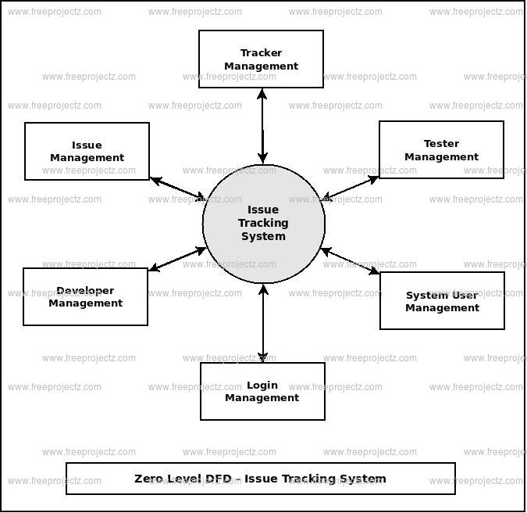

CHAPTER 4
TESTING AND IMPLEMENTATION

  - TESTING
Implementation is the stage of the project when the theoretical design is turned into a working system. This is the final and important phase in the system life cycle It is actually the process of converting the new system into a operational one.

4.1.1Unit Testing
Unit testing comprises the set of tests performed by an individual programmer prior to integration of the unit into a larger system. The module interface is tested to ensure that information properly flows into and out of the program unit. The local data structure is examined to ensure that data stored temporarily maintains its integrity during all steps in an algorithm’s execution. Boundary conditions are tested to ensure that the module operates properly at boundaries established to limit or restrict processing. All independent paths through the control structure are tested. All error-handling paths are tested.

4.1.2 Block Box Testing
Black-box testing is a method of software testing that examines the functionality of an application without peering into its internal structures or workings. This method of test can be applied virtually to every level of software testing: unit, integration, system and acceptance. It is sometimes referred to as specification-based testing.

4.2 SYSTEM IMPLEMENTATION
Implementation is the stage of the project when the theoretical design is turned into a working system. This is the final and important phase in the system life cycle It is actually the process of converting the new system into a operational one.

CHAPTER 5
CONCLUSION:
This paper has discussed about a Web Application which aims to serve offices that has to do with paper work, especially universities, in the best way possible. The goal of this web application is to improve file management, increase staff efficiency, save staff energy and time, reduce cost and improve the work efficiency by using the latest and fastest technologies. The one important thing that needs to be mentioned in this conclusion is that from the research I have done on file tracking systems, there is no file tracking system developed or implemented for universities at all. There are some file tracking systems used for some other purposes (ex: governmental purpose) implemented in few countries, however they are also some simple ones who tracks only receipts. Hence, I took this condition as a favors and hope that the project I am developing will have a massive usage worldwide in the near future.

CHAPTER-6
REFERENCE
- [1]. N. DoPT, “File Tracking System: User Manual,” MADHYA PRADESH FOREST DEPARTMENT, Bhopal, 2013.
- [2] J. Anne, “FILETACTICS - File Tracking Software and System,” Wordpress, 11 July 2012. [Online] Available: http://blog.filetactics.com/
- [3] Infronics, “Files Management System,” Infronics Systems, 2011.
- [4] T. Mikonen and A. Taivalsaari, “The Web as a Platform: The Saga Continues,” in Proceedings of the 37th EUROMICRO Conference on Software Engineering and Applications, Oulu, IEEE Computer Society, 2011, pp. 170-174.
- [5] M. Richards, “Web Based vs. Desktop Based Software for Self Storage,” Hi-Tech Smart Systems, Inc, Honolulu County, 2011.
- [6] D. G. Bakshi, “Kerala Govt Nod For Online File Tracking,” Alphabet Media, 22 August 2011. [Online]. Available: http://www.futuregov.in/.
- [7] R. Chaladan, “File Tracking System for State Government Offices,” 11 August 2010.[Online] Available: http://www.sics.kerala.gov.in.
- [8] A. Taivalsaari, “Mashware: The Future of Web Applications,” Sun Microsystems Laboratories, New Jersey, 2009.
- [9] T. Mikkonen and A.Taivalsaari,“Apps vs. Open Web: The Battle of Decade,” Oulu, 2010.
- [10] P. Staff, “PHP: What can PHP do?,” 04 January 2010. [Online]. Available: http://php.net/manual/en/introwhatcando.php

