Blood organ donar system

ABSTRACT
This paper gives detailed report on the application available for tracking blood donor and organ donors which helps to assist between blood donors and necessitous people. It facilitates the search process for necessitous people and it will be effortless before. With development in healthcare services Organ transplantation is increasing in demand so blood donation has become important It is important all this information to be available as when required by hospital and patients. There is a need of uniform tool to maintain much medical related information like organ transplantation requirement of organs in different hospital. Information about blood donors across the globe. The recent trends in technology has helped in healthcare field to facilitate the blood and organ donors for the necessitous people & provides complete health solutions that supplies blood for the required patients in time, it is safest & through trustable means. For blood samples that are uncommon or the software can search in the MIS & displays the information to the user.

CHAPTER 2
2. SYSTEM ANALYSIS
  - EXISTING SYSTEM

- There are many existing applications promoting organ and blood donation system.
- There exist manual entry of data and manual analysis of results, more confidentiality maintained in the software so that the person who is not eligible will not be allowed to access.
- The death rates are increasing day by day due to increase in number of fatal accidents that are occurring in metro cities like Delhi, Mumbai, Bangalore, Chennai, due to this many people are losing lives because that are not getting proper treatment in time so this paper, we study on the available application that exists currently to serve the purpose.
2.1.1 DRAWBACKS OF EXISTING SYSTEM :
- There was many in the disadvantage in traditional approach that it causing delay disseminate results to blood donors.
- Cardiac problems, hypertension, epilepsy, diabetes (on insulin therapy), history of cancer, chronic kidney or liver disease, bleeding tendencies, venereal disease etc.
- The means of optimization developed for the many health related problems, emerging from resource collection and management in the hospitals to the delivery of the care services in a region.
- This whole problem for managing the blood and organ requirements can be accomplished by using a recommender system where it lets the hospital to match the particular requirement with the currently available things.
2.2. PROPOSED SYSTEM
- This website can also be used by organ donor and seeker where person can register for organ donation. Proposed system will contain a Directory which includes details of all Blood Bank across India.
- Similar to any web-based application user has to register themselves with user id and password for logging in for authentication purpose.
- The purpose of any application is to simplify and automate the process of searching the blood in case of emergency and maintaining the records of blood donors, recipients, blood donation programs and blood stocks in the bank.
- The most influential people in an online social network by Social Network Analysis were proposed. Its uses clusterindexing Collaborative filtering for accurate SNA recommendation results.
2.2.1. ADVANTAGES OF PROPOSED SYSTEM
- It can make this as a feasible model by comparing the result of both the data set methods and consider the efficient one.
- However, this is still inefficient up to day. The main aim of this paper to find the quick donor and their contact number to Know their willingness for donation.
- The whole procedure is divided four main stages as depicted in first step is Registration, receive of blood, then transportation & saving blood storing in safe & proper way so that it can be reuse in an efficient way.
- Situations where the need of blood arises such as accident victims, patients undergoing major surgeries require whole blood, where the blood is used directly after testing.
2.3 FEASIBILITY STUDY
The feasibility Analysis is an analytical program through project manager determines the project success ratio and through feasibility study project manager able to see either project. The key considerations involved in the feasibility analysis are:
- Economic Feasibility
- Technical Feasibility
- Operational Feasibility
- Environmental Feasibility
2.3.1 ECONOMICAL FEASIBILITY
Hence this project is economically feasible there is no need to involve any cost for this project.
2.3.2 TECHNICAL FEASIBILITY
Software Technologies used are PHP and MySql. In the educational institutions, it is possible to update the system in future. No special hardware is required for the purpose of using this system. Hence it is declared that this project is technically feasible.
2.3.3 OPERATIONAL FEASIBILITY
As the admin work mainly to maintain the Patient and Doctor .Doctor will predict patient cancer disease. Hence it is easy to operate with training. Therefore it is operationally feasible for implementation.
2.3.4 ENVIRONMENTAL FEASIBILITY
This project environment is correct as a admin has developed this system and no expenditure is involved under any head and this process is part of admin document management, this project environment is accessible.
2.4 SYSTEM REQUIREMENTS
- System : Pentium IV 2.4 GHz.
- Hard Disk : 40 GB.
- Monitor : 15 inch VGA Color.
- Mouse : Logitech Mouse.
- Ram : 512 MB
- Keyboard : Standard Keyboard

2.4.1 HARDWARE REQUIREMENTS
The Hardware of the computer consists of physical component such as Input Devices, Storage Devices, Processing & Control units and Output Devices. Computer includes external storage unit to store data in programs.
The Hardware Configuration involved in this project
- System : Pentium IV 2.4 GHz.
- Hard Disk : 40 GB.
- Monitor : 15 inch VGA Color.
- Mouse : Logitech Mouse.
- Ram : 512 MB
- Keyboard : Standard Keyboard

2.4.2 SOFTWARE REQUIREMENTS
Software is a group of programs that computers need to do a particular task. It is an essential requirement of Computer System. The Software used to develop the project is
- Operating System : Windows XP.
- Platform : DOT NET TECHNOLOGY
- Front End : ASP.Net 3.5
- Back End : SQL SERVER 2005

CHAPTER 3
SYSTEM DESIGN AND DEVELOPEMENT
SYSTEM ARCHICTURE

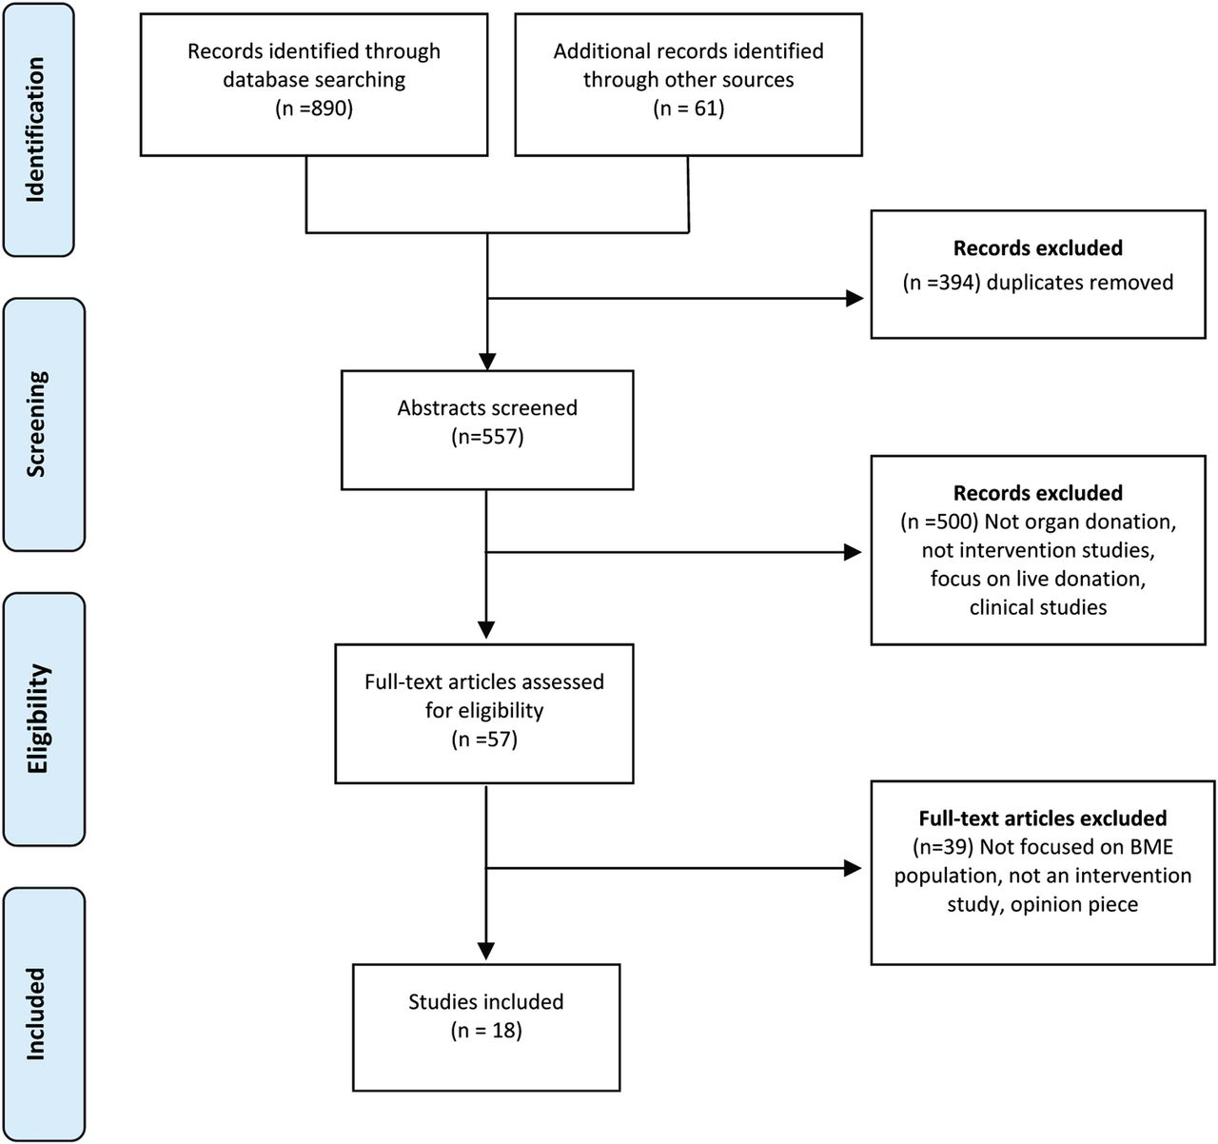

CHAPTER 4
TESTING AND IMPLEMENTATION

  - TESTING
Implementation is the stage of the project when the theoretical design is turned into a working system. This is the final and important phase in the system life cycle It is actually the process of converting the new system into a operational one.

4.1.1Unit Testing
Unit testing comprises the set of tests performed by an individual programmer prior to integration of the unit into a larger system. The module interface is tested to ensure that information properly flows into and out of the program unit. The local data structure is examined to ensure that data stored temporarily maintains its integrity during all steps in an algorithm’s execution. Boundary conditions are tested to ensure that the module operates properly at boundaries established to limit or restrict processing. All independent paths through the control structure are tested. All error-handling paths are tested.

4.1.2 Block Box Testing
Black-box testing is a method of software testing that examines the functionality of an application without peering into its internal structures or workings. This method of test can be applied virtually to every level of software testing: unit, integration, system and acceptance. It is sometimes referred to as specification-based testing.

4.2 SYSTEM IMPLEMENTATION
Implementation is the stage of the project when the theoretical design is turned into a working system. This is the final and important phase in the system life cycle It is actually the process of converting the new system into a operational one.

CHAPTER 5
CONCLUSION:
Blood is primary necessity of life. There are different scenarios for searching blood donors. This proposed system will be one step head from other blood donation system. Blood recipient can contact blood donor directly using this system. The purpose of any application is to simplify and automate the process of searching the blood in case of emergency and maintaining the records of blood donors, recipients, blood donation programs and blood stocks in the bank. Using this application one can search for blood donors or organ donor. This website can also be used by organ donor and seeker where person can register for organ donation. Proposed system will contain a Directory which includes details of all Blood Bank across India. User can search Blood Bank using PIN code and typing name of State or city. This paper introduced those applied outline and improvement of provision for blood conveyance. This paper gives the complete detailed information about both blood donor and organ donor application.

