Advanced encypted blind watermarking hiding text

ABSTRACT
Information security is a critical issue in modern society and image watermarking can effectively prevent unauthorized information access. Optical image watermarking techniques generally have advantages of parallel high-speed processing and multi-dimensional capabilities compared with digital approaches. This paper provides a comprehensive review on the research works related to optical image hiding and watermarking techniques conducted in the past decade. The past research works are focused on two major aspects, various optical systems for image hiding and the methods for embedding optical system output into a host image. A summary of the state-of-the-art works is made from these two perspectives.

CHAPTER 2
2. SYSTEM ANALYSIS
  - EXISTING SYSTEM

- Encryption techniques transform the original image into noise-like ciphertext, which is not accessible by unauthorized users without the correct key.
- However, the existence of ciphertext is usually known to the third party. The aim of watermarking is to hide the existence of original image to unauthorized users.
- In this scheme, the crosstalk between different depth sections of the 3D object can yield a noise-like recorded diffraction patterns, which are favorable for watermarking applications.
- As a drawback, a large number of optical exposures, recorded diffraction patterns and host images are required.
2.1.1 DRAWBACKS OF EXISTING SYSTEM :
- The problem of inconsistency in data representation format between gray scale image and phase-only image (or binary image) is addressed in these works with appropriate algorithms.
- With the rapid development of Internet and information technology, the problem of unauthorized acquisition, transmission, manipulation and distribution of digital content is increasingly more severe in recent years.
- This problem can be possibly tackled by combining these optical systems with some incoherent operations such as visual cryptography, where an approximate overlapping (rather than very precise alignment) of optical components can yield correct decrypted result.
2.2. PROPOSED SYSTEM
- This paper presents a comprehensive review on various optical image watermarking systems and schemes proposed in the past decade.
- A method to detect whether there is DRPE encrypted secret information embedded in a given image is proposed.
- In, an image hiding technique is proposed that combines the complementary advantages of cascaded Fourier transform and RSA encryption algorithm, which is a hybrid of optical and digital security approaches.
- An improved single-shot-ptychography watermarking scheme is proposed by recording one diffraction intensity pattern constituting a series of tiny diffraction spots.
2.2.1. ADVANTAGES OF PROPOSED SYSTEM
- These adaptive watermarking schemes can give more satisfactory watermarking performance (embedding more hidden ciphertext information into the host image while causing less damage to the host image) but the expense is much higher complexity.
- In, the hologram is weight added to the median-frequency coefficients of the discrete cosine transformed (DCT) host image instead of spatial domain.
- The low frequency and high frequency coefficients are well preserved so the host image quality after watermarking is better than the work.
- The wavelet coefficients are quantized by two different quantizers according to the binary bit values of the hidden holographic data.
Literature Survey:
TITLE | AUTHORS | DESCRIPTION
Multimedia encryption and watermarking | B. Furht, E. Muharemagic, D. Socek. | Digital rights management (DRM) is a collection of techniques and technologies that enable technically enforced licensing of digital information.
Roadmap on optical security | B. Javidi, A. Carnicer, M. Yamaguchi, et al. | This roadmap article presents an overview of the potential, recent advances, and challenges of optical security and encryption using free space optics.
Advances in optical security systems | W. Chen, B. Javidi, and X. Chen. | It has been demonstrated that optical technology possesses several unique characteristics for securing information compared with its electronic counterpart, such as many degrees of freedom.
A review of image watermarking applications in healthcare | G. Coatrieux, L. Lecornu, B. Sankur, and C. Roux. | In this article, we focus on the complementary role of watermarking with respect to medical information security (integrity, authenticity ...) and management.

2.3 FEASIBILITY STUDY
The feasibility Analysis is an analytical program through project manager determines the project success ratio and through feasibility study project manager able to see either project. The key considerations involved in the feasibility analysis are:
- Economic Feasibility
- Technical Feasibility
- Operational Feasibility
- Environmental Feasibility

2.3.1 ECONOMICAL FEASIBILITY
Hence this project is economically feasible there is no need to involve any cost for this project.
2.3.2 TECHNICAL FEASIBILITY
Software Technologies used are PHP and MySql. In the educational institutions, it is possible to update the system in future. No special hardware is required for the purpose of using this system. Hence it is declared that this project is technically feasible.
2.3.3 OPERATIONAL FEASIBILITY
As the admin work mainly to maintain the Patient and Doctor .Doctor will predict patient cancer disease. Hence it is easy to operate with training. Therefore it is operationally feasible for implementation.
2.3.4 ENVIRONMENTAL FEASIBILITY
This project environment is correct as a admin has developed this system and no expenditure is involved under any head and this process is part of admin document management, this project environment is accessible.
2.4 SYSTEM REQUIREMENTS
- System : Pentium IV 2.4 GHz.
- Hard Disk : 40 GB.
- Monitor : 15 inch VGA Color.
- Mouse : Logitech Mouse.
- Ram : 512 MB
- Keyboard : Standard Keyboard
2.4.1 HARDWARE REQUIREMENTS
The Hardware of the computer consists of physical component such as Input Devices, Storage Devices, Processing & Control units and Output Devices. Computer includes external storage unit to store data in programs.
The Hardware Configuration involved in this project
- System : Pentium IV 2.4 GHz.
- Hard Disk : 40 GB.
- Monitor : 15 inch VGA Color.
- Mouse : Logitech Mouse.
- Ram : 512 MB
- Keyboard : Standard Keyboard
2.4.2 SOFTWARE REQUIREMENTS
Software is a group of programs that computers need to do a particular task. It is an essential requirement of Computer System. The Software used to develop the project is
- Operating System : Windows XP.
- Platform : DOT NET TECHNOLOGY
- Front End : ASP.Net 3.5
- Back End : SQL SERVER 2005

CHAPTER 3
SYSTEM DESIGN AND DEVELOPEMENT
SYSTEM ARCHICTURE

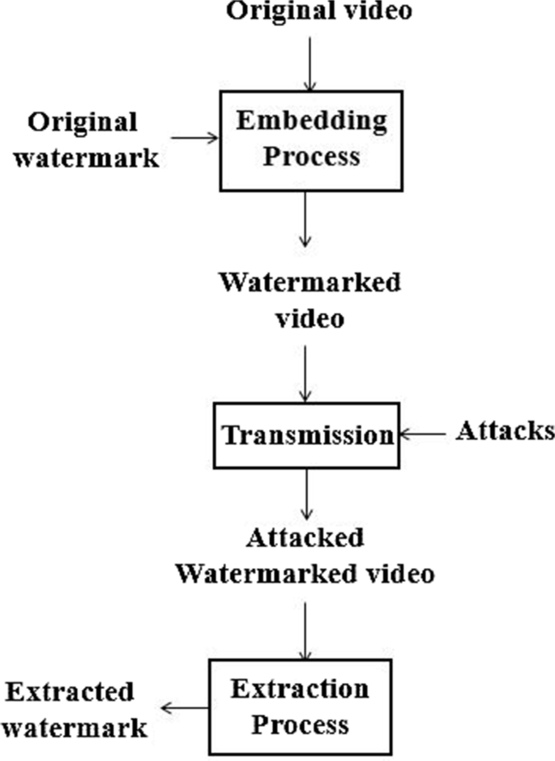

CHAPTER 4
TESTING AND IMPLEMENTATION

  - TESTING
Implementation is the stage of the project when the theoretical design is turned into a working system. This is the final and important phase in the system life cycle It is actually the process of converting the new system into a operational one.

4.1.1Unit Testing
Unit testing comprises the set of tests performed by an individual programmer prior to integration of the unit into a larger system. The module interface is tested to ensure that information properly flows into and out of the program unit. The local data structure is examined to ensure that data stored temporarily maintains its integrity during all steps in an algorithm’s execution. Boundary conditions are tested to ensure that the module operates properly at boundaries established to limit or restrict processing. All independent paths through the control structure are tested. All error-handling paths are tested.

4.1.2 Block Box Testing
Black-box testing is a method of software testing that examines the functionality of an application without peering into its internal structures or workings. This method of test can be applied virtually to every level of software testing: unit, integration, system and acceptance. It is sometimes referred to as specification-based testing.

4.2 SYSTEM IMPLEMENTATION
Implementation is the stage of the project when the theoretical design is turned into a working system. This is the final and important phase in the system life cycle It is actually the process of converting the new system into a operational one.

CHAPTER 5
CONCLUSION:
To the best of our knowledge, this is the first comprehensive summary of various optical architectures and related processing algorithms for optical image hiding or optical watermarking proposed in the past decade. The past research works are focused on two major aspects, various optical systems for image hiding and the methods for embedding optical system output into a host image. The previously proposed optical systems for image hiding include Double Random Phase Encoding (DRPE), off-axis holography system, phase shifting holography system, cascaded phase only mask architecture, Joint Transform Correlator (JTC), ghost imaging system and ptychography system. The features of each system are compared and discussed. Furthermore, different methods for embedding optical system output (ciphertext) into a host image are summarized, from simple weighted addition to sophisticated adaptive embedding. Some future research directions for optical image hiding are discussed in this paper.

CHAPTER-6
REFERENCE
- [1] B. Furht, E. Muharemagic, D. Socek. Multimedia encryption and watermarking. Springer Science & Business Media; 2006.
- [2] B. Javidi, A. Carnicer, M. Yamaguchi, et al. Roadmap on optical security. J Opt 2016; 18(8): 083001.
- [3] W. Chen, B. Javidi, and X. Chen. Advances in optical security systems. Adv Opt Photonics 2014; 6:120-55.
- [4] B. U. Rani, B. Praveena, and K. Ramanjaneyulu. Literature review on digital image Watermarking. Proceedings of the 2015 International Conference on Advanced Research in Computer Science Engineering & Technology (ICARCSET 2015). ACM, 2015.
- [5] G. Coatrieux, L. Lecornu, B. Sankur, and C. Roux. A review of image watermarking applications in healthcare. In Engineering in Medicine and Biology Society, 2006. EMBS'06. 28th Annual International Conference of the IEEE (pp. 4691-4).
- [6] N. K. Nishchal. Hierarchical encrypted image watermarking using fractional Fourier domain random phase encoding. Opt Eng 2011; 50(9): 097003.
- [7] I. Mehra, N. K. Nishchal. Image fusion using wavelet transform and its application to asymmetric cryptosystem and hiding. Opt Express 2014; 22(5):5474-82.
- [8] Y. Sheng, Z. Xin, C. Jian-guo, X. Yong-liang, L. Qiang. A blind image detection method for information hiding with double random-phase encoding. Opt Laser Technol 2009; 41(5):590-5.
- [9] L. C. Ferri, A. Mayerhoefer, M. Frank, C. Vielhauer, R. Steinmetz. Biometric authentication for ID cards with hologram watermarks. Electronic Imaging 2002, International Society for Optics and Photonics, 629-40.
- [10] N. Takai, Y. Mifune. Digital watermarking by a holographic technique. Appl Opt 2002; 41(5):865-873.

