Hostel management system

ABSTRACT
As the name specifies “HOSTEL MANAGEMENT SYSTEM” is a software developed for managing various activities in the hostel. For the past few years the number of educational institutions are increasing rapidly. Thereby the number of hostels are also increasing for the accommodation of the students studying in this institution. And hence there is a lot of strain on the person who are running the hostel and software’s are not usually used in this context. This particular project deals with the problems on managing a hostel and avoids the problems which occur when carried manually.

CHAPTER 2
2. SYSTEM ANALYSIS
  - EXISTING SYSTEM

- Thereby the number of hostels are also increasing for the accommodation of the students studying in this institution.
- And hence there is a lot of strain on the person who are running the hostel and software’s are not usually used in this context.
- Identification of the drawbacks of the existing system leads to the designing of computerized system that will be compatible to the existing system with the system which is more user friendly and more GUI oriented.
- The project, developed using PHP and MySQL is based on the requirement specification of the user and the analysis of the existing system, with flexibility for future enhancement.
2.1.1 DRAWBACKS OF EXISTING SYSTEM :
- This particular project deals with the problems on managing a hostel and avoids the problems which occur when carried manually.
- The Standard PHP Library (SPL) attempts to solve standard problems and implements efficient data access interfaces and classes.
- This leads to confusion over which data is escaped and which is not, and to problems when data is not in fact used as input to a database and when the escaping used is not completely correct.
- Maintenance often includes minor enhancements or corrections to problems that surface in the system’s operation.
- Maintenance is also done based on fixing the problems reported, changing the interface with other software or hardware enhancing the software.
2.2. PROPOSED SYSTEM
- It is a widely-used general-purpose scripting language that is especially suited for web development and can be embedded into HTML.
- PHP is a general-purpose scripting language that is especially suited for web development. PHP generally runs on a web server, taking PHP code as its input and creating web pages as output.
- This purpose user manuals are prepared and handled over to the user to operate the developed system. Thus the users are trained to operate the developed system.
- The proposed system has three major inputs. They are Machine Registration, Machine Scheduling and Request Form.
2.2.1. ADVANTAGES OF PROPOSED SYSTEM
- A database is a collection of interrelated data stored with minimum redundancy to serve many users quickly and efficiently.
- Code optimizers aim to reduce the computational complexity of the compiled code by reducing its size and making other changes that can reduce the execution time with the overall goal of improving performance.
- These can offer significant performance gains by caching the compiled form of a PHP script in shared memory to avoid the overhead of parsing and compiling the code every time the script runs.
- System testing is the stage of implementation, which is aimed at ensuring that the system works accurately and efficiently before live operation commences.
2.3 FEASIBILITY STUDY
The feasibility Analysis is an analytical program through project manager determines the project success ratio and through feasibility study project manager able to see either project. The key considerations involved in the feasibility analysis are:
- Economic Feasibility
- Technical Feasibility
- Operational Feasibility
- Environmental Feasibility
2.3.1 ECONOMICAL FEASIBILITY
Hence this project is economically feasible there is no need to involve any cost for this project.

2.3.2 TECHNICAL FEASIBILITY
Software Technologies used are PHP and MySql. In the educational institutions, it is possible to update the system in future. No special hardware is required for the purpose of using this system. Hence it is declared that this project is technically feasible.
2.3.3 OPERATIONAL FEASIBILITY
As the admin work mainly to maintain the Patient and Doctor .Doctor will predict patient cancer disease. Hence it is easy to operate with training. Therefore it is operationally feasible for implementation.
2.3.4 ENVIRONMENTAL FEASIBILITY
This project environment is correct as a admin has developed this system and no expenditure is involved under any head and this process is part of admin document management, this project environment is accessible.
2.4 SYSTEM REQUIREMENTS
- System : Pentium IV 2.4 GHz.
- Hard Disk : 40 GB.
- Monitor : 15 inch VGA Color.
- Mouse : Logitech Mouse.
- Ram : 512 MB
- Keyboard : Standard Keyboard

2.4.1 HARDWARE REQUIREMENTS
The Hardware of the computer consists of physical component such as Input Devices, Storage Devices, Processing & Control units and Output Devices. Computer includes external storage unit to store data in programs.
The Hardware Configuration involved in this project
- System : Pentium IV 2.4 GHz.
- Hard Disk : 40 GB.
- Monitor : 15 inch VGA Color.
- Mouse : Logitech Mouse.
- Ram : 512 MB
- Keyboard : Standard Keyboard
2.4.2 SOFTWARE REQUIREMENTS
Software is a group of programs that computers need to do a particular task. It is an essential requirement of Computer System. The Software used to develop the project is
- Operating System : Windows XP.
- Platform : DOT NET TECHNOLOGY
- Front End : ASP.Net 3.5
- Back End : SQL SERVER 2005

CHAPTER 3
SYSTEM DESIGN AND DEVELOPEMENT
SYSTEM ARCHICTURE

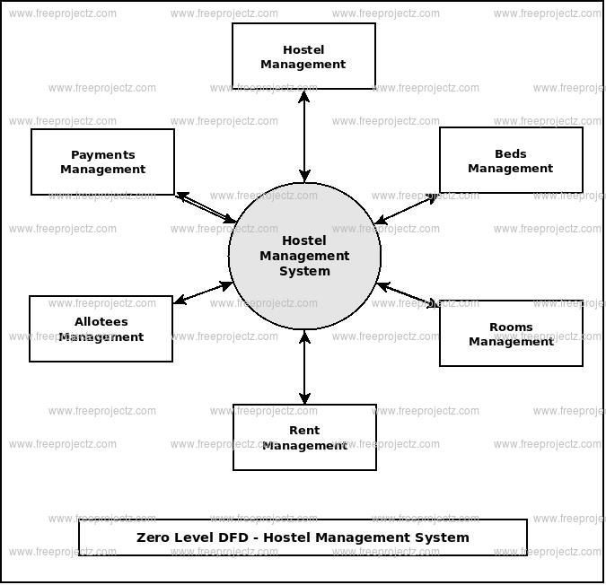

CHAPTER 4
TESTING AND IMPLEMENTATION

  - TESTING
Implementation is the stage of the project when the theoretical design is turned into a working system. This is the final and important phase in the system life cycle It is actually the process of converting the new system into a operational one.

4.1.1Unit Testing
Unit testing comprises the set of tests performed by an individual programmer prior to integration of the unit into a larger system. The module interface is tested to ensure that information properly flows into and out of the program unit. The local data structure is examined to ensure that data stored temporarily maintains its integrity during all steps in an algorithm’s execution. Boundary conditions are tested to ensure that the module operates properly at boundaries established to limit or restrict processing. All independent paths through the control structure are tested. All error-handling paths are tested.

4.1.2 Block Box Testing
Black-box testing is a method of software testing that examines the functionality of an application without peering into its internal structures or workings. This method of test can be applied virtually to every level of software testing: unit, integration, system and acceptance. It is sometimes referred to as specification-based testing.

4.2 SYSTEM IMPLEMENTATION
Implementation is the stage of the project when the theoretical design is turned into a working system. This is the final and important phase in the system life cycle It is actually the process of converting the new system into a operational one.

CHAPTER 5
CONCLUSION:
To conclude the description about the project : The project, developed using PHP and MySQL is based on the requirement specification of the user and the analysis of the existing system, with flexibility for future enhancement. The expanded functionality of today’s software requires an appropriate approach towards software development. This hostel management software is designed for people who want to manage various activities in the hostel. For the past few years the number of educational institutions are increasing rapidly. Thereby the number of hostels are also increasing for the accommodation of the students studying in this institution. And hence there is a lot of strain on the person who are running the hostel and software’s are not usually used in this context. This particular project deals with the problems on managing a hostel and avoids the problems which occur when carried manually. Identification of the drawbacks of the existing system leads to the designing of computerized system that will be compatible to the existing system with the system which is more user friendly and more GUI oriented.

CHAPTER-6
REFERENCE
- 1. www.w3schools.com
- 2. in.php.net
- 3. en.wikipedia.org/wiki/PHP
- 4 . www.hotscripts.com/category/php/
- 5. www.apache.org/
- 6. www.mysql.com/click.php?e=35050

