Flood alert monitoring system

ABSTRACT
Flooding is the most common worldwide natural disaster which is stylish throughout the year. There are various methods of alerts such as the email notifications, sirens etc. The design goal of this project is to monitor sudden floods can create a alert that will reach an end user through their mobile phone. Living in a very place that gets several warnings might create it troublesome to induce insurance. People might not hear or have access to warnings. Television and radio take time to get electronic sirens capable of reproducing warning signals and voice announcement. Information can be broadcast simultaneously through SMS. Here we propose to use such as Ultrasonic pressure, Node MCU, GSM module. The ultrasonic pressure will monitor the water level. The GSM modem is a device that can be either a mobile phone or a modem device that can be used to make a computer or any other processor communicate over a network. In addition, it requires a SIM card to be operated and operates over a network range subscribed by the network operator. It may be connected to laptop through serial, USB or Bluetooth connection..The advantage of this system is to monitor the sudden flood occur and then it will send the report immediately for protecting lives and livelihoods.

CHAPTER 2
2. SYSTEM ANALYSIS
  - EXISTING SYSTEM

- There have been many successful solution on flood alerts using SMS, yet most count on either having a constant power source or which rely completely on solar energy as their main source of power.
- In the existing system a sensing unit is built using a GSM module and a PIC18F452 micro controller with 3 different liquid level sensor as input.
- The system defines a level threshold and sends one SMS text alert via GSM.
- Once the levels start receding it will also alert the user on said event.
2.1.1 DRAWBACKS OF EXISTING SYSTEM :
- The drawbacks of this design are that the sensing and alert system are concentrated into one unit. Also, the system is designed to be only be triggered by the levels and does not store historical data.
- However, the system can only be used by two users at a time, which input their phone numbers to the system and receive three alerts per threshold reached.
- This design relies on solar power as its only energy source, making it unsuitable for twenty-four hour operation.
- It measures distance by causation out a acoustic wave at a particular frequency and listening for that acoustic wave to heal.
2.2. PROPOSED SYSTEM
- The proposed system is an enhanced technique for monitoring the water level and to alert the end user. It uses such as Ultrasonic sensor, Node MCA, GSM module.
- The ultrasonic pressure will monitor the water level. The GSM modem is a device that can be either a mobile phone or a modem device that can be used to make a computer or any other processor communicate over a network.
- In addition, it requires a SIM card to be operated and operates over a network range subscribed by the network operator.
- It will be connected to a pc through serial, USB or Bluetooth affiliation.
2.2.1. ADVANTAGES OF PROPOSED SYSTEM
- The advantage of this system is to monitor the sudden flood occur and then it will send the report immediately for protecting lives and livelihoods.
- There are four main components used in IoT: Low- power embedded systems –Less battery consumption, high performance are the inverse factors play a significant role during the design of electronic systems.
- Massively scalable and efficientIP-based addressing cannot be appropriate within the forthcoming future.
- These sensors are used for a large sort of functions from observance the extent of water in a very tank to fluid identification/concentration, to police investigation object proximity.
Literature Survey:
TITLE | AUTHORS | DESCRIPTION
Early flood alerts using short message service(SMS) | E. Kuantama, L. Setyawan, and J.Darma | This system focused on an accurate measurement of the height of the water level and sending a warning message of the threshold height set before to the clients.
Cooperative flood detection using GSM via SMS | I. A. Aziz, I. A. Hamizan, N. S. Haron, and M. Mehat, | It is hope that the proposed architecture can be further develop into a functioning system, which would be beneficial to the community and act as a precautionary action to save lives in the case of flood disaster.
Evaluation of Global Flood Detection Using Satellite-Based Rainfall and a Hydrologic Model | Wu, H., Adler, R. F., Hong, Y., Tian, Y., & Policelli. F, | The purpose of this paper is to evaluate the performance of this new version of the GFMS in terms of flood event detection against flood event archives to establish a baseline of performance and directions for improvement.
Flash flood detection through a multi-stage probabilistic warning system for heavy precipitation events | Alfieri, L., Velasco, D., & Thielen, J, | This paper contributes to flash flood early warning by proposing a multi-stage warning system for heavy precipitation events based on threshold exceedances within a probabilistic framework.

2.3 FEASIBILITY STUDY
The feasibility Analysis is an analytical program through project manager determines the project success ratio and through feasibility study project manager able to see either project. The key considerations involved in the feasibility analysis are:
- Economic Feasibility
- Technical Feasibility
- Operational Feasibility
- Environmental Feasibility
2.3.1 ECONOMICAL FEASIBILITY
Hence this project is economically feasible there is no need to involve any cost for this project.
2.3.2 TECHNICAL FEASIBILITY
Software Technologies used are PHP and MySql. In the educational institutions, it is possible to update the system in future. No special hardware is required for the purpose of using this system. Hence it is declared that this project is technically feasible.
2.3.3 OPERATIONAL FEASIBILITY
As the admin work mainly to maintain the Patient and Doctor .Doctor will predict patient cancer disease. Hence it is easy to operate with training. Therefore it is operationally feasible for implementation.
2.3.4 ENVIRONMENTAL FEASIBILITY
This project environment is correct as a admin has developed this system and no expenditure is involved under any head and this process is part of admin document management, this project environment is accessible.
2.4 SYSTEM REQUIREMENTS
- System : Pentium IV 2.4 GHz.
- Hard Disk : 40 GB.
- Monitor : 15 inch VGA Color.
- Mouse : Logitech Mouse.
- Ram : 512 MB
- Keyboard : Standard Keyboard
2.4.1 HARDWARE REQUIREMENTS
The Hardware of the computer consists of physical component such as Input Devices, Storage Devices, Processing & Control units and Output Devices. Computer includes external storage unit to store data in programs.
The Hardware Configuration involved in this project
- System : Pentium IV 2.4 GHz.
- Hard Disk : 40 GB.
- Monitor : 15 inch VGA Color.
- Mouse : Logitech Mouse.
- Ram : 512 MB
- Keyboard : Standard Keyboard
2.4.2 SOFTWARE REQUIREMENTS
Software is a group of programs that computers need to do a particular task. It is an essential requirement of Computer System. The Software used to develop the project is
- Operating System : Windows XP.
- Platform : DOT NET TECHNOLOGY
- Front End : ASP.Net 3.5
- Back End : SQL SERVER 2005

CHAPTER 3
SYSTEM DESIGN AND DEVELOPEMENT
SYSTEM ARCHICTURE

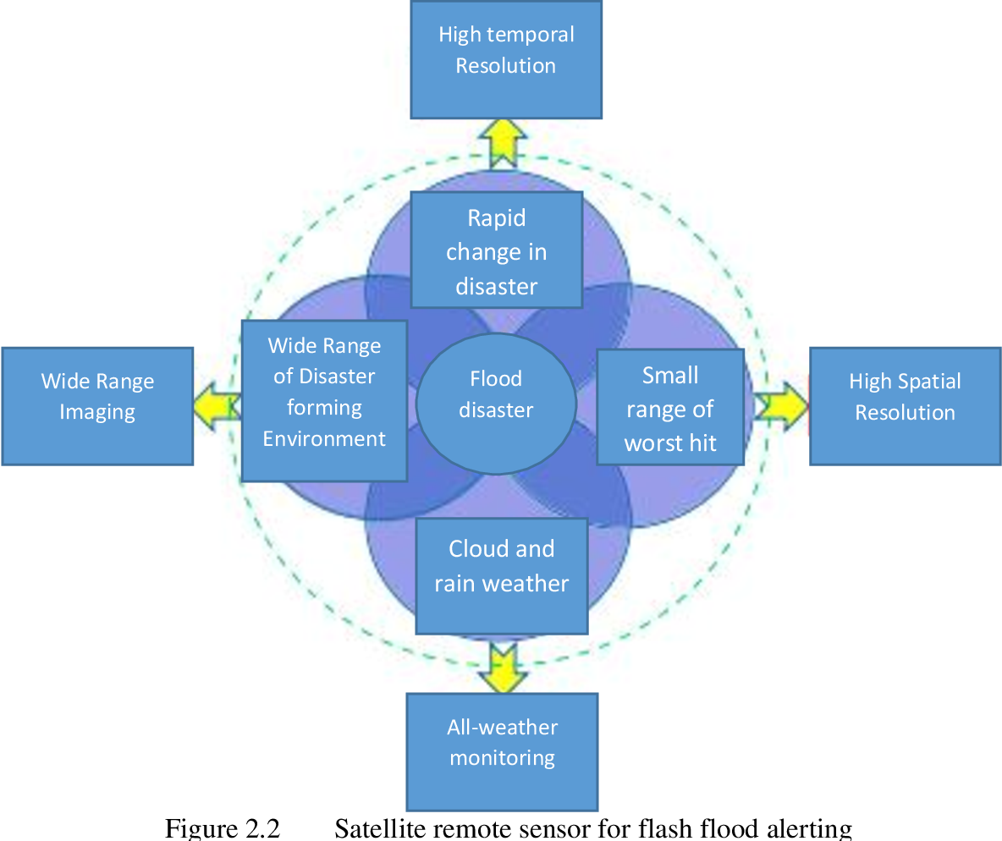

CHAPTER 4
TESTING AND IMPLEMENTATION

  - TESTING
Implementation is the stage of the project when the theoretical design is turned into a working system. This is the final and important phase in the system life cycle It is actually the process of converting the new system into a operational one.

4.1.1Unit Testing
Unit testing comprises the set of tests performed by an individual programmer prior to integration of the unit into a larger system. The module interface is tested to ensure that information properly flows into and out of the program unit. The local data structure is examined to ensure that data stored temporarily maintains its integrity during all steps in an algorithm’s execution. Boundary conditions are tested to ensure that the module operates properly at boundaries established to limit or restrict processing. All independent paths through the control structure are tested. All error-handling paths are tested.

4.1.2 Block Box Testing
Black-box testing is a method of software testing that examines the functionality of an application without peering into its internal structures or workings. This method of test can be applied virtually to every level of software testing: unit, integration, system and acceptance. It is sometimes referred to as specification-based testing.

4.2 SYSTEM IMPLEMENTATION
Implementation is the stage of the project when the theoretical design is turned into a working system. This is the final and important phase in the system life cycle It is actually the process of converting the new system into a operational one.

CHAPTER 5
CONCLUSION:
The project proposed is a simple technique which can be easily implemented and cost effective for the flood alerting system. The idea has been implemented as a prototype and verified successfully. The results shows that immediate report will be given to the concerned authority which helps in immediate remedial measures. In future the other parameters measuring can be included and remedial measurements may be added. The idea proposed is now concentrates on flood alerting system and the same can be used to other types of flood alerting also. Here blynk app is used to notice the sensor measurement and also the water level then it will inform the end user through SMS or email or sirens.

CHAPTER-6
REFERENCE
- [1] E. Kuantama, L. Setyawan, and J.Darma “Early flood alerts using short message service(SMS),” in 2012 (Early flood alerts system is use to create a tool to measure water level, which powered by solar cell panel).
- [2] M. S. Baharum, R. A. Awang, and N. H. Baba, “Flood monitoring system (MYMFS),” in 2011 pp, IEEE 06 2011.
- [3] L. S. T. Molina, E. W. Harmsen, and S. Cruz- Pol, “Flood alert system using rainfall forecast data in western puerto rico,” in 2013 (Flooding due to sudden, extreme rainfall events, some of which fail to be detected by radar).
- [4] I. A. Aziz, I. A. Hamizan, N. S. Haron, and M. Mehat, “Cooperative flood detection using GSM via SMS,” in 2008 (This project focuses on monitoring water level remotely using wireless sensor network).
- [5] Johor Bahru,”UTM SMS Based Flood Device Minimizes” 2015(Flood warning device that alerts people through Short Message System(SMS) once the water level nearby starts to rise).
- [6] Wu, H., Adler, R. F., Hong, Y., Tian, Y., & Policelli. F, “Evaluation of Global Flood Detection Using Satellite-Based Rainfall and a Hydrologic Model”,2012(The purpose of this paper is to evaluate the performance of this new version of the GFMS in terms of flood event detection against flood event archives to establish a baseline of performance and directions for improvement).
- [7] Alfieri, L., Velasco, D., & Thielen, J, “Flash flood detection through a multi-stage probabilistic warning system for heavy precipitation events”,2011(This paper contributes to flash flood early warning by proposing a multi-stage warning system for heavy precipitation events based on threshold exceedances within a probabilistic framework).
- [8] Yamada, Y, “Flood extent detection in paddy area and future plan of disaster information sharing platform in rural areas”,2011(The author also tried to make a disaster information sharing platform, ‘GeoWeb’, using open source software and the ISO orOGC standards).
- [9] Fang, S., Xu, L., Zhu, Y., Liu, Y., Liu, Z., Pei, H., … Zhang, H.“An integrated information system for snowmelt flood earlywarning based on internet of things”,2015(This paper presents an integrated approach to snowmelt floods early warning based on geo informatics (i.e. remote sensing (RS), geographical information systems (GIS) and global positioning systems(GPS)),Internet of Things(IoT) and cloud services).
- [10] Bartholmes, J. C., Thielen, J., Ramos, M. H., & Gentilini. S,”The European Flood Alert System EFAS – Part 2: Statistical skill assessment of probabilistic and deterministic operational forecasts”,2008(EFAS aims at increasing preparedness for floods in trans-national European river basins by providing medium-range deterministic and probabilistic flood forecasting information, from 3 to 10 days in advance, to national hydro-meteorological services).

