Railway reservation system

ABSTRACT
The railway reservation system facilitates the passengers to enquiry about the trains available on the basis of source and destination, booking and cancellation of tickets, enquiry about the status of the booked ticket, etc. The aim of case study is to design and develop a data base maintaining records of different trains, train status and passengers.This project contains introduction to the railways reservation system. It is the computerized system of reserving the seats of train seats in advance. It is mainly used for a long route. Online reservation has made the process for the reservation of seats very much easier than ever before. In our country India, there are number of counters for the reservation of the seats and one can easily make reservations and get tickets. Railway reservation system, has described above, can lead to error free, secure, reliable and fast management system. It can assist the user to concentrate on their other activities rather to concentrate on the record keeping. Thus it will help organization it better utilization of resources.Administrator of the project, with the help of a password, can enter new train record, display all train records, modify train records and delete train records. The record of train includes its number, name, source, destination, and days on which it is available, whereas record of train status includes dates for which tickets can be booked, total number of seats available, and number of seats already booked.

CHAPTER 2
2. SYSTEM ANALYSIS
  - EXISTING SYSTEM

- Existing railway reservation system not having feature of displaying appropriate messages for events and errors which occur while accessing the system.
- This railway reservation system do not able to provide the details of customers transactions and their payment mode along with date time and processing charge details. Making changing in information and perform administrative task was not possible while using existing system.
- Making changes in information and perform administrative task was not possible while using existing system.
- In the existing system the exams are done only manually but in proposed system we have to computerize the exams using this application.
2.1.1 DRAWBACKS OF EXISTING SYSTEM :
- The “Railway reservation system” has been developed to override the problems prevailing in the practicing manual system.
- The Current Day Reservation System also posed problems and reservations to intermediate stations were not possible. The Coaching Refund System was also not integrated with the PRS.
- The Railways faced a number of problems in the restoration of disrupted BSNL channels as the maintenance was very poor.
- Though the problems in the system existed for more than three years, they were not rectified.
- If the passenger was still available after restoration of the link, the operator had to search the data base for the saved transaction and then issue a blank paper ticket.
2.2. PROPOSED SYSTEM
- Security of data.
- Ensure data accuracy’s
- Proper control of the higher officials.
- Minimize manual data entry.
- Minimum time needed for the various processing.
- Greater efficiency.
- Better service.
- User friendliness and interactive.
2.2.1. ADVANTAGES OF PROPOSED SYSTEM
- In PRS, the role of the communication system is also vital, as the functioning of the system is primarily dependent on the performance of the network.
- In spite of involving CRIS, the performance of the contractors was not satisfactory particularly in ER, where there were undue delays in rectification of faults.
- Where BSNL links have to be continued for strategic reasons it is necessary to ensure effective performance and efficient delivery of services through proper agreements and penal clauses.
- Any discrepancies in the outputs generated would present a skewed picture of railway performance.
2.3 FEASIBILITY STUDY
The feasibility Analysis is an analytical program through project manager determines the project success ratio and through feasibility study project manager able to see either project. The key considerations involved in the feasibility analysis are:
- Economic Feasibility
- Technical Feasibility
- Operational Feasibility
- Environmental Feasibility
2.3.1 ECONOMICAL FEASIBILITY
Hence this project is economically feasible there is no need to involve any cost for this project.
2.3.2 TECHNICAL FEASIBILITY
Software Technologies used are PHP and MySql. In the educational institutions, it is possible to update the system in future. No special hardware is required for the purpose of using this system. Hence it is declared that this project is technically feasible.

2.3.3 OPERATIONAL FEASIBILITY
As the admin work mainly to maintain the Patient and Doctor .Doctor will predict patient cancer disease. Hence it is easy to operate with training. Therefore it is operationally feasible for implementation.
2.3.4 ENVIRONMENTAL FEASIBILITY
This project environment is correct as a admin has developed this system and no expenditure is involved under any head and this process is part of admin document management, this project environment is accessible.
2.4 SYSTEM REQUIREMENTS
- System : Pentium IV 2.4 GHz.
- Hard Disk : 40 GB.
- Monitor : 15 inch VGA Color.
- Mouse : Logitech Mouse.
- Ram : 512 MB
- Keyboard : Standard Keyboard
2.4.1 HARDWARE REQUIREMENTS
The Hardware of the computer consists of physical component such as Input Devices, Storage Devices, Processing & Control units and Output Devices. Computer includes external storage unit to store data in programs.
The Hardware Configuration involved in this project
- System : Pentium IV 2.4 GHz.
- Hard Disk : 40 GB.
- Monitor : 15 inch VGA Color.
- Mouse : Logitech Mouse.
- Ram : 512 MB
- Keyboard : Standard Keyboard

2.4.2 SOFTWARE REQUIREMENTS
Software is a group of programs that computers need to do a particular task. It is an essential requirement of Computer System. The Software used to develop the project is
- Operating System : Windows XP.
- Platform : DOT NET TECHNOLOGY
- Front End : ASP.Net 3.5
- Back End : SQL SERVER 2005

CHAPTER 3
SYSTEM DESIGN AND DEVELOPEMENT
SYSTEM ARCHICTURE

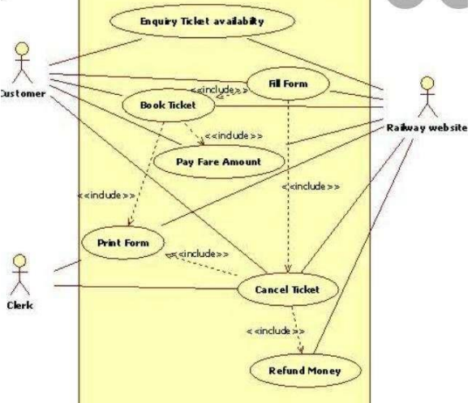

CHAPTER 4
TESTING AND IMPLEMENTATION

  - TESTING
Implementation is the stage of the project when the theoretical design is turned into a working system. This is the final and important phase in the system life cycle It is actually the process of converting the new system into a operational one.

4.1.1Unit Testing
Unit testing comprises the set of tests performed by an individual programmer prior to integration of the unit into a larger system. The module interface is tested to ensure that information properly flows into and out of the program unit. The local data structure is examined to ensure that data stored temporarily maintains its integrity during all steps in an algorithm’s execution. Boundary conditions are tested to ensure that the module operates properly at boundaries established to limit or restrict processing. All independent paths through the control structure are tested. All error-handling paths are tested.

4.1.2 Block Box Testing
Black-box testing is a method of software testing that examines the functionality of an application without peering into its internal structures or workings. This method of test can be applied virtually to every level of software testing: unit, integration, system and acceptance. It is sometimes referred to as specification-based testing.

4.2 SYSTEM IMPLEMENTATION
Implementation is the stage of the project when the theoretical design is turned into a working system. This is the final and important phase in the system life cycle It is actually the process of converting the new system into a operational one.

CHAPTER 5
CONCLUSION:
The main of developing reservation system is to provide all information that is required by the users. User friendliness is a must that is the user must get the details without complicated searching procedures .Other important requirements of software are data security, extensibility and maintainability.

CHAPTER-6
REFERENCE
- 1. http://www.google.com/
- 2. http://en.wikipedia.org
- 3. Computer science with C++ by Sumita Arora

